**How To Set Up vsftpd on Ubuntu 12.04**

Posted Jun 19, 2012

Top of Form

Bottom of Form

47

695.7k views [Linux Basics](https://www.digitalocean.com/community/tags/linux-basics?type=tutorials) [Security](https://www.digitalocean.com/community/tags/security?type=tutorials) [Ubuntu](https://www.digitalocean.com/community/tags/ubuntu?type=tutorials)

**About vsftpd**

**Warning: FTP is inherently insecure. If you *must* use FTP, consider** [**securing your FTP connection with SSL/TLS**](https://www.digitalocean.com/community/articles/how-to-configure-vsftpd-to-use-ssl-tls-on-an-ubuntu-vps)**. Otherwise, it is best to** [**use SFTP, a secure alternative to FTP**](https://www.digitalocean.com/community/articles/how-to-use-sftp-to-securely-transfer-files-with-a-remote-server)**.**

The first two letters of vsftpd stand for "very secure" and the program was built to have strongest protection against possible FTP vulnerabilities.

**Step One—Install vsftpd**

You can quickly install vsftpd on your virtual private server in the command line:

sudo apt-get install vsftpd

Once the file finishes downloading, the VSFTP will be on your droplet. Generally speaking, it is already configured with a reasonable amount of security. However, it does provide access on your VPS to anonymous users.

**Step Two—Configure vsftpd**

Once vsftpd is installed, you can adjust the configuration.

Open up the configuration file:

sudo nano /etc/vsftpd.conf

The biggest change you need to make is to switch the Anonymous\_enable from YES to NO:

anonymous\_enable=NO

Prior to this change, vsftpd allowed anonymous, unidentified users to access the server's files. This is useful if you are seeking to distribute information widely, but may be considered a serious security issue in most other cases.

After that, uncomment the local\_enable option, changing it to yes and, additionally, allow the user to write to the directory.

local\_enable=YES

write\_enable=YES

Finish up by uncommenting command to chroot\_local\_user. When this line is set to Yes, all the local users will be jailed within their chroot and will be denied access to any other part of the server.

chroot\_local\_user=YES

Save and Exit that file.

Because of a recent vsftpd upgrade, vsftpd is "refusing to run with writable root inside chroot". A handy way to address this issue to is to take the following steps:

1. Create a new directory within the user's home directory

mkdir /home/*username*/files

1. Change the ownership of that file to root

chown root:root /home/*username*

1. Make all necessary changes within the "files" subdirectory

Then, as always, restart:

sudo service vsftpd restart

**Step Three—Access the FTP server**

Once you have installed the FTP server and configured it to your liking, you can now access it.

You can reach an FTP server in the browser by typing the domain name into the address bar and logging in with the appropriate ID. Keep in mind, you will only be able to access the user's home directory.

ftp://example.com

Alternatively, you can reach the FTP server on your virtual server through the command line by typing:

ftp example.com

Then you can use the word, "exit," to get out of the FTP shell.

**How to setup FTP server on ubuntu 14.04 ( VSFTPD )**

FTP is used to transfer files from one host to another over TCP network. This article explains how to setup FTP server on ubuntu 14.04 .  
There are 3 popular FTP server packages available PureFTPD, VsFTPD and ProFTPD. Here i’ve used VsFTPD which is lightweight and less Vulnerability.

**Setup FTP server on Ubuntu 14.04**

**Step 1 »** Update repositories .  
krizna@leela:~$ sudo apt-get update   
**Step 2 »** Install VsFTPD package using the below command.  
krizna@leela:~$ sudo apt-get install vsftpd  
**Step 3 »** After installation open **/etc/vsftpd.conf** file and make changes as follows.  
Uncomment the below lines (line no:29 and 33).  
write\_enable=YES  
local\_umask=022 » Uncomment the below line (line no: 120 ) to prevent access to the other folders outside the Home directory.  
chroot\_local\_user=YES and add the following line at the end.  
allow\_writeable\_chroot=YES» Add the following lines to enable passive mode.  
pasv\_enable=Yes  
pasv\_min\_port=40000  
pasv\_max\_port=40100  
**Step 4 »** Restart vsftpd service using the below command.  
krizna@leela:~$ sudo service vsftpd restart  
**Step 5 »** Now ftp server will listen on port 21. Create user with the below command.Use **/usr/sbin/nologin** shell to prevent access to the bash shell for the ftp users .  
krizna@leela:~$ sudo useradd -m john -s /usr/sbin/nologin  
krizna@leela:~$ sudo passwd john  
**Step 6 »** Allow login access for nologin shell . Open **/etc/shells** and add the following line at the end.  
/usr/sbin/nologin  
Now try to connect this ftp server with the username on port 21 using [winscp](http://winscp.net/eng/download.php) or [filezilla](https://filezilla-project.org/download.php?type=client) client and make sure that user cannot access the other folders outside the home directory.  
[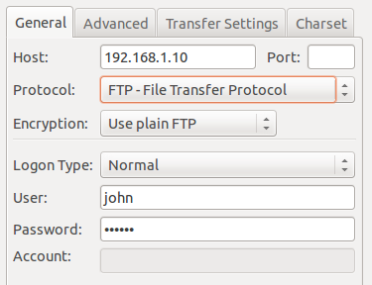](http://cdn.krizna.com/wp-content/uploads/2014/05/setup-FTP-server-ubuntu-14-04-1.png)  
**Please note using ftp on port 21 is a big security risk . it’s highly recommended to use SFTP. Please continue for SFTP configuration**

**Secure FTP ( SFTP )**

SFTP is called as “Secure FTP” which generally use SSH File Transfer Protocol . so we need openssh-server package installed , Issue the below command if it’s not already installed.  
krizna@leela:~$ sudo apt-get install openssh-server  
**Step 7 »** Create a new group **ftpaccess** for FTP users.  
krizna@leela:~$ sudo groupadd ftpaccess  
**Step 8 »** Now make changes in this **/etc/ssh/sshd\_config** file.  
» Find and comment the below line  
Subsystem sftp /usr/lib/openssh/sftp-server and Add these lines at the end of the file.  
Subsystem sftp internal-sftp  
Match group ftpaccess  
ChrootDirectory %h  
X11Forwarding no  
AllowTcpForwarding no  
ForceCommand internal-sftp  
**Step 9 »** Restart sshd service.  
krizna@leela:~$ sudo service ssh restart  
**Step 10 »** The below steps must be followed while creating Users for sftp access.  
Create user **john** with **ftpaccess** group and **/usr/bin/nologin** shell.  
krizna@leela:~$ sudo useradd -m john -g ftpaccess -s /usr/sbin/nologin  
krizna@leela:~$ sudo passwd johnChange ownership for the home directory.  
krizna@leela:~$ sudo chown root /home/johnCreate a folder inside home directory for writing and change ownership of that folder.  
krizna@leela:~$ sudo mkdir /home/john/www  
krizna@leela:~$ sudo chown john:ftpaccess /home/john/www  
Now try to connect server using SFTP ( port : 22 ) and makesure Users can upload files to **www** directory and cannot access other folders outside home directory.[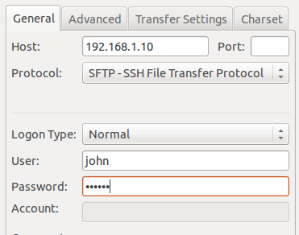](http://cdn.krizna.com/wp-content/uploads/2014/05/setup-FTP-server-ubuntu-14-04.png)  
If you want use both FTP and SFTP together, please perform above steps ( Step 10 ) while creating users . For existing users, move them to ftpaccess group and create folder structure and ownership changes as below.  
krizna@leela:~$ sudo usermod john -g ftpaccess -s /usr/sbin/nologin  
krizna@leela:~$ sudo chown root /home/john  
krizna@leela:~$ sudo mkdir /home/john/www  
krizna@leela:~$ sudo chown john:ftpaccess /home/john/www  
Now john can able to upload files to www folder using FTP as well as SFTP.

**How to Install and Configure vsftpd on Ubuntu 14.04 LTS**

Category: [Technical Support](http://www.liquidweb.com/kb/category/technical-support/), [Tutorials](http://www.liquidweb.com/kb/category/tutorials/)

**FTP** (File Transfer Protocol) is probably the most popular method of uploading files to a server; a wide array of FTP servers, such as vsftpd, and clients exist for every platform.

**Pre-Flight Check**

* These instructions are intended specifically for installing the vsfptd on Ubuntu 14.04 LTS.
* I’ll be working from a Liquid Web Core Managed Ubuntu 14.04 LTS server, and I’ll be logged in as root.

**Step 1: Install vsftpd**

Warning: FTP data is insecure; traffic is not encrypted, and all transmissions are clear text (including usernames, passwords, commands, and data). Consider securing your FTP connection with SSL/TLS.

First, you’ll follow a simple best practice: ensuring the list of available packages is up to date before installing anything new.

apt-get update

Then let’s install vsftpd and any required packages:

apt-get -y install vsftpd

**Step 2: Configure vsftpd**

For a refresher on editing files with vim see: [New User Tutorial: Overview of the Vim Text Editor](http://www.liquidweb.com/kb/overview-of-vim-text-editor/)

Let’s edit the configuration file for vsftpd:

vim /etc/vsftpd.conf

Disallow anonymous, unidentified users to access files via FTP; change the **anonymous\_enable** setting to **NO**:

anonymous\_enable=NO

Allow local uses to login by changing the **local\_enable** setting to **YES**:

local\_enable=YES

If you want local user to be able to write to a directory, then change the **write\_enable** setting to **YES**:

write\_enable=YES

Local users will be ‘chroot jailed’ and they will be denied access to any other part of the server; change the **chroot\_local\_user** setting to **YES**:

chroot\_local\_user=YES

Exit and save the file with the command **:wq**.

Restart the vsftpd service:

service vsftpd restart

**Step 3: Configure the User’s Home Directory**

With certain version of vsftpd you may receive the following error: **500 OOPS: vsftpd: refusing to run with writable root inside chroot()**.

Not to worry! Create a new directory for the user receiving the error (**user2** in this case) that is a subdirectory of their home directory (**/home/user2**). For example:

Fix permissions for **user2**‘s home directory:

chmod a-w /home/user2/

Make a new directory for uploading files:

mkdir /home/user2/files  
chown user2:user2 /home/user2/files/

## How to setup and use FTP Server in Ubuntu Linux

**1. Introduction**

FTP is a service known to almost anyone who works with Internet on daily basis. This guide will describe in detail how to setup an FTP server on Ubuntu Linux in simple to follow steps. We will show how to setup an FTP server in normal and stand-alone mode. We will also provide some security tips for your new FTP setup. This guide will use lightweight and efficient FTP server **vsFTPd,** which is designed to withstand on servers with high load.

**2. Conventions**

Occasionally in this article we will refer to **vsFTPd** simply as FTP server.

**3. What is FTP**

For those who are not familiar with FTP here is a short description of what this service offers. FTP stand for **F**ile **T**ransfer **P**rotocol. As the name suggest this network protocol allows you to transfer files or directories from one host to another over the network whether it is your LAN or Internet.

Main [features of **vsFTPd**](https://security.appspot.com/vsftpd.html#features) are: Virtual IP configurations, Virtual users, Standalone or inetd operation, Powerful per-user configurability, Bandwidth throttling, Per-source-IP configurability, Per-source-IP limits, IPv6 andEncryption support through SSL integration.

**4. Installation of FTP server in Ubuntu**

As in any other Ubuntu like Linux systems, installation of the FTP server comes down to a single command. Open up your terminal and enter the command:

$ sudo apt-get install vsftpd

The above command will install and start the ftp server on your Linux system.

Setting up vsftpd (2.3.5-1ubuntu2) ...  
vsftpd start/running, process 1891

**5. Stand-alone vs Normal FTP mode**

**5.1. Stand-alone mode**

By default vsftpd starts for stand-alone mode. In stand-alone mode the service you run on your server has its own startup script called daemon. In case of vsftpd it is a **/etc/init.d/vsftpd** . This stand-alone daemon will take control of the FTP service the moment it gets started. The vsftpd daemon provides the administrator with a couple of commands to manage the vsftpd FTP server:

* **start** or **stop** - used to start and stop the ftp server
* **status** - provides more information about the current status of your FTP server
* **restart** - this is an alternative to consequent execution of **stop** and **start** commands. If the FTP server is down, the **restart** command will start it.
* **reload** - this will instruct the FTP server to reload and apply all new configurations. The difference between **reload** and **restart** is that with **reload** you are not shutting down your FTP but rather only reloading it with new configuration settings and at the same time ensure continuous uptime.

To start, restart, reload or get the status of our FTP server we can use the **service** utility:

$ sudo service vsftpd start

The above syntax applies to all other commands so simply replace start with a command you wish to execute.

**5.2. Normal mode**

The different approach is to start the vsftpd FTP service in a normal mode, which means that the **xinetd** superserver will be responsible for keeping up your FTP service alive. To start the vsftpd FTP server in the normal mode we first need to install the **xinetd** superserver:

$ sudo apt-get install xinetd

The above command will install and start the **xinetd** superserver on your system. The chances are that you already have **xinetd** installed on your system. In that case you can omit the above installation command.

Next, create a file called vsftpd in /etc/xinetd.d/ with the following content:

service ftp

{

disable = no

socket\_type = stream

wait = no

user = root

server = /usr/sbin/vsftpd

per\_source = 5

instances = 200

no\_access = 10.1.1.10

banner\_fail = /etc/vsftpd.busy

log\_on\_success += PID HOST DURATION

log\_on\_failure += HOST

}

and at the same time alter any options to match your situation. The options you need to keep an eye on are:

* **server** - type "$ which vsftpd" on a command line to get a correct path
* **no\_access** - this will block any hosts with IP address defined by this directive
* **banner\_fail** - this can be a path to any text file with a text to show to any blocked IP address

In the next step we need to edit the FTP server's configuration file **/etc/vsftpd.conf** and change the following line:

listen=YES

to

listen=NO

This will instruct the FTP server not to open any ports and leave it entirely to the **xinetd** superserver. Before you start the FPT server in the normal mode using **xinetd** make sure to shutdown the vsftpd daemon first with:

$ sudo service vsftpd stop

Now, that we are ready we can start the FTP server in the normal mode with:

$ sudo service xinetd restart

To confirm that your FTP server started normally test and open port 21 with the **netstat** command:

$ netstat -ant | grep 21  
tcp 0 0 0.0.0.0:21 0.0.0.0:\* LISTEN

**6. Making first FTP connection**

Whether you start your FTP server in a stand-alone or normal mode you should be able to make your first local ftp connection. The vsftpd FTP server by default allows anonymous access. This is the user we are going to employ to make our first FTP connection to test the FTP server installation. To do that, simply execute the ftp command with a localhost as an argument:

$ ftp localhost  
Connected to localhost.  
220 (vsFTPd 2.3.5)  
Name (localhost:root): anonymous  
331 Please specify the password.  
Password:  
230 Login successful.  
Remote system type is UNIX.  
Using binary mode to transfer files.  
ftp>  
ftp> quit  
221 Goodbye.

The above only confirms that your FTP server is setup correctly on the local system. Before you go deeper into the FTP server configuration you should test your new FTP server installation using some remote hosts.

**7. Configuring FTP server**

In the following section we list some basic and simple to configure options.

**Important:** When making any changes to the FTP server configuration make sure to restart / reload in order to apply all changes you've made.

**7.1. Configuring user access**

With the vsftpd FTP server you have the option to leave the FTP service authentication for only anonymous access or you can allow users , defined in /etc/passwd or in relevant access list, to login.

**7.1.1. Anonymous FTP access**

By default the vsftpd FTP server is configured for an anonymous access only. If this is what your intention is for the FTP server to be used for, you can make anonymous access even easier by disabling the password requirement. The most secure option for the FTP server is not to allow users authenticate with the password in a simple clear text format. To disable the requirement for an anonymous password simply edit the FTP server's configuration file /etc/vsftpd.conf and set directive no\_anon\_password to NO:

no\_anon\_password=YES

**7.1.2. Local users FTP access**

By now your server should be set to disallow any access except for an anonymous user. Set local\_enable directive in the configuration file /etc/vsftpd.conf to allow login all users defined in /etc/passwd. The default is NO.

local\_enable=YES

Now any user defined in /etc/passwd will be able to login with their relevant passwords.

$ **ftp localhost**  
Connected to localhost.  
220 (vsFTPd 2.3.5)  
Name (localhost:root): **lubos**  
331 Please specify the password.  
**Password:**  
**230 Login successful.**  
Remote system type is UNIX.  
Using binary mode to transfer files.  
ftp> quit  
221 Goodbye.

**7.1.3. User Access list**

First create an access list to be used with the vsFTPd FTP server. Normally, you would define such list in /etc/ directory. Use some arbitrary file name and list all user names in this file, which you wish to allow or deny access. For example, let's define a new list with a single user "lubos":

echo lubos > /etc/vsftpd.userlist

Next, define a new user list in the configuration file /etc/vsftpd.conf and enable userlist\_enable directive:

userlist\_file=/etc/vsftpd.userlist

userlist\_enable=YES

userlist\_deny=NO

Simply, just by defining and enabling a user list any users listed in /etc/vsftpd.userlist will have access denied to your FTP server.

To reverse this option and only allow users listed in /etc/vsftpd.userlist set userlist\_deny configuration directive to NO. By doing so you only allow users defined in /etc/vsftpd.userlist to access your system. **The format of /etc/vsftpd.userlist file is one user per line.**

$ ftp localhost  
Connected to localhost.  
220 (vsFTPd 2.3.5)  
Name (localhost:root): **lubos**  
530 **Permission denied.**  
**Login failed.**  
ftp>

**7.2. Changing default port number**

By default any FTP server listens on standard port 21 for user authentication and port 20 for data transfer. The vsFTPd FTP server is no exception. To change default listening port simply change your /etc/vsftpd.conf configuration file and alter directive listen\_port. Thus, to change your FTP server to listen to on port 2121 simply add the following directive to you configuration file:

listen\_port=2121

followed by the FTP server restart.

However, this only applies if you run vsFPTd in stand-alone mode. In case that you run your FTP server in a normal mode using the **xinetd** superserver and you wish to change listening port to 2121, edit line FTP line /etc/services file and change it from 21 to 2121 and restart **xinetd.**

$ sudo service xinetd restart

Now, you should be able to see your FTP server to listen on port 2121:

$ netstat -ant | grep 2121  
tcp 0 0 0.0.0.0:2121 0.0.0.0:\* LISTEN

**7.3. Other Configuration Options**

The vsFTPd server comes with a number of configuration options to suit your needs. Here we list some other worth to mention configuration options:

* **max\_clients** - This option sets the maximum number of users allowed to use your FTP server at the same time. 0 = unlimited.
* **max\_per\_ip** - set the maximum number of users from the same IP address
* **download\_enable** - if set to NO any download request will be denied

**8. Conclusion**

Currently vsFTPd comes with around 125 configuration options. This makes this FTP server to be extremely versatile and at the same time very easy to use and configure. Whether you are setting up the FTP server for local home use, within a company or on some remote server, be sure that vsFTPd will accommodate you. The vsFTPd FTP server can also be turned to sftp, but this we will discuss in the next tutorial, so do not forget to subscribe to our RSS.

# [Install and Enable Telnet server in Ubuntu Linux](http://ubuntuguide.net/install-and-enable-telnet-server-in-ubuntu-linux)

1.Install telnet use this command in terminal(Applications/Accessories/Terminal):

sudo apt-get install xinetd telnetd

2.Edit /etc/inetd.conf using your favourite file editor with root permission,add this line:

telnet stream tcp nowait telnetd /usr/sbin/tcpd /usr/sbin/in.telnetd

3.Edit /etc/xinetd.conf,make its content look like following:

# Simple configuration file for xinetd  
#  
# Some defaults, and include /etc/xinetd.d/  
defaults  
{  
# Please note that you need a log\_type line to be able to use log\_on\_success  
# and log\_on\_failure. The default is the following :  
# log\_type = SYSLOG daemon info  
instances = 60  
log\_type = SYSLOG authpriv  
log\_on\_success = HOST PID  
log\_on\_failure = HOST  
cps = 25 30  
}

4.You can change telnet port number by edit /etc/services with this line:

telnet 23/tcp

5.If you’re not satisfied with default configuration.Edit etc/xinetd.d/telnet, add following:

# default: on  
# description: The telnet server serves telnet sessions; it uses  
# unencrypted username/password pairs for authentication.  
service telnet  
{  
disable = no  
flags = REUSE  
socket\_type = stream  
wait = no  
user = root  
server = /usr/sbin/in.telnetd  
log\_on\_failure += USERID  
}

add these lines as you like:

only\_from = 192.168.120.0/24 #Only users in 192.168.120.0 can access to  
only\_from = .bob.com #allow access from bob.com  
no\_access = 192.168.120.{101,105} #not allow access from the two IP.  
access\_times = 8:00-9:00 20:00-21:00 #allow access in the two times  
......

6.Use this command to start telnet server:

sudo /etc/init.d/xinetd restart

**[Quick Tip] Enable Telnet Service in Ubuntu 14.04**

December 20, 2014 — [3 Comments](http://ubuntuhandbook.org/index.php/2014/12/enable-telnet-ubuntu-14-04/#comments)

This is quick tutorial that shows you how to install and setup a Telnet server in Ubuntu 14.04 LTS.

TELNET (TELetype NETwork) is a network protocol used on the Internet or local area network LAN connections. It allows one computer to access a command-line interface on a remote host.

***Telnet is insecure because the communication is not encrypted, your password and all other data will be transmitted as clear text. If possible avoid Telnet, and use*** [***Secure Shell (SSH)***](http://ubuntuhandbook.org/index.php/2014/04/enable-ssh-ubuntu-14-04-trusty-tahr/) ***instead.***

If you really want to enable the Telnet in Ubuntu, just run the command below in text console (terminal) to install Telnet server:

sudo apt-get install xinetd telnetd

[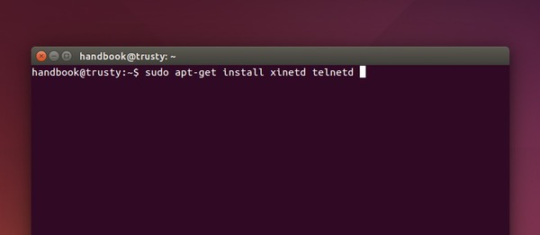](http://ubuntuhandbook.org/wp-content/uploads/2014/12/install-telnet-server.jpg)

The Telnet service is started automatically once the installation is done. And you can either run telnet serverip or use a Telnet client (PuTTy, SecureCRT, etc.) to access this server.

[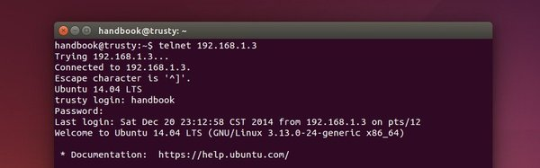](http://ubuntuhandbook.org/wp-content/uploads/2014/12/telnet-login.jpg)

To change the port (default is 23), edit the **/etc/services** file with your favorite text editor. Find out and change the number in the line below:

telnet 23/tcp

To apply changes, you have to restart the service by running the command below:

sudo /etc/init.d/xinetd restart

# How to Install and Use TELNET in Ubuntu

By [bhakti](http://quehow.com/author/bhakti) [Leave a Comment](http://quehow.com/how-to-install-and-use-telnet-in-ubuntu/3629.html#respond)

TELNET (Teletype Network) is the service that allows you to access another computer by logging in to the remote system, such that, you can pass commands to another system by sitting back at your place. It allows you to send the instructions to a remote client, but in a plain-text format. Telnet listens to all the requests by the user usually on **TCP port 23**, but you can change it accordingly.

Telnet is one of the oldest communication protocol to perform this activity, later on with the advancement of technology **“SSH”** came into existence, which is a secure method as it sends all the data in an encrypted format. SSH is used by the professionals in the public network where they can’t take a chance to expose their credentials to everyone. But with this, it doesn’t mean that Telnet is vanished. There are many situations where people use Telnet specifically for testing and debugging, in a local or private network.

Through this tutorial, you will learn the steps to install and use TELNET in Ubuntu. Each step is explained along with the images so that you may realize how to practically implement it.

## Steps to Install and Use Telnet in Ubuntu

**Step 1:** Firstly, open the **“Terminal”** window by pressing **“Ctrl + Alt + T”**. In the figure, you may see **“$”** that signifies that you are not logged in as a root user.

So, I”ll write **“sudo apt-get install telnetd”** and press enter. If you are a root user, then you don’t need to write sudo in Ubuntu. **“telnetd”** is a daemon that gets invoked by “inetd” or its extension “xinetd”, both are the internet servers.

[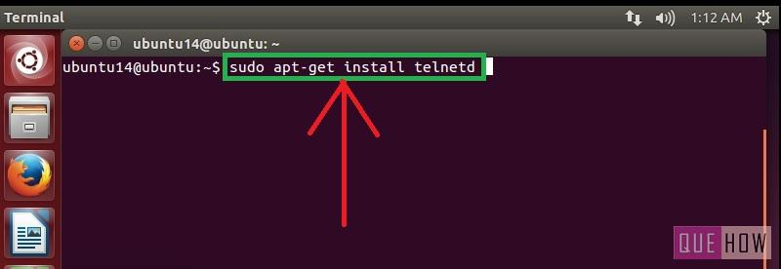](http://quehow.com/wp-content/uploads/2015/03/how-to-install-telnet-in-ubuntu-step1.jpg)

**Step 2:** Then you are asked to enter the user password and then press enter. Processing will start as soon as you press enter. After this, I have noticed a line **“274 KB additional disk space will be used”** on the terminal screen.

You may also observe some sort of a message like this and then you”ll be asked to continue or not. Just write **“y”** and then press enter to continue.

[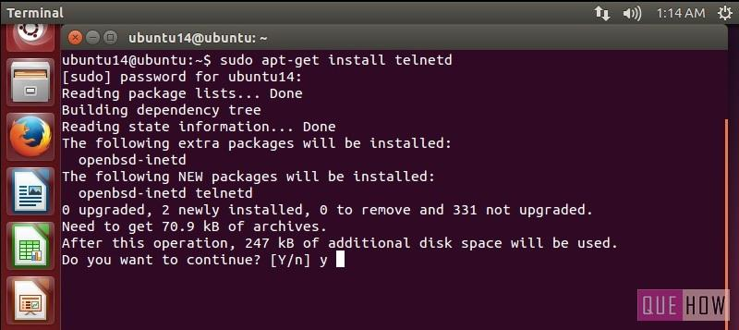](http://quehow.com/wp-content/uploads/2015/03/how-to-install-telnet-in-ubuntu-step2.jpg)

**Step 3:** Now when you are done with it, **restart “inetd”**. Type **“sudo /etc/init.d.open-bsd-inetd restart”**.

“inetd” is daemon used for dealing with incoming network and it is responsible for deciding which program to run when a request comes.

[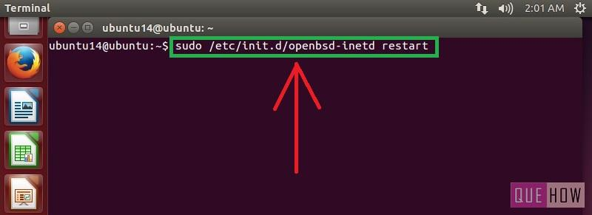](http://quehow.com/wp-content/uploads/2015/03/how-to-install-telnet-in-ubuntu-step3.jpg)

**Step 4:** To ensure “inetd” is started, press enter after writing the above command.

[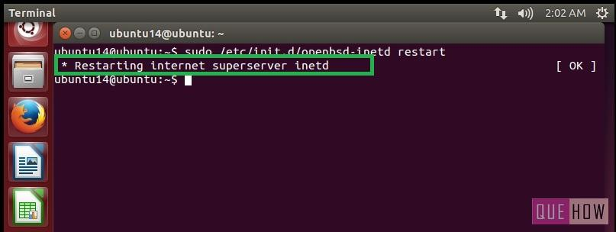](http://quehow.com/wp-content/uploads/2015/03/how-to-install-telnet-in-ubuntu-step4.jpg)

**To connect with any remote client:**

**Step 5:** Just type:**“telnet hostipaddress”**. For an example: “telnet 122.175.140.221” and press enter.

[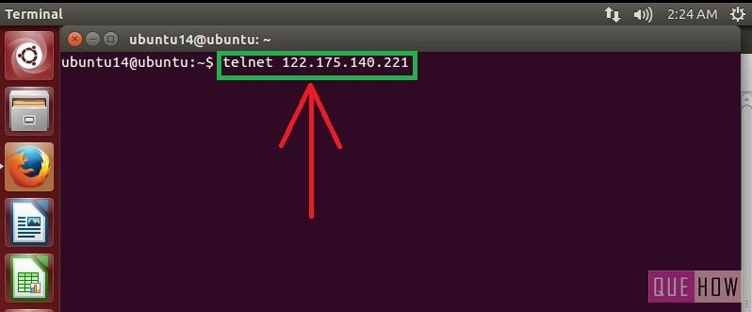](http://quehow.com/wp-content/uploads/2015/03/how-to-install-telnet-in-ubuntu-step5.jpg)

**Step 6:** Then you”ll see, it is connected to **“host ip address”**. For security reasons, you are required to provide “username” and “password” as well.

[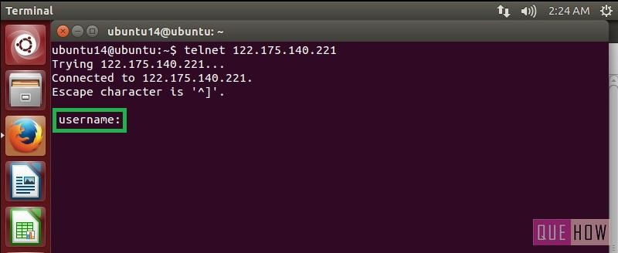](http://quehow.com/wp-content/uploads/2015/03/how-to-install-telnet-in-ubuntu-step6.jpg)

**NOTE:** In order to access Ubuntu/ Windows client using Telnet you must have to **install open source terminal emulators** such as Putty, Tera Term, etc. depending upon the OS you are using. To know how to use Putty on Windows 7 to access Ubuntu, check out the post [to connect to remote computer](http://quehow.com/how-to-install-and-use-putty-to-connect-to-a-remote-computer/3644.html).

[**How to configure telnet server in Linux**](http://computernetworkingnotes.com/network-administrations/telnet-server.html)

* [](http://computernetworkingnotes.com/network-administrations/telnet-server/print.html)

**telnet server** is used to login into another system. You can use the **telnet** command to log in remotely to another system on your network. The system can be on your local area network or available through an Internet connection. **Telnet** operates as if you were logging in to another system from a remote terminal. You will be asked for a login name and password. In effect, you are logging in to another account on another system. In fact, if you have an account on another system, you could use Telnet to log in to it.

Dear visitor this article is written for RHEL 5. We have updated version of this article for RHEL6 with video tutorial. If you are looking for RHEL6 please check this article. [How to configure Telnet Server in RHEL6.](http://computernetworkingnotes.com/network-administration/how-to-configure-telnet-server-in-rhel6.html)

You invoke the Telnet utility with the keyword **telnet**. If you know the name of the site you want to connect with, you can enter telnet and the name of the site on the Linux command line.

**CAUTION** The original version of Telnet is noted for being very insecure. For secure connections over a network or the Internet, you should use the Secure Shell (SSH). We will cover SSH server in next article. SSH operate in the same way as the original but use authentication and encryption to secure the Telnet connection. Even so, it is advisable never to use Telnet to log in to your root account. That why by defaults root account is disable for root login.

**Configure telnet server**

In this example we will configure a telnet server and will invoke connection from client side.

For this example we are using three systems one linux server one linux clients and one window clients. To complete these per quest of telnet server Follow this link

[Network configuration in Linux](http://computernetworkingnotes.com/network-administrations/network-configurations.html)

* A linux server with ip address 192.168.0.254 and hostname Server
* A linux client with ip address 192.168.0.1 and hostname Client1
* A windows xp system with ip address 192.168.0.2 and hostname Client2
* Updated /etc/hosts file on both linux system
* Running portmap and xinetd services
* Firewall should be off on server

We suggest you to review that article before start configuration of telnet server. Once you have completed the necessary steps follow this guide.

Four rpm are required to configure telnet server. **telnet, telnet-server, portmap, xinetd** check them if not found then install  
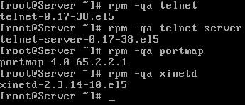

Now check **telnet, portmap, xinetd** service in system service it should be on

**#setup  
Select System service from list  
[\*]portmap   
[\*]xinetd  
[\*]telnet**

Now restart **xinetd** and **portmap** service  
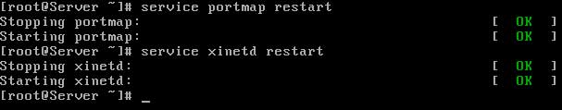  
To keep on these services after reboot on then via **chkconfig** command  
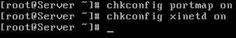  
After reboot verify their status. It must be in running condition  
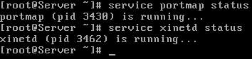

Create a normal user named vinita

**On Linux client**

**ping** from **telnet server** and run **telnet** command and give **user name and password**  
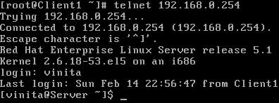

**On Window client**

**ping** from **telnet server** and run **telnet** command  
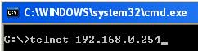  
Give **user name and password**  
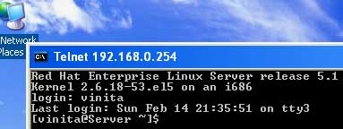

**How to enable root login from telnet server**

On linux server open file securetty  


In the end of file add **pts/0** to enable one telnet session for root. if you need to open more telnet session for root and add more **pts/1 pts/2** and so on.  
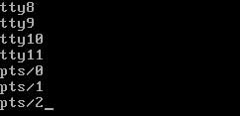

Now restart **xinetd** and **portmap** service  


Verfiy from window by login from root  
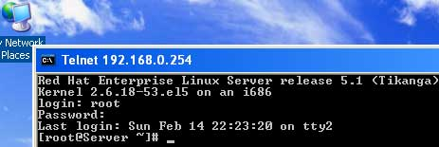

# Install SSH server on Ubuntu Linux

* **Share:**
* 

SSH (“secure shell”) offers a powerful collection of tools for remote control of networked computers and transfer of data between networked computers. In this post, I will explain how to install SSH server on [Ubuntu](http://www.ubuntu.com/) system. It should work on all recent releases of Ubuntu, including 12.04 Precise Pangolin. This post is an and updated and follow-up on my previous post on how to [install SSH server](http://www.htpcbeginner.com/connecting-to-ubuntu-server-using-ssh-and-putty/) on Ubuntu. To *install SSH server* on Linux, most users resort to [OpenSSH](http://www.openssh.com/). It offers a secure encrypted connection to remotely administer systems, with protection from eavesdropping and is the single most important tool for Linux administration.

**Install SSH Server**

If you install [Ubuntu server](http://www.ubuntu.com/server), you can choose to install OpenSSH server from the tasksel screen as shown in the picture below. In fact, on Ubuntu server install you can run sudo tasksel command any time to install SSH server and more.

**Install SSH Server**

[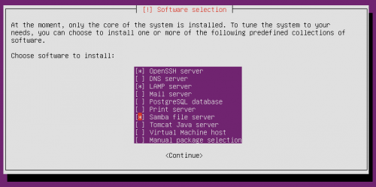](http://www.htpcbeginner.com/images/2012/04/Tasksel.png)

Ubuntu Tasksel – Package Selection

On Ubuntu desktop or server install, you can also directly install the OpenSSH server package as you would install any other package. To install SSH server on Ubuntu, all you have to do is to install the OpenSSH server package that is readily available through the respositories. Use the following command to setup SSH server:

sudo apt-get install openssh-server

It is as simple as that.

**Recommended for you:** [Learn more about OpenSSH, PuTTY, Tunnels and Keys](http://buy.geni.us/Proxy.ashx?TSID=9019&GR_URL=http%3A%2F%2Fwww.amazon.com%2Fgp%2Fproduct%2F1470069717%2Fref%3Das_li_ss_tl%3Fie%3DUTF8%26camp%3D1789%26creative%3D390957%26creativeASIN%3D1470069717%26linkCode%3Das2%26tag%3Dhtpcbeg-20)

**Configure SSH Server**

To **install SSH server** is very easy but making it much more secure requires a bit more work. After the installation is complete, edit the /etc/ssh/sshd\_config file. But before you start editing any configuration file, I suggest you backup the original file:

sudo cp -a /etc/ssh/sshd\_config /etc/ssh/sshd\_config\_backup

Now, use the following command to edit the file:

sudo nano /etc/ssh/sshd\_config

The first thing you will want to edit is the port on which your SSH server listens. By default SSH server listens on port 22. Everybody knows that. Therefore, to secure your connection it is always advisable to run your SSH server on a non-standard port. So edit the following section to choose a random port number:

# What ports, IPs and protocols we listen for

Port 2122

To increase your security further you can optional customize a couple more settings. The first is PermitRootLogin. Set this to no to disallow anybody to login as root, significantly reducing the chance of serious changes by hackers.

# Authentication:

LoginGraceTime 120

PermitRootLogin no

The second optional change to increase security is to list the users who are allowed to access the system remotely through SSH. To do this, add the following line to the end of the sshd\_config file:

AllowUsers user1 user2

Replace user1 and user2 with the actual usernames.

The only other thing you might want to ensure is that X11Forwarding is set to “yes”. This will allow you to run the softwares on your remote server on your local system. If the local system is Windows, which does not come with an X Server you could use free softwares such as [Xming](https://en.wikipedia.org/wiki/Xming).

After you install SSH server and make any changes to the configuration file (sshd\_config) you will have to restart the service. Use the following command to restart SSH:

sudo service ssh restart

If you [setup bash aliases as described in this post](http://www.htpcbeginner.com/create-shortcut-to-commands-using-bashaliases-in-ubuntu/), you could use shortcuts (eg. sshrestart) to restart your OpenSSH server.

[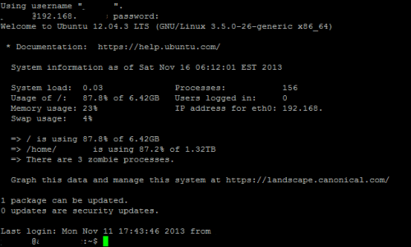](http://www.htpcbeginner.com/images/2012/08/SSH-ubuntu-putty-screenshot.png)

Secure Shell Ubuntu

There you go, [install SSH server](https://help.ubuntu.com/lts/serverguide/openssh-server.html) on your Ubuntu system and start enjoying your remote access. You can now access your system folders and files through SFTP using softwares such as [FileZilla](https://filezilla-project.org/).

# Enable SSH in Ubuntu 14.04 Trusty Tahr

This simple tutorial is going to show you how to enable Secure Shell (SSH) service in Ubuntu 14.04 Trusty Tahr.

Secure Shell (SSH) is a cryptographic network protocol for secure data communication, remote command-line login, remote command execution, and other secure network services between two networked computers.

SSH is not enabled by default in Ubuntu, but you can easily enable this service via **OpenSSH**, a free version of the SSH connectivity tools developed by the OpenBSD Project.

To do so, run the command below in terminal:

sudo apt-get install openssh-server

Or install the **openssh-server** package via Ubuntu Software Center if you’re on Desktop edition:

[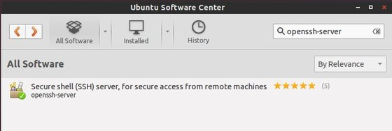](http://ubuntuhandbook.org/wp-content/uploads/2014/04/ssh-server-ubuntu1404.jpg)

Once installed, you can change the port, disable root login and do other changes by editing the config file:

sudo gedit /etc/ssh/sshd\_config

Finally restart the ssh server to take place:

sudo /etc/init.d/ssh restart

That’s it. Enjoy!

# How to Install and Configure OpenSSH Server In Linux

Being a network administrator requires a deep knowledge about remote login protocols such as **rlogin**, **telnet** and **ssh**. The one I will discuss in this article is **ssh**, a secure remote protocol which is used to work remotely on other machines or transfer data between computers using [SCP (Secure Copy)](http://www.tecmint.com/scp-commands-examples/) command. But, what is **OpenSSH** and how to install it in your **Linux** distribution?

### What is OpenSSH?

**OpenSSH** is a free open source set of computer tools used to provide secure and encrypted communication over a computer network by using the **ssh** protocol. Many people, new to computers and protocols, create a misconception about **OpenSSH**, they think it is a protocol, but it is not, it is a set of computer programs that use the **ssh protocol**.

**OpenSSH** is developed by the Open BSD group and it is released

under **Simplified BSD License**. A main factor which has made possible for **OpenSSH** to be used so much among system administrators is its multi-platform capability and very useful nice features it has. The latest version is **OpenSSH 6.4** which has been released on **November 8, 2013**.

This version of **OpenSSH** comes with many new features and patches, so if you already use **OpenSSH** for administering your machines, I suggest you to do an upgrade.

### Why Use OpenSSH And Over Telnet Or Ftp?

The most important reason why should use **OpenSSH** tools over **ftp** and **telnet** is that all communications and user credentials using **OpenSSH** are encrypted, they are also protected from man in the middle attacks. If a third party tries to intercept your connection, **OpenSSH** detects it and informs you about that.

### What Are Some Of The OpenSSH Features?

1. Secure Communication
2. Strong Encryption (**3DES**, **Blowfish**, **AES**, **Arcfour**)
3. **X11** Forwarding (encrypt **X** Window System traffic)
4. Port Forwarding (encrypted channels for legacy protocols)
5. Strong Authentication (**Public Key**, One-Time Password and Kerberos Authentication)
6. Agent Forwarding (**Single-Sign-On**)
7. Interoperability (Compliance with **SSH 1.3, 1.5**, and **2.0** protocol Standards)
8. **SFTP** client and server support in both **SSH1** and **SSH2** protocols.
9. **Kerberos** and **AFS Ticket Passing**
10. Data Compression

### Installation of OpenSSH in Linux

To install **OpenSSH**, open a terminal and run the following commands with superuser permissions.

#### On Ubuntu/Debian/Linux Mint

$ sudo apt-get install openssh-server openssh-client

#### On RHEL/Centos/Fedora

Type the following **yum** command to install openssh client and server.

# yum -y install openssh-server openssh-clients

### Configuration of OpenSSH

It’s time to configure our **OpenSSH** behaviour through the **ssh config** file, but before editing the **/etc/ssh/sshd\_config** file we need to backup a copy of it, so in case we make any mistake we have the original copy.

Open a terminal and run the following command to make a copy of the original sshd configuration file.

$ sudo cp /etc/ssh/sshd\_config /etc/ssh/sshd\_config.original\_copy

As you can see from the command I typed, I added the **original\_copy suffix**, so every time I see this file I know it is an original copy of the sshd config file.

### How Do I Connect to OpenSSH

Before we go further, we need to verify if our **openssh** server is working or not. How to do that? You can try to connect to the **openssh** server from your **localhost** through your **openssh client** or do a **portscan** with **nmap**, but I like to use a small tool called **netcat**, also known as the **TCP**/**IP** Swiss army knife. I love working with this amazing tool on my machine, so let me show it to you.

# nc -v -z 127.0.0.1 22

Referring to the **netcat** results, the ssh service is running on port **22** on my machine. Very good! What if we want to use another port, instead of **22**? We can do that by editing the sshd configuration file.

Set your **OpenSSH** to listen on **TCP** port **13** instead of the default TCP port **22**. Open the **sshd\_config** file with your favourite text editor and change the port directive to **13**.

# What ports, IPs and protocols we listen for

Port 13

Restart **OpenSSH** server so the changes in config file can take place by typing the following command and run **netcat** to verify if the port you set for listening is open or not.

$ sudo /etc/init.d/ssh restart

Should we verify is our openssh server is listening on port 13, or not?. This verification is necessary, so I am calling my lovely tool **netcat** to help me do the job.

# nc -v -z 127.0.0.1 13

Do you like to make your openssh server display a nice login banner? You can do it by modifying the content of **/etc/issue.net** file and adding the following line inside the sshd configuration file.

Banner /etc/issue.net

### Conclusion

There are many things you can do with the **openssh** tools when it comes to the way you configure your **openssh server**, I can say that your imagination is the limit!.

**Enable SSH (Secure Shell) in Ubuntu 12.04 (Precise Pangolin)**

This brief tutorial shows you how to enable SSH in Ubuntu 12.04 Precise Pangolin. This request came in from one of our readers who wanted to know how to enable SSH in Ubuntu 12.04. As you may already know, SSH is a secure communication protocol that lets you remotely access networked computers. It is known as a replacement for Telnet which is very unsecure. While Telnet sends traffic in plain text, SSH on the other hand uses a secure protocol to communicate.

**Objectives:**

* Enable SSH in Ubuntu 12.04
* Enjoy!

To get started, press **Ctrl – Alt – T** on your keyboard to open Terminal. When it opens, run the commands below to install SSH Server.

sudo apt-get install openssh-server

[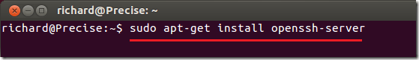](https://i0.wp.com/www.liberiangeek.net/wp-content/uploads/2012/03/openssh_server_precise.png?ssl=1)

That’s it! Use your SSH clients to connect to your machine using the default port **22**. If you wish to change the connection port, run the commands below to open the configuration file.

sudo gedit /etc/ssh/sshd\_config

[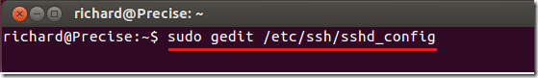](https://i1.wp.com/www.liberiangeek.net/wp-content/uploads/2012/03/openssh_server_precise_1.png?ssl=1)

Then change the port # shown to whatever you want and save the file. But remember to use the new port number every time you want to connect to your system via SSH.

[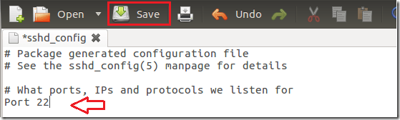](https://i2.wp.com/www.liberiangeek.net/wp-content/uploads/2012/03/openssh_server_precise_2.png?ssl=1)

Enjoy!

[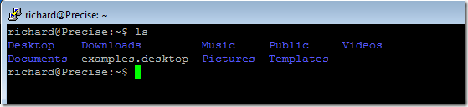](https://i1.wp.com/www.liberiangeek.net/wp-content/uploads/2012/03/openssh_server_precise_3.png?ssl=1)

For a simple and quick SSH client, [click here](http://www.chiark.greenend.org.uk/%7Esgtatham/putty/download.html) to download Putty.

[**How to configure web server in Linux**](http://computernetworkingnotes.com/network-administrations/web-server.html)

* [](http://computernetworkingnotes.com/network-administrations/web-server/print.html)

When you view a web page over the Internet, the code to create that page must be retrieved from a server somewhere on the Internet. The server that sends your web browser the code to display a web page is called a web server. There are countless web servers all over the Internet serving countless websites to people all over the world. Whether you need a web server to host a website on the Internet a Red Hat Enterprise Linux server can function as a web server using the **Apache HTTP server**. The Apache HTTP server is a popular, open source server application that runs on many UNIX-based systems as well as Microsoft Windows.

Dear visitor this article is written for RHEL 5. We have updated version of this article for RHEL6 with video tutorial. If you are looking for RHEL6 please check this article. [How to configure Web Server in RHEL6.](http://computernetworkingnotes.com/network-administration/how-to-configure-apache-server-in-linux.html)

**Exam question 1** There are two sites **www.vinita.com** and **www.nikita.com.** Both sites are mappings to 192.168.0.X IP address where X is your Host address. Configure the Apache web server for these sites to make accessible on web

**Configure web server**

In this example we will configure a **web server.**

necessary rpm for web server is **httpd, httpd-devel** and **apr** check them for install

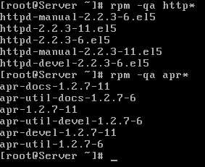

Now configure the ip address to **192.168.0.254** and check it   
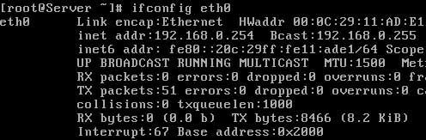

start **httpd daemons** and verify its running **status**   
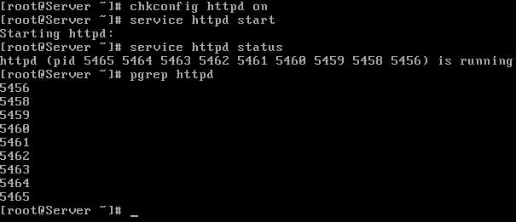

**Configure virtual hosting**

In this example we will host a website **www.vinita.com** to apache web server. create a **documents root** directory for this website and a **index page**   
  
for testing purpose we are writing **site name** in its **index page**   
  
**save** file and **exit**

now open **/etc/hosts** file   
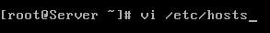  
in the **end of file** bind system **ip** with **www.vinita.com**  
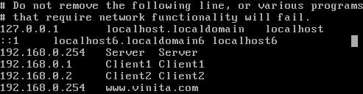

now open **/etc/httpd/conf/httpd.conf** main configuration file of **apache server**   
  
locate **virtual host** tag   
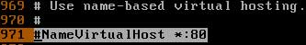  
remove **#** from the beginning and add the **IP of host**   
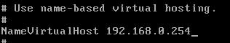  
Now go in the end of file and copy last seven line [ virtual host tag ] and paste them in the end of file. **change these seven lines as shown in image**   
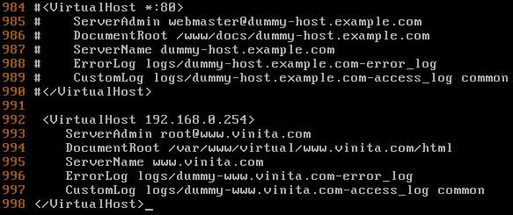  
now **save** this file and exit from it

you have done necessary configuration now **restart the httpd service** and test this configuration run **links** command   
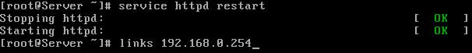

if **links** command retrieve your **home page**  
  
means you have successfully configured the **virtual host** now test it with **site name**   
  
In output of **links** command you should see the **index page** of site   


**Configure multiple site with same ip address**

At this point you have configured one site **www.vinita.com** with the ip address **192.168.0.254.** Now we will configure one more site **www.nikita.com** with **same** ip address

create a **documents root** directory for **www.nikita.com** website and a **index page**  
  
for testing purpose we are writing **site name** in its **index page**   
  
**save** file and exit

now open **/etc/hosts** file and bind **system ip** with **www.nikita.com**  
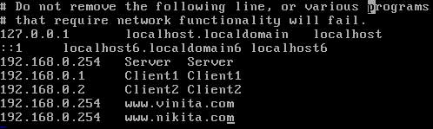

now open **/etc/httpd/conf/httpd.conf** main configuration file of apache server   
  
Now go in the end of file and copy last seven line [ virtual host tag ] and paste them in the end of file. **change these seven lines as shown in image**   
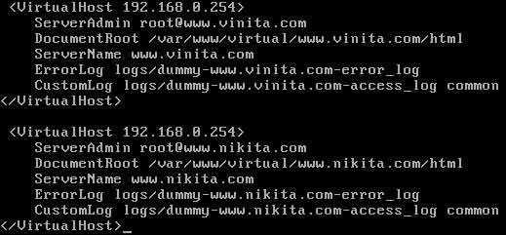  
now **save** this file and exit from it

you have done necessary configuration now restart the **httpd service**   
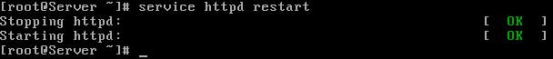  
test this configuration run **links** command  
  
In output of **links command** you should see the **index page** of site

**configure multiple site with multiple ip address**

Now we will host multiple sites with multiple ip address. Create a virtual lan card on server and assign its an ip address of **192.168.0.253.** we will create a testing site **www.nidhi.com** and will bind it with ip address of **192.168.0.253**

create a **documents root** directory for **www.nidhi.com** website and a index page  
  
for testing purpose we are writing **site name** in its **index page**   
  
**save** file and exit

now open **/etc/hosts** file and bind **system ip** with **www.nidhi.com**  
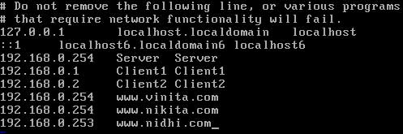

now open **/etc/httpd/conf/httpd.conf** main configuration file of apache server   
  
Now go in the end of file and copy last seven line [ virtual host tag ] and paste them in the end of file. **change these seven lines as shown in image**   
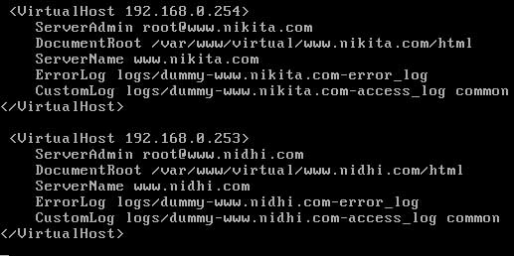  
now **save** this file and exit from it

you have done necessary configuration now restart the **httpd service**   
  
test this configuration run **links** command  
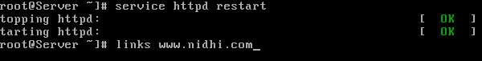  
In output of **links** command you should see the **index page** of site

**How to create site alias**

Now I will show you that how can you use **site alias** to configure more name of same site. we configure a site **www.vinita.com** in stating of example. now we will create **www.goswami.com** site alias for this site so this site can be access with both name.

To create **alias** first make its entry in **/etc/hosts** file as shown here   
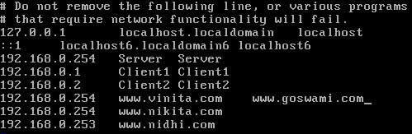

Now open main apache configuration **/etc/httpd/conf/httpd.conf**  
  
Now go in the end of file and copy last seven line [ virtual host tag ] and paste them in the end of file. **change these seven lines as shown in image**   
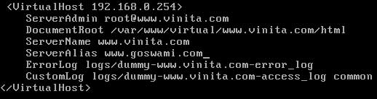  
now **save** this file and exit from it

you have done necessary configuration now restart the **httpd service** and test this configuration run **links** command  
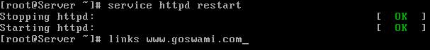  
In output of **links** command you should see the **index page** of site   


# Apache Web Server on Ubuntu 14.04 LTS

Updated Friday, July 31st, 2015 by Elle Krout

**Contribute on GitHub**

[View Project](https://github.com/linode/docs) | [View File](https://github.com/linode/docs/blob/master/docs/websites/apache/apache-web-server-on-ubuntu-14-04.md) | [Edit File](https://github.com/linode/docs/edit/master/docs/websites/apache/apache-web-server-on-ubuntu-14-04.md)

The Apache HTTP Web Sever (Apache) is an open source web application for deploying web servers. This guide explains how to install and configure an Apache web server on Ubuntu 14.04 LTS.

If instead you would like to install a full LAMP (Linux, Apache, MySQL and PHP) stack, please see the [LAMP on Ubuntu 14.04](https://www.linode.com/docs/websites/lamp/lamp-server-on-ubuntu-14-04) guide.

This guide is written for a non-root user. Commands that require elevated privileges are prefixed with sudo. If you’re not familiar with the sudo command, you can check our [Users and Groups](https://www.linode.com/docs/tools-reference/linux-users-and-groups) guide.

## Before You Begin

1. Ensure that you have followed the [Getting Started](https://www.linode.com/docs/getting-started) and [Securing Your Server](https://www.linode.com/docs/security/securing-your-server) guides, and the Linode’s [hostname is set](https://www.linode.com/docs/getting-started#setting-the-hostname).

To check your hostname run:

|  |  |
| --- | --- |
| 1  2 | hostname  hostname -f |

The first command should show your short hostname, and the second should show your fully qualified domain name (FQDN).

1. Update your system:

|  |  |
| --- | --- |
| 1 | sudo apt-get update && sudo apt-get upgrade |

## Install Apache

1. Install Apache 2.4, its documentation, and a collection of utilities:

|  |  |
| --- | --- |
| 1 | sudo apt-get install apache2 apache2-doc apache2-utils |

1. Edit the main Apache configuration file and turn off the KeepAlive setting:

/etc/apache2/apache2.conf

|  |  |
| --- | --- |
| 1 | KeepAlive Off |

### Configure the Multi-Processing Module

Apache 2.4 offers various multi-processing modules (MPMs) to handle connections. The default MPM is the event module, although the prefork module is still recommended if you’re using standard PHP.

#### The Prefork Module

1. Open /etc/apache2/mods-available/mpm\_prefork.conf in your text editor and edit the values as needed. The following is optimized for a 1GB Linode:

/etc/apache2/mods-available/mpm\_prefork.conf

|  |  |
| --- | --- |
| 1  2  3  4  5  6  7  8  9  10  11  12  13  14 | # prefork MPM  # StartServers: number of server processes to start  # MinSpareServers: minimum number of server processes which are kept spare  # MaxSpareServers: maximum number of server processes which are kept spare  # MaxRequestWorkers: maximum number of server processes allowed to start  # MaxConnectionsPerChild: maximum number of requests a server process serves  <IfModule mpm\_prefork\_module>  StartServers 2  MinSpareServers 6  MaxSpareServers 12  MaxRequestWorkers 30  MaxConnectionsPerChild 3000  </IfModule> |

1. On Ubuntu 14.04, the event module is enabled by default. Disable it, and enable the prefork module :

|  |  |
| --- | --- |
| 1  2 | sudo a2dismod mpm\_event  sudo a2enmod mpm\_prefork |

1. Restart Apache:

|  |  |
| --- | --- |
| 1 | sudo service apache2 restart |

#### The Event Module

If you choose to keep the event module enabled, these settings are suggested for a 1GB Linode.

1. Open /etc/apache2/mods-available/mpm\_event.conf in your text editor and edit the values as needed:

/etc/apache2/mods-available/mpm\_event.comf

|  |  |
| --- | --- |
| 1  2  3  4  5  6  7  8  9  10  11  12  13  14  15  16 | # event MPM  # StartServers: initial number of server processes to start  # MinSpareThreads: minimum number of worker threads which are kept spare  # MaxSpareThreads: maximum number of worker threads which are kept spare  # ThreadsPerChild: constant number of worker threads in each server process  # MaxRequestWorkers: maximum number of worker threads  # MaxConnectionsPerChild: maximum number of requests a server process serves  <IfModule mpm\_event\_module>  StartServers 2  MinSpareThreads 15  MaxSpareThreads 50  ThreadLimit 64  ThreadsPerChild 25  MaxRequestWorkers 30  MaxConnectionsPerChild 3000  </IfModule> |

1. Restart Apache:

|  |  |
| --- | --- |
| 1 | sudo service apache2 restart |

### Configure Virtual Hosting

Apache supports name-based virtual hosting, which allows you to host multiple domains on a single server with a single IP. Although there are different ways to set up virtual hosts, the method below is recommended.

1. Disable the default Apache virtual host:

|  |  |
| --- | --- |
| 1 | sudo a2dissite 000-default.conf |

1. Create an example.com.conf file in /etc/apache2/sites-available with your text editor, replacing instances of example.com with your own domain URL in both the configuration file and in the file name:

/etc/apache2/sites-available/example.com.conf

|  |  |
| --- | --- |
| 1  2  3  4  5  6  7  8 | <VirtualHost \*:80>  ServerAdmin webmaster@example.com  ServerName example.com  ServerAlias www.example.com  DocumentRoot /var/www/example.com/public\_html/  ErrorLog /var/www/example.com/logs/error.log  CustomLog /var/www/example.com/logs/access.log combined  </VirtualHost> |

Repeat this process for any other domains you host.

If you would like to enable Perl support, add the following lines above the closing </VirtualHost> tag:

/etc/apache2/sites-available/example.com.conf

|  |  |
| --- | --- |
| 1  2 | Options ExecCGI  AddHandler cgi-script .pl |

1. Create directories for your websites and websites’ logs, replacing example.com with your own domain information:

|  |  |
| --- | --- |
| 1  2 | sudo mkdir -p /var/www/example.com/public\_html  sudo mkdir /var/www/example.com/logs |

1. Enable the site:

|  |  |
| --- | --- |
| 1 | sudo a2ensite example.com.conf |

1. Restart Apache:

|  |  |
| --- | --- |
| 1 | sudo service apache2 restart |

## Apache Mods and Scripting

### Install Apache Modules

One of Apache’s strengths is its ability to be customized with modules. The default installation directory for Apache modules is the /etc/apache2/mods-available/ directory.

1. List available Apache modules:

|  |  |
| --- | --- |
| 1 | sudo apt-cache search libapache2\* |

1. Install any desired modules:

|  |  |
| --- | --- |
| 1 | sudo apt-get install [module-name] |

1. All mods are located in the /etc/apache2/mods-avaiable directory. Edit the .conf file of any installed module if needed, then enable the module:

|  |  |
| --- | --- |
| 1 | sudo a2enmod [module-name] |

1. To disable a module that is currently enabled:

|  |  |
| --- | --- |
| 1 | a2dismod [module-name] |

### Optional: Install Support for Scripting

The following commands install Apache support for server-side scripting in PHP, Ruby, Python, and Perl. Support for these languages is optional based on your server environment.

To install:

* Perl support:

|  |  |
| --- | --- |
| 1 | sudo apt-get install libapache2-mod-perl2 |

* Python support:

|  |  |
| --- | --- |
| 1 | sudo apt-get install libapache2-mod-python |

* PHP support:

|  |  |
| --- | --- |
| 1 | sudo apt-get install libapache2-mod-php5 php5 php-pear php5-xcache |

## More Information

You may wish to consult the following resources for additional information on this topic. While these are provided in the hope that they will be useful, please note that we cannot vouch for the accuracy or timeliness of externally hosted materials.

* [Apache HTTP Server Version 2.4 Documentation](http://httpd.apache.org/docs/2.4/)
* [Apache Configuration](https://www.linode.com/docs/web-servers/apache/configuration/)

# How to Install And Configure Apache In Ubuntu

If you intend to set up a web server (or streaming server) in your Ubuntu machine, apache is one important module that you must install. In this tutorial, we will show you how to install and configure apache for your Ubuntu.

**Note**: If you just want to have a quick setup of LAMP server, [follow the guide here](http://maketecheasier.com/setting-up-a-lamp-server-in-ubuntu-hardy-heron/2008/08/06).

## Installing Apache

Getting apache onto your Ubuntu machine is easy. Using either the Synaptic Package Manager, Ubuntu Software Center, search and install the “apache2” module. Alternatively, you can open a terminal and type the following command:

**sudo** **apt-get install** apache2

Once the installation finished, open a browser and go to the URL “http://localhost“. If you see the word “**It Works!**“, then your installation of apache is successful.

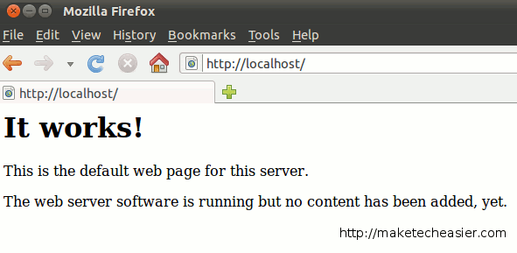

## Configuring Apache

**Start, Stop and Restart Apache**

After you have installed Apache, it will be added to the init.d list and will auto start whenever you boot up your computer. The following commands allow you to start, restart, stop Apache.

**sudo** **/**etc**/**init.d**/**apache2 start *#start apache*

**sudo** **/**etc**/**init.d**/**apache2 stop *#stop apache*

**sudo** **/**etc**/**init.d**/**apache2 restart *#restart apache*

To prevent Apache from autostart when booting up:

**sudo** update-rc.d -f apache2 remove

To restore Apache back to the autostart list:

**sudo** update-rc.d apache2 defaults

**Note**: the above commands will work in debian-based distro (including Ubuntu) only.

**Changing the default localhost folder**

By default, apache will operate on the “/var/www” folder. This means that whatever files you place in this /var/www folder will be visible from the URL http://localhost. In some instances, you may want the “localhost” to point to another folder instead, say /home/user/public\_html. Here is how you do it:

First, make sure the /home/damien/public\_html folder exists. Create a simple html file, name it index.html and place it in the public\_html folder.

Open a terminal and type:

gksu gedit **/**etc**/**apache2**/**sites-enabled**/**000-default

Change DocumentRoot /var/www to DocumentRoot /home/user/public\_html.

Change <Directory /var/www/> to <Directory /home/user/public\_html/>.

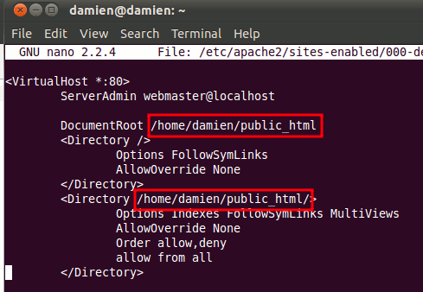

Save and exit the file.

Restart the apache

**sudo** **/**etc**/**init.d**/**apache2 restart

Now, in your browser, reload the URL http://localhost. You should see the html file that you have placed in the public\_html folder.

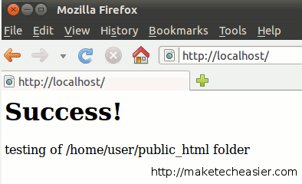

**Configuring different sites**

The above trick allows you to change the default operating folder of apache, however, some of you might not want to override the default settings. An alternative is to create multiple sites and point apache to the active site.

Create a new settings file for your new site.

**sudo** **cp** **/**etc**/**apache2**/**sites-available**/**default **/**etc**/**apache2**/**sites-available**/**site1

Next, edit this settings file.

gksu gedit **/**etc**/**apache2**/**sites-available**/**site1

Change DocumentRoot /var/www to DocumentRoot /home/user/public\_html.

Change <Directory /var/www/> to <Directory /home/user/public\_html/>.

Save and exit the file.

Disable the default setting and make active the site1 settings

**sudo** a2dissite default **&&** **sudo** a2ensite site1

Lastly, restart the apache.

**sudo** **/**etc**/**init.d**/**apache2 restart

With this trick, you can create multiple site configuration file, each pointing to a different folder. You can then easily switch between the sites with the a2dissite and a2ensite command

**Enabling .htaccess file**

.htaccess file is a powerful file that can be used to control and customize a site server behavior without editing the core Apache module. By default, the .htaccess functionality is turned off and all instances of .htaccess files are completely ignored. The server will not even attempt to read .htaccess files in the filesystem.

To enable .htaccess file, open up the settings file that you have created earlier:

gksu gedit **/**etc**/**apache2**/**sites-available**/**site1

Scroll down the file until you see the part “<Directory /home/user/public\_html/>“. Underneath that line of code, change AllowOverride None to AllowOverride All.

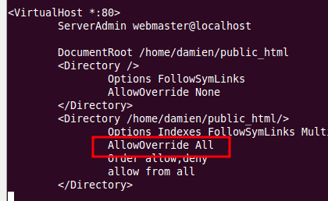

Save and exit the file.

**How To Install Linux, Apache, MySQL, PHP (LAMP) stack on Ubuntu**

Posted May 31, 2012

Top of Form

Bottom of Form

159

2.4m views [LAMP Stack](https://www.digitalocean.com/community/tags/lamp-stack?type=tutorials) [Apache](https://www.digitalocean.com/community/tags/apache?type=tutorials) [MySQL](https://www.digitalocean.com/community/tags/mysql?type=tutorials) [PHP](https://www.digitalocean.com/community/tags/php?type=tutorials) [Ubuntu](https://www.digitalocean.com/community/tags/ubuntu?type=tutorials)

For Ubuntu 12.04 - see [this updated tutorial for Ubuntu 14.04](https://www.digitalocean.com/community/tutorials/how-to-install-linux-apache-mysql-php-lamp-stack-on-ubuntu-14-04).

**About LAMP**

LAMP stack is a group of open source software used to get web servers up and running. The acronym stands for Linux, Apache, MySQL, and PHP. Since the virtual private server is already running Ubuntu, the linux part is taken care of. Here is how to install the rest.

**Set Up**

The steps in this tutorial require the user to have root privileges on your VPS. You can see how to set that up in the [Initial Server Setup](https://www.digitalocean.com/community/articles/initial-server-setup-with-ubuntu-12-04) in steps 3 and 4.

**Step 1: Install Apache**

Apache is a free open source software which runs over 50% of the world’s web servers.

To install apache, open terminal and type in these commands:

sudo apt-get update

sudo apt-get install apache2

That’s it. To check if Apache is installed, direct your browser to your server’s IP address (eg. http://12.34.56.789). The page should display the words “It works!" like [this](https://assets.digitalocean.com/tutorial_images/333VJ.png).

**How to Find your Server’s IP address**

You can run the following command to reveal your server’s IP address.

ifconfig eth0 | grep inet | awk '{ print $2 }'

**Step 2: Install MySQL**

MySQL is a powerful database management system used for organizing and retrieving data

To install MySQL, open terminal and type in these commands:

sudo apt-get install mysql-server libapache2-mod-auth-mysql php5-mysql

During the installation, MySQL will ask you to set a root password. If you miss the chance to set the password while the program is installing, it is very easy to set the password later from within the MySQL shell.

Once you have installed MySQL, we should activate it with this command:

sudo mysql\_install\_db

Finish up by running the MySQL set up script:

sudo /usr/bin/mysql\_secure\_installation

The prompt will ask you for your current root password.

Type it in.

Enter current password for root (enter for none):

OK, successfully used password, moving on...

Then the prompt will ask you if you want to change the root password. Go ahead and choose N and move on to the next steps.

It’s easiest just to say Yes to all the options. At the end, MySQL will reload and implement the new changes.

By default, a MySQL installation has an anonymous user, allowing anyone

to log into MySQL without having to have a user account created for

them. This is intended only for testing, and to make the installation

go a bit smoother. You should remove them before moving into a

production environment.

Remove anonymous users? [Y/n] y

... Success!

Normally, root should only be allowed to connect from 'localhost'. This

ensures that someone cannot guess at the root password from the network.

Disallow root login remotely? [Y/n] y

... Success!

By default, MySQL comes with a database named 'test' that anyone can

access. This is also intended only for testing, and should be removed

before moving into a production environment.

Remove test database and access to it? [Y/n] y

- Dropping test database...

... Success!

- Removing privileges on test database...

... Success!

Reloading the privilege tables will ensure that all changes made so far

will take effect immediately.

Reload privilege tables now? [Y/n] y

... Success!

Cleaning up...

Once you're done with that you can finish up by installing PHP.

**Step 3: Install PHP**

PHP is an open source web scripting language that is widely use to build dynamic webpages.

To install PHP, open terminal and type in this command.

sudo apt-get install php5 libapache2-mod-php5 php5-mcrypt

After you answer yes to the prompt twice, PHP will install itself.

It may also be useful to add php to the directory index, to serve the relevant php index files:

sudo nano /etc/apache2/mods-enabled/dir.conf

Add index.php to the beginning of index files. The page should now look like this:

<IfModule mod\_dir.c>

DirectoryIndex index.php index.html index.cgi index.pl index.php index.xhtml index.htm

</IfModule>

**PHP Modules**

PHP also has a variety of useful libraries and modules that you can add onto your virtual server. You can see the libraries that are available.

apt-cache search php5-

Terminal will then display the list of possible modules. The beginning looks like this:

php5-cgi - server-side, HTML-embedded scripting language (CGI binary)

php5-cli - command-line interpreter for the php5 scripting language

php5-common - Common files for packages built from the php5 source

php5-curl - CURL module for php5

php5-dbg - Debug symbols for PHP5

php5-dev - Files for PHP5 module development

php5-gd - GD module for php5

php5-gmp - GMP module for php5

php5-ldap - LDAP module for php5

php5-mysql - MySQL module for php5

php5-odbc - ODBC module for php5

php5-pgsql - PostgreSQL module for php5

php5-pspell - pspell module for php5

php5-recode - recode module for php5

php5-snmp - SNMP module for php5

php5-sqlite - SQLite module for php5

php5-tidy - tidy module for php5

php5-xmlrpc - XML-RPC module for php5

php5-xsl - XSL module for php5

php5-adodb - Extension optimising the ADOdb database abstraction library

php5-auth-pam - A PHP5 extension for PAM authentication

[...]

Once you decide to install the module, type:

sudo apt-get install *name of the module*

You can install multiple libraries at once by separating the name of each module with a space.

Congratulations! You now have LAMP stack on your droplet!

**Step 4: RESULTS — See PHP on your Server**

Although LAMP is installed, we can still take a look and see the components online by creating a quick php info page

To set this up, first create a new file:

sudo nano /var/www/info.php

Add in the following line:

<?php

phpinfo();

?>

Then Save and Exit.

Restart apache so that all of the changes take effect:

sudo service apache2 restart

Finish up by visiting your php info page (make sure you replace the example ip address with your correct one): http://12.34.56.789/info.php

It should look similar to [this](https://assets.digitalocean.com/tutorial_images/HCQEu.png).

**See More**

After installing LAMP, you can [Set Up phpMyAdmin](https://www.digitalocean.com/community/articles/how-to-install-and-secure-phpmyadmin-on-ubuntu-12-04), [Install WordPress](https://www.digitalocean.com/community/articles/how-to-install-wordpress-on-ubuntu-12-04), go on to do more with MySQL ([A Basic MySQL Tutorial](https://www.digitalocean.com/community/articles/a-basic-mysql-tutorial)), [Create an SSL Certificate](https://www.digitalocean.com/community/articles/how-to-create-a-ssl-certificate-on-apache-for-ubuntu-12-04), or [Install an FTP Server](https://www.digitalocean.com/community/articles/how-to-set-up-vsftpd-on-ubuntu-12-04).

**How To Configure the Apache Web Server on an Ubuntu or Debian VPS**

Posted Aug 7, 2013

Top of Form

Bottom of Form

35

795.2k views [Apache](https://www.digitalocean.com/community/tags/apache?type=tutorials) [Ubuntu](https://www.digitalocean.com/community/tags/ubuntu?type=tutorials) [Debian](https://www.digitalocean.com/community/tags/debian?type=tutorials)

**What is Apache?**

Apache is the most popular web server on the internet. It is used to serve more than half of all active websites.

Although there are many viable web servers that will serve your content, it is helpful to understand how Apache works because of its ubiquity.

In this article, we will examine some general configuration files and options that can be controlled within them. This article will follow the Ubuntu/Debian layout of Apache files, which is different from how other distributions build the configuration hierarchy.

**How to Install Apache on Ubuntu and Debian**

If you do not already have Apache installed, you can do so now by issuing the following commands:

sudo apt-get update

sudo apt-get install apache2

This is all that is necessary to have a working web server. If you visit your VPS's IP address in a web browser, you will get the default Apache index page:

your\_domain\_name\_or\_ip\_address

It works!

This is the default web page for this server.

The web server software is running but no content has been added, yet.

**The Apache File Hierarchy in Ubuntu and Debian**

On Ubuntu and Debian, Apache keeps its main configuration files within the "/etc/apache2" folder:

cd /etc/apache2

ls -F

apache2.conf envvars magic mods-enabled/ sites-available/

conf.d/ httpd.conf mods-available/ ports.conf sites-enabled/

There are a number of plain text files and some sub-directories in this directory. These are some of the more useful locations to be familiar with:

* **apache2.conf**: This is the main configuration file for the server. Almost all configuration can be done from within this file, although it is recommended to use separate, designated files for simplicity. This file will configure defaults and be the central point of access for the server to read configuration details.
* **ports.conf**: This file is used to specify the ports that virtual hosts should listen on. Be sure to check that this file is correct if you are configuring SSL.
* **conf.d/**: This directory is used for controlling specific aspects of the Apache configuration. For example, it is often used to define SSL configuration and default security choices.
* **sites-available/**: This directory contains all of the virtual host files that define different web sites. These will establish which content gets served for which requests. These are available configurations, not active configurations.
* **sites-enabled/**: This directory establishes which virtual host definitions are actually being used. Usually, this directory consists of symbolic links to files defined in the "sites-available" directory.
* **mods-[enabled,available]/**: These directories are similar in function to the sites directories, but they define modules that can be optionally loaded instead.

As you can see, Apache configuration does not take place in a single monolithic file, but instead happens through a modular design where new files can be added and modified as needed.

**Looking at the Apache2.conf File**

The main configuration details for your Apache server are held in the "/etc/apache2/apache2.conf" file.

This file is divided into three main sections: configuration for the global Apache server process, configuration for the default server, and configuration of Virtual Hosts.

In Ubuntu and Debian, the majority of the file is for global definitions, and the configuration of the default server and virtual hosts is handled at the end, by using the "Include ..." directive.

The "Include" directive allows Apache to read other configuration files into the current file at the location that the statement appears. The result is that Apache dynamically generates an overarching configuration file on startup.

If you scroll to the bottom of the file, there are a number of different "Include" statements. These load module definitions, the ports.conf document, the specific configuration files in the "conf.d/" directory, and finally, the Virtual Host definitions in the "sites-enabled/" directory.

We will focus on the first part of the file to learn how Apache defines its global settings.

**Global Configuration Section**

This section is used to configure some options that control how Apache works as a whole.

There are some interesting options you may want to modify in this section:

**Timeout**

By default, this parameter is set to "300", which means that the server has a maximum of 300 seconds to fulfill each request.

This is probably too high for most set ups and can safely be dropped to something between 30 and 60 seconds.

**KeepAlive**

This option, if set to "On", will allow each connection to remain open to handle multiple requests from the same client.

If this is set to "Off", each request will have to establish a new connection, which can result in significant overhead depending on your setup and traffic situation.

**MaxKeepAliveRequests**

This controls how many separate request each connection will handle before dying. Keeping this number high will allow Apache to serve content to each client more effectively.

Setting this value to 0 will allow Apache to serve an unlimited amount of request for each connection.

**KeepAliveTimeout**

This setting specifies how long to wait for the next request after finishing the last one. If the timeout threshold is reached, then the connection will die.

This just means that the next time content is requested, the server will establish a new connection to handle the request for the content that make up the page the client is visiting.

**MPM Configuration**

The next section specifies the configuration of the MPM (Multi-Processing Module) options. You can cross-reference which section your Apache installation was compiled with by exiting into the terminal and typing:

apache2 -l

Compiled in modules:

core.c

mod\_log\_config.c

mod\_logio.c

prefork.c

http\_core.c

mod\_so.c

As you can see, in this server, "prefork.c" is a module that was compiled in and is also in the "apache2.conf" file. Your installation may have multiple to choose from, but only one can be selected.

You can adjust the configuration of the prefork MPM in the appropriate section.

**Exploring the Default Virtual Host File**

The default Virtual Host declaration can be found in a file called "default" in the "sites-available" directory.

We can learn about the general format of a Virtual Host file by examining this file. Open the file with the following command:

sudo nano /etc/apache2/sites-available/default

<VirtualHost \*:80>

ServerAdmin webmaster@localhost

DocumentRoot /var/www

<Directory />

Options FollowSymLinks

AllowOverride None

</Directory>

<Directory /var/www/>

Options Indexes FollowSymLinks MultiViews

AllowOverride None

Order allow,deny

allow from all

</Directory>

. . .

The default Virtual Host is configured to handle any request on port 80, the standard http port. This is defined in the declaration header where it says "\*:80", meaning port 80 on any interface.

This does not mean that it will necessarily handle each request to the server on this port however. Apache uses the most specific Virtual Host definition that matches the request. This means that if there was a more specific definition, it could supersede this definition.

**Virtual Host Top Level Configuration**

These options are set within the Virtual Host definition outside of any other lower level sub-declaration. They apply to the whole Virtual Host.

The "ServerAdmin" option specifies a contact email that should be used when there are server problems.

This can be inserted into an error page if you have "ServerSignature" set to "Email" in the "/etc/apache2/conf.d/security" file, so make sure you are willing to receive the mail if you adjust that setting.

If we were using this as a template for other Virtual Host definitions, we would want to add a "ServerName" definition that specifies the domain name or IP address that this request should handle. This is the option that would add specificity to the Virtual Host, allowing it to trump the default definition if it matches the ServerName value.

You can also make the Virtual Host apply to more than one name by using the "ServerAlias" definition. This provide alternate paths to get to the same content. A good use-case for this is adding the same domain, preceded by "www".

The "DocumentRoot" option specifies where the content that is requested for this Virtual Host will be located. The default Virtual Host is set up to serve content out of the "/var/www" directory on Ubuntu.

**Directory Definitions**

Within the Virtual Host definition, there are definitions for how the server handles different directories within the file system. Apache will apply all of these directions in order from shortest to longest, so there is again a chance to override previous options.

The first directory definition applies rules for the "/", or root, directory. This will provide the baseline configuration for your Virtual Host, as it applies to all files served on the file system.

By default, Ubuntu does not set up any access restrictions to the filesystem. Apache recommends that you add some default access restrictions. You can modify this like so:

<Directory />

Options FollowSymLinks

AllowOverride None

Order Deny,Allow

Deny from All

</Directory>

This will deny access to all content unless specified otherwise in subsequent directory definitions.

The next directory definition is for the document root, so it specifies the "allow from all" option that overrides the "/" option for this directory.

The "AllowOverride" option is used to decide whether an ".htaccess" file can override settings if it is placed in the content directory. This is not allowed by default, but can be useful to enable in a variety of circumstances.

**Alias and ScriptAlias Statements**

Directory definitions are sometimes preceded by "Alias" or "ScriptAlias" statements. Alias maps a url path to a directory path.

ScriptAlias operates in the same way, but is used to define directories that will have executable components in them.

For instance, this line in a Virtual Host that handles request to "example.com" would allow access to content within "/path/to/content/" by navigating to "example.com/content/":

Alias /content/ /path/to/content/

Following the alias, you should remember to define the directory with access privileges as discussed in the previous section.

**Enabling Sites and Modules in Apache**

Once you have a Virtual Host file that meets your requirements, you can use the tools included with Apache to transition them into live sites.

To automatically create a symbolic link in the "sites-enabled" directory to an existing file in the "sites-available" directory, issue the following command:

sudo a2ensite virtual\_host\_file\_name

After enabling a site, issue the following command to tell Apache to re-read its configuration files, allowing the change to propagate:

sudo service apache2 reload

There is also a companion command for disabling a Virtual Host. It operates by removing the symbolic link from the "sites-enabled" directory:

sudo a2dissite virtual\_host\_file\_name

Again, reload the configuration to make the change happen:

sudo service apache2 reload

Modules can be enabled or disabled by using the "a2enmod" and "a2dismod" commands respectively. They work in the same way as the "site" versions of these commands.

Remember to reload your configuration changes after modules have been enabled or disabled as well.

**Conclusion**

We have gone over some basic Apache configuration files. Apache is versatile and very modular, so configuration needs will be different depending on your setup.

You should have a good understanding of what the main configuration files are used for and how they interact with each other. If you need to know about specific configuration options, the provided files are well commented and [Apache provides excellent documentation](http://httpd.apache.org/docs/).

Hopefully, the configuration files will not be as intimidating now, and you feel more comfortable experimenting and modifying to suit your needs.

**6 Excellent Linux/Open Source Web Servers**

**Apache, Nginx, Lighttpd**

* December 6, 2010
* By Eric Geier

By [Eric Geier](mailto:me@egeier.com)

Here are six different web servers freely provided by the open source community for Linux, Windows, and other OSs:

[**Apache HTTP Server**](http://httpd.apache.org/)

Initially released in 1995, this is the most popular web server across the entire World Wide Web, currently used by around 60% of web domains. Its released under an Apache License, which requires preservation of the copyright notices and disclaimers, but doesn't require modified versions to be distributed using the same license. Though most prevalent on Unix-like operating system, it also runs on Windows, Mac OS X, and others.



The Challenges of Cloud Integration

[Download Now](http://o1.qnsr.com/cgi/r?WT.qs_dlk=V2EhBwrIZ7cAAGYuN8AAAAAL;;n=203;c=1395315;s=9497;x=7936;f=201308291503070;u=j;z=TIMESTAMP;k=http://assetform.linuxplanet.com/controller?asset=175119710&srvid=95900&vkey=4190310&io=11111&qset=CONTACTFORM_HQB&formHQB=y&domain=www.linuxplanet.com)

Common languages supported by the Apache server include Perl, Python, Tcl, and PHP. The core functionality of the server can be extended with modules to add server-side programming language support, authentication schemes, and other features. Popular authentication modules include mod\_access, mod\_auth, mod\_digest, and mod\_auth\_digest. Modules are also available for SSL/TLS support (mod\_ssl), proxying (mod\_proxy), URL rewriting (mod\_rewrite), custom logging (mod\_log\_config), and filtering support (mod\_include and mod\_ext\_filter).

* [Email Article](http://www.linuxplanet.com/linuxplanet/email/7239/?ReturnURL=/linuxplanet/reviews/7239/1/)
* [Print Article](http://www.linuxplanet.com/linuxplanet/print/7239)
* [Share Articles](http://www.linuxplanet.com/linuxplanet/reviews/7239/1)

When searching the web you'll find an endless slew of distributions and packages containing the Apache HTTP server along with other web applications, such as MySQL and PHP, for Linux, Windows, and other OSs. These can make it much easier to install and deploy a feature-rich web server.

- Advertisement -

[**Nginx**](http://www.nginx.org/)

Nginx (pronounced "engine X") is the second most popular open source web server currently on the Internet. Though development only started in 2002, its currently used by over 6% of web domains. It is a lightweight HTTP server, and can also serve as a reverse proxy and IMAP/POP3 proxy server. It's licensed under a BSD-like license. It runs on UNIX, GNU/Linux, BSD, Mac OS X, Solaris, and Windows.

Nginx was built with performance in mind, in particular to handle ten thousand clients simultaneously. Instead of using threads to handle requests, like traditional servers, Nginx uses an event-driven (asynchronous) architecture. Its more scalable and uses less, and more predictable, amounts of memory. In addition to the basic HTTP features, Nginx also supports name-based and IP-based virtual servers, keep-alive and pipelined connections, and FLV streaming. It can also be reconfigured and upgraded online without interruption of the client processing.

[**Lighttpd**](http://www.lighttpd.net/)

Lighttpd (pronounced "lighty") is the third most popular open source web server. This lightweight server was initially released in 2003 and currently serves less than 1% of web domains. It's licensed under a revised BSD license and runs on Unix and Linux.

Like nginux, lighttpd is a lightweight server built for performance with a goal of handling ten thousand clients simultaneously. It also uses an event-driven (asynchronous) architecture.

**Apache, Nginx, Lighttpd**

* December 6, 2010
* By Eric Geier

[**Cherokee**](http://www.cherokee-project.com/)

Cherokee is a full-featured web server with a user friendly configuration GUI, just released in 2010 under the GNU General Public License (GPL). It runs on Linux, Solaris, Mac OS X, and Windows.



The Challenges of Cloud Integration

[Download Now](http://o1.qnsr.com/cgi/r?WT.qs_dlk=V2EhBwrIZ7cAAGYuN8AAAAAL;;n=203;c=1395315;s=9497;x=7936;f=201308291503070;u=j;z=TIMESTAMP;k=http://assetform.linuxplanet.com/controller?asset=175119710&srvid=95900&vkey=4190310&io=11111&qset=CONTACTFORM_HQB&formHQB=y&domain=www.linuxplanet.com)

Cherokee supports the popular technologies, such as FastCGI, SCGI, PHP, CGI, SSI, and TLS/SSL. It also features virtual host capability, authentication, load balancing, and Apache compatible log files. Plus there are some neat features, such as zero downtime updates where configuration changes can be applied with no restart required and secure downloads with temporal URL generation.

[**HTTP Explorer**](http://http-explorer.sourceforge.net/)

HTTP Explorer is a web server specially designed to serve files over the HTTP protocol. It was released in 2006 under the GNU General Public License (GPL). Its available for Windows in many different languages as a full installation or binary-only.

This server makes it easy to share your photos, music, videos and other files. Using the server application, you can select folders and files to share. You can define user accounts and permissions. Shared files can be access and viewed via the web interface; no client application is required. Photos are automatically shown with thumbnails and music can be played with the integrated player.

- Advertisement -

[**HFS HTTP File Server**](http://www.rejetto.com/hfs/)

* [Email Article](http://www.linuxplanet.com/linuxplanet/email/7239/?ReturnURL=/linuxplanet/reviews/7239/1/)
* [Print Article](http://www.linuxplanet.com/linuxplanet/print/7239)
* [Share Articles](http://www.linuxplanet.com/linuxplanet/reviews/7239/2)

The HFS web server is for serving files, similar to HTTP Explorer but with a simpler web interface. It was released in 2009 under the GNU General Public License (GPL). It's a single executable file that can run on 32bit-versions of Windows and in Linux with Wine.

The HFS server lets you and/or your friends easily send, receive, and remotely access files over the web. Files can be downloaded and uploaded to and from the server via the web interface, in addition to using the server application. It's customizable and features a user account authentication, virtual file system, HTML template, bandwidth controls, logs, and a dynamic DNS updater.

[*Eric Geier*](http://www.egeier.com/) *is the founder of* [*NoWiresSecurity*](http://www.nowiressecurity.com/)*, which helps businesses easily protect their Wi-Fi networks with the Enterprise mode of WPA/WPA2 encryption by offering an outsourced RADIUS service. He is also a freelance tech writer, and has authored many networking and computing books for brands like For Dummies and Cisco Press.*

**Web - Server Types**

Advertisements

[Previous Page](http://www.tutorialspoint.com/web_developers_guide/web_browser_types.htm)

[Next Page](http://www.tutorialspoint.com/web_developers_guide/web_site_advantages.htm)

Every Website sits on a computer known as a Web server. This server is always connected to the internet. Every Web server that is connected to the Internet is given a unique address made up of a series of four numbers between 0 and 255 separated by periods. For example, 68.178.157.132 or 68.122.35.127.

When you register a web address, also known as a domain name, such as tutorialspoint.com you have to specify the IP address of the Web server that will host the site. You can load up with Dedicated Servers that can support your web-based operations.

There are four leading web servers − Apache, IIS, lighttpd and Jagsaw. Now we will see these servers in bit more detail.

Apart from these Web Servers, there are other Web Servers also available in the market but they are very expensive. Major ones are Netscape's iPlanet, Bea's Web Logic and IBM's WebSphere.

**Apache HTTP Server**

This is the most popular web server in the world developed by the Apache Software Foundation. Apache web server is an open source software and can be installed on almost all operating systems including Linux, Unix, Windows, FreeBSD, Mac OS X and more. About 60% of the web server machines run the Apache Web Server.

You can have Apache with [tomcat module](http://tomcat.apache.org/) to have JSP and J2EE related support.

You can have detailed information about this server at [Apache HTTP Server](http://httpd.apache.org/)

**Internet Information Services**

The Internet Information Server (IIS) is a high performance Web Server from Microsoft. This web server runs on Windows NT/2000 and 2003 platforms ( and may be on upcoming new Windows version also). IIS comes bundled with Windows NT/2000 and 2003; Because IIS is tightly integrated with the operating system so it is relatively easy to administer it.

You can have detailed information about this server at [Miscrosoft IIS](http://www.iis.net/)

**lighttpd**

The **lighttpd**, pronounced *lighty* is also a free web server that is distributed with the FreeBSD operating system. This open source web server is fast, secure and consumes much less CPU power. Lighttpd can also run on Windows, Mac OS X, Linux and Solaris operating systems.

You can have detailed information about this server at [lighttpd](http://www.lighttpd.net/)

**Sun Java System Web Server**

This web server from Sun Microsystems is suited for medium and large websites. Though the server is free it is not open source. It however, runs on Windows, Linux and Unix platforms. The Sun Java System web server supports various languages, scripts and technologies required for Web 2.0 such as JSP, Java Servlets, PHP, Perl, Python, Ruby on Rails, ASP and Coldfusion etc.

You can have detailed information about this server at [Sun Java System Web Server](http://www.sun.com/software/products/web_srvr/home_web_srvr.xml)

**Jigsaw Server**

Jigsaw (W3C's Server) comes from the World Wide Web Consortium. It is open source and free and can run on various platforms like Linux, Unix, Windows, Mac OS X Free BSD etc. Jigsaw has been written in Java and can run CGI scripts and PHP programs.

You can have detailed information about this server at [Jigsaw Server](http://www.w3.org/Jigsaw/)

If you are constructing a Website, then we hope you are aware of its advantages as well. Here, in this chapter, we have listed out a few major advantages of keeping a website.

## Business is Open 24x7

This means that once you put your business onsite, then your business is open 7 days a week and 365 days a year. Even if you are in different locations of the world then you will be able to serve your customers on 24x7 hours basis.

## Increased Customer Base

Because anyone in the world can see your website so you will gain customers from other states and countries while you are putting in the same amount of effort and money.

## Tremendous Cost Saving

This is one of the biggest advantages of having a business online. You do not need to keep a big man power and lot of resources to maintain a business on site. There are many other cost saving opportunities while keeping business online. Think of how many cards you mail out to let customers know about your sale. All of that can be eliminated by putting the sale information on your website and inviting your customers to visit it.

## Advertising Opportunities

Apart from saving your advertising cost, you have additional opportunities to run advertisements from other companies and start making money. If you ever advertised in a local newspaper, you know the costs. You are being charged per line, per inch, and per color. On the Web, there is no limit to how much you can put. So whenever there is a new product or service, then you can advertise it in a better way.

## Creates a Brand Image

Internet is a great medium through which you can create any image of yourself which you want. It is all in your hands. For example, you can design a professional website, add helpful content, and your company will immediately take a step up in the image it represents. No matter how small your business is, with the right tools and a great desire you can make it look like a corporation on the Web.

## Customer Satisfaction

If you have a really good site online, then you can give your customers a lot of satisfaction in terms of customer care. You can keep online help, FAQ, and other important information which is useful for your customers. You can create online forums for open discussion and you can conduct customer survey to take customer feedback etc.

## Showcase Your Work

Whether you are a real estate agent, construction business owner or a beauty salon specialist − you can put your work on display when you have a website. Anytime a potential client wants to see your past work and projects, simply refer him or her to your site. No need to scan and mail pictures, or bring your client to a finished building project.

If you are planning to maintain a Website, then you would require a specific set of skills. This skillset can be endless because today, there are numerous technologies available and many are coming everyday. So you have to plan and affirm on any one of the available technologies and go ahead for your project.

This is not required that you should have knowledge of all the listed skills. If you want to develop a simple Website, then you would needs just first four skills listed here. Rest of the skills are required if you want to go for a bigger and more interactive Website.

* **Computer Operations** − All you need to know is how to operate a computer − Windows, Linux or Macintosh. This depends on which Web Server you want to host your website. So you should have basic knowledge of that system only. You should be well acquainted of basic operations like creating file, deleting file, updating file, directory creation, file permission etc.
* **Remote Access** − Most of the times your Web Server will be accessed from remote site only. You should be well aware how to connect a computer from remote site. So at least you should have basic knowledge of *telnet* utility to connect to a remote machine. There are many service providers who will provide you control panel to manage your Website.
* **File Uploading & Downloading** − As I told you most of the times your Web Server will be on remote site. So you would need to upload and download all the files related to your Website. So at least you should have basic knowledge of *FTP* utility to connect to a remote machine and download or upload your files. Almost service providers give you facility to upload your files on your Web server.
* **HTML / XHTML Knowledge** − These are the markup languages which you will use to build your website. So you should have good understanding on these languages. You can refer our tutorial to learn [HTML / XHTML](http://www.tutorialspoint.com/xhtml/index.htm)
* **CSS Knowledge** − Cascading Style Sheet knowledge is required to achieve many results which are not possible through HTML or XHTML.
* **PHP Script** − Now-a-days many sites are being developed using PHP language. This script helps you to create an interactive Website. You can refer our tutorial to learn [PHP Script](http://www.tutorialspoint.com/php/index.htm)
* **PERL Script** − PERL is another language which is being highly used to develop interactive Web Applications. So if you are planning to use PERL to develop your Website, then you can refer our tutorial to learn [PERL Script](http://www.tutorialspoint.com/perl/index.htm)
* **Java or VB Scripts** − These scripts are required to perform user level validations and to add more interactivity in your Website. So a web developer is desired to have knowledge of any of the client side scripts.
* **AJAX Technology** − This is the latest technology in the web. Google and Yahoo are using this technology to give a better browsing experience to their site visitors. You can refer our tutorial to learn [AJAX Technology](http://www.tutorialspoint.com/ajax/index.htm)
* **ASP or JSP** − These are another technologies to be used to develop interactive Websites.
* **Flash Knowledge** − You can plan to use Macromedia Flash to build your Website. This is a bit time consuming to learn this technology but once you learnt then you can develop very beautiful and attractive websites using Flash.
* **HTTP Protocol** − As you grow you are desired to have more knowledge about Web. So I would suggest you to go through the web backbone i.e. HTTP protocol as well. You can refer our tutorial to learn [HTTP Protocol](http://www.tutorialspoint.com/http/index.htm)

As a basic necessity, you need a good internet connection from a reliable service provider which provides decent connectivity and speed. Evaluate vendors based on their services and support before selecting. Here due diligence plays a major part.

The following tools and infrastructure will help you in developing a Website −

* **Computer Machine** − If you do not have computer available and you received this tutorial printed on a paper then I would say that first of all you would need a computer machine running either Windows or Linux or UNIX or Macintosh system or any other operating system.
* **Internet Connection** − If you are not connected to the internet and you received this tutorial printed on a paper then I would say that this is second and another most important tool would need to connect to the Internet and to you Web Server where you will host your website. For this purpose you can buy either a dial up connection or broadband connection of high speed connectivity based on your requirement and budget.
* **A Web Server** − Apart from basic Internet connectivity you will need one Web Server to keep all the files related to your Website. So you would need to buy space on a Web Server. There are millions of ISPs who are in business of selling web space at competitive prices. We will give more detail on this in [Web Hosting Concepts](http://www.tutorialspoint.com/web_developers_guide/web_hosting_concepts.htm)chapter.
* **A Text Editor** − This is another most important tool which you will need to develop your Website. If you are using Windows then you can use *notepad* as a text editor, or if you are using Linux/Unix then *vi* editor is one of my favorite editors. You will need this editor to write your HTML, PHP or ASP pages or for any other editing purpose. For practice purpose, you can use our [Online HTML Editor](http://www.tutorialspoint.com/html/online_html_editor.htm)
* **A Web Browser** − You will need this tool to see the result of your HTML file. So you should have either Internet Explorer or Firefox etc. installed on your computer.
* **Web Authoring Tools** − If you don't want to use a simple Text Editor to edit your HTML files then there are many commercial Web Authoring Tools available. These tools are also called HTML editors. Microsoft's FrontPage and Macromedia Dreamweaver are both a *visual HTML* (WYSIWYG) and HTML source code editor. These editors helps you to develop your HTML pages vary rapidly.
* **Secure telnet client** − If you are connecting to your Web server directly then you can use a tool called [PuTTY](http://www.chiark.greenend.org.uk/%7Esgtatham/putty/download.html). This is what I'm using while connecting to my web server.
* **Secure FTP client** − If you are connecting to your Web server directly using FTP client to upload or download your web files then you can use a tool called [PSFTP](http://www.chiark.greenend.org.uk/%7Esgtatham/putty/download.html). FTP stands for File Transfer Protocol. Simply put, after you design your website, you need to send it to the Web and your FTP program will do just that for you. This is what I'm using while connecting to my web server.

A domain name is the part of your Internet address that comes after "www". For example, in [Tutorialspoint.com](http://www.tutorialspoint.com) the domain name is tutorialspoint.com.

A domain name becomes your Business Address so care should be taken to select a domain name. Your domain name should be easy to remember and easy to type.

## How to Get a Domain Name?

When you plan to put a site online, this is one of the important steps to buy a domain name. This is always not necessary that whatever domain name you are looking that is available so in that case you will have to opt for any other good domain name.

When you buy a domain name it is registered and when domain names are registered they are added to a large domain name register, and information about your site − including your Internet IP address is stored on a DNS server and your contact information etc. is registered with your registrar.

You can buy domain name from any domain registrar like [GoDaddy](http://www.godaddy.com)

## Domain Extension Types

There are many types of domain extensions you can choose for your domain name. This depends on your business nature.

For example, if you are going to register a domain name for education purpose then you can choose ***.edu*** extension.

Below is a reference of the correct usage of certain extensions. But there is no hard and fast rule to go for any extension. Most commonly used is ***.com***

* **.com** − Stands for company/commercial, but it can be used for any website.
* **.net** − Stands for network and is usually used for a network of sites.
* **.org** − Stands for organization and is supposed to be for non-profit bodies.
* **.us, .in** − They are based on your country names so that you can go for country specific domain extensions
* **.biz** − A newer extension on the Internet and can be used to indicate that this site is purely related to business.
* **.info** − Stands for information. This domain name extension can be very useful, and as a new comer it's doing well.
* **.tv** − Stands for Television and are more appropriate for TV channel sites.

Newer domain extensions such as .biz .info and .us etc. have more name choices available as many of the popular domains have yet to be taken and most of the them are available at very nominal prices.

## Choosing a Domain Name

The domain name will be your business address. Hence, it is imperative that you choose the domain name with utmost care.

Many people think it is important to have keywords in a domain. Keywords in the domain name are usually important, but it usually can be done while keeping the domain name short, memorable, and free of hyphens.

Using keywords in your domain name gives you a strong competitive advantage over your competitors. Having your keywords in your domain name can increase click through rates on search engine listings and paid ads as well as make it easier to using your keywords in get keyword rich descriptive inbound links.

Avoid buying long and confusing domain names. May people separate the words in their domain names using dashes or hyphen. In the past the domain name itself was a significant ranking factor but now with advanced search engines, it is not a significant factor anymore.

Keep two to three words in your domain name − it will be more memorable. Some of the most memorable websites do a great job of branding by creating their own words. Examples include eBay, Yahoo!, Expedia, Slashdot, Fark, Wikipedia, Google...

You should be able to say it over the telephone once and the other person should know how to spell it and they should know what you sell. If you can do that AND work keywords in there, good for you. If you can't, skip the keywords.

## What are Sub-Domains

You can divide your domain into many sub domains based on your requirement. If you are doing multiple business using the same domain, then it would be useful to have sub-domains for every business. Following are examples of some sub-domains −

You must have seen [*google.com*](http://www.google.com) as a main domain but google has created many subdomains based on their business. Some of them are as follows −

* [*adwords.google.com*](http://adwords.google.com) − This sub domain is being used for Google Adwords.
* [*groups.google.com*](http://groups.google.com) − This sub domain is being used for Google Groups.
* [*images.google.com*](http://images.google.com) − This sub domain is being used for Google Images.

This way, you can present your different business sections in a very good segregated way. It is not a big thing to create a sub-domains. If you already have registered a domain, then your registrar will provide you a way to create sub-domains. You may need to talk to your registrar for more detail.

Now you are ready for a website construction. Before proceeding further, you have to take many factors into consideration. I cannot list out each and everything but I have described the major factors in this tutorial which will help you to have a better website −

**What to Put on Your Website?**

What you would have on your website totally depends on your business and the nature of your website. Here is a list of pages that you might want to create for your website.

* Attractive Home Page: Always required for every website.
* List of Product and Services along with complete detail.
* Complete Pricing Information.
* About your company and nature of business including your achievements.
* About your staff and if possible their experience.
* Your complete contact information.
* Frequently Asked Questions.
* Success Stories and Feedback from Customers.

Finally, make your site useful and interesting for your customers. Your site visitors are your customers and they should find each and everything they are looking for. Customer satisfaction should be your prime concern.

**How to Design Your Website?**

You should not simply start developing your website, otherwise you will end up with a bogus website. First, you should put a complete plan and your design on a paper or in an electronic document.

In this section, we have listed out a few points which can help you to design a better website −

* Consider what technology you are going to use to develop your website. Adopt one which gives you better flexibility and rapid development opportunities and then design it accordingly.
* Design a generic framework so that in future you can enhance and modify your website by putting minimal effort.
* Design a site to keep required performance in mind. If you are designing database driven website then lot of effort has to put to design good database schemas.
* Keep your design as simple as possible so that any new developer should become familiar with your design as soon as possible.
* Identify repeatable components of your website and then keep them separate and try to use them wherever possible.
* Identify the nature and qualification of your site visitors and give importance to look and feel accordingly.
* Think from the perspective of a site visitor. If you were a visitor, then how would you like to see this website? If the same site belongs to somebody else, then would you like to spend some time on such site?
* You should create a search engine friendly website.

Once again....your presentation should be unique and attractive, otherwise there are a lot of websites available on the Internet and it will be difficult for you to retain a site visitor for more than a minute.

**How to Make a Website Interactive?**

Many statistics show that if you are able to retain your site visitors for a long time, then they do bigger shopping and visit the site again and again.

So make sure you have done something for your site visitors to do on your website. Offering a lot of quality information can serve as a great magnet for visitors.

Here is a list of some interactive tools that you can add to your website without any programming skills or incurring any costs −

* Poll
* Forum
* Guest book
* Chat room
* Greeting cards
* Tell-a-friend about this site
* Feedback form
* Live customer service
* Daily joke or daily cartoon
* Daily news headlines
* Site Search Engine
* Mailing List
* Automated Frequently Asked Questions
* The list can go on and on, depending on what will attract your type of visitors.

**How to Code Your Website?**

Finally, when you start coding for your website, you should be well aware of the following tips for a better website −

* Your site should meet all the quality requirements defined by W3C. Today we are using [XHTML](http://www.tutorialspoint.com/xhtml/index.htm) to develop any website. XHTML is just a cleaner version of HTML.
* You should keep validating your source code using [W3C Validator](http://validator.w3.org/).
* Do use appropriate comments but avoid using to many comments inside HTML files.
* Keep your style sheets and JAVA or VB scripts into separate files and then include them where ever is required.
* Do not use too much graphics in your web pages.
* Try to keep your web pages static instead of generating them dynamically.
* Make sure there is no broken link on any web page.
* Test your developed web page in major browsers like Internet Explorer, Firefox, Mozilla, Netscape, etc.
* Test your all the scripts for all the possible scenarios. Do not host any page without complete testing.

**How to Create a Search Engine Friendly Website?**

It is very important to make your website search friendly, otherwise you will be away from a large chunk of your customer base which comes from search engines like google and yahoo.

This subject is so important that we have put a complete tutorial on [Search Engine Optimization](http://www.tutorialspoint.com/seo/index.htm) and I will strongly recommend you to go through this tutorial before you start developing your website.

**Securing Your Source Code Frequently**

While developing your website, it is very important to keep a backup of your complete source code. Many times, you might accidentally delete a file. If you have a backup, then you can restore previous files and start doing your work.

It is a good practice to take backup on an hourly basis or at least on a daily basis. Keep this backup on a different machine or media.

Web hosting deals with putting the contents of your website on a Web server. Hosting your website on your own server could be an option. But this will become very much expensive unless you are hosting a site like yahoo.com or google.com. So this tutorials does not cover how to set up your own hosting server.

Buying a server space or renting a complete server from an Internet Service Provider (ISP) is the most widely used option. This section guides you to choose a hosting type and makes you aware of other related concepts.

## Hosting Platforms

You can go for any of the following two most widely used hosting platforms −

* **Windows Hosting Servers** − If you are a Windows lover then you will find many hosting servers running different flavors of Windows and you can buy space from these servers. Normally [Windows hosting](http://www.webhostgear.com/windows-hosting.php) servers are more expensive because of lot of software licensing costs are involved with these servers.
* **Linux Hosting Servers** − If you want to go for Linux then opportunities are unlimited and they will have to pay less then what you will pay for Windows Hosting Server. There are many ISP who provides Hosting Servers with different flavors of Unix.

## Hosting Types

There are many options available and you can select any hosting type based on your requirement and budget. Following are most widely used hosting types −

### Free Hosting

Yes, this is true there are many service providers who will give you free space on their web server with a condition that you will allow them to run their advertisement at your web pages. So if you are OK with this option, then you have nothing to pay for a space. There are some websites like geocities.com, lycos.com, myspace.com, etc. that give you space to build your web pages.

### Shared Hosting

With [shared hosting](http://www.webhostgear.com/shared-hosting.php), your website is hosted on a powerful server along with other websites. On a shared host, you will have your own user ID and password to login to the shared host and you will be allowed to work in your work area. You would not be able to touch any file or directory belonging to other host partner. Even you would not know how many sites are hosted on your shared host. This type of hosting is very cost effective and good for small websites where your space and speed are not very important. Here traffic on one site will affect the speed of all other hosted sites.

### Virtual Dedicated Hosting

This type of hosting is better for medium size business. With virtual dedicated hosting, you will have a dedicated bandwidth and dedicated RAM for your site. You will be given a root ID and password to maintain your Web server. You will be the complete owner of your virtual dedicated server and will be able to install or de-install any software. This type of hosting is created on a single server, but it is managed in such a way that every user will have dedicated speed and bandwidth. This is bit more expensive but really good one for medium size business.

### Dedicated Hosting

This type of hosting is very similar to virtual dedicated hosting, but here, a complete machine will be allotted for you. They are more expensive than virtual dedicated hosting and should be considered when you have a very high traffic requirement.

### Collocated Hosting

It is very difficult to set dedicated resources such as high-security against fire and vandalism, regulated backup power, dedicated Internet connections and more. Collocation is the option which allows you to put your machine in a service provider's premises to avail all the available facilities. This is also a very expensive option and should be opted when you have very high traffic requirement.

## Hosting Components

When you buy a Web server space, then you should be clear about the follows. You should do a price comparison between different service providers based on the following components −

### Disc Space

A small or medium website will require between 10 and 100MB of disk space. If you plan to keep a lot of audio and video on your website, then you need plan to buy more space. Before buying server space, you should check the options available to expand your disc space if you need it in future.

### Monthly Traffic

A small or medium website will need between 1GB and 10GB of data transfer on a monthly basis. If you plan to keep a lot of audio and video on your website, then you need a plan with more data transfer capacity. Check different options based on your requirements. What are the other options available in case you cross the given data transfer limit. Your site should not be stopped in case you exceed given limit.

### Processing Speed

If you are buying space on a shared machine, then you cannot guess how much speed will be given to you. In that case, only way is to see other hosted sites with the same service provider to know about their hosting quality. But if you are buying virtual dedicated server or dedicated server, then you should consider how much RAM is being allocated to you. Your pricing will depend on the given processing power to you.

### Connection Speed

Nowadays, most service providers allow very fast connection speed. So choose a service provider who is giving better connection speed in terms of bits per second. You can have a connection speed ranging from 64Kb per second to 2.488Gb per second.

### Email Accounts

Make sure you are going to get sufficient number of e-mail accounts. There are many other options available which come along with your e-mail account. Like, will you get IMAP, POP and E-mail Forwarding options available along with your e-mail facilities.

### Emailing Support

Apart form having email accounts, it is also very important that your web server should have a facility to send emails from back-end. In case your site visitors want to contact to you using a form, then you will be able to use that emailing facility to send emails to your designated account. In simple terms, you should make sure that the SMTP Server is setup and working on your Web server.

### Latest Technologies

You should make sure that your web server is equipped with all the latest technologies. It should have the latest version support for PHP, PERL, ASP and JAVA, etc.

### Databases

There are many databases available MySQL, Oracle, SQL Server, etc. You should choose your server based on your database requirement. If you are buying space on a shared server, then you need to verify how much space will be allocated for your database. Many ISPs do not give more than a limited space for databases. If your site needs a lot of database size, then you should go for a virtual dedicated server.

### Server Uptime

It is important that you buy a web server from a reliable and reputed ISP. You should make sure your ISP is giving you 99.99% server uptime. If the is server down, then there are many service providers who gives you compensation in case your sites goes down more than a limited number of time.

### Backup & FTP

Make sure your Service Provider is giving you more ways of taking regular backup of your website. If your site is changing everyday, then it becomes very important that you should take regular backup of your website. Many service providers do it on your behalf by charging a small cost for this service.

### Control Panel

Just make sure what type of facilities you will get to maintain your hosting account. Check if your service provider is providing you an easy-to-use Control Panel or some other similar tool. Using a Control Panel, you should be able to maintain basic operations related to your website such as logging your service request, your reboot request, or any other problem.

### Customer Support

Before finalizing a deal with your service provider, you should make sure they provide you the required support. You can get this information using Internet forums or from your friends. There are many service providers who give you 24x7 support for any technical or non-technical problem.

Ecommerce is a way of doing business through Internet. You are doing ecommerce, especially when you are selling your products or services through Internet. If you planning to put a website which will have transactions such as buying or selling items or services, then it means you are going to setup an ecommerce website. If this is the case, then I don't think this guide will help you up to a level where should be able to setup an ecommerce site because there are many more things which should be considered while setting up an ecommerce website.

Still you can start from here − E-commerce hosting is a bit expensive, but they are not as expensive that you cannot start an ecommerce website. Nowadays, it is very easy to set up an ecommerce site. All that one needs to do is to get in touch with any good service provider and start gathering basic information.

There are many service providers who help you set up your virtual store and charge you unexpectedly very low. Google has also started google account service in which you can sell your products.

While finalizing your ecommerce hosting setup, you should be very clear on how to handle the following −

* Customer Registrations
* Customer Transactions
* Product Catalogs
* Customer Orders
* Order Security
* Server Security
* Server Maintenance
* Server Backup
* Server downtime
* Inventory Control
* Shipment Methods
* Payment Methods
* Foreign currency
* Credit Cards
* Taxes issues

You should take this list and discuss it with your service provider as well to understand how they will support you to handle all these items.

Your server's hard drive crashed. Your site is hacked and the hacker deleted all your files. Your web host disappeared with your money and your data. Even worse, there was and earth quack and your ISP building is gone down and everything is lost.

Touch Wood!!! Nobody should face such a situation. But if you are not prepared for these situations, your hard work might be lost forever. That is why it is of the utmost importance that you keep regular backups of your data.

Now there are many questions −

* How frequently backup should be taken?
* Where this backup should be preserved?
* What type of backup should be taken?
* Who should take these backup?
* Now let us answer these questions one by one −

**How Frequently Backup Should be Taken?**

If your site is not changing over a period of time, then it is advisable to take backups only once and keep it on your hard disc or data disc or DVD wherever you like. In case you need to restore it, just do it and see if your website is up and running.

But if you are in the habit of making frequent modifications on your site, then it is necessary that you take regular backup. Websites like amazon.com have very tight backup schedules and very expensive backup infrastructure.

It depends on your business and you have to see how much data loss you can bear. If you think it is not affordable to lose even a single day’s data, then I would recommend to schedule daily backup and similarly, you can decide if weekly or monthly backup are OK for you or not.

**Where the Backup Should be Preserved?**

Most of the times, backups are taken from one machine and saved on another machine or media. If possible, you should arrange a different backup server where you can FTP your complete data to be backup up. If this is not too much then you can keep it in data CD or DVD etc.

If possible, keep multiple copies of backup but with a managed way to avoid any confusion. You should have a proper version control over different backups. There are many service providers who provide you different backup servers with a very nominal cost and it is recommended that you spend that amount on backup services.

**What Type of Backup Should be Taken?**

There are two types of backup − **incremental** and **full**. It depends on what type of backup tools you are using. There are many backup tools − for example, Oracle provides its own utilities to take different types of backup.

* **Incremental Backup** − The backup’s controller compares the existing backup with the data that you wish to backup. If there is an exact match between the two, then no additional files will be backed up. However, if you have added or edited any file, these files will be updated in the backup, thus the name incremental.
* **Full Backup** − Here all files are written to the backup, even if they already exist in the most current backup.

**Who Should Take These Backup?**

The simplest case is that you can login to your web server on a monthly or weekly basis and copy all the website related files on different computer or media. It works only in case you have limited amount of data on your site.

If you have a huge database and numerous files, then it is difficult to manage such backups on an everyday and weekly basis. In such cases, you may need to have automated scripts to take backup and keep them at another machine or media.

You can write your shell script or perl script and browse through different directories and collect all the files and zip them automatically, assign them a unique backup number and then ftp those files on a designated backup server or media like tap drive.

**Conclusion**

It is up to you to decide how you want to take your backup. If you are a website owner, then you must take regular backup without failure. Else, it might lead to serious consequences.

Once your site is up and running, it is important that you track your visitors and analyze what they are using. You should have a detailed information on the following −

* **Who is your visitor?** − You should have your site visitor IP address available with you to know the geographical location and identity of that visitor.
* **Visitors’ Timestamp** − You should be aware of the time when your site gets the most number of visitors so that you can plan a server down easily. Secondly, timestamp and IP address will help you identify your site visitors in case an investigation is required against a site visitor.
* **What the visitors prefer?** − What pages did the site visitor view on your website will give you an idea about the importance of various sections of your website.
* **How visitors came?** − This is another important information you should be aware of. How are you getting your site visitors? Are they coming directly or coming through some other website or advertising program.
* **How long do they stay?** − How much time a visitor spends on your site? If visitors are leaving your site just after browsing 1 or 2 pages, then you should come up with some innovative ways to retain them for a longer duration.
* **Visitors’ Browser** − This information is important to improve your website for that type of web browsers.

## Statistics Programs

There are many websites that help you to find out all the information discussed in the previous section. You just need to keep a small piece of code in the <head<....</head> section of your web pages and you will have not only all the above mentioned information but also a complete analysis of your site.

* You can try [Googles Analytics](http://www.google.com/analytics/) Program to capture your website statistics.
* Another good program is [Webalizer](http://www.mrunix.net/webalizer/). This will give you all the basic site statistics you need.
* There is a site from sourceforge which gives you opportunity to collect your website statistics. So you can try it as well [AWStats](http://awstats.sourceforge.net/).

## Site Statistics Terminology

Go through the following terms so that become more comfortable with your site statistics report and analysis.

* **Unique Visits** − The number of unique visitors you had in a given time period. Example − if there was only a single person who visited your website, and visited 1,000 separate times in a day, the unique visits would just be one. The uniqueness is counted based on the IP address of the visitor.
* **Total Visits** − The total number of visits including duplicate visits that a website receives in a given time period. Each time a site visitor reaches your site, it is counted as one visit.
* **Page Views or Page Impressions** − Each time a web page is loaded, it is referred to as a page view. If you are counting a website link available on this page, then it will be counted as a page impression.
* **Hits** − Hits are very similar to page views and will be counted every time a visitor clicks any link related to your website.
* **Direct Access** − It refers to the people who accessed your website through their bookmarks or typed in your URL manually in the URL box of the browser.
* **Referrer & Referral URL** − The web address where the visitor followed a link to reach your website. For example, if someone finds your website in google search and clicks over the link to reach your site, then google will be the referrer.

You designed a website and developed it and finally hosted it. Now just think how many site visitors know about this site address and related service.

If you want to make your site a success, then the actual work starts after hosting your website successfully. It includes the following actions, but gaining popularity is certainly not limited to these actions.

* **Search Engine Inclusion** − First step, you should go and include your website in various search engines like google, yahoo, and msn. Never trust automated software to include your site in search engines. There are many fraud companies in this business, so stay away from them and don't waste your money.
* **Open directory inclusion** − This is another way to make your site popular. There are many open directory projects like dmoz.com and yahoo.com where you can include your website to get attention from net surfers.
* **Google AdWords** − This is a paid program from google where you can register and you can pay based on the number of clicks on your website link or based on the number of page impressions.
* **Advertising Programs** − If you have a big budget, then you can go for higher resources like TV ads or Newspaper or magazine advertising programs. They are most effective and expensive as well.
* **Whitepapers and Article** − If you write whitepapers or articles, then you can include your website link in those whitepapers or articles to get more traffic on your site.
* **Site Link Exchange** − There are many sites including tutorialspoint.com that do site link exchange. What it means is − You will keep the link of another website on your site and the other site will keep yours. This is for the mutual benefit of the site link exchangers.

Graphic elements play a crucial role on any website. If you have time and talent to design your web graphics, then it is great. It does not only require time and talent to have web graphics, but you need to spend a good deal of money as well to buy good graphics software like Paint Shop Pro or Adobe Photoshop.

However, if you are not blessed with an artist's hand and you don't have money as well to spend on buying graphics software, then Internet is the heaven and you should appreciate thousands of graphics designers who have created free web graphics for you.

We also have listed tons of Free Graphics for you which you can use on your website. You will find it here [Free Web Graphics](http://www.tutorialspoint.com/free_web_graphics.htm). A sample page is also given here.

**Beautiful Flowers Clipart**

* Click on any image, it will display a bigger image.
* Right-click on the image and select "Save Image As" to save the image on your PC.

|  |  |  |  |  |
| --- | --- | --- | --- | --- |
| [flower image 1](http://www.tutorialspoint.com/images/clipart/flow/flow1.gif) | [flower image 2](http://www.tutorialspoint.com/images/clipart/flow/flow2.gif) | [flower image 3](http://www.tutorialspoint.com/images/clipart/flow/flow3.gif) | [flower image 4](http://www.tutorialspoint.com/images/clipart/flow/flow4.gif) | [flower image 5](http://www.tutorialspoint.com/images/clipart/flow/flow5.gif) |
| [flower image 6](http://www.tutorialspoint.com/images/clipart/flow/flow6.gif) | [flower image 7](http://www.tutorialspoint.com/images/clipart/flow/flow7.gif) | [flower image 8](http://www.tutorialspoint.com/images/clipart/flow/flow8.gif) | [flower image 9](http://www.tutorialspoint.com/images/clipart/flow/flow9.gif) | [flower image 10](http://www.tutorialspoint.com/images/clipart/flow/flow10.gif) |
| [flower image 11](http://www.tutorialspoint.com/images/clipart/flow/flow11.gif) | [flower image 12](http://www.tutorialspoint.com/images/clipart/flow/flow12.gif) | [flower image 13](http://www.tutorialspoint.com/images/clipart/flow/flow13.gif) | [flower image 14](http://www.tutorialspoint.com/images/clipart/flow/flow14.gif) | [flower image 15](http://www.tutorialspoint.com/images/clipart/flow/flow15.gif) |
| [flower image 16](http://www.tutorialspoint.com/images/clipart/flow/flow16.gif) | [flower image 17](http://www.tutorialspoint.com/images/clipart/flow/flow17.gif) | [flower image 18](http://www.tutorialspoint.com/images/clipart/flow/flow18.gif) | [flower image 19](http://www.tutorialspoint.com/images/clipart/flow/flow19.gif) | [flower image 20](http://www.tutorialspoint.com/images/clipart/flow/flow20.gif) |

We do hope that you found this tutorial useful and informative. Here we have covered all the basics of Web and Web Hosting.

Now it is time to move forward and we will encourage you to start developing your website using our [HTML Tutorial](http://www.tutorialspoint.com/html/index.htm).

If you are planning to develop an interactive website, then we recommend you go through our [PERL Tutorial](http://www.tutorialspoint.com/perl/index.htm) or [PHP Tutorial](http://www.tutorialspoint.com/php/index.htm). We have complete reference manuals for these server-side scripting languages.

Search Engine Optimization techniques are very important and you should be well-versed with them before designing and developing your website. You can go through our [SEO Tutorial](http://www.tutorialspoint.com/seo/index.htm) to gain a complete understanding of SEO techniques.

Comments and suggestions for the improvement of this tutorial are welcome. Please send us your feedback at webmaster@tutorialspoint.com.

Thank you very much for visiting tutorialspoint.com

**Comparison of mail servers**

From Wikipedia, the free encyclopedia

This is a **comparison of mail servers**: [mail transfer agents](https://en.wikipedia.org/wiki/Mail_transfer_agent), [mail delivery agents](https://en.wikipedia.org/wiki/Mail_delivery_agent), and other [computer software](https://en.wikipedia.org/wiki/Computer_software) that provide [e-mail](https://en.wikipedia.org/wiki/E-mail) services.

Linux-based mail servers are built using a number of components because a Linux environment is, by default, a [toolbox](https://en.wikipedia.org/wiki/Unix_philosophy)[[1]](https://en.wikipedia.org/wiki/Comparison_of_mail_servers#cite_note-1) operating system. A stock Linux server already has internal mail. To allow the server to send external emails, a [Mail Transfer Agent](https://en.wikipedia.org/wiki/Message_transfer_agent) such as [sendmail](https://en.wikipedia.org/wiki/Sendmail), [postfix](https://en.wikipedia.org/wiki/Postfix_%28software%29) or [exim](https://en.wikipedia.org/wiki/Exim) is required. Mail is read either through direct access ([shell](https://en.wikipedia.org/wiki/Shell_%28computing%29) login) or mailbox protocols like [POP](https://en.wikipedia.org/wiki/Post_office_protocol) and [IMAP](https://en.wikipedia.org/wiki/IMAP).

**Contents**

* [1 Feature comparison](https://en.wikipedia.org/wiki/Comparison_of_mail_servers#Feature_comparison)
* [2 Authentication](https://en.wikipedia.org/wiki/Comparison_of_mail_servers#Authentication)
* [3 Antispam features](https://en.wikipedia.org/wiki/Comparison_of_mail_servers#Antispam_features)
* [4 See also](https://en.wikipedia.org/wiki/Comparison_of_mail_servers#See_also)
* [5 References](https://en.wikipedia.org/wiki/Comparison_of_mail_servers#References)

**Feature comparison**

|  | **Server OS support** | | | **Features** | | | | | | | | | | | **Storage** | | | **Users** |
| --- | --- | --- | --- | --- | --- | --- | --- | --- | --- | --- | --- | --- | --- | --- | --- | --- | --- | --- |
| **Mail server** | [**Linux**](https://en.wikipedia.org/wiki/Linux)**/**[**Unix**](https://en.wikipedia.org/wiki/Unix) | [**Windows**](https://en.wikipedia.org/wiki/Microsoft_Windows) | [**Mac OS**](https://en.wikipedia.org/wiki/Mac_OS) | [**SMTP**](https://en.wikipedia.org/wiki/SMTP) | [**POP3**](https://en.wikipedia.org/wiki/POP3) | [**IMAP**](https://en.wikipedia.org/wiki/IMAP) | [**IMAP IDLE**](https://en.wikipedia.org/wiki/IMAP_IDLE) | [**SMTP**](https://en.wikipedia.org/wiki/SMTP) **over** [**TLS**](https://en.wikipedia.org/wiki/Transport_Layer_Security) | [**POP**](https://en.wikipedia.org/wiki/Post_Office_Protocol) **over** [**TLS**](https://en.wikipedia.org/wiki/Transport_Layer_Security) | [**IPv6**](https://en.wikipedia.org/wiki/IPv6) | [**NNTP**](https://en.wikipedia.org/wiki/Network_News_Transfer_Protocol) | [**SSL**](https://en.wikipedia.org/wiki/Secure_Sockets_Layer) | [**Webmail**](https://en.wikipedia.org/wiki/Webmail) | [**ActiveSync**](https://en.wikipedia.org/wiki/Exchange_ActiveSync) | [**Database**](https://en.wikipedia.org/wiki/Database) | [**Filesystem**](https://en.wikipedia.org/wiki/Filesystem) | **Other** | **License** |
| [**agorum core**](https://en.wikipedia.org/wiki/Agorum_core) | Yes | Yes | No | Yes | No | Yes | ? | No | No | ? | No | Yes | Yes | No | Yes | No | No | [GPLv2](https://en.wikipedia.org/wiki/GNU_Public_License) |
| [**Apache James**](https://en.wikipedia.org/wiki/Apache_James) | Yes | Yes | Yes | Yes | Yes | Yes | Yes | Yes | Yes | ? | Yes | Yes | No | No | Yes | Yes | No | [ASLv2](https://en.wikipedia.org/wiki/Apache_Software_License) |
| [**Atmail**](https://en.wikipedia.org/wiki/Atmail) | Yes | No | Yes | Yes | Yes | Yes | Yes | Yes | Yes | ? | No | Yes | Yes | Yes | Yes | Yes | No | [Proprietary](https://en.wikipedia.org/wiki/Proprietary_software) (100 user/30 day demo) |
| [**Axigen**](https://en.wikipedia.org/wiki/Axigen) | Yes | Yes | No | Yes | Yes | Yes | Yes | Yes | Yes | No | No | Yes | Ajax & Basic | Yes | No | No | Yes | [Proprietary](https://en.wikipedia.org/wiki/Proprietary_software) (free version: 10 premium accounts + 10 basic accounts) |
| [**BlueMind**](https://en.wikipedia.org/w/index.php?title=BlueMind&action=edit&redlink=1) | Yes | No | No | Yes | Yes | Yes | Yes | Yes | Yes | ? | No | Yes | Yes | Yes | Yes | Yes | Yes | [AGPL v3](https://en.wikipedia.org/wiki/GNU_AGPL) |
| [**Citadel**](https://en.wikipedia.org/wiki/Citadel/UX) | Yes | No | Yes | Yes | Yes | Yes | No | Yes | Yes | Yes | ? | Yes | Yes | No | Yes | No | No | [GPLv3](https://en.wikipedia.org/wiki/GNU_General_Public_License) |
| [**CommuniGate Pro**](https://en.wikipedia.org/wiki/CommuniGate_Pro) | Yes | Yes | Yes | Yes | Yes | Yes | Yes | Yes | Yes | Yes | No | Yes | Yes | Yes | Yes | Yes | Yes | [Proprietary](https://en.wikipedia.org/wiki/Proprietary_software) (Free for up to 5 users) |
| [**Courier Mail Server**](https://en.wikipedia.org/wiki/Courier_Mail_Server) | Yes | No | Yes | Yes | Yes | Yes | Yes | Yes | Yes | Yes | ? | Yes | Yes | No | No | [maildir](https://en.wikipedia.org/wiki/Maildir) | No | [GPLv3](https://en.wikipedia.org/wiki/GPLv3)[[2]](https://en.wikipedia.org/wiki/Comparison_of_mail_servers#cite_note-2) |
| [**Cyrus IMAP**](https://en.wikipedia.org/wiki/Cyrus_IMAP) | Yes | No | Yes | No | Yes | Yes | Yes | No | Yes | Yes | Yes | Yes | No | No | Yes (indexes) | Yes | Yes | [4-clause BSD](https://en.wikipedia.org/wiki/BSD_licenses#4-clause)[[3]](https://en.wikipedia.org/wiki/Comparison_of_mail_servers#cite_note-3) |
| [**Dovecot**](https://en.wikipedia.org/wiki/Dovecot_%28software%29) | Yes[[4]](https://en.wikipedia.org/wiki/Comparison_of_mail_servers#cite_note-DovecotOSCompatibility-4) | No[[4]](https://en.wikipedia.org/wiki/Comparison_of_mail_servers#cite_note-DovecotOSCompatibility-4) | Yes[[4]](https://en.wikipedia.org/wiki/Comparison_of_mail_servers#cite_note-DovecotOSCompatibility-4) | No | Yes | Yes | Yes | No | Yes | Yes | No | Yes | No | No | Yes | [maildir](https://en.wikipedia.org/wiki/Maildir), [mbox](https://en.wikipedia.org/wiki/Mbox), dbox | No | Mixed: [MIT](https://en.wikipedia.org/wiki/MIT_License) and [LGPL 2.1](https://en.wikipedia.org/wiki/GNU_Lesser_General_Public_License)[[5]](https://en.wikipedia.org/wiki/Comparison_of_mail_servers#cite_note-DovecotLicense-5) |
| [**Eudora Internet Mail Server**](https://en.wikipedia.org/wiki/Eudora_Internet_Mail_Server) | No | No | Yes | Yes | Yes | Yes | ? | No | No | ? | No | No | No | No | No | No | Yes | [Proprietary](https://en.wikipedia.org/wiki/Proprietary_software) |
| [**Exim**](https://en.wikipedia.org/wiki/Exim) | Yes | Yes (via Cygwin) | Yes | Yes | [Dovecot](https://en.wikipedia.org/wiki/Dovecot_%28software%29), [UW IMAP](https://en.wikipedia.org/wiki/UW_IMAP) | [Dovecot](https://en.wikipedia.org/wiki/Dovecot_%28software%29), [UW IMAP](https://en.wikipedia.org/wiki/UW_IMAP) | [Dovecot](https://en.wikipedia.org/wiki/Dovecot_%28software%29), [UW IMAP](https://en.wikipedia.org/wiki/UW_IMAP) | Yes | No | Yes | No | Yes | No | No | Yes | Yes | No | [GPLv2+](https://en.wikipedia.org/wiki/GPL)[[6]](https://en.wikipedia.org/wiki/Comparison_of_mail_servers#cite_note-6) |
| [**FirstClass**](https://en.wikipedia.org/wiki/FirstClass) | Yes | Yes | Yes | Yes | Yes | Yes | ? | Yes | Yes | ? | Yes | Yes | Yes | Yes | Yes | Yes | Yes | [Proprietary](https://en.wikipedia.org/wiki/Proprietary_software) |
| [**Gordano Messaging Suite**](https://en.wikipedia.org/wiki/Gordano_Messaging_Suite) | Yes | Yes | No | Yes | Yes | Yes | ? | Yes | Yes | ? | No | Yes | Yes | No | Yes | Yes | Yes | [Proprietary](https://en.wikipedia.org/wiki/Proprietary_software) |
| [**GroupWise**](https://en.wikipedia.org/wiki/GroupWise) | Yes | Yes | No | Yes | Yes | Yes | ? | Yes | Yes | ? | ? | Yes | Yes | Yes | Yes | No | No | [Proprietary](https://en.wikipedia.org/wiki/Proprietary_software) |
| [**Halon**](https://en.wikipedia.org/wiki/Halon_%28software%29) | Yes | No | No | Yes | No | No | No | Yes | No | Yes | No | Yes | No | No | Yes | Yes | Yes | [Proprietary](https://en.wikipedia.org/wiki/Proprietary_software) |
| [**Haraka**](https://en.wikipedia.org/wiki/Haraka_%28software%29) | Yes | Yes | Yes | Yes | No | No | No | Yes | No | Yes | No | Yes | No | No | Yes | Yes | Yes | [MIT](https://en.wikipedia.org/wiki/MIT_License) |
| [**Hectane**](https://en.wikipedia.org/w/index.php?title=Hectane_%28software%29&action=edit&redlink=1) | Yes | Yes | Yes | Yes | No | No | No | Yes | No | Yes | No | Yes | No | No | No | Yes | No | [MIT](https://en.wikipedia.org/wiki/MIT_License) |
| [**hMailServer**](https://en.wikipedia.org/wiki/HMailServer) | No | Yes | No | Yes | Yes | Yes | Yes | Yes | Yes | Yes | No | Yes | Yes | No | Yes | Yes | No | [GNU AGPL](https://en.wikipedia.org/wiki/GNU_AGPL) |
| [**IBM**](https://en.wikipedia.org/wiki/IBM)[**Lotus Domino**](https://en.wikipedia.org/wiki/Lotus_Domino) | Yes | Yes | No | Yes | Yes | Yes | ? | Yes | Yes | ? | Yes | Yes | Yes | Yes | Yes | No | No | [Proprietary](https://en.wikipedia.org/wiki/Proprietary_software) |
| [**IceWarp Mail Server**](https://en.wikipedia.org/wiki/IceWarp_Mail_Server) | Yes | Yes | No | Yes | Yes | Yes | Yes | Yes | Yes | Yes | No | Yes | Yes | Yes | Yes | Yes | No | [Proprietary](https://en.wikipedia.org/wiki/Proprietary_software) |
| [**Ipswitch IMail Server**](https://en.wikipedia.org/wiki/Ipswitch_IMail_Server) | No | Yes | No | Yes | Yes | Yes | ? | Yes | Yes | ? | No | Yes | Yes | Yes | No | Yes | No | [Proprietary](https://en.wikipedia.org/wiki/Proprietary_software) |
| [**Kerio Connect**](https://en.wikipedia.org/wiki/Kerio_Connect) | Yes | Yes | Yes | Yes | Yes | Yes | Yes | Yes | Yes | Yes | Yes | Yes | Yes | Yes | Yes | Yes | No | [Proprietary](https://en.wikipedia.org/wiki/Proprietary_software) |
| [**Kolab**](https://en.wikipedia.org/wiki/Kolab) | Yes | No | No | Yes | Yes | Yes | Yes | Yes | Yes | Yes | Yes | Yes | Yes | Yes | Yes | Yes | Yes | [GPLv3](https://en.wikipedia.org/wiki/GNU_General_Public_License) |
| [**MagicMail**](https://en.wikipedia.org/w/index.php?title=MagicMail&action=edit&redlink=1) | Yes | No | No | Yes | Yes | Yes | ? | Yes | Yes | ? | No | Yes | Yes | No | Yes | Yes | Yes | [Proprietary](https://en.wikipedia.org/wiki/Proprietary_software) |
| [**Mailenable**](https://en.wikipedia.org/w/index.php?title=Mailenable&action=edit&redlink=1) | No | Yes | No | Yes | Yes | Yes | Yes | Yes | Yes | Yes | No | Yes | Yes | Yes | Yes | Yes | No | [Proprietary](https://www.mailenable.com/licensing/) |
| [**Mailsite**](https://en.wikipedia.org/wiki/Mailsite) | No | Yes | No | Yes | Yes | Yes | ? | Yes | Yes | ? | No | Yes | Yes | Yes | Yes | Yes | Yes | [Proprietary](https://en.wikipedia.org/wiki/Proprietary_software) |
| [**Mailtraq**](https://en.wikipedia.org/wiki/Mailtraq) | No | Yes | No | Yes | Yes | Yes | Yes | Yes | Yes | ? | Yes | Yes | Yes | No | Yes | Yes | Yes | [Proprietary](https://en.wikipedia.org/wiki/Proprietary_software) |
| [**MDaemon Messaging Server**](https://en.wikipedia.org/wiki/MDaemon) | No | Yes | No | Yes | Yes | Yes | Yes | Yes | Yes | Yes | No | Yes | Yes | Yes | Yes | Yes | No | [Proprietary](https://en.wikipedia.org/wiki/Proprietary_software) |
| [**Mercury Mail Transport System**](https://en.wikipedia.org/wiki/Mercury_Mail_Transport_System) | No | Yes | No | Yes | Yes | Yes | Yes | Yes | Yes | ? | No | Yes | Yes | No | No | Yes | No | Proprietary donationware |
| [**Microsoft Exchange Server**](https://en.wikipedia.org/wiki/Microsoft_Exchange_Server) | No | Yes | No | Yes | Yes | Yes | Yes[[7]](https://en.wikipedia.org/wiki/Comparison_of_mail_servers#cite_note-7)[[8]](https://en.wikipedia.org/wiki/Comparison_of_mail_servers#cite_note-8) | Yes | Yes | Yes (2007 sp1 onwards)[[9]](https://en.wikipedia.org/wiki/Comparison_of_mail_servers#cite_note-9) | Yes | Yes | Yes | Yes | [ESE only](https://en.wikipedia.org/wiki/Extensible_Storage_Engine) | Yes (up to 2003 only)[[10]](https://en.wikipedia.org/wiki/Comparison_of_mail_servers#cite_note-10) | Yes | [Proprietary](https://en.wikipedia.org/wiki/Proprietary_software) |
| [**Momentum**](https://en.wikipedia.org/wiki/Message_Systems) | Yes | No | No | Yes | No | No | No | Yes | No | Yes | No | Yes | No | No | Yes | Yes | No | [Proprietary](https://en.wikipedia.org/wiki/Proprietary_software) |
| [**NetMail**](https://en.wikipedia.org/wiki/NetMail) | Yes | Yes | No | Yes | Yes | Yes | ? | Yes | Yes | ? | ? | Yes | Yes | No | Yes | No | No | [Proprietary](https://en.wikipedia.org/wiki/Proprietary_software) |
| [**OpenSMTPD**](https://en.wikipedia.org/wiki/OpenSMTPD) | Yes | No | Yes | Yes | No | No | No | Yes | No | Yes | No | Yes | No | No | possible through custom backends | Yes | No | [ISC](https://en.wikipedia.org/wiki/ISC_license) |
| [**Open-Xchange**](https://en.wikipedia.org/wiki/Open-Xchange) | Yes | No | No | Yes | Yes | Yes | ? | Yes | Yes | ? | ? | Yes | Yes | Yes | Yes | No | No | Proprietary/[SaaS](https://en.wikipedia.org/wiki/SaaS), with open-source parts[[11]](https://en.wikipedia.org/wiki/Comparison_of_mail_servers#cite_note-11) |
| [**Oracle Communications Messaging Server**](https://en.wikipedia.org/wiki/Oracle_Communications_Messaging_Server) | Yes | No | No | Yes | Yes | Yes | ? | Yes | Yes | ? | No | Yes | Yes | No | Yes | Yes | No | [Proprietary](https://en.wikipedia.org/wiki/Proprietary_software) |
| [**Postfix**](https://en.wikipedia.org/wiki/Postfix_%28software%29) | Yes | No | Yes | Yes | [Dovecot](https://en.wikipedia.org/wiki/Dovecot_%28software%29), [UW IMAP](https://en.wikipedia.org/wiki/UW_IMAP) | [Dovecot](https://en.wikipedia.org/wiki/Dovecot_%28software%29), [UW IMAP](https://en.wikipedia.org/wiki/UW_IMAP) | [Dovecot](https://en.wikipedia.org/wiki/Dovecot_%28software%29), [UW IMAP](https://en.wikipedia.org/wiki/UW_IMAP) | Yes | No | Yes | No | Yes | No | No | Yes | Yes | Yes | [IBM Public License](https://en.wikipedia.org/wiki/IBM_Public_License) |
| [**qmail**](https://en.wikipedia.org/wiki/Qmail) | Yes | No | Yes | Yes | Yes | [Dovecot](https://en.wikipedia.org/wiki/Dovecot_%28software%29), [UW IMAP](https://en.wikipedia.org/wiki/UW_IMAP) | [Dovecot](https://en.wikipedia.org/wiki/Dovecot_%28software%29), [UW IMAP](https://en.wikipedia.org/wiki/UW_IMAP) | No | [Dovecot](https://en.wikipedia.org/wiki/Dovecot_%28software%29), [UW IMAP](https://en.wikipedia.org/wiki/UW_IMAP) | via Qsmtp | ? | No | No | No | (cdb) | Yes | No | [Public domain](https://en.wikipedia.org/wiki/Public_domain) |
| [**Qpopper**](https://en.wikipedia.org/wiki/Qpopper) | Yes | via Cygwin | Yes | No | Yes | No | No | No | Yes | ? | No | Yes | No | No | No | Yes | Yes | [BSD-style](http://www.eudora.com/products/unsupported/qpopper/license.html), GPL-incompatible[[12]](https://en.wikipedia.org/wiki/Comparison_of_mail_servers#cite_note-12) |
| [**Sendmail**](https://en.wikipedia.org/wiki/Sendmail) | Yes | No | Yes | Yes | [Dovecot](https://en.wikipedia.org/wiki/Dovecot_%28software%29), [UW IMAP](https://en.wikipedia.org/wiki/UW_IMAP) | [Dovecot](https://en.wikipedia.org/wiki/Dovecot_%28software%29), [UW IMAP](https://en.wikipedia.org/wiki/UW_IMAP) | [Dovecot](https://en.wikipedia.org/wiki/Dovecot_%28software%29), [UW IMAP](https://en.wikipedia.org/wiki/UW_IMAP) | Yes | No | Yes | No | Yes | No | No | ? | Yes | ? | [Sendmail License](http://ftp.sunet.se/pub/unix/mail/sendmail/LICENSE) |
| [**SparkEngine**](https://en.wikipedia.org/wiki/SparkEngine) | Yes | Yes | Yes | Yes | No | No | No | Yes | No | ? | No | Yes | No | No | Yes | Yes | Yes | [Proprietary](https://en.wikipedia.org/wiki/Proprietary_software) |
| [**Synovel Collabsuite**](https://en.wikipedia.org/wiki/Synovel_Collabsuite) | Yes | No | No | Yes | Yes | Yes | ? | Yes | Yes | ? | ? | Yes | Yes | No | Yes | Yes | ? | [Proprietary](https://en.wikipedia.org/wiki/Proprietary_software) with OSS parts, [Freeware](https://en.wikipedia.org/wiki/Freeware) and paid editions[[13]](https://en.wikipedia.org/wiki/Comparison_of_mail_servers#cite_note-13) |
| [**UW IMAP**](https://en.wikipedia.org/wiki/UW_IMAP) | Yes | Yes | Yes | No | Yes | Yes | Yes | No | Yes | ? | No | Yes | [WebPine](https://en.wikipedia.org/wiki/Pine_%28e-mail_client%29) | No | Yes (Indexes) | Yes | No | [Apache License 2.0](https://en.wikipedia.org/wiki/Apache_license)[[14]](https://en.wikipedia.org/wiki/Comparison_of_mail_servers#cite_note-14) |
| [**WinGate**](https://en.wikipedia.org/wiki/WinGate_%28computing%29) | No | Yes | No | Yes | Yes | Yes | Yes | Yes | Yes | No | No | Yes | Yes | No | No | Yes | No | [Proprietary](https://en.wikipedia.org/wiki/Proprietary_software) |
| [**Xeams**](https://en.wikipedia.org/w/index.php?title=Xeams&action=edit&redlink=1) | Yes | Yes | Yes | Yes | Yes | Yes | No | Yes | Yes | ***?*** | No | Yes | No | No | Yes | No | No | [Proprietary](https://en.wikipedia.org/wiki/Proprietary_software) (unlimited private/commercial use, support with SLA requires a license) |
| [**XgenPlus**](https://en.wikipedia.org/w/index.php?title=XgenPlus&action=edit&redlink=1) | Yes | No | No | Yes | Yes | Yes | Yes | Yes | Yes | Yes | ? | Yes | Yes | Yes | Yes | Yes | Yes | [Proprietary](https://en.wikipedia.org/wiki/Proprietary_software) |
| [**Zarafa**](https://en.wikipedia.org/wiki/Zarafa_%28software%29) | Yes | No | No | External[[15]](https://en.wikipedia.org/wiki/Comparison_of_mail_servers#cite_note-ZarafaSMTP-15) | Yes | Yes | Yes | External[[15]](https://en.wikipedia.org/wiki/Comparison_of_mail_servers#cite_note-ZarafaSMTP-15) | Yes | No | No | Yes | Yes | Yes | Yes | Yes | No | [AGPLv3](https://en.wikipedia.org/wiki/Affero_General_Public_License), paid[[16]](https://en.wikipedia.org/wiki/Comparison_of_mail_servers#cite_note-16) |
| [**Zentyal**](https://en.wikipedia.org/wiki/Zentyal) | Yes | No | No | Yes | Yes | Yes | Yes | Yes | Yes | No | No | Yes | Yes | Yes | Yes | Yes | No | [GPLv2](https://en.wikipedia.org/wiki/GPLv2)[[17]](https://en.wikipedia.org/wiki/Comparison_of_mail_servers#cite_note-17) |
| [**Zimbra**](https://en.wikipedia.org/wiki/Zimbra) | Yes | No | Yes | Yes | Yes | Yes | Yes | Yes | Yes | No | No | Yes | Yes | Yes | Yes | Yes | No | [ZPL](http://www.zimbra.com/license/zimbra-public-license-1-3.html) and proprietary editions[[18]](https://en.wikipedia.org/wiki/Comparison_of_mail_servers#cite_note-18) |

**Authentication**

| **Mail server** | [**SMTP AUTH**](https://en.wikipedia.org/wiki/SMTP_AUTH) | [**POP before SMTP**](https://en.wikipedia.org/wiki/POP_before_SMTP) | [**APOP**](https://en.wikipedia.org/wiki/APOP) | [**Filesystem**](https://en.wikipedia.org/wiki/Filesystem) | [**Database**](https://en.wikipedia.org/wiki/Database) | [**LDAP**](https://en.wikipedia.org/wiki/Lightweight_Directory_Access_Protocol) | **Other** |
| --- | --- | --- | --- | --- | --- | --- | --- |
| [**agorum core**](https://en.wikipedia.org/wiki/Agorum_core) | Yes | No | No | No | Yes | Yes | PLAIN, LOGIN, CRAM-MD5, NTLM |
| [**Apache James**](https://en.wikipedia.org/wiki/Apache_James) | Yes | ? | ? | ? | Yes | Yes | PLAIN, LOGIN |
| [**Atmail**](https://en.wikipedia.org/wiki/Atmail) | Yes | Yes | Yes | Yes | Yes | Yes | PLAIN, LOGIN, CRAM-MD5, DIGEST-MD5, Active Directory, any LDAP-compatible source |
| [**Axigen**](https://en.wikipedia.org/wiki/Axigen) | Yes | No | Yes | No | No | Yes | GSSAPI, CRAM-MD5, DIGEST-MD5, APOP, CLRTXT, LOGIN, PLAIN, LDAP, Internal |
| [**CommuniGate Pro**](https://en.wikipedia.org/wiki/CommuniGate_Pro) | Yes | Yes | Yes | Yes | Yes | Yes | Active Directory (LDAP), CLRTXT, CRAM-MD5, DIGEST-MD5, APOP, GSSAPI, NTLM, MSN, SESSIONID, External Authentication Plug-in. Also supports X.509 PKI auth via STARTTLS/SSL |
| [**Courier Mail Server**](https://en.wikipedia.org/wiki/Courier_Mail_Server) | Yes | Yes | Yes | Yes | Yes | Yes | Managed by [Courier authentication library](http://www.courier-mta.org/authlib/) which can use [PAM](https://en.wikipedia.org/wiki/Pluggable_Authentication_Modules), Userdb, [PostgreSQL](https://en.wikipedia.org/wiki/PostgreSQL)(beta), [MySQL](https://en.wikipedia.org/wiki/MySQL), [LDAP](https://en.wikipedia.org/wiki/LDAP), and EXTERNAL. |
| [**Cyrus IMAP**](https://en.wikipedia.org/wiki/Cyrus_IMAP) | No | Yes | Yes | Yes | Yes | Yes | Supports [X.509](https://en.wikipedia.org/wiki/X.509) PKI auth via [STARTTLS](https://en.wikipedia.org/wiki/STARTTLS) and EXTERNAL. Uses *Cyrus SASL* authentication library for support for other mechanisms: [Berkeley DB](https://en.wikipedia.org/wiki/Berkeley_DB), GDBM, or NDBM (sasldb), [PAM](https://en.wikipedia.org/wiki/Pluggable_Authentication_Modules), [MySQL](https://en.wikipedia.org/wiki/MySQL), [PostgreSQL](https://en.wikipedia.org/wiki/PostgreSQL), [SQLite](https://en.wikipedia.org/wiki/SQLite), [LDAP](https://en.wikipedia.org/wiki/LDAP), [Active Directory](https://en.wikipedia.org/wiki/Active_Directory)(LDAP), [DCE](https://en.wikipedia.org/wiki/Distributed_Computing_Environment), [Kerberos](https://en.wikipedia.org/wiki/Kerberos_%28protocol%29) 4 and 5, proxied IMAP auth, getpwent, shadow, SIA, Courier Authdaemon, httpform, APOP and SASL mechanisms: ANONYMOUS, [CRAM-MD5](https://en.wikipedia.org/wiki/CRAM-MD5), DIGEST-MD5, EXTERNAL, GSSAPI, LOGIN, NTLM, [OTP](https://en.wikipedia.org/wiki/One-time_password), PASSDSS, PLAIN, SRP |
| [**Dovecot**](https://en.wikipedia.org/wiki/Dovecot_%28software%29) | No | Yes | Yes | Yes | Yes | Yes | Not an SMTP server, but offers SASL to MTAs.[[19]](https://en.wikipedia.org/wiki/Comparison_of_mail_servers#cite_note-19)[[20]](https://en.wikipedia.org/wiki/Comparison_of_mail_servers#cite_note-20) POP-before-SMTP via DRAC plugin. [PAM](https://en.wikipedia.org/wiki/Pluggable_Authentication_Modules), [MySQL](https://en.wikipedia.org/wiki/MySQL), [PostgreSQL](https://en.wikipedia.org/wiki/PostgreSQL), [SQLite](https://en.wikipedia.org/wiki/SQLite), [LDAP](https://en.wikipedia.org/wiki/LDAP), [Active Directory](https://en.wikipedia.org/wiki/Active_Directory)(LDAP), [Kerberos](https://en.wikipedia.org/wiki/Kerberos_%28protocol%29) 5, proxied IMAP auth, getpwent, shadow, SIA, BSDauth, [Vpopmail](https://en.wikipedia.org/wiki/Vpopmail). APOP and SASL mechanisms: ANONYMOUS, PLAIN, LOGIN, [CRAM-MD5](https://en.wikipedia.org/wiki/CRAM-MD5), DIGEST-MD5, SCRAM-SHA1, EXTERNAL, GSSAPI, NTLM, [OTP](https://en.wikipedia.org/wiki/One-time_password), SKEY, RPA. |
| [**Eudora Internet Mail Server**](https://en.wikipedia.org/wiki/Eudora_Internet_Mail_Server) | Yes | No | Yes | Yes | No | No | CRAM-MD5, DIGEST-MD5, PLAIN, LOGIN |
| [**Exim**](https://en.wikipedia.org/wiki/Exim) | Yes | Yes | Yes | Yes | Yes | Yes | Cyrus SASL, Dovecot SASL, GNU SASL, CRAM-MD5, Heimdal GSSAPI, PLAIN, LOGIN, SPA |
| [**FirstClass**](https://en.wikipedia.org/wiki/FirstClass) | Yes | ? | ? | Yes | Yes | Yes |  |
| [**Gordano Messaging Suite**](https://en.wikipedia.org/wiki/Gordano_Messaging_Suite) | Yes | Yes | Yes | No | Yes | Yes | PLAIN, LOGIN, CRAM-MD5, DIGEST-MD5, APOP, ODBC, Active Directory, NT Domain |
| [**GroupWise**](https://en.wikipedia.org/wiki/GroupWise) | Yes | Yes | Yes | Yes | Yes | Yes | [eDirectory](https://en.wikipedia.org/wiki/EDirectory), Any LDAPv3-compliant source |
| [**Halon**](https://en.wikipedia.org/wiki/Halon_%28software%29) | Yes | No | No | Yes | Yes | Yes | Many mechanism (SMTP callout, [Dovecot](https://en.wikipedia.org/wiki/Dovecot) SASL, [REST](https://en.wikipedia.org/wiki/REST), etc.) via script.[[21]](https://en.wikipedia.org/wiki/Comparison_of_mail_servers#cite_note-21) |
| [**Haraka**](https://en.wikipedia.org/wiki/Haraka_%28software%29) | Yes | No | No | Yes | Yes | Yes | Proxy to other server, any other mechanism via AUTH plugins. |
| [**IceWarp Mail Server**](https://en.wikipedia.org/wiki/IceWarp_Mail_Server) | Yes | Yes | Yes | Yes | Yes | Yes | PLAIN, LOGIN, CRAM-MD5, NTLM |
| [**Ipswitch IMail Server**](https://en.wikipedia.org/wiki/Ipswitch_IMail_Server) | Yes | No | Yes | Yes | Yes | Yes | Active Directory, Windows authentication, CRAM-MD5, PLAIN, LOGIN |
| [**Kolab**](https://en.wikipedia.org/wiki/Kolab) | Yes | Yes | Yes | Yes | Yes | Yes | Kolab employs Cyrus and Postfix and thus supports all Cyrus SASL authentication methods and [X.509](https://en.wikipedia.org/wiki/X.509) PKI auth via [STARTTLS](https://en.wikipedia.org/wiki/STARTTLS) and EXTERNAL. |
| [**Kerio Connect**](https://en.wikipedia.org/wiki/Kerio_Connect) | Yes | Yes | Yes | Yes | Yes | Yes | [Active Directory](https://en.wikipedia.org/wiki/Active_Directory), [Apple Open Directory](https://en.wikipedia.org/wiki/Apple_Open_Directory), [Pluggable Authentication Modules](https://en.wikipedia.org/wiki/Pluggable_Authentication_Modules), PLAIN, LOGIN, CRAM-MD5, internal user database |
| [**MagicMail**](https://en.wikipedia.org/w/index.php?title=MagicMail&action=edit&redlink=1) | Yes | No | No | Yes | Yes | No | ? |
| [**Mailsite**](https://en.wikipedia.org/wiki/Mailsite) | Yes | No | Yes | Yes | Yes | Yes | NT Domain, Active Directory, PLAIN, LOGIN, NTLM, SCRAM-MD5, CRAM-MD5 |
| [**Mailtraq**](https://en.wikipedia.org/wiki/Mailtraq) | Yes | Yes | Yes | Yes | Yes | Yes | NT Domain, Active Directory, Local Directory |
| [**MDaemon Mail Server**](https://en.wikipedia.org/wiki/MDaemon) | Yes | Yes | Yes | No | Yes | Yes | Active Directory, PLAIN, CRAM-MD5, LOGIN |
| [**Mercury Mail Transport System**](https://en.wikipedia.org/wiki/Mercury_Mail_Transport_System) | Yes | Yes | Yes | Yes | No | ? | Internal, LOGIN, PLAIN, CRAM-MD5, Netware, LDAP?, partial NT Domain |
| [**Microsoft Exchange Server**](https://en.wikipedia.org/wiki/Microsoft_Exchange_Server) | Yes | ? | Yes | No | No | Yes | Active Directory, LOGIN,[[22]](https://en.wikipedia.org/wiki/Comparison_of_mail_servers#cite_note-22) NTLM |
| [**Momentum**](https://en.wikipedia.org/wiki/Message_Systems) | Yes | No | No | Yes | Yes | Yes | PLAIN, LOGIN, CRAM-MD5, LDAP |
| [**NetMail**](https://en.wikipedia.org/wiki/NetMail) | Yes | Yes | Yes | Yes | Yes | Yes | eDirectory, LDAP |
| [**Oracle Communications Messaging Server**](https://en.wikipedia.org/wiki/Oracle_Communications_Messaging_Server) | Yes | Yes | Yes | Yes | Yes | Yes | Plain, Login, CRAM-MD5, Digest-MD5, Certificate |
| [**OpenSMTPD**](https://en.wikipedia.org/wiki/OpenSMTPD) | Yes | No | No | Yes | Yes | Yes | By default PLAIN and LOGIN over SSL only, Certificates, bsd\_auth and PAM. Supports adding new authentication mechanisms through custom backends. |
| [**Postfix**](https://en.wikipedia.org/wiki/Postfix_%28software%29) | Yes | No | No | Yes | Yes | Yes | Supports all Cyrus SASL authentication methods except for APOP. |
| [**Qpopper**](https://en.wikipedia.org/wiki/Qpopper) | No | Yes | Yes | Yes | Yes | Yes | [Pluggable Authentication Modules](https://en.wikipedia.org/wiki/Pluggable_Authentication_Modules), GSSAPI, CRAM-MD5, DIGEST-MD5, APOP, PLAIN, LDAP, [CMU SASL library](http://asg.web.cmu.edu/sasl/), Kerberos |
| [**qmail**](https://en.wikipedia.org/wiki/Qmail) | with patch | with vpopmail | Yes | Yes | Yes | Yes | Works with any checkpassword utility. The original supports only LOGIN and PLAIN. Alternate checkpassword utilities support authentication against PAM, LDAP, and databases. |
| [**Sendmail**](https://en.wikipedia.org/wiki/Sendmail) | Yes | Yes | No | Yes | Yes | Yes | Supports all Cyrus SASL authentication methods except for APOP. Also supports [X.509](https://en.wikipedia.org/wiki/X.509) PKI auth via [STARTTLS](https://en.wikipedia.org/wiki/STARTTLS) and EXTERNAL. |
| [**WinGate**](https://en.wikipedia.org/wiki/WinGate_%28computing%29) | Yes | Yes | Yes | Yes | Yes | No | NT Domain, Active Directory, CRAM-MD5, SASL PLAIN, SASL LOGIN |
| [**XgenPlus**](https://en.wikipedia.org/w/index.php?title=XgenPlus&action=edit&redlink=1) | Yes | No | No | No | Yes | Yes | PLAIN, LOGIN, CRAM-MD5, NTLM |
| [**Zarafa**](https://en.wikipedia.org/wiki/Zarafa_%28software%29) | Yes | Yes | No | Yes | Yes | Yes | Internal, Active Directory, any LDAP-compatible source, Unix |
| [**Zentyal**](https://en.wikipedia.org/wiki/Zentyal) | Yes | Yes | Yes | Yes | Yes | Yes | Active Directory using [Dovecot](https://en.wikipedia.org/wiki/Dovecot_%28software%29) SASL mechanisms |
| [**Zimbra**](https://en.wikipedia.org/wiki/Zimbra) | Yes | No | Yes | Yes | Yes | Yes | Internal, LDAP, Open LDAP, Active Directory |
| **Mail server** | [**SMTP AUTH**](https://en.wikipedia.org/wiki/SMTP_AUTH) | [**POP before SMTP**](https://en.wikipedia.org/wiki/POP_before_SMTP) | [**APOP**](https://en.wikipedia.org/wiki/APOP) | [**Filesystem**](https://en.wikipedia.org/wiki/Filesystem) | [**Database**](https://en.wikipedia.org/wiki/Database) | [**LDAP**](https://en.wikipedia.org/wiki/Lightweight_Directory_Access_Protocol) | **Other** |

**Antispam features**

| **Mail Server** | [**DNSBL**](https://en.wikipedia.org/wiki/DNSBL) | [**SURBL**](https://en.wikipedia.org/wiki/SURBL) | [**Spamtraps**](https://en.wikipedia.org/wiki/Spamtrap) | [**Greylisting**](https://en.wikipedia.org/wiki/Greylisting) | [**SPF**](https://en.wikipedia.org/wiki/Sender_Policy_Framework) | [**DKIM**](https://en.wikipedia.org/wiki/DKIM) | [**DMARC**](https://en.wikipedia.org/wiki/DMARC) | [**Tarpit**](https://en.wikipedia.org/wiki/Tarpit_%28networking%29) | [**Bayesian filters**](https://en.wikipedia.org/wiki/Bayesian_spam_filtering) | [**Regular expressions**](https://en.wikipedia.org/wiki/Regular_expression) | [**Embedded Antivirus**](https://en.wikipedia.org/wiki/Antivirus) | [**Embedded Antispam**](https://en.wikipedia.org/wiki/Antispam) |
| --- | --- | --- | --- | --- | --- | --- | --- | --- | --- | --- | --- | --- |
| [**agorum core**](https://en.wikipedia.org/wiki/Agorum_core) | No | No | No | No | No | ? | ? | No | No | Yes | No | No |
| [**Apache James**](https://en.wikipedia.org/wiki/Apache_James) | ? | ? | ? | ? | ? | ? | ? | ? | Yes | ? | Yes [ClamAV](https://en.wikipedia.org/wiki/Clam_AntiVirus)[[23]](https://en.wikipedia.org/wiki/Comparison_of_mail_servers#cite_note-23) | Optional ([Apache](https://en.wikipedia.org/wiki/Apache) [SpamAssassin](https://en.wikipedia.org/wiki/SpamAssassin)) |
| [**Atmail**](https://en.wikipedia.org/wiki/Atmail) | Yes | Yes | Yes | Yes | Yes | ? | ? | Yes | Yes | Yes | Yes [ClamAV](https://en.wikipedia.org/wiki/Clam_AntiVirus) | Yes [SpamAssassin](https://en.wikipedia.org/wiki/SpamAssassin) and Exim ACLs |
| [**Axigen**](https://en.wikipedia.org/wiki/Axigen) | Yes | Yes[[24]](https://en.wikipedia.org/wiki/Comparison_of_mail_servers#cite_note-Kaspersky-anti-spam-24) | No | Yes | Yes | ? | ? | No | Yes, in [SpamAssassin](https://en.wikipedia.org/wiki/SpamAssassin) | Yes | Yes [CYREN](https://en.wikipedia.org/wiki/CYREN) | Yes [SpamAssassin](https://en.wikipedia.org/wiki/Spam_Assassin) |
| [**Citadel**](https://en.wikipedia.org/wiki/Citadel/UX) | Yes | Yes | No | No | Optional (via [SpamAssassin](https://en.wikipedia.org/wiki/SpamAssassin)) | ? | ? | No | Optional (via [SpamAssassin](https://en.wikipedia.org/wiki/SpamAssassin)) | No | Optional ([ClamAV](https://en.wikipedia.org/wiki/Clam_AntiVirus)) | Optional ([SpamAssassin](https://en.wikipedia.org/wiki/SpamAssassin)) |
| [**CommuniGate Pro**](https://en.wikipedia.org/wiki/CommuniGate_Pro) | Yes | Yes | Yes | No | Yes | Yes | Yes | Yes | Optional | Yes | Optional [Kaspersky Lab](https://en.wikipedia.org/wiki/Kaspersky_Lab), [McAfee](https://en.wikipedia.org/wiki/McAfee), [Sophos](https://en.wikipedia.org/wiki/Sophos), [Cloudmark](https://en.wikipedia.org/wiki/Cloudmark) (via plugins) | Optional SpamCatcher, [Cloudmark](https://en.wikipedia.org/wiki/Cloudmark) (via plugins) |
| [**Courier Mail Server**](https://en.wikipedia.org/wiki/Courier_Mail_Server) | Yes | ? | Yes | Yes[[25]](https://en.wikipedia.org/wiki/Comparison_of_mail_servers#cite_note-courier-pythonfilter-25) | Yes | Yes[[26]](https://en.wikipedia.org/wiki/Comparison_of_mail_servers#cite_note-26) | ? | Yes | Yes[[25]](https://en.wikipedia.org/wiki/Comparison_of_mail_servers#cite_note-courier-pythonfilter-25) | Yes[[25]](https://en.wikipedia.org/wiki/Comparison_of_mail_servers#cite_note-courier-pythonfilter-25) | Yes [Clamav](https://en.wikipedia.org/wiki/Clamav) | Yes[[25]](https://en.wikipedia.org/wiki/Comparison_of_mail_servers#cite_note-courier-pythonfilter-25) |
| [**Dovecot**](https://en.wikipedia.org/wiki/Dovecot_%28software%29) | ? | ? | ? | ? | ? | ? | ? | ? | ? | ? | ? | ? |
| [**Eudora Internet Mail Server**](https://en.wikipedia.org/wiki/Eudora_Internet_Mail_Server) | Yes | ? | Yes | Yes | ? | ? | ? | ? | ? | ? | ? | ? |
| [**Exim**](https://en.wikipedia.org/wiki/Exim) | Yes | Yes | Yes | Yes | Optional at build time | Yes | Optional at build time | Yes | Optional with spamassassin etc. | Yes | Optional any | Optional any |
| [**FirstClass**](https://en.wikipedia.org/wiki/FirstClass) | Yes | Yes | No | ? | Yes | ? | ? | Yes | Yes | Yes | Yes [Symantec](https://en.wikipedia.org/wiki/Symantec) | ? |
| [**Gordano Messaging Suite**](https://en.wikipedia.org/wiki/Gordano_Messaging_Suite) | Yes | Yes | Yes | Yes | Yes | ? | ? | Yes | Yes | Yes | Yes [CYREN](https://en.wikipedia.org/wiki/CYREN), [Authentium](https://en.wikipedia.org/wiki/Authentium) | Yes [CYREN](https://en.wikipedia.org/wiki/CYREN) |
| [**GroupWise**](https://en.wikipedia.org/wiki/GroupWise) | Yes | ? | ? | ? | ? | ? | ? | ? | ? | ? | ? | ? |
| [**Halon**](https://en.wikipedia.org/wiki/Halon_%28software%29) | Yes | Yes | Yes | Yes | Yes | Yes | Yes | Yes | Optional (via [SpamAssassin](https://en.wikipedia.org/wiki/SpamAssassin)) | Yes | Optional ([Sophos](https://en.wikipedia.org/wiki/Sophos), [ClamAV](https://en.wikipedia.org/wiki/Clam_AntiVirus)) | Optional ([CYREN](https://en.wikipedia.org/wiki/CYREN), [SpamAssassin](https://en.wikipedia.org/wiki/SpamAssassin)) |
| [**Haraka**](https://en.wikipedia.org/wiki/Haraka_%28software%29) | Yes | Yes | Yes | Yes | Yes | Yes | ? | Yes | Optional with spamassassin etc. | Yes | Optional [ClamAV](https://en.wikipedia.org/wiki/Clam_AntiVirus), [AVG](https://en.wikipedia.org/wiki/AVG_%28software%29), any via plugins | Optional [SpamAssassin](https://en.wikipedia.org/wiki/SpamAssassin), [MessageSniffer](https://en.wikipedia.org/w/index.php?title=MessageSniffer&action=edit&redlink=1) |
| [**hMailServer**](https://en.wikipedia.org/wiki/HMailServer) | Yes | Yes | No | Yes | Yes | Yes | ? | No | No | Yes | Yes [ClamAV](https://en.wikipedia.org/wiki/Clam_AntiVirus) | Yes [SpamAssassin](https://en.wikipedia.org/wiki/Spam_Assassin) |
| [**IBM**](https://en.wikipedia.org/wiki/IBM)[**Lotus Domino**](https://en.wikipedia.org/wiki/Lotus_Domino) | Yes[[27]](https://en.wikipedia.org/wiki/Comparison_of_mail_servers#cite_note-27) | ? | ? | ? | No[[28]](https://en.wikipedia.org/wiki/Comparison_of_mail_servers#cite_note-28) | ? | ? | ? | ? | ? | ? | ? |
| [**IceWarp Mail Server**](https://en.wikipedia.org/wiki/IceWarp_Mail_Server) | Yes | Yes | Yes | Yes | Yes | ? | ? | Yes | Yes | Yes | Yes | Yes |
| [**Ipswitch IMail Server**](https://en.wikipedia.org/wiki/Ipswitch_IMail_Server) | Yes | Yes | No | No | Yes | Yes[[29]](https://en.wikipedia.org/wiki/Comparison_of_mail_servers#cite_note-29) | Yes[[30]](https://en.wikipedia.org/wiki/Comparison_of_mail_servers#cite_note-30) | No | Yes | Yes | Yes [Symantec](https://en.wikipedia.org/wiki/Symantec), [BitDefender](https://en.wikipedia.org/wiki/BitDefender) | Yes [CYREN](https://en.wikipedia.org/wiki/CYREN) |
| [**Kolab**](https://en.wikipedia.org/wiki/Kolab) | Yes | ? | ? | Yes | Yes | ? | ? | ? | Optional with spamassassin etc. | Yes | Optional (via [content filter](http://www.postfix.org/FILTER_README.html) interface) | Optional (via [content filter](http://www.postfix.org/FILTER_README.html) interface) |
| [**Kerio Connect**](https://en.wikipedia.org/wiki/Kerio_Connect) | Yes | Yes | ? | Yes | Yes | Yes | ? | Yes | Yes | Yes | Optional [Sophos](https://en.wikipedia.org/wiki/Sophos) + optional secondary (dual) | Yes |
| [**MagicMail**](https://en.wikipedia.org/w/index.php?title=MagicMail&action=edit&redlink=1) | Yes | No | Yes | No | ? | ? | ? | ? | No | Yes | Yes | Yes |
| [**Mailsite**](https://en.wikipedia.org/wiki/Mailsite) | Yes | Yes | Yes | Yes | Yes | ? | ? | No | Yes | Yes | Yes | Yes |
| [**Mailtraq**](https://en.wikipedia.org/wiki/Mailtraq) | ? | ? | ? | ? | ? | ? | ? | ? | ? | ? | ? | ? |
| [**MDaemon Messaging Server**](https://en.wikipedia.org/wiki/MDaemon) | Yes | Yes | Yes | Yes | Yes | Yes | Yes | Yes | Yes | Yes | Optional [Kaspersky Lab](https://en.wikipedia.org/wiki/Kaspersky_Lab) | Yes |
| [**Mercury Mail Transport System**](https://en.wikipedia.org/wiki/Mercury_Mail_Transport_System) | Yes | ? | ? | Yes (GreyWall extension) | ? | ? | ? | ? | Yes (SpamHalter extension) | ? | Yes (ClamWall extension) | ? |
| [**Microsoft Exchange Server**](https://en.wikipedia.org/wiki/Microsoft_Exchange_Server) | Yes (2003 & later) | ? | ? | Yes | Yes | ? | ? | Yes (2003 & later) | ? | ? | ? | ? |
| [**Momentum**](https://en.wikipedia.org/wiki/Message_Systems) | Yes | Yes | Yes | Yes | Yes | Yes | Yes | Yes | Yes | Yes | Yes | Yes |
| [**NetMail**](https://en.wikipedia.org/wiki/NetMail) | ? | ? | ? | ? | ? | ? | ? | ? | ? | ? | ? | ? |
| [**OpenSMTPD**](https://en.wikipedia.org/wiki/OpenSMTPD) | ? | ? | ? | ? | Yes | Yes [[1]](http://www.opensmtpd.org/presentations/asiabsdcon2013-smtpd/#slide-16) | ? | ? | ? | ? | ? | ? |
| [**Oracle Communications Messaging Server**](https://en.wikipedia.org/wiki/Oracle_Communications_Messaging_Server) | Yes | Yes | Yes | Yes | Yes | ? | ? | Yes | Optional with spamassassin etc. | Yes | Optional any | Optional any |
| [**Postfix**](https://en.wikipedia.org/wiki/Postfix_%28software%29) | Yes | ? | ? | Yes | Yes | Optional [[31]](https://en.wikipedia.org/wiki/Comparison_of_mail_servers#cite_note-opendkim-31) | Optional [[32]](https://en.wikipedia.org/wiki/Comparison_of_mail_servers#cite_note-opendmarc-32) | ? | Optional with spamassassin etc. | Yes | Optional (via [content filter](http://www.postfix.org/FILTER_README.html) interface) | Optional (via [content filter](http://www.postfix.org/FILTER_README.html) interface) |
| [**qmail**](https://en.wikipedia.org/wiki/Qmail) | ? | ? | ? | Yes | ? | ? | ? | ? | No | ? | No | No |
| [**Sendmail**](https://en.wikipedia.org/wiki/Sendmail) | Yes | Yes (via milter/SA) | ? | Yes | Optional | Optional [[31]](https://en.wikipedia.org/wiki/Comparison_of_mail_servers#cite_note-opendkim-31) | Optional [[32]](https://en.wikipedia.org/wiki/Comparison_of_mail_servers#cite_note-opendmarc-32) | ? | Optional with spamassassin etc. | ? | Yes [ClamAV](https://en.wikipedia.org/wiki/Clam_AntiVirus) | Yes [SpamAssassin](https://en.wikipedia.org/wiki/Spam_Assassin) |
| [**SparkEngine**](https://en.wikipedia.org/wiki/SparkEngine) | ? | ? | ? | ? | ? | ? | ? | ? | ? | ? | ? | ? |
| [**Synovel Collabsuite**](https://en.wikipedia.org/wiki/Synovel_Collabsuite) | Yes | Yes | Yes | Yes | Yes | ? | ? | ? | Yes | Yes | Yes[ClamAV](https://en.wikipedia.org/wiki/Clam_AntiVirus) | Yes [SpamAssassin](https://en.wikipedia.org/wiki/Spam_Assassin) |
| [**UW IMAP**](https://en.wikipedia.org/wiki/UW_IMAP) | ? | ? | ? | ? | ? | ? | ? | ? | ? | ? | ? | ? |
| [**WinGate**](https://en.wikipedia.org/wiki/WinGate_%28computing%29) | ? | ? | ? | ? | ? | ? | ? | ? | ? | ? | ? | ? |
| [**Xeams**](https://en.wikipedia.org/w/index.php?title=Xeams&action=edit&redlink=1) | ? | ? | Yes | Yes | Yes | ? | ? | ? | Yes | ? | Optional [ClamAV](https://en.wikipedia.org/wiki/Clam_AntiVirus) | Yes (Proprietary) |
| [**Zarafa**](https://en.wikipedia.org/wiki/Zarafa_%28software%29) | External[[15]](https://en.wikipedia.org/wiki/Comparison_of_mail_servers#cite_note-ZarafaSMTP-15) | External[[15]](https://en.wikipedia.org/wiki/Comparison_of_mail_servers#cite_note-ZarafaSMTP-15) | External[[15]](https://en.wikipedia.org/wiki/Comparison_of_mail_servers#cite_note-ZarafaSMTP-15) | External[[15]](https://en.wikipedia.org/wiki/Comparison_of_mail_servers#cite_note-ZarafaSMTP-15) | External[[15]](https://en.wikipedia.org/wiki/Comparison_of_mail_servers#cite_note-ZarafaSMTP-15) | External[[15]](https://en.wikipedia.org/wiki/Comparison_of_mail_servers#cite_note-ZarafaSMTP-15) | External[[15]](https://en.wikipedia.org/wiki/Comparison_of_mail_servers#cite_note-ZarafaSMTP-15) | External[[15]](https://en.wikipedia.org/wiki/Comparison_of_mail_servers#cite_note-ZarafaSMTP-15) | External[[15]](https://en.wikipedia.org/wiki/Comparison_of_mail_servers#cite_note-ZarafaSMTP-15) | External[[15]](https://en.wikipedia.org/wiki/Comparison_of_mail_servers#cite_note-ZarafaSMTP-15) | External[[15]](https://en.wikipedia.org/wiki/Comparison_of_mail_servers#cite_note-ZarafaSMTP-15) | External[[15]](https://en.wikipedia.org/wiki/Comparison_of_mail_servers#cite_note-ZarafaSMTP-15) |
| [**Zimbra**](https://en.wikipedia.org/wiki/Zimbra) | Yes | ? | ? | ? | Yes | Yes | ? | Yes | Yes | ? | Yes [ClamAV](https://en.wikipedia.org/wiki/Clam_AntiVirus) | Yes [SpamAssassin](https://en.wikipedia.org/wiki/Spam_Assassin) |
| **Mail Server** | [**DNSBL**](https://en.wikipedia.org/wiki/DNSBL) | [**SURBL**](https://en.wikipedia.org/wiki/SURBL) | [**Spamtraps**](https://en.wikipedia.org/wiki/Spamtrap) | [**Greylisting**](https://en.wikipedia.org/wiki/Greylisting) | [**SPF**](https://en.wikipedia.org/wiki/Sender_Policy_Framework) | [**DKIM**](https://en.wikipedia.org/wiki/DKIM) | [**DMARC**](https://en.wikipedia.org/wiki/DMARC) | [**Tarpit**](https://en.wikipedia.org/wiki/Tarpit_%28networking%29) | [**Bayesian filters**](https://en.wikipedia.org/wiki/Bayesian_spam_filtering) | [**Regular expressions**](https://en.wikipedia.org/wiki/Regular_expression) | [**Embedded Antivirus**](https://en.wikipedia.org/wiki/Antivirus) | [**Embedded Antispam**](https://en.wikipedia.org/wiki/Antispam) |

**List of mail server software**

From Wikipedia, the free encyclopedia

This is a **list of mail server software**: [mail transfer agents](https://en.wikipedia.org/wiki/Message_transfer_agent), [mail delivery agents](https://en.wikipedia.org/wiki/Mail_delivery_agent), and other [computer software](https://en.wikipedia.org/wiki/Computer_software) which provide [e-mail](https://en.wikipedia.org/wiki/E-mail) within [Internet](https://en.wikipedia.org/wiki/Internet) [message handling services](https://en.wikipedia.org/wiki/Message_handling_service) (MHS).

**Contents**

* [1 Product statistics](https://en.wikipedia.org/wiki/List_of_mail_server_software#Product_statistics)
* [2 SMTP](https://en.wikipedia.org/wiki/List_of_mail_server_software#SMTP)
* [3 POP/IMAP](https://en.wikipedia.org/wiki/List_of_mail_server_software#POP.2FIMAP)
* [4 Mail filtering](https://en.wikipedia.org/wiki/List_of_mail_server_software#Mail_filtering)
* [5 See also](https://en.wikipedia.org/wiki/List_of_mail_server_software#See_also)
* [6 References](https://en.wikipedia.org/wiki/List_of_mail_server_software#References)
* [7 External links](https://en.wikipedia.org/wiki/List_of_mail_server_software#External_links)

**Product statistics**

According to one survey, [sendmail](https://en.wikipedia.org/wiki/Sendmail), [Microsoft Exchange Server](https://en.wikipedia.org/wiki/Microsoft_Exchange_Server), [Postfix](https://en.wikipedia.org/wiki/Postfix_%28software%29), and [Exim](https://en.wikipedia.org/wiki/Exim) together control over 90% of market share for [SMTP](https://en.wikipedia.org/wiki/SMTP) service in 2014.[[1]](https://en.wikipedia.org/wiki/List_of_mail_server_software#cite_note-1)

Another survey suggests a more balanced distribution, though it included hosted e-mail services such as [Postini](https://en.wikipedia.org/wiki/Postini).[[2]](https://en.wikipedia.org/wiki/List_of_mail_server_software#cite_note-oreilly-2)

These surveys are rather difficult to produce,[[3]](https://en.wikipedia.org/wiki/List_of_mail_server_software" \l "cite_note-3) hence it is no surprise if they disagree.

[**SMTP**](https://en.wikipedia.org/wiki/Simple_Mail_Transfer_Protocol)

* [agorum core](https://en.wikipedia.org/wiki/Agorum_core)
* [Apache James](https://en.wikipedia.org/wiki/Apache_James)
* [Atmail](https://en.wikipedia.org/wiki/Atmail)
* [Axigen](https://en.wikipedia.org/wiki/Axigen)
* [Bongo](https://en.wikipedia.org/wiki/Bongo_%28software%29)
* [Citadel](https://en.wikipedia.org/wiki/Citadel/UX)
* [CommuniGate Pro](https://en.wikipedia.org/wiki/CommuniGate_Pro)
* [Courier](https://en.wikipedia.org/wiki/Courier_Mail_Server)
* [Digital Integration](https://en.wikipedia.org/wiki/Digital_Integration) [iMail](https://en.wikipedia.org/wiki/IMail)
* [Eudora Internet Mail Server](https://en.wikipedia.org/wiki/Eudora_Internet_Mail_Server)
* [Exim](https://en.wikipedia.org/wiki/Exim)
* [FirstClass](https://en.wikipedia.org/wiki/FirstClass)
* [Gammadyne Mailer](https://en.wikipedia.org/wiki/Gammadyne_Mailer)
* [Gordano Messaging Suite](https://en.wikipedia.org/wiki/Gordano_Messaging_Suite)
* [Halon](https://en.wikipedia.org/wiki/Halon_%28software%29)
* [Haraka](https://en.wikipedia.org/wiki/Haraka_%28software%29)
* [HMailServer](https://en.wikipedia.org/wiki/HMailServer)
* [IBM](https://en.wikipedia.org/wiki/IBM) [Lotus Domino](https://en.wikipedia.org/wiki/Lotus_Domino)
* [IceWarp Mail Server](https://en.wikipedia.org/wiki/IceWarp_Mail_Server)
* [Ipswitch IMail Server](https://en.wikipedia.org/wiki/Ipswitch_IMail_Server)
* [Ironport](https://en.wikipedia.org/wiki/Ironport)
* [Kerio Connect](https://en.wikipedia.org/wiki/Kerio_Connect)
* [Mailtraq](https://en.wikipedia.org/wiki/Mailtraq)
* [MDaemon](https://en.wikipedia.org/wiki/MDaemon)
* [Mercury Mail Transport System](https://en.wikipedia.org/wiki/Mercury_Mail_Transport_System)
* [MeTA1](https://en.wikipedia.org/wiki/MeTA1)
* [Microsoft Exchange Server](https://en.wikipedia.org/wiki/Microsoft_Exchange_Server)
* [MMDF](https://en.wikipedia.org/wiki/MMDF)
* [Momentum](https://en.wikipedia.org/wiki/Message_Systems)
* [Novell GroupWise](https://en.wikipedia.org/wiki/Novell_GroupWise)
* [Novell NetMail](https://en.wikipedia.org/wiki/Novell_NetMail)
* [Opendium Iceni](https://en.wikipedia.org/wiki/Opendium)
* [OpenSMTPD](https://en.wikipedia.org/wiki/OpenSMTPD)
* [Openwave Systems](https://en.wikipedia.org/wiki/Openwave_Systems)
* [Open-Xchange](https://en.wikipedia.org/wiki/Open-Xchange)
* [Oracle Beehive](https://en.wikipedia.org/wiki/Oracle_Beehive)
* [Oracle Communications Messaging Server](https://en.wikipedia.org/wiki/Oracle_Communications_Messaging_Server)
* [PowerMTA](https://en.wikipedia.org/wiki/PowerMTA)
* [Postfix](https://en.wikipedia.org/wiki/Postfix_%28software%29)
* [qmail](https://en.wikipedia.org/wiki/Qmail)
* [qpsmtpd](https://en.wikipedia.org/wiki/Qpsmtpd)
* [Scalix](https://en.wikipedia.org/wiki/Scalix)
* [Sendmail](https://en.wikipedia.org/wiki/Sendmail)
* [Smail](https://en.wikipedia.org/wiki/Smail)
* [SparkEngine](https://en.wikipedia.org/wiki/SparkEngine)
* [SMTP Proxy](https://en.wikipedia.org/wiki/SMTP_proxy)
* [Sun Java System](https://en.wikipedia.org/wiki/Sun_Java_System)
* [Synovel Collabsuite](https://en.wikipedia.org/wiki/Synovel_Collabsuite)
* [Univention Corporate Server](https://en.wikipedia.org/wiki/Univention_Corporate_Server)
* [WinGate](https://en.wikipedia.org/wiki/WinGate_%28computing%29)
* [XMail](https://en.wikipedia.org/wiki/XMail)
* [XMS Email Application Server](https://en.wikipedia.org/wiki/XMS_Email_Application_Server)
* [Zarafa](https://en.wikipedia.org/wiki/Zarafa_%28software%29)
* [Zentyal](https://en.wikipedia.org/wiki/Zentyal)
* [Zimbra](https://en.wikipedia.org/wiki/Zimbra)
* [ZMailer](https://en.wikipedia.org/wiki/ZMailer)

[**POP**](https://en.wikipedia.org/wiki/Post_Office_Protocol)**/**[**IMAP**](https://en.wikipedia.org/wiki/Internet_Message_Access_Protocol)

* [agorum core](https://en.wikipedia.org/wiki/Agorum_core)
* [Apache James](https://en.wikipedia.org/wiki/Apache_James)
* [Axigen](https://en.wikipedia.org/wiki/Axigen)
* [Bongo](https://en.wikipedia.org/wiki/Bongo_%28software%29)
* [Citadel/UX](https://en.wikipedia.org/wiki/Citadel/UX)
* [CommuniGate Pro](https://en.wikipedia.org/wiki/CommuniGate_Pro)
* [Courier Mail Server](https://en.wikipedia.org/wiki/Courier_Mail_Server)
* [Cyrus IMAP server](https://en.wikipedia.org/wiki/Cyrus_IMAP_server)
* [Dovecot](https://en.wikipedia.org/wiki/Dovecot_%28software%29)
* [Eudora Internet Mail Server](https://en.wikipedia.org/wiki/Eudora_Internet_Mail_Server)
* [FirstClass](https://en.wikipedia.org/wiki/FirstClass)
* [Gordano Messaging Suite](https://en.wikipedia.org/wiki/Gordano_Messaging_Suite)
* [hMailServer](https://en.wikipedia.org/wiki/HMailServer)
* [IceWarp Mail Server](https://en.wikipedia.org/wiki/IceWarp_Mail_Server)
* [Ipswitch IMail Server](https://en.wikipedia.org/wiki/Ipswitch_IMail_Server)
* [Kerio Connect](https://en.wikipedia.org/wiki/Kerio_Connect)
* [IBM Lotus Domino](https://en.wikipedia.org/wiki/IBM_Lotus_Domino)
* [Mailtraq](https://en.wikipedia.org/wiki/Mailtraq)
* [MDaemon](https://en.wikipedia.org/wiki/MDaemon)
* [Mercury Mail Transport System](https://en.wikipedia.org/wiki/Mercury_Mail_Transport_System)
* [Microsoft Exchange Server](https://en.wikipedia.org/wiki/Microsoft_Exchange_Server)
* [Novell GroupWise](https://en.wikipedia.org/wiki/Novell_GroupWise)
* [Novell NetMail](https://en.wikipedia.org/wiki/Novell_NetMail)
* [Open-Xchange](https://en.wikipedia.org/wiki/Open-Xchange)
* [Opendium Iceni](https://en.wikipedia.org/wiki/Opendium)
* [Oracle Beehive](https://en.wikipedia.org/wiki/Oracle_Beehive)
* [Synovel Collabsuite](https://en.wikipedia.org/wiki/Synovel_Collabsuite)
* [UW IMAP](https://en.wikipedia.org/wiki/UW_IMAP)
* [WinGate](https://en.wikipedia.org/wiki/WinGate_%28computing%29)
* [XMail](https://en.wikipedia.org/wiki/XMail)
* [Zarafa](https://en.wikipedia.org/wiki/Zarafa_%28software%29)
* [Zentyal](https://en.wikipedia.org/wiki/Zentyal)
* [Zimbra](https://en.wikipedia.org/wiki/Zimbra)

[**Mail filtering**](https://en.wikipedia.org/wiki/Mail_filter)

* [Anti-Spam SMTP Proxy](https://en.wikipedia.org/wiki/Anti-Spam_SMTP_Proxy)
* [Axigen](https://en.wikipedia.org/wiki/Axigen)
* [Bogofilter](https://en.wikipedia.org/wiki/Bogofilter)
* [Clearswift Secure Email Gateway](https://en.wikipedia.org/wiki/Clearswift#SECURE_Email_Gateway)
* [DSPAM](https://en.wikipedia.org/wiki/DSPAM)
* [Gordano Messaging Suite](https://en.wikipedia.org/wiki/Gordano_Messaging_Suite)
* [Halon](https://en.wikipedia.org/wiki/Halon_%28software%29)
* [IceWarp Mail Server](https://en.wikipedia.org/wiki/IceWarp_Mail_Server)
* [Kerio Connect](https://en.wikipedia.org/wiki/Kerio_Connect)
* [MailChannels](https://en.wikipedia.org/wiki/MailChannels)
* [MailScanner](https://en.wikipedia.org/wiki/MailScanner)
* [Mailtraq](https://en.wikipedia.org/wiki/Mailtraq)
* [Mimecast](https://en.wikipedia.org/wiki/Mimecast)
* [MDaemon](https://en.wikipedia.org/wiki/MDaemon)
* [MIMEDefang](https://en.wikipedia.org/wiki/MIMEDefang)
* [Momentum](https://en.wikipedia.org/wiki/Message_Systems)
* [Opendium Iceni](https://en.wikipedia.org/wiki/Opendium)
* [Procmail](https://en.wikipedia.org/wiki/Procmail)
* [PureMessage](https://en.wikipedia.org/wiki/PureMessage)
* [SurfControl](https://en.wikipedia.org/wiki/SurfControl)
* [SpamAssassin](https://en.wikipedia.org/wiki/SpamAssassin)
* [WinGate](https://en.wikipedia.org/wiki/WinGate_%28computing%29)
* [Vipul's Razor](https://en.wikipedia.org/wiki/Vipul%27s_Razor)
* [Webroot](https://en.wikipedia.org/wiki/Webroot)
* [Proofpoint, Inc.](https://en.wikipedia.org/wiki/Proofpoint,_Inc.)[[4]](https://en.wikipedia.org/wiki/List_of_mail_server_software#cite_note-4)

**See also**

* [Comparison of mail servers](https://en.wikipedia.org/wiki/Comparison_of_mail_servers)
* [Message transfer agent](https://en.wikipedia.org/wiki/Message_transfer_agent)

**References**

• [Security Space Mail (MX) Server Survey](http://www.securityspace.com/s_survey/data/man.201403/mxsurvey.html), April 1, 2014.

• • MailChannels [Mail Server Survey](http://www.oreillynet.com/pub/a/sysadmin/2007/01/05/fingerprinting-mail-servers.html), 2006

• • *Ken Simpson; Stas Bekman (2007).* [*"Fingerprinting the World's Mail Servers"*](http://www.oreillynet.com/lpt/a/6849)*.* [*O'Reilly Media*](https://en.wikipedia.org/wiki/O%27Reilly_Media)*. Retrieved October 23, 2010.*

* 1. • <https://www.proofpoint.com/us/solutions/products/enterprise-protection>

**External links**

* [MTA Comparison](http://shearer.org/MTA_Comparison) article by Dan Shearer, last updated January 2007
* [Mail Servers Distribution Around the World](http://www.mailradar.com/mailstat/)

|  |  |  |  |  |  |  |  |  |  |  |  |  |  |  |  |  |  |  |  |  |  |  |  |  |  |  |  |  |  |  |  |
| --- | --- | --- | --- | --- | --- | --- | --- | --- | --- | --- | --- | --- | --- | --- | --- | --- | --- | --- | --- | --- | --- | --- | --- | --- | --- | --- | --- | --- | --- | --- | --- |
| |  |  |  | | --- | --- | --- | | **[**[**hide**](https://en.wikipedia.org/wiki/List_of_mail_server_software)**]**   * [**v**](https://en.wikipedia.org/wiki/Template:Email_servers) * [**t**](https://en.wikipedia.org/w/index.php?title=Template_talk:Email_servers&action=edit&redlink=1) * [**e**](https://en.wikipedia.org/w/index.php?title=Template:Email_servers&action=edit)   [**Email servers**](https://en.wikipedia.org/wiki/Message_transfer_agent) | | | |  | |  | | [**Open source**](https://en.wikipedia.org/wiki/Open-source_software) | * [Apache James](https://en.wikipedia.org/wiki/Apache_James) * [Courier Mail Server](https://en.wikipedia.org/wiki/Courier_Mail_Server) * [Cyrus IMAP server](https://en.wikipedia.org/wiki/Cyrus_IMAP_server) * [Dovecot](https://en.wikipedia.org/wiki/Dovecot_%28software%29) * [Exim](https://en.wikipedia.org/wiki/Exim) * [hMailServer](https://en.wikipedia.org/wiki/HMailServer) * [Kolab](https://en.wikipedia.org/wiki/Kolab) * [OpenSMTPD](https://en.wikipedia.org/wiki/OpenSMTPD) * [Postfix](https://en.wikipedia.org/wiki/Postfix_%28software%29) * [Qmail](https://en.wikipedia.org/wiki/Qmail) * [Sendmail](https://en.wikipedia.org/wiki/Sendmail) ([dual-licensed](https://en.wikipedia.org/wiki/Multi-licensing)) * [Zarafa](https://en.wikipedia.org/wiki/Zarafa_%28software%29) * [Zentyal](https://en.wikipedia.org/wiki/Zentyal) * [Zimbra](https://en.wikipedia.org/wiki/Zimbra) | [Email](https://en.wikipedia.org/wiki/File:Internet-mail.svg) | |  | | | [**Proprietary**](https://en.wikipedia.org/wiki/Proprietary_software) | * [Axigen](https://en.wikipedia.org/wiki/Axigen) * [CommuniGate Pro](https://en.wikipedia.org/wiki/CommuniGate_Pro) * [Eudora Internet Mail Server](https://en.wikipedia.org/wiki/Eudora_Internet_Mail_Server) * [Gordano Messaging Suite](https://en.wikipedia.org/wiki/Gordano_Messaging_Suite) * [IBM/Lotus Notes/Domino](https://en.wikipedia.org/wiki/IBM_Notes) * [IceWarp Mail Server](https://en.wikipedia.org/wiki/IceWarp_Mail_Server) * [Internet Information Services](https://en.wikipedia.org/wiki/Internet_Information_Services) * [Ipswitch IMail Server](https://en.wikipedia.org/wiki/Ipswitch_IMail_Server) * [Kerio Connect](https://en.wikipedia.org/wiki/Kerio_Connect) * [Microsoft Exchange Server](https://en.wikipedia.org/wiki/Microsoft_Exchange_Server) * [Novell GroupWise](https://en.wikipedia.org/wiki/GroupWise) * [Unison (collaboration software)](https://en.wikipedia.org/wiki/Unison_%28collaboration_software%29) | |  | | | [**Discontinued**](https://en.wikipedia.org/wiki/Abandonware) | * [Delivermail](https://en.wikipedia.org/wiki/Delivermail) * [Hula](https://en.wikipedia.org/wiki/Hula_%28software%29) | |  | | | **Related technologies** | * [Extended SMTP](https://en.wikipedia.org/wiki/Extended_SMTP) * [IMAP](https://en.wikipedia.org/wiki/Internet_Message_Access_Protocol) * [POP](https://en.wikipedia.org/wiki/Post_Office_Protocol) * [Push-IMAP](https://en.wikipedia.org/wiki/Push-IMAP) * [SMAP](https://en.wikipedia.org/wiki/Simple_Mail_Access_Protocol) * [SMTP](https://en.wikipedia.org/wiki/Simple_Mail_Transfer_Protocol) * [UUCP](https://en.wikipedia.org/wiki/UUCP) | |  | | | **Related articles** | * [Email](https://en.wikipedia.org/wiki/Email) * [Unicode and email](https://en.wikipedia.org/wiki/Unicode_and_email) * [List of mail servers](https://en.wikipedia.org/wiki/List_of_mail_servers) * [Comparison of mail servers](https://en.wikipedia.org/wiki/Comparison_of_mail_servers) | |  | |  | | * [**Category**](https://en.wikipedia.org/wiki/Category:Message_transfer_agents) * [**Comparison**](https://en.wikipedia.org/wiki/Comparison_of_mail_servers) * [**List**](https://en.wikipedia.org/wiki/List_of_mail_servers) | | | |

[Categories](https://en.wikipedia.org/wiki/Help:Category):

* [Email](https://en.wikipedia.org/wiki/Category:Email)
* [Message transfer agents](https://en.wikipedia.org/wiki/Category:Message_transfer_agents)
* [Internet-related lists](https://en.wikipedia.org/wiki/Category:Internet-related_lists)

**Comparison of web server software**

From Wikipedia, the free encyclopedia

This article is a **comparison of** [**web server**](https://en.wikipedia.org/wiki/Web_server) **software.**

The first web servers only supported static files, such as [HTML](https://en.wikipedia.org/wiki/HTML) (and images), but now they most commonly allow embedding of server side applications, written in some programming language. Sometimes a setup of a separate web server software, apart from your application, isn't needed; e.g. [Escher web library](https://github.com/shashi/Escher.jl), for [Julia language](https://en.wikipedia.org/wiki/Julia_%28programming_language%29), includes a web server, and later versions of the official [PHP](https://en.wikipedia.org/wiki/PHP) language runtime, that historically was dependent on the Apache web server, now includes a web server, while that embedded web server is only meant to be used for development (but not in production).

**Contents**

* [1 Overview](https://en.wikipedia.org/wiki/Comparison_of_web_server_software#Overview)
* [2 Features](https://en.wikipedia.org/wiki/Comparison_of_web_server_software#Features)
* [3 Operating system support](https://en.wikipedia.org/wiki/Comparison_of_web_server_software#Operating_system_support)
* [4 See also](https://en.wikipedia.org/wiki/Comparison_of_web_server_software#See_also)
* [5 References](https://en.wikipedia.org/wiki/Comparison_of_web_server_software#References)
* [6 External links](https://en.wikipedia.org/wiki/Comparison_of_web_server_software#External_links)

**Overview**

| **Server** | **Developed by** | [**Software license**](https://en.wikipedia.org/wiki/Software_license) | **Last stable version** | **Latest release date** |
| --- | --- | --- | --- | --- |
| [**AOLserver**](https://en.wikipedia.org/wiki/AOLserver) | [NaviSoft](https://en.wikipedia.org/wiki/NaviSoft) | [Mozilla](https://en.wikipedia.org/wiki/Mozilla_Public_License) | 4.5.2 | 2012-09-19 |
| [**Apache HTTP Server**](https://en.wikipedia.org/wiki/Apache_HTTP_Server) | [Apache Software Foundation](https://en.wikipedia.org/wiki/Apache_Software_Foundation) | [Apache](https://en.wikipedia.org/wiki/Apache_License) | 2.4.20 | 2016-04-08 |
| [**Apache Tomcat**](https://en.wikipedia.org/wiki/Apache_Tomcat) | Apache Software Foundation | Apache | 8.0.33 | 2016-03-24 |
| [**Barracuda Web Server**](https://en.wikipedia.org/wiki/Barracuda_Web_Server) | Real Time Logic LLC[[1]](https://en.wikipedia.org/wiki/Comparison_of_web_server_software#cite_note-1) | Non-free [proprietary](https://en.wikipedia.org/wiki/Proprietary_software) | 3853 | 2016-03-15 |
| [**Boa**](https://en.wikipedia.org/wiki/Boa_%28web_server%29) | [Jon Nelson and Larry Doolittle](https://en.wikipedia.org/w/index.php?title=Jon_Nelson_and_Larry_Doolittle&action=edit&redlink=1) | GNU GPL | 0.94.13 | 2002-07-30 |
| [**bozohttpd**](https://en.wikipedia.org/w/index.php?title=The_bozotic_HTTP_server_%28web_server%29&action=edit&redlink=1) | [Matthew R. Green](https://en.wikipedia.org/w/index.php?title=Matthew_R._Green&action=edit&redlink=1) | [BSD](https://en.wikipedia.org/wiki/BSD_licenses) variant | 5.15 | 2016-04-15 |
| [**Caddy**](https://en.wikipedia.org/wiki/Caddy_%28web_server%29) | Matt Holt | Apache | 0.8.3 | 2016-04-26 |
| [**Caudium**](https://en.wikipedia.org/wiki/Caudium_%28web_server%29) | The Caudium Group | GNU GPL | 1.4.18 | 2012-02-24 |
| [**Cherokee HTTP Server**](https://en.wikipedia.org/wiki/Cherokee_%28Webserver%29) | [Álvaro López Ortega](https://en.wikipedia.org/w/index.php?title=%C3%81lvaro_L%C3%B3pez_Ortega&action=edit&redlink=1) | GNU GPL | 1.2.103 | 2013-04-21 |
| [**Darkhttpd**](https://en.wikipedia.org/w/index.php?title=Darkhttpd&action=edit&redlink=1) | [Emil Mikulic](https://en.wikipedia.org/w/index.php?title=Emil_Mikulic&action=edit&redlink=1) | [BSD](https://en.wikipedia.org/wiki/BSD_licenses) | 1.12 | 2016-01-27 |
| [**GlassFish**](https://en.wikipedia.org/wiki/GlassFish) | "[Oracle Corporation](https://en.wikipedia.org/wiki/Oracle_Corporation) (initial code from [Sun Microsystems](https://en.wikipedia.org/wiki/Sun_Microsystems))" | [Common Development and Distribution License](https://en.wikipedia.org/wiki/Common_Development_and_Distribution_License) & [GNU General Public License](https://en.wikipedia.org/wiki/GNU_General_Public_License) | 4.1.1 | 2015-10-07 |
| [**Hiawatha**](https://en.wikipedia.org/wiki/Hiawatha_%28web_server%29) | Hugo Leisink | GNU GPLv2 | 10.2 | 2016-05-01 |
| [**HFS**](https://en.wikipedia.org/wiki/HTTP_File_Server) | [Rejetto](https://en.wikipedia.org/w/index.php?title=Rejetto&action=edit&redlink=1) | GNU GPL | 8.8f | 2009-02-17 |
| [**IBM HTTP Server**](https://en.wikipedia.org/wiki/IBM_HTTP_Server) | [IBM](https://en.wikipedia.org/wiki/IBM) | Non-free [proprietary](https://en.wikipedia.org/wiki/Proprietary_software) | 8.5.5 | 2013-06-14 |
| [**Internet Information Services**](https://en.wikipedia.org/wiki/Internet_Information_Services) | [Microsoft](https://en.wikipedia.org/wiki/Microsoft) | Non-free proprietary | 10 | 2015-07-29 |
| [**Jetty**](https://en.wikipedia.org/wiki/Jetty_%28web_server%29) | [Eclipse Foundation](https://en.wikipedia.org/wiki/Eclipse_Foundation) | Apache | 9.2.7 | 2015-01-16 |
| [**Jexus**](https://en.wikipedia.org/wiki/Jexus) | Bing Liu | Non-free proprietary | 5.5.2 | 2014-04-27 |
| [**lighttpd**](https://en.wikipedia.org/wiki/Lighttpd) | [Jan Kneschke](https://en.wikipedia.org/w/index.php?title=Jan_Kneschke&action=edit&redlink=1) (Incremental) | [BSD](https://en.wikipedia.org/wiki/BSD_licenses) variant | 1.4.39 | 2016-01-02 |
| [**LiteSpeed Web Server**](https://en.wikipedia.org/wiki/LiteSpeed_Web_Server) | [LiteSpeed Technologies](https://en.wikipedia.org/wiki/LiteSpeed_Technologies_Inc.) | Non-free proprietary | 4.2.21 | 2015-01-15 |
| [**Mongoose**](https://en.wikipedia.org/wiki/Mongoose_%28web_server%29) | Cesanta Software | [GNU GPLv2](https://en.wikipedia.org/wiki/GNU_General_Public_License#Version_2) / proprietary license | 6.2 | 2016-01-11 |
| [**Monkey HTTP Server**](https://en.wikipedia.org/wiki/Monkey_HTTP_Server) | [Monkey Software](https://en.wikipedia.org/w/index.php?title=Monkey_Software&action=edit&redlink=1) | [Apache](https://en.wikipedia.org/wiki/Apache_License) | 1.5.5 | 2014-10-18 |
| [**NaviServer**](https://en.wikipedia.org/wiki/NaviServer) | Various | Mozilla 1.1 | 4.99.6 | 2014-06-29 |
| [**NCSA HTTPd**](https://en.wikipedia.org/wiki/NCSA_HTTPd) | [Robert McCool](https://en.wikipedia.org/wiki/Robert_McCool) | Non-free proprietary | 1.5.2a | 1996-10-08 |
| [**Nginx**](https://en.wikipedia.org/wiki/Nginx) | [NGINX, Inc.](https://en.wikipedia.org/wiki/NGINX,_Inc.) | [BSD](https://en.wikipedia.org/wiki/BSD_licenses) variant | 1.10.0 | 2016-04-26 |
| [**OpenLink Virtuoso**](https://en.wikipedia.org/wiki/Virtuoso_Universal_Server) | [OpenLink Software](https://en.wikipedia.org/wiki/OpenLink_Software) | GNU GPL and proprietary versions | 7.1.0 | 2014-02-17 |
| [**OpenLiteSpeed**](https://en.wikipedia.org/wiki/OpenLiteSpeed) | [LiteSpeed Technologies](https://en.wikipedia.org/wiki/LiteSpeed_Technologies_Inc.) | [GNU GPLv3](https://en.wikipedia.org/wiki/GNU_General_Public_License#Version_3) / proprietary license | 1.4.15 | 2016-01-21 |
| [**Oracle HTTP Server**](https://en.wikipedia.org/wiki/Oracle_HTTP_Server) | [Oracle Corporation](https://en.wikipedia.org/wiki/Oracle_Corporation) | Non-free proprietary | 12.1.2 | 2014-09-23 |
| [**Oracle iPlanet Web Server**](https://en.wikipedia.org/wiki/Oracle_iPlanet_Web_Server) | [Oracle Corporation](https://en.wikipedia.org/wiki/Oracle_Corporation) | [BSD](https://en.wikipedia.org/wiki/BSD_licenses) | 7.0.19 | 2014-01-14 |
| [**Oracle WebLogic Server**](https://en.wikipedia.org/wiki/Oracle_WebLogic_Server) | [Oracle Corporation](https://en.wikipedia.org/wiki/Oracle_Corporation) (formerly [BEA Systems](https://en.wikipedia.org/wiki/BEA_Systems)) | Non-free proprietary | 12cR3 (12.1.3) | 2014-06-26 |
| [**Resin Open Source**](https://en.wikipedia.org/wiki/Resin_Server) | [Caucho Technology](https://en.wikipedia.org/wiki/Caucho_Technology) | [GNU GPLv3](https://en.wikipedia.org/wiki/GNU_General_Public_License#Version_3) / proprietary license | 4.0.42 | 2015-01-20 |
| [**Resin Professional**](https://en.wikipedia.org/wiki/Resin_Server) | Caucho Technology | Non-free proprietary | 4.0.39 | 2014-04-07 |
| [**thttpd**](https://en.wikipedia.org/wiki/Thttpd) | [Jef Poskanzer](https://en.wikipedia.org/wiki/Jef_Poskanzer) for [ACME Laboratories](https://en.wikipedia.org/wiki/ACME_Laboratories) | [BSD](https://en.wikipedia.org/wiki/BSD_licenses) variant | 2.27 | 2014-10-03 |
| [**TUX web server**](https://en.wikipedia.org/wiki/TUX_web_server) | [Ingo Molnár](https://en.wikipedia.org/wiki/Ingo_Moln%C3%A1r) | GNU GPL | 3.2.6.18 | 2006-09-20 |
| [**Wakanda Server**](https://en.wikipedia.org/wiki/Wakanda_%28software%29) | Wakanda | [GNU AGPLv3](https://en.wikipedia.org/wiki/GNU_Affero_General_Public_License#Version_3) / proprietary license | 1.0.3 | 2016-02-25 |
| [**WEBrick**](https://en.wikipedia.org/wiki/WEBrick) | Ruby Community | [Ruby](https://en.wikipedia.org/wiki/Ruby_License) | 1.9.3 p286 (Ruby) | 2012-10-12 |
| [**Xitami**](https://en.wikipedia.org/wiki/Xitami) | [iMatix Corporation](https://en.wikipedia.org/w/index.php?title=IMatix_Corporation&action=edit&redlink=1) | [BSD](https://en.wikipedia.org/wiki/BSD_licenses) | 5.0a0 | 2009-02-19 |
| [**Yaws**](https://en.wikipedia.org/wiki/Yaws_%28web_server%29) | [Claes Wikström](https://en.wikipedia.org/w/index.php?title=Claes_Wikstr%C3%B6m&action=edit&redlink=1) | [BSD](https://en.wikipedia.org/wiki/BSD_licenses) variant | 2.0.2 | 2015-10-07 |
| [**Zeus Web Server**](https://en.wikipedia.org/wiki/Zeus_Web_Server) | [Zeus Technology](https://en.wikipedia.org/wiki/Zeus_Technology) | Non-free proprietary | 4.3r5 | 2010-01-13 |
| [**Zope**](https://en.wikipedia.org/wiki/Zope) | Zope Corporation | [Zope](https://en.wikipedia.org/wiki/Zope_Public_License) | 2.13.21 | 2013-07-16 |
| **Server** | **Creator** | **Software license** | **Last stable version** | **Release date** |

**Features**

| **Server** | **Security** | | |  | **Dynamic content**[**[a]**](https://en.wikipedia.org/wiki/Comparison_of_web_server_software#cite_note-Dynamic_content-2) | | | | | | | |  | | | |
| --- | --- | --- | --- | --- | --- | --- | --- | --- | --- | --- | --- | --- | --- | --- | --- | --- |
| [**basic access authentication**](https://en.wikipedia.org/wiki/Basic_access_authentication) | [**digest access authentication**](https://en.wikipedia.org/wiki/Digest_access_authentication) | [**SSL/TLS**](https://en.wikipedia.org/wiki/Transport_Layer_Security)[**https**](https://en.wikipedia.org/wiki/HTTP_Secure) | [**virtual hosting**](https://en.wikipedia.org/wiki/Shared_web_hosting_service) | [**CGI**](https://en.wikipedia.org/wiki/Common_Gateway_Interface) | [**FCGI**](https://en.wikipedia.org/wiki/FastCGI) | [**SCGI**](https://en.wikipedia.org/wiki/Simple_Common_Gateway_Interface) | [**WSGI**](https://en.wikipedia.org/wiki/Web_Server_Gateway_Interface) | [**Java Servlets**](https://en.wikipedia.org/wiki/Java_Servlets) | [**SSI**](https://en.wikipedia.org/wiki/Server_Side_Includes) | [**ISAPI**](https://en.wikipedia.org/wiki/Internet_Server_Application_Programming_Interface) | [**SSJS**](https://en.wikipedia.org/wiki/JavaScript#Server-side_JavaScript) | **Runs in** [**user space**](https://en.wikipedia.org/wiki/User_space) **or** [**kernel space**](https://en.wikipedia.org/wiki/Kernel_space) | **Administration console** | **IPv6** | [**HTTP/2**](https://en.wikipedia.org/wiki/HTTP/2) |
| [**AOLserver**](https://en.wikipedia.org/wiki/AOLserver) | Yes | No | Yes[[b]](https://en.wikipedia.org/wiki/Comparison_of_web_server_software#cite_note-RSA_BSAFE-3)[[c]](https://en.wikipedia.org/wiki/Comparison_of_web_server_software#cite_note-openSSL-4)[[d]](https://en.wikipedia.org/wiki/Comparison_of_web_server_software#cite_note-NSS-5)[[2]](https://en.wikipedia.org/wiki/Comparison_of_web_server_software#cite_note-6) | Yes | Yes | No | Unknown | No | No | Yes | Unknown | Unknown | user | Unknown | Unknown | Unknown |
| [**Apache HTTP Server**](https://en.wikipedia.org/wiki/Apache_HTTP_Server) | Yes | Yes | Yes[[e]](https://en.wikipedia.org/wiki/Comparison_of_web_server_software#cite_note-modules-7)[[c]](https://en.wikipedia.org/wiki/Comparison_of_web_server_software#cite_note-openSSL-4)[[3]](https://en.wikipedia.org/wiki/Comparison_of_web_server_software#cite_note-8)[[f]](https://en.wikipedia.org/wiki/Comparison_of_web_server_software#cite_note-GnuTLS-9)[[4]](https://en.wikipedia.org/wiki/Comparison_of_web_server_software#cite_note-10) | Yes | Yes | Yes | Yes | Yes[[e]](https://en.wikipedia.org/wiki/Comparison_of_web_server_software#cite_note-modules-7) | No[[g]](https://en.wikipedia.org/wiki/Comparison_of_web_server_software#cite_note-AJP-11) | Yes | Yes[[h]](https://en.wikipedia.org/wiki/Comparison_of_web_server_software#cite_note-mod_isapi-12) | Unknown | user | Yes[[i]](https://en.wikipedia.org/wiki/Comparison_of_web_server_software#cite_note-13) | Yes | Yes |
| [**Apache Tomcat**](https://en.wikipedia.org/wiki/Apache_Tomcat) | Yes | Yes | Yes[[j]](https://en.wikipedia.org/wiki/Comparison_of_web_server_software#cite_note-jsse-14)[[5]](https://en.wikipedia.org/wiki/Comparison_of_web_server_software#cite_note-15) | Yes | Yes | No | Unknown | No | Yes | Yes | No[[k]](https://en.wikipedia.org/wiki/Comparison_of_web_server_software#cite_note-ApacheTomcatISAPI-16) | Unknown | user | Yes | Yes[[l]](https://en.wikipedia.org/wiki/Comparison_of_web_server_software#cite_note-RequiresJVMIPv6Support-17) | Unknown |
| [**Barracuda Web Server**](https://en.wikipedia.org/wiki/Barracuda_Web_Server) | Yes | Yes | Yes | Yes | No | No | No | No | No | Yes | No | No | user | Yes | Yes | Unknown |
| [**Boa**](https://en.wikipedia.org/wiki/Boa_%28web_server%29) | No | No | Yes[[m]](https://en.wikipedia.org/wiki/Comparison_of_web_server_software#cite_note-18) | Yes | Yes | No | Unknown | No | No | No | No | Unknown | user | Unknown | Yes | Unknown |
| [**bozohttpd**](https://en.wikipedia.org/w/index.php?title=The_bozotic_HTTP_server_%28web_server%29&action=edit&redlink=1) | Yes | No | Yes | Yes | Yes | No | Unknown | Unknown | No[[n]](https://en.wikipedia.org/wiki/Comparison_of_web_server_software#cite_note-19) | No | No | Unknown | user | No | Yes | Unknown |
| [**Caddy**](https://en.wikipedia.org/wiki/Caddy_%28web_server%29) | Yes | No | Yes | Yes | Partial[[o]](https://en.wikipedia.org/wiki/Comparison_of_web_server_software#cite_note-20) | Yes | No | No | No | No[[p]](https://en.wikipedia.org/wiki/Comparison_of_web_server_software#cite_note-21) | No | No | user | No | Yes | Yes |
| [**Caucho Resin Server**](https://en.wikipedia.org/wiki/Resin_Server) | Yes | Yes | paid version[[c]](https://en.wikipedia.org/wiki/Comparison_of_web_server_software#cite_note-openSSL-4) | Yes | Yes | Yes | Unknown | No | Yes | Yes | No | Unknown | user | Yes | Yes | Unknown |
| [**Caudium**](https://en.wikipedia.org/wiki/Caudium_%28web_server%29) | Yes | Yes | Yes | Yes | Yes | Yes | Unknown | No | Yes | Yes | Unknown | Unknown | user | Yes | Yes[[q]](https://en.wikipedia.org/wiki/Comparison_of_web_server_software#cite_note-CIPVN-22) | Unknown |
| [**Cherokee HTTP Server**](https://en.wikipedia.org/wiki/Cherokee_HTTP_Server) | Yes | Yes | Yes | Yes | Yes | Yes | Yes | Yes | No | Yes | No | Unknown | user | Yes | Yes[[6]](https://en.wikipedia.org/wiki/Comparison_of_web_server_software#cite_note-23) | Unknown |
| [**Darkhttpd**](https://en.wikipedia.org/w/index.php?title=Darkhttpd&action=edit&redlink=1) | No | No | Unknown | Yes | No | No | No | No | No | No | No | No | user | No | Yes | Unknown |
| [**HFS**](https://en.wikipedia.org/wiki/HTTP_File_Server) | Yes | No | Yes via Stunnel[[7]](https://en.wikipedia.org/wiki/Comparison_of_web_server_software#cite_note-24) | No | No | No | Unknown | No | No | No | Unknown | Unknown | user | Unknown | No | Unknown |
| [**Hiawatha HTTP Server**](https://en.wikipedia.org/wiki/Hiawatha_webserver) | Yes | Yes | Yes[[r]](https://en.wikipedia.org/wiki/Comparison_of_web_server_software#cite_note-PolarSSL-25)[[8]](https://en.wikipedia.org/wiki/Comparison_of_web_server_software#cite_note-26) | Yes | Yes | Yes | No | No | No | Yes | No | Unknown | user | Yes | Yes | Unknown |
| [**IBM HTTP Server**](https://en.wikipedia.org/wiki/IBM_HTTP_Server) | Yes | Yes | Yes | Yes | Yes | Yes | Unknown | No | No | Yes | No | Unknown | user | Yes | Yes | Unknown |
| [**Internet Information Services**](https://en.wikipedia.org/wiki/Internet_Information_Services) | Yes | Yes | Yes | Yes | Yes | Yes | Yes | No | No[[s]](https://en.wikipedia.org/wiki/Comparison_of_web_server_software#cite_note-IIS_Java-27) | Yes | Yes | Yes | kernel and user[[9]](https://en.wikipedia.org/wiki/Comparison_of_web_server_software#cite_note-28) | Yes | Yes | Yes |
| [**Jetty**](https://en.wikipedia.org/wiki/Jetty_%28web_server%29) | Yes | Yes | Yes | Yes | Yes | Unknown | Unknown | No | Yes | Unknown | Unknown | Yes | user | Unknown | Unknown | Unknown |
| [**Jexus**](https://en.wikipedia.org/wiki/Jexus) | No | No | Yes | Yes | No | Yes | No | No | No | No | No | Yes | user | Yes | No | Unknown |
| [**lighttpd**](https://en.wikipedia.org/wiki/Lighttpd) | Yes | Yes | Yes[[c]](https://en.wikipedia.org/wiki/Comparison_of_web_server_software#cite_note-openSSL-4)[[10]](https://en.wikipedia.org/wiki/Comparison_of_web_server_software#cite_note-29) | Yes | Yes | Yes | Yes | No | No[[g]](https://en.wikipedia.org/wiki/Comparison_of_web_server_software#cite_note-AJP-11) | Yes | No | Unknown | user | No | Yes | Unknown |
| [**LiteSpeed Web Server**](https://en.wikipedia.org/wiki/LiteSpeed_Web_Server) | Yes | Yes | Yes | Yes | Yes | Yes | Unknown | No | No[[g]](https://en.wikipedia.org/wiki/Comparison_of_web_server_software#cite_note-AJP-11) | Yes | No | Unknown | user | Yes | Yes | Yes |
| [**Mongoose**](https://en.wikipedia.org/wiki/Mongoose_%28web_server%29) | Yes | Yes | Yes | Yes | Yes | No | No | No | No | Yes | No | No | user | Yes | Yes | Unknown |
| [**Monkey HTTP Server**](https://en.wikipedia.org/wiki/Monkey_HTTP_Server) | Yes | No | Yes[[r]](https://en.wikipedia.org/wiki/Comparison_of_web_server_software#cite_note-PolarSSL-25) | Yes | Yes | Yes | No | No | No | No | No | No | user | No | Yes | Unknown |
| [**NaviServer**](https://en.wikipedia.org/wiki/NaviServer) | Yes | No | Yes | Yes | Yes | No | Unknown | No | No | No | Unknown | Unknown | user | Yes | Unknown | Unknown |
| [**NCSA HTTPd**](https://en.wikipedia.org/wiki/NCSA_HTTPd) | Yes | Yes | Unknown | Partial[[t]](https://en.wikipedia.org/wiki/Comparison_of_web_server_software#cite_note-NCSA_virtual_hosting-30) | Yes | Unknown | Unknown | No | No | Yes | No | Unknown | user | Unknown | Unknown | Unknown |
| [**nginx**](https://en.wikipedia.org/wiki/Nginx) | Yes | Yes (module) | Yes | Yes | No | Yes | Yes | Yes | No[[11]](https://en.wikipedia.org/wiki/Comparison_of_web_server_software#cite_note-31) | Yes | No | Unknown | user | Yes[[12]](https://en.wikipedia.org/wiki/Comparison_of_web_server_software#cite_note-32) | Yes[[13]](https://en.wikipedia.org/wiki/Comparison_of_web_server_software#cite_note-33) | Yes[[14]](https://en.wikipedia.org/wiki/Comparison_of_web_server_software#cite_note-34) |
| [**OpenLink Virtuoso**](https://en.wikipedia.org/wiki/Virtuoso_Universal_Server) | Yes | Yes | Yes | Yes | No | No | Unknown | No | Yes | Yes | Unknown | Unknown | Unknown | Unknown | Unknown | Unknown |
| [**Oracle HTTP Server**](https://en.wikipedia.org/wiki/Oracle_HTTP_Server)[**[15]**](https://en.wikipedia.org/wiki/Comparison_of_web_server_software#cite_note-35) | Yes | Yes | Yes | Yes | Yes | Yes | Unknown | No | No | Yes | No | Unknown | user | Yes[[u]](https://en.wikipedia.org/wiki/Comparison_of_web_server_software#cite_note-36) | Yes | Unknown |
| [**Oracle iPlanet Web Server**](https://en.wikipedia.org/wiki/Oracle_iPlanet_Web_Server) | Yes | Yes | Yes | Yes | Yes | Yes | Unknown | No | Yes | Yes | No | Yes | user | Yes | Yes | Unknown |
| [**Saetta Web Server**](https://en.wikipedia.org/wiki/Saetta_Web_Server) | Yes | Yes | Yes | Yes | Yes | No | No | No | No | No | No | Unknown | user | No | Yes | Unknown |
| [**thttpd**](https://en.wikipedia.org/wiki/Thttpd) | Yes | Unknown | No | Yes | Yes | No | Unknown | No | No | No | No | Unknown | user | No | Yes | Unknown |
| [**TUX web server**](https://en.wikipedia.org/wiki/TUX_web_server) | No | No | No | Yes | Yes | No | Unknown | No | No | No | No | Unknown | kernel | Unknown | Unknown | Unknown |
| [**Wakanda Server**](https://en.wikipedia.org/wiki/Wakanda_%28software%29) | Yes | Yes | Yes | Yes | No | No | No | No | No | No | No | Yes | user | Yes | Yes | Unknown |
| [**Xitami**](https://en.wikipedia.org/wiki/Xitami) | Yes | Unknown | paid version | Yes | Yes | Unknown | Unknown | No | Unknown | Yes | Unknown | Unknown | user | Unknown | Unknown | Unknown |
| [**Yaws**](https://en.wikipedia.org/wiki/Yaws_%28web_server%29) | Yes | Unknown | Yes | Yes | Yes | Yes | Unknown | No | No | Yes | No | Unknown | user | Unknown | Yes | Unknown |
| [**Zeus Web Server**](https://en.wikipedia.org/wiki/Zeus_Web_Server) | Yes | Yes | Yes | Yes | Yes | Yes | Unknown | No | No[[g]](https://en.wikipedia.org/wiki/Comparison_of_web_server_software#cite_note-AJP-11) | Yes | Yes | Unknown | user | Yes | No | Unknown |

• The "dynamic content" columns indicate whether the server *itself* implements the given feature. Other features may be available by delegation (e.g. Apache HTTP Server can delegate to Apache Tomcat for Servlet support).

• • support for using [RSA BSAFE](https://en.wikipedia.org/wiki/RSA_BSAFE)

• • support for using [openSSL](https://en.wikipedia.org/wiki/OpenSSL)

• • support for using [Network Security Services](https://en.wikipedia.org/wiki/Network_Security_Services)

• • via modules

• • support for using [GnuTLS](https://en.wikipedia.org/wiki/GnuTLS)

• • This server implements [AJP](https://en.wikipedia.org/wiki/Apache_JServ_Protocol); compatible third-party Servlet containers can be integrated to provide seamless Servlet support.

• • This server can use the mod\_isapi module for this support.

• • via [Geronimo](https://en.wikipedia.org/wiki/Apache_Geronimo)

• • support for using [Java Secure Socket Extension](https://en.wikipedia.org/wiki/Java_Secure_Socket_Extension)

• • While Tomcat does not implement ISAPI directly, it integrates well with Apache mod\_jk which contains an ISAPI module for this purpose.

• • Requires a JVM and OS that support IPv6.

• • with external patch

• • [LUA](https://en.wikipedia.org/wiki/Lua_%28programming_language%29)-based servlets are available instead

• • CGI implemented for WebSocket connections

• • Same capabilities as SSI available with templates

• • [Version 1.4.8 of Caudium](http://freecode.com/projects/caudium/releases/238766) mentions IPv6 support but this is not explicitly specified on the [official website](http://www.caudium.net). Maintainers have been sent a Documentation Update Query; please remove this warning notice when they update their website

• • support for using [PolarSSL](https://en.wikipedia.org/wiki/PolarSSL)

• • Servlet Engines are supported via isapi\_redirect.

• • Due to lack of support for HTTP/1.1, name based virtual hosts are not fully implemented.

* 1. • via Enterprise Manager

**Operating system support**

| **Server** | **Windows** | **Linux** | **OS X** | **BSD** | **Solaris** | **eComStation** | **OpenVMS** | **AIX** | **IBM i** | **z/OS** | **HP-UX** |
| --- | --- | --- | --- | --- | --- | --- | --- | --- | --- | --- | --- |
| [**AOLserver**](https://en.wikipedia.org/wiki/AOLserver) | Yes | Yes | Yes | Yes | Yes | No | No | Unknown | No | Unknown | Unknown |
| [**Apache HTTP Server**](https://en.wikipedia.org/wiki/Apache_HTTP_Server) | Yes | Yes | Yes | Yes | Yes | Yes | Yes | Yes | Yes | Yes | Yes |
| [**Apache Tomcat**](https://en.wikipedia.org/wiki/Apache_Tomcat) | Yes | Yes | Yes | Yes | Yes | No | Yes | Yes | Yes | Yes | Yes |
| [**Barracuda Web Server**](https://en.wikipedia.org/wiki/Barracuda_Web_Server) | Yes | Yes | Yes | Yes | Yes | No | No | Unknown | No | No | Unknown |
| [**Boa**](https://en.wikipedia.org/wiki/Boa_%28web_server%29) | Unknown | Yes | No | Yes | Unknown | No | No | Unknown | No | Unknown | Unknown |
| [**bozohttpd**](https://en.wikipedia.org/w/index.php?title=The_bozotic_HTTP_server_%28web_server%29&action=edit&redlink=1) | Unknown | Yes | Unknown | Yes | Unknown | Unknown | Unknown | Unknown | Unknown | Unknown | Unknown |
| [**Caddy**](https://en.wikipedia.org/wiki/Caddy_%28web_server%29) | Yes | Yes | Yes | Yes | Yes | No | No | Unknown | Unknown | Unknown | Unknown |
| [**Caucho Resin Server**](https://en.wikipedia.org/wiki/Resin_Server) | Yes | Yes | Yes | Yes | Yes | Yes | Yes | Yes | Yes | Yes | Yes |
| [**Caudium**](https://en.wikipedia.org/wiki/Caudium_%28web_server%29)[**[16]**](https://en.wikipedia.org/wiki/Comparison_of_web_server_software#cite_note-37) | No | Yes | Yes | Yes | Yes | No | No | Yes | No | Unknown | Unknown |
| [**Cherokee HTTP Server**](https://en.wikipedia.org/wiki/Cherokee_HTTP_Server) | No[[17]](https://en.wikipedia.org/wiki/Comparison_of_web_server_software#cite_note-cherokeeAbout-38) | Yes | Yes | Yes | Yes | No | No | Unknown | No | Unknown | Unknown |
| [**Darkhttpd**](https://en.wikipedia.org/w/index.php?title=Darkhttpd&action=edit&redlink=1) | Unknown | Yes | Unknown | Yes | Yes | Unknown | Unknown | Unknown | Unknown | Unknown | Unknown |
| [**HFS**](https://en.wikipedia.org/wiki/HTTP_File_Server) | Yes | No | No | No | No | No | No | No | No | No | No |
| [**Hiawatha HTTP Server**](https://en.wikipedia.org/wiki/Hiawatha) | with [Cygwin](https://en.wikipedia.org/wiki/Cygwin)[[18]](https://en.wikipedia.org/wiki/Comparison_of_web_server_software#cite_note-hiawathaAbout-39) | Yes[[18]](https://en.wikipedia.org/wiki/Comparison_of_web_server_software#cite_note-hiawathaAbout-39) | Yes[[18]](https://en.wikipedia.org/wiki/Comparison_of_web_server_software#cite_note-hiawathaAbout-39) | Yes[[18]](https://en.wikipedia.org/wiki/Comparison_of_web_server_software#cite_note-hiawathaAbout-39) | Yes[[18]](https://en.wikipedia.org/wiki/Comparison_of_web_server_software#cite_note-hiawathaAbout-39) | No | No | No | No | No | No |
| [**IBM HTTP Server**](https://en.wikipedia.org/wiki/IBM_HTTP_Server) | Yes | Yes | No | No | Yes | No | No | Yes | Yes | Yes | Yes |
| [**Internet Information Services**](https://en.wikipedia.org/wiki/Internet_Information_Services) | Yes | No | No | No | No | No | No | No | No | No | No |
| [**Jetty (Java)**](https://en.wikipedia.org/wiki/Jetty_%28web_server%29) | Yes | Yes | Yes | Yes | Yes | Yes | No | Unknown | No | Yes | Unknown |
| [**Jexus**](https://en.wikipedia.org/wiki/Jexus) | No | Yes | No | Yes | Unknown | No | No | No | No | No | No |
| [**lighttpd**](https://en.wikipedia.org/wiki/Lighttpd) | Yes ([Cygwin](https://en.wikipedia.org/wiki/Cygwin)) | Yes | Yes | Yes | Yes | No | No | Yes | No | No | Yes |
| [**LiteSpeed Web Server**](https://en.wikipedia.org/wiki/LiteSpeed_Web_Server) | No | Yes | Yes | Yes | Yes | No | No | Unknown | No | Unknown | Unknown |
| [**Mongoose**](https://en.wikipedia.org/wiki/Mongoose_%28web_server%29) | Yes | Yes | Yes | Yes | Yes | No | Yes | Yes | Yes | No | Yes |
| [**Monkey HTTP Server**](https://en.wikipedia.org/wiki/Monkey_HTTP_Server) | No | Yes | No | No | No | No | No | No | No | No | No |
| [**NaviServer**](https://en.wikipedia.org/wiki/NaviServer) | Yes | Yes | Yes | Yes | Yes | Unknown | Unknown | Yes | No | Unknown | Unknown |
| [**NCSA HTTPd**](https://en.wikipedia.org/wiki/NCSA_HTTPd) | Unknown | Yes | No | Yes | Yes | Yes | No | Unknown | No | Unknown | Yes |
| [**nginx**](https://en.wikipedia.org/wiki/Nginx) | Yes | Yes | Yes | Yes | Yes | No | No | Yes | No | No | Yes |
| [**OpenLink Virtuoso**](https://en.wikipedia.org/wiki/Virtuoso_Universal_Server) | Yes | Yes | Yes | Yes | Yes | No | No | Unknown | No | Unknown | Unknown |
| [**Oracle HTTP Server**](https://en.wikipedia.org/wiki/Oracle_HTTP_Server) | Yes | Yes | No | Unknown | Yes | No | No | Yes | No | Unknown | Unknown |
| [**Oracle iPlanet Web Server**](https://en.wikipedia.org/wiki/Oracle_iPlanet_Web_Server) | Yes | Yes | No | No | Yes | No | No | Yes | No | No | Yes |
| [**Saetta Web Server**](https://en.wikipedia.org/wiki/Saetta_Web_Server) | No | Yes | No | Yes | No | No | No | No | No | No | No |
| [**thttpd**](https://en.wikipedia.org/wiki/Thttpd) | Yes ([Cygwin](https://en.wikipedia.org/wiki/Cygwin)) | Yes | Yes | Yes | Yes | No | No | Unknown | No | Unknown | Unknown |
| [**TUX web server**](https://en.wikipedia.org/wiki/TUX_web_server) | No | Yes | No | No | No | No | No | No | No | No | No |
| [**Wakanda Server**](https://en.wikipedia.org/wiki/Wakanda_%28software%29) | Yes | Yes (via libbsd) | Yes | Yes | Unknown | No | No | No | No | No | No |
| [**Xitami**](https://en.wikipedia.org/wiki/Xitami) | Yes | Yes | Yes | Yes | Yes | Yes | Yes | Yes | No | Unknown | Yes |
| [**Yaws**](https://en.wikipedia.org/wiki/Yaws_%28web_server%29) | Yes | Yes | Yes | Yes | Yes | No | No | Yes | No | Unknown | Unknown |

**See also**

* [Embedded HTTP server](https://en.wikipedia.org/wiki/Embedded_HTTP_server)
* [Comparison of application servers](https://en.wikipedia.org/wiki/Comparison_of_application_servers)
* [Gunicorn (HTTP server)](https://en.wikipedia.org/wiki/Gunicorn_%28HTTP_server%29)
* **How To Install and Setup Postfix on Ubuntu 14.04**
* Posted Apr 29, 2014
* Top of Form
* Bottom of Form
* 67
* 406.4k views [Email](https://www.digitalocean.com/community/tags/email?type=tutorials) [Ubuntu](https://www.digitalocean.com/community/tags/ubuntu?type=tutorials)
* **Introduction**
* Postfix is a very popular open source Mail Transfer Agent (MTA) that can be used to route and deliver email on a Linux system. It is estimated that around 25% of public mail servers on the internet run Postfix.
* In this guide, we'll teach you how to get up and running quickly with Postfix on an Ubuntu 14.04 server.
* **Prerequisites**
* In order to follow this guide, you should have a Fully Qualified Domain Name pointed at your Ubuntu 14.04 server. You can find help on [setting up your domain name with DigitalOcean](https://www.digitalocean.com/community/articles/how-to-set-up-a-host-name-with-digitalocean) by clicking here.
* **Install the Software**
* The installation process of Postfix on Ubuntu 14.04 is easy because the software is in Ubuntu's default package repositories.
* Since this is our first operation with apt in this session, we're going to update our local package index and then install the Postfix package:
* sudo apt-get update
* sudo apt-get install postfix
* You will be asked what type of mail configuration you want to have for your server. For our purposes, we're going to choose "Internet Site" because the description is the best match for our server.
* Next, you will be asked for the Fully Qualified Domain Name (FQDN) for your server. This is your full domain name (like example.com). Technically, a FQDN is required to end with a dot, but Postfix does not need this. So we can just enter it like:
* example.com
* The software will now be configured using the settings you provided. This takes care of the installation, but we still have to configure other items that we were not prompted for during installation.
* **Configure Postfix**
* We are going to need to change some basic settings in the main Postfix configuration file.
* Begin by opening this file with root privileges in your text editor:
* sudo nano /etc/postfix/main.cf
* First, we need to find the myhostname parameter. During the configuration, the FQDN we selected was added to the mydestination parameter, but myhostname remained set to localhost. We want to point this to our FQDN too:
* myhostname = example.com
* If you would like to configuring mail to be forwarded to other domains or wish to deliver to addresses that don't map 1-to-1 with system accounts, we can remove the alias\_maps parameter and replace it with virtual\_alias\_maps. We would then need to change the location of the hash to /etc/postfix/virtual:
* virtual\_alias\_maps = hash:/etc/postfix/virtual
* As we said above, the mydestination parameter has been modified with the FQDN you entered during installation. This parameter holds any domains that this installation of Postfix is going to be responsible for. It is configured for the FQDN and the localhost.
* One important parameter to mention is the mynetworks parameter. This defines the computers that are able to use this mail server. It should be set to local only (127.0.0.0/8 and the other representations). Modifying this to allow other hosts to use this is a huge vulnerability that can lead to extreme cases of spam.
* To be clear, the line should be set like this. This should be set automatically, but double check the value in your file:
* mynetworks = 127.0.0.0/8 [::ffff:127.0.0.0]/104 [::1]/128
* **Configure Additional Email Addresses**
* We can configure additional email addresses by creating aliases. These aliases can be used to deliver mail to other user accounts on the system.
* If you wish to utilize this functionality, make sure that you configured the virtual\_alias\_maps directive like we demonstrated above. We will use this file to configure our address mappings. Create the file by typing:
* sudo nano /etc/postfix/virtual
* In this file, you can specify emails that you wish to create on the left-hand side, and username to deliver the mail to on the right-hand side, like this:
* blah@example.com username1
* For our installation, we're going to create a few email addresses and route them to some user accounts. We can also set up certain addresses to forward to multiple accounts by using a comma-separated list:
* blah@example.com demouser
* dinosaurs@example.com demouser
* roar@example.com root
* contact@example.com demouser,root
* Save and close the file when you are finished.
* Now, we can implement our mapping by calling this command:
* sudo postmap /etc/postfix/virtual
* Now, we can reload our service to read our changes:
* sudo service postfix restart
* **Test your Configuration**
* You can test that your server can receive and route mail correctly by sending mail from your regular email address to one of your user accounts on the server or one of the aliases you set up.
* Once you send an email to:
* demouser@your\_server\_domain.com
* You should get mail delivered to a file that matches the delivery username in /var/mail. For instance, we could read this message by looking at this file:
* nano /var/mail/demouser
* This will contain all of the email messages, including the headers, in one big file. If you want to consume your email in a more friendly way, you might want to install a few helper programs:
* sudo apt-get install mailutils
* This will give you access to the mail program that you can use to check your inbox:
* mail
* This will give you an interface to interact with your mail.
* **Conclusion**
* You should now have basic email functionality configured on your server.
* It is important to secure your server and make sure that Postfix is not configured as an open relay. Mail servers are heavily targeted by attackers because they can send out massive amounts of spam email, so be sure to set up a firewall and implement other security measures to protect your server. You can learn about some [security options here](https://digitalocean.com/community/articles/an-introduction-to-securing-your-linux-vps).
* **Setup mail server on ubuntu 14.04 ( Postfix – dovecot )**
* This tutorial explains how to setup mail server on ubuntu 14.04 using postfix,dovecot and squirrelmail.  
  » [**Postfix**](http://www.postfix.org/BASIC_CONFIGURATION_README.html) ( for sending )  
  » [**Dovecot**](http://www.dovecot.org/) ( for receiving )  
  » [**Squirrelmail**](http://squirrelmail.org/) ( for webmail access ).  
  Here i have used mail.krizna.com for hostname and krizna.com for Domain . please replace with your domain .
* **Setup mail server on ubuntu 14.04**
* » [Installing and configuring  postfix](http://www.krizna.com/ubuntu/setup-mail-server-ubuntu-14-04/#postfix)   
  » [Installing and configuring  dovecot](http://www.krizna.com/ubuntu/setup-mail-server-ubuntu-14-04/#dovecot)  
  » [Installing and configuring squirrelmail](http://www.krizna.com/ubuntu/setup-mail-server-ubuntu-14-04/#squirrelmail)
* **»** **Installing and configuring  postfix**
* **Step 1 »** Assign static IP and hostname and add a host entry for the host name .  
  Assign hostname in **/etc/hostname**  
  mail.krizna.comAdd a hostentry in **/etc/hosts**  
  192.168.1.10 mail.krizna.com  
  **Step 2 »** Update the repositories.  
  krizna@mail:~$ sudo apt-get update  
  **Step 3 »** Install postfix and dependencies . Press enter for all prompted questions during installation. we will do that in the next step.  
  krizna@mail:~$ sudo apt-get install postfix  
  **Step 4 »** After installation issue the below command to configure postfix.krizna@mail:~$ sudo dpkg-reconfigure postfixNow you will be prompted for set of details . choose the following values and replace krizna.com with your domain name.  
  1. Internet Site  
  2. krizna.com  
  3. krizna  
  4. krizna.com, localhost.localdomain, localhost  
  5. No  
  6. 127.0.0.0/8 [::ffff:127.0.0.0]/104 [::1]/128 192.168.0.0/24  
  7. 0  
  8. +  
  9. all
* **Step 5 »** Now configure Postfix for SMTP-AUTH using Dovecot SASL by adding the below lines to postfix config file **/etc/postfix/main.cf** .  
  home\_mailbox = Maildir/  
  smtpd\_sasl\_type = dovecot  
  smtpd\_sasl\_path = private/auth  
  smtpd\_sasl\_local\_domain =  
  smtpd\_sasl\_security\_options = noanonymous  
  broken\_sasl\_auth\_clients = yes  
  smtpd\_sasl\_auth\_enable = yes  
  smtpd\_recipient\_restrictions = permit\_sasl\_authenticated,permit\_mynetworks,reject\_unauth\_destination  
  smtp\_tls\_security\_level = may  
  smtpd\_tls\_security\_level = may  
  smtp\_tls\_note\_starttls\_offer = yes  
  smtpd\_tls\_loglevel = 1  
  smtpd\_tls\_received\_header = yes  
  **Step 6 »** Now generate a digital certificate for tls. Issue the commands one by one and provide details as per your domain.  
  krizna@mail:~$ openssl genrsa -des3 -out server.key 2048  
  krizna@mail:~$ openssl rsa -in server.key -out server.key.insecure  
  krizna@mail:~$ mv server.key server.key.secure  
  krizna@mail:~$ mv server.key.insecure server.key  
  krizna@mail:~$ openssl req -new -key server.key -out server.csr  
  krizna@mail:~$ openssl x509 -req -days 365 -in server.csr -signkey server.key -out server.crt  
  krizna@mail:~$ sudo cp server.crt /etc/ssl/certs  
  krizna@mail:~$ sudo cp server.key /etc/ssl/private  
  **Step 7 »** Now configure certificate path  
  krizna@mail:~$ sudo postconf -e 'smtpd\_tls\_key\_file = /etc/ssl/private/server.key'  
  krizna@mail:~$ sudo postconf -e 'smtpd\_tls\_cert\_file = /etc/ssl/certs/server.crt'  
  **Step 8 »** Open **/etc/postfix/master.cf** file and uncomment below lines to enable smtps ( 465 ) and submission ( 587 ) .
* 

|  |  |
| --- | --- |
| 1  2  3  4  5  6  7  8  9  10  11  12 | submission inet n       -       -       -       -       smtpd    -o syslog\_name=postfix/submission    -o smtpd\_tls\_security\_level=encrypt    -o smtpd\_sasl\_auth\_enable=yes    -o smtpd\_relay\_restrictions=permit\_sasl\_authenticated,reject    -o milter\_macro\_daemon\_name=ORIGINATING  smtps     inet  n       -       n       -       -       smtpd    -o syslog\_name=postfix/smtps    -o smtpd\_tls\_wrappermode=yes    -o smtpd\_sasl\_auth\_enable=yes    -o smtpd\_relay\_restrictions=permit\_sasl\_authenticated,reject    -o milter\_macro\_daemon\_name=ORIGINATING |

* **Step 9 »** Now install Dovecot SASL by typing the below command.  
  krizna@mail:~$ sudo apt-get install dovecot-commonIssue the following values for the prompts during installation.  
  1. yes  
  2. mail.krizna.com
* **Step 10 »** Make changes to the files as follows.  
  Open **/etc/dovecot/conf.d/10-master.conf** file and find ***# Postfix smtp-auth*** line ( line no:95 ) and add the below lines .  
  # Postfix smtp-auth  
  unix\_listener /var/spool/postfix/private/auth {  
  mode = 0660  
  user = postfix  
  group = postfix  
  }Open **/etc/dovecot/conf.d/10-auth.conf** file and find (line no:100)  
  auth\_mechanisms = plain and replace auth\_mechanisms = plain login  
  **Step 11 »** Restart postfix and dovecot services  
  krizna@mail:~$ sudo service postfix restart  
  krizna@mail:~$ sudo service dovecot restart  
  **Step 12 »** Now test SMTP-AUTH and smtp/pop3 port access .  
  Type the below command and should get below response.  
  krizna@mail:~$ telnet mail.krizna.com smtp  
  Trying 127.0.0.1...  
  Connected to localhost.  
  Escape character is '^]'.  
  220 mail.kriznaa.com ESMTP Postfix (Ubuntu)now type **ehlo mail.krizna.com** and should get below response , please make sure you get those bolded lines .  
  ehlo mail.krizna.com  
  250-mail.krizna.com  
  --------  
  **250-STARTTLS  
  250-AUTH PLAIN LOGIN  
  250-AUTH=PLAIN LOGIN**  
  ---------  
  250 DSN and try the same with port 587 (telnet mail.krizna.com 587).  
  Postfix configuration is over, continue for dovecot installation.
* **»** **Installing and configuring dovecot**
* **Step 12 »** Install dovecot using the below command  
  krizna@mail:~$ sudo apt-get install dovecot-imapd dovecot-pop3d  
  **Step 13 »** Now configure mailbox. Open **/etc/dovecot/conf.d/10-mail.conf** file and find (Line no:30 )  
  mail\_location = mbox:~/mail:INBOX=/var/mail/%uReplace with  
  mail\_location = maildir:~/Maildir  
  **Step 14 »** Now change pop3\_uidl\_format . Open **/etc/dovecot/conf.d/20-pop3.conf** file and find and uncomment the below line ( Line no : 50 )  
  pop3\_uidl\_format = %08Xu%08Xv  
  **Step 15 »** Now enable SSL . Open **/etc/dovecot/conf.d/10-ssl.conf** file and find and uncomment the below line ( Line no : 6 )  
  ssl = yes  
  **Step 16 »**Restart dovecot service.  
  krizna@mail:~$ sudo service dovecot restart  
  **Step 17 »** Now test pop3 and imap port access using the telnet command.  
  krizna@mail:~$ telnet mail.krizna.com 110  
  Trying 127.0.0.1...  
  Connected to localhost.  
  Escape character is '^]'.  
  +OK Dovecot (Ubuntu) ready. Repeat the same for 995,993,143 ports.  
  OR check for listening ports using netstat command .  
  krizna@mail:~$ netstat -nl4 you should get the result like below.  
  [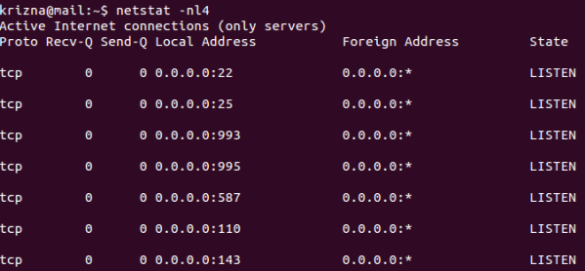](http://cdn.krizna.com/wp-content/uploads/2014/05/setup-mail-server-ubuntu-14-04.png)  
  **Step 18 »** Create some users and check using mail clients like thunderbird or outlook  
  krizna@mail:~$ sudo useradd -m bobby -s /sbin/nologin  
  krizna@mail:~$ sudo passwd bobby  
  [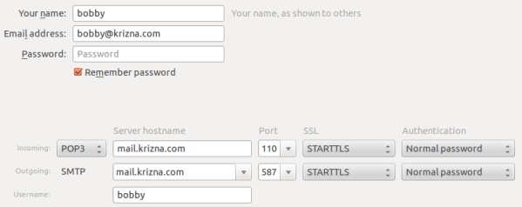](http://cdn.krizna.com/wp-content/uploads/2014/05/setup-mail-server-ubuntu-14-04-1.png)  
  Now mail server is ready, you can send and receive mail using the server. Continue for squirrelmail ..
* **»** **Installing and configuring squirrelmail**
* **Step 19 »** Install squirrelmail using the below command. This will install apache and PHP packages.  
  krizna@mail:~$ sudo apt-get install squirrelmail  
  **Step 20 »** Configure squirrelmail  
  krizna@mail:~$ sudo squirrelmail-configureEverything is pre-configured , we just need to change Organization name .  
  » Press 1 (Organization Preferences) » again press 1 (Organization Name) » Organization Name » Press S » Press Q to quit  
  **Step 19 »** Now configure apache to enable squirrelmail .  
  krizna@mail:~$ sudo cp /etc/squirrelmail/apache.conf /etc/apache2/sites-available/squirrelmail.conf  
  krizna@mail:~$ sudo a2ensite squirrelmail  
  **Step 20 »** Restart Apache service  
  krizna@mail:~$ sudo service apache2 restart  
  **Step 21 »** Now open **http://serverIP/squirrelmail** in your browser and login using username (bobby) . you can send and receive mail using squirrelmail.  
  Okay .. its over now ..  
  **Please note when you decide to move server to the production, it is very important to implement Spam filter and antivirus . please check this post for more detail** [**Postfix spamfilter and antivirus implementation**](https://help.ubuntu.com/community/PostfixAmavisNew)
* **How to Setup a Complete Mail Server (Postfix) using ‘SquirrelMail’ (Webmail) on Ubuntu/Debian**
* by [Hanny Helal](http://www.tecmint.com/author/hannyhelal/) | Published: December 5, 2014 | Last Updated: June 6, 2016
* **Download Your Free eBooks NOW** - [10 Free Linux eBooks for Administrators](http://www.tecmint.com/10-useful-free-linux-ebooks-for-newbies-and-administrators/) | [4 Free Shell Scripting eBooks](http://www.tecmint.com/free-linux-shell-scripting-books/)
* Creating a mail server on Linux powered machines can be one of the most essential things that every system administrator needs to do while configuring his servers for the first time, if you don’t know what it means; it’s simple, if you have a website like “**example.com**”, you can create an email account like “**username@example.com**” to use it to send / receive emails easily instead of using services like Hotmail, Gmil, Yahoo Mail.. etc.
* [](http://www.tecmint.com/wp-content/uploads/2014/12/Setup-Mail-Server-in-Ubuntu.jpg)
* Setup Postfix Mail Server in Ubuntu/Debian
* In this article, we’ll learn how to do so by installing the Postfix with “**SquirrelMail**” webmail application and its dependences on Debian/Ubuntu machines.
* **Step 1: Installing Apache2 and PHP5**
* **1.** In order to create a running mail server using “**SquirrelMail**”, we’ll have to install both **Apache2** & **PHP5** packages first, to do so, run.
* $ sudo apt-get update
* $ sudo apt-get install apache2 php5
* [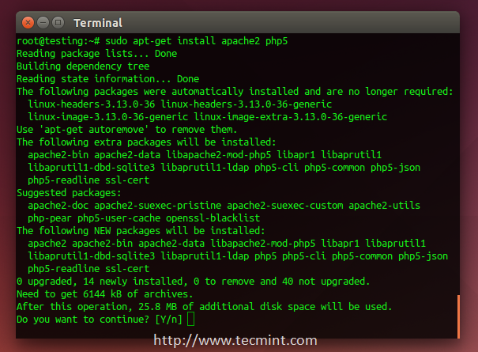](http://www.tecmint.com/wp-content/uploads/2014/12/Install-Apache-and-PHP.png)
* Install Apache and PHP
* **Step 2: Installing Postfix Mail Server**
* **2.** **Postfix** is a mail transfer agent (**MTA**) which is the responsible software for delivering & receiving emails, it’s essential in order to create a complete mail server.
* To install it on Ubuntu/Debian or even Mint, run:
* $ sudo apt-get install postfix
* During installation, you will be asked to choose the default file configuration for your server.
* [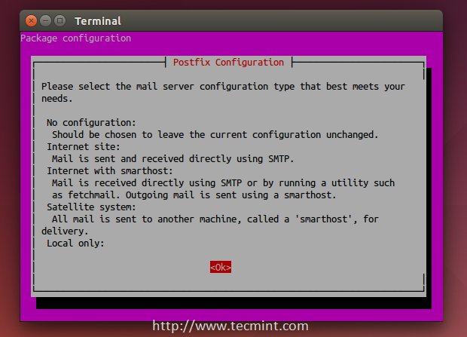](http://www.tecmint.com/wp-content/uploads/2014/12/Select-Postfix-Configuration.png)
* Select Postfix Configuration
* **3.** Next, it asks you to select type of mail configuration, choose “**Internet Site**”.
* [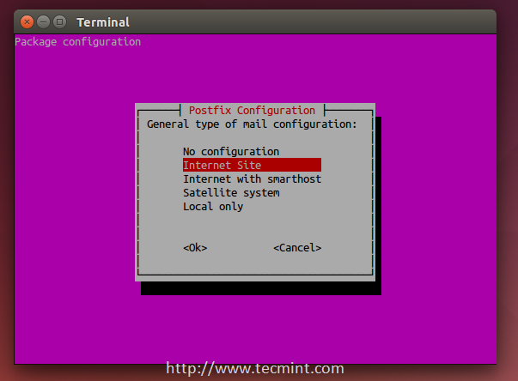](http://www.tecmint.com/wp-content/uploads/2014/12/Select-Mail-Configuration.png)
* Select Mail Configuration
* **4.** Now enter the fully qualified domain name that you want to use for send and receive mails.
* [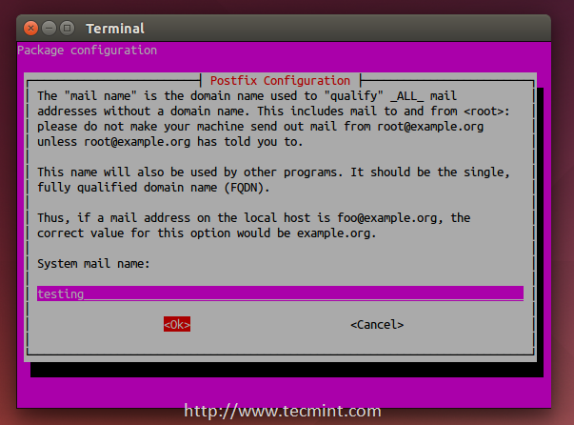](http://www.tecmint.com/wp-content/uploads/2014/12/System-Mail-Name.png)
* Enter System Mail Name
* **5.** Once the FQDN set, you’ve restart the Postfix mail server using.
* $ sudo service postfix restart
* **Step 3: Installing Dovecot**
* **6.** **Dovecot** is a mail delivery agent (**MDA**), it delivers the emails from/to the mail server, to install it, run the following command.
* $ sudo apt-get install dovecot-imapd dovecot-pop3d
* [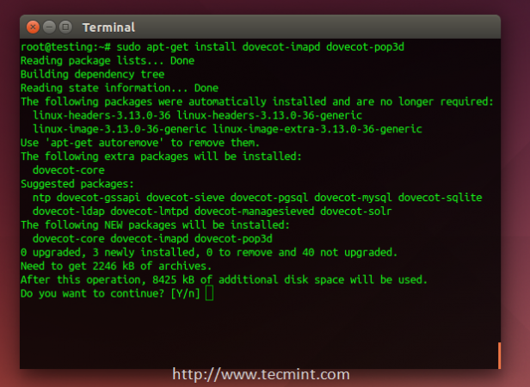](http://www.tecmint.com/wp-content/uploads/2014/12/Install-Dovecot.png)
* Install Dovecot
* During the installation process, you will be asked if you want to create a self-signed SSL certificate, choose **Yes**.
* [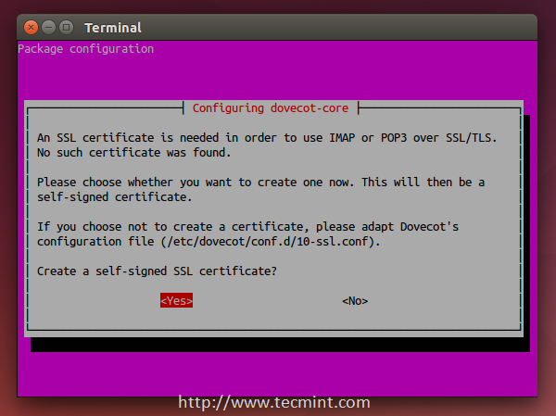](http://www.tecmint.com/wp-content/uploads/2014/12/Create-SSL-Certificate.png)
* Create Mail SSl Certificate
* **7.** Next, enter your host name to use in the SSL certificate.
* [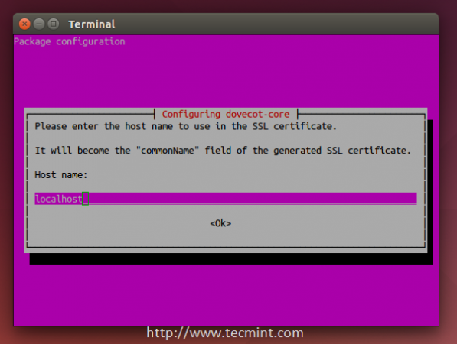](http://www.tecmint.com/wp-content/uploads/2014/12/Hostname-to-use-SSL.png)
* Enter Hostname to use SSL
* **8.** Next, restart Dovecot service using the following command.
* $ sudo service dovecot restart
* **Step 4: Installing SquirrelMail**
* **9.** **SquirrelMail** is the email server that you’ll be using to manage emails on your server, it has a simple web interface to do the job, it can be customized by installing more modules & themes.
* $ sudo apt-get install squirrelmail
* [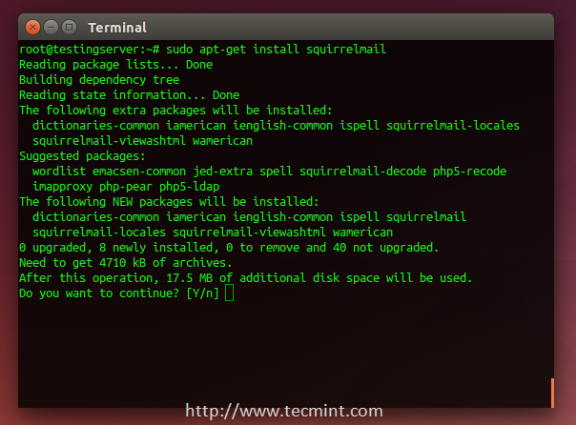](http://www.tecmint.com/wp-content/uploads/2014/12/Install-Squirrelmail.png)
* install Squirrelmail
* **10.** After the installation, you will have to run this command in order to configure SquirrelMail.
* $ sudo squirrelmail-configure
* [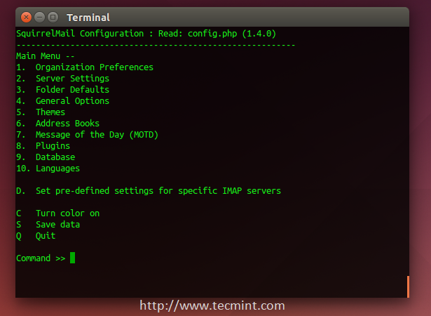](http://www.tecmint.com/wp-content/uploads/2014/12/Configure-Squirrelmail.png)
* Configure Squirrelmail
* **11.** Next, enter “**2**” in order to edit the server settings, and you will be prompted to it.
* [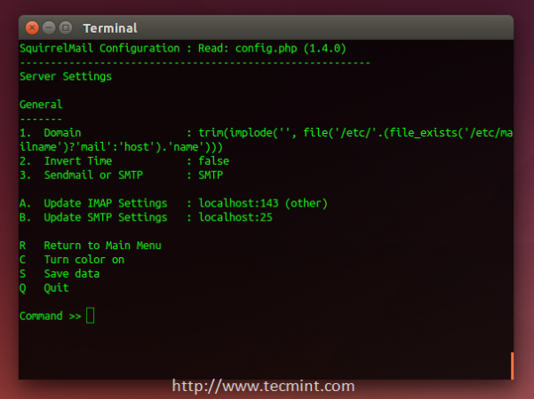](http://www.tecmint.com/wp-content/uploads/2014/12/Configure-Server-Settings.png)
* Configure Server Settings for Mail
* **12.** Now enter “**1**” in order to change the domain name and write up your domain (e.g: **example.com**).
* [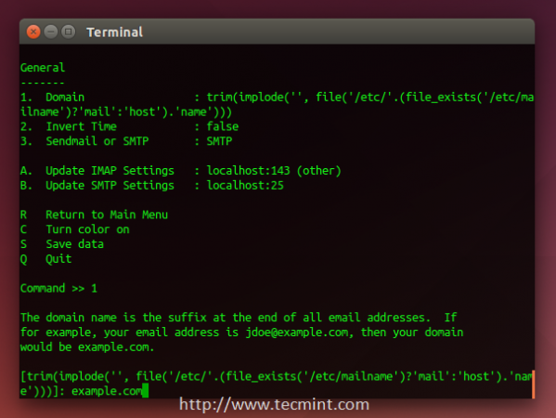](http://www.tecmint.com/wp-content/uploads/2014/12/Set-Domain-Name.png)
* Set Mail Domain Name
* **13.** Go back to the main menu by writing “**R**” and hitting the enter key, write “**4**” in order to configure the general options.
* [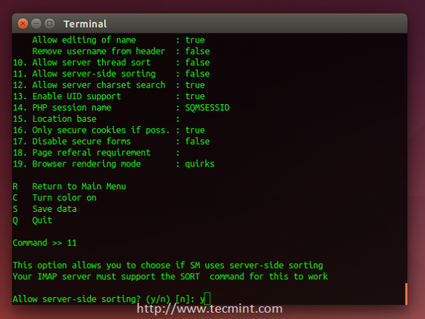](http://www.tecmint.com/wp-content/uploads/2014/12/Configure-General-Options.png)
* Configure Mail General Options
* You see “**Allow server-side sorting**”? Enter “**11**” and change it from “**false**” to “**true**” by entering “**y**”. Now hit the **Enter** key, and enter the “**S”** key in order to save the configuration file.
* Now, we’ll copy the default configuration file to the apache2 directory in order to be able to access the web interface, run.
* $ sudo cp /etc/squirrelmail/apache.conf /etc/apache2/sites-available/squirrelmail.conf
* And enable it using:
* $ sudo a2ensite squirrelmail.conf
* **14.** You can now access the mail server by going to **example.com/squirrelmail**.
* [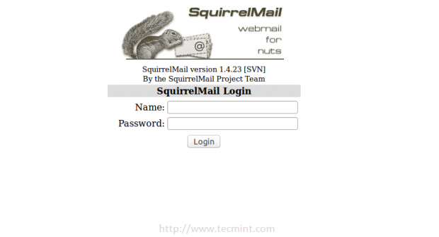](http://www.tecmint.com/wp-content/uploads/2014/12/Access-Squirrelmail.png)
* Access Squirrelmail
* **Step 5: Creating Mail Users**
* **15.** In order to start using squirrelmail webmail, you’ll have to create a new user, to do so, run.
* $ sudo useradd myusername
* Replace “**myusername**” with the user name you want, create a password for the new user by running.
* $ sudo passwd myusername
* **16.** Create a home folder for the user in **/var/www/html/myusername** and make it default home directory.
* $ sudo mkdir -p /var/www/html/myusername
* $ usermod -m -d /var/www/html/myusername myusername
* **17.** Now go back to the login page and enter the user name and the password of newly created user.
* [](http://www.tecmint.com/wp-content/uploads/2014/12/Access-Squirrelmail.png)
* Access Squirrelmail
* You will be surprise to see the following error message.
* [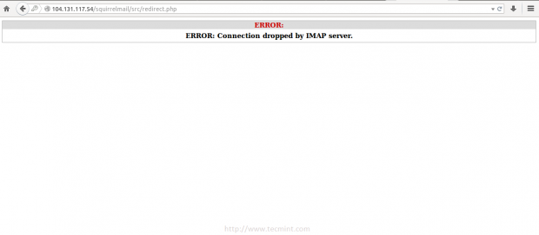](http://www.tecmint.com/wp-content/uploads/2014/12/Login-to-Squirrelmail.png)
* Login to Squirrelmail
* This is just a problem in the permissions, you have to give the user “**myusername**” the complete permissions on its home folder.
* $ sudo chown -R myusername:myusername /var/www/html/myusername
* **18.** Once permission set, you should able to login into squirrelmail.
* [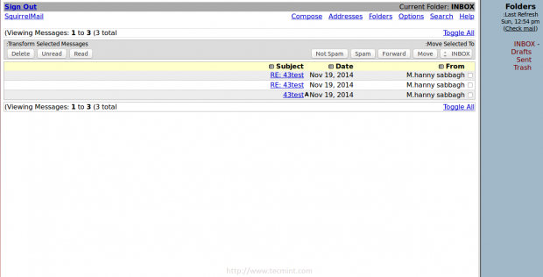](http://www.tecmint.com/wp-content/uploads/2014/12/Squirrelmail-Webmail.png)
* Squirrelmail Mail Interface
* You can try to send email from it, or you can try to receive emails by sending it to “**myusername@example.com**” , don’t forget to replace “**myusername**” with the user name you created.
* If you faced any other error.. Just check the “**/var/log/mail.err**” file, all the error message will be stored there, you won’t lose your way :)
* Have you tried to create an email server before? How did it go? Have you used SquirrelMail or any other mail server before? What do you think about it?

**Email with Postfix, Dovecot, and MySQL**

Updated Wednesday, April 29th, 2015 by James Stewart

**Contribute on GitHub**

[View Project](https://github.com/linode/docs) | [View File](https://github.com/linode/docs/blob/master/docs/email/postfix/email-with-postfix-dovecot-and-mysql.md) | [Edit File](https://github.com/linode/docs/edit/master/docs/email/postfix/email-with-postfix-dovecot-and-mysql.md)

Learn how to set up a secure mail server with Postfix, Dovecot, and MySQL on Debian or Ubuntu. Specifically, create new user mailboxes and send or receive email for configured domains.

For a different Linux distribution or different mail server, [search our tutorials](https://www.linode.com/docs/).

**Prerequisites**

1. Set up the Linode as specified in the [Getting Started](https://www.linode.com/docs/getting-started) and [Securing Your Server](https://www.linode.com/docs/securing-your-server) guides.
2. Ensure that the iptables [firewall](https://www.linode.com/docs/securing-your-server#creating-a-firewall) is not blocking any of the standard mail ports (25, 465, 587, 110, 995, 143, and 993). If using a different form of firewall, confirm that it is not blocking any of the needed ports either.

**Configuring DNS**

When ready to update the DNS and to start sending mail to the server, edit the domain’s MX record so that it points to the Linode’s domain or IP address, similar to the example below:

|  |  |
| --- | --- |
| 1  2  3 | example.com MX 10 example.com  example.com MX 10 12.34.56.78  mail.example.com MX 10 12.34.56.78 |

Ensure that the MX record is changed for all domains and subdomains that might receive email. If setting up a brand new domain, these steps can be performed prior to configuring the mail server. When using Linode’s [DNS Manager](https://www.linode.com/docs/dns-manager), create an MX record that points to the desired domain or subdomain, and then create an A record for that domain or subdomain, which points to the correct IP address.

**Installing an SSL Certificate**

Dovecot offers a default self-signed certificate for free. This certificate encrypts the mail connections similar to a purchased certificate. However, the email users receive warnings about the certificate when they attempt to set up their email accounts. Optionally, purchase and configure a commercial SSL certificate to avoid the warnings. For information about SSL certificates, see [Linode’s SSL Certificate guides](https://www.linode.com/docs/security/ssl/).

As of version 2.2.13-7, Dovecot no longer provides a default SSL certificate. This affects Debian 8 users, and means that if you wish to use SSL encryption (reccomended), you must generate your own self-signed certificate or use a trusted certificate from a Certificate Authority.

Many email service providers such as Gmail will only accept commercial SSL certificates for secure IMAP/POP3 connections. To communicate with these providers, follow our guide for [Obtaining a Commercial SSL Certificate](https://www.linode.com/docs/security/ssl/obtaining-a-commercial-ssl-certificate).

**Installing Packages**

The next steps are to install the required packages on the Linode.

1. Log in as the root user:

|  |  |
| --- | --- |
| 1 | su |

1. Install the required packages:

|  |  |
| --- | --- |
| 1 | apt-get install postfix postfix-mysql dovecot-core dovecot-imapd dovecot-pop3d dovecot-lmtpd dovecot-mysql mysql-server |

1. Follow the prompt to type in a secure MySQL password and to select the type of mail server you wish to configure. Select **Internet Site**. The *System Mail Name* should be the FQDN.
2. [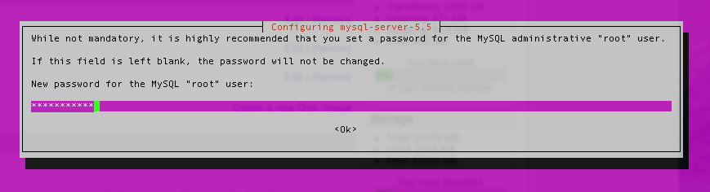](https://www.linode.com/docs/assets/1234-mysql_setroot1.png)
3. [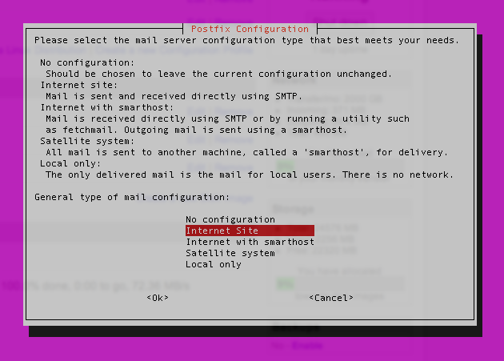](https://www.linode.com/docs/assets/1236-postfix_internetsite.png)
4. [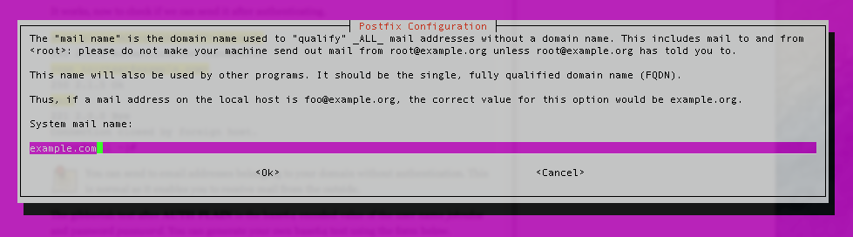](https://www.linode.com/docs/assets/1237-postfix_systemmailname.png)

**MySQL**

1. Create a new database:

|  |  |
| --- | --- |
| 1 | mysqladmin -p create mailserver |

1. Enter the MySQL root password.
2. Log in to MySQL:

|  |  |
| --- | --- |
| 1 | mysql -p mailserver |

1. Create the MySQL user and grant the new user permissions over the database. Replace mailuserpass with a secure password:

|  |  |
| --- | --- |
| 1 | GRANT SELECT ON mailserver.\* TO 'mailuser'@'127.0.0.1' IDENTIFIED BY 'mailuserpass'; |

1. Flush the MySQL privileges to apply the change:

|  |  |
| --- | --- |
| 1 | FLUSH PRIVILEGES; |

1. Create a table for the domains that will receive mail on the Linode:

|  |  |
| --- | --- |
| 1  2  3  4  5 | CREATE TABLE `virtual\_domains` (  `id` int(11) NOT NULL auto\_increment,  `name` varchar(50) NOT NULL,  PRIMARY KEY (`id`)  ) ENGINE=InnoDB DEFAULT CHARSET=utf8; |

1. Create a table for all of the email addresses and passwords:

|  |  |
| --- | --- |
| 1  2  3  4  5  6  7  8  9 | CREATE TABLE `virtual\_users` (  `id` int(11) NOT NULL auto\_increment,  `domain\_id` int(11) NOT NULL,  `password` varchar(106) NOT NULL,  `email` varchar(100) NOT NULL,  PRIMARY KEY (`id`),  UNIQUE KEY `email` (`email`),  FOREIGN KEY (domain\_id) REFERENCES virtual\_domains(id) ON DELETE CASCADE  ) ENGINE=InnoDB DEFAULT CHARSET=utf8; |

1. Create a table for the email aliases:

|  |  |
| --- | --- |
| 1  2  3  4  5  6  7  8 | CREATE TABLE `virtual\_aliases` (  `id` int(11) NOT NULL auto\_increment,  `domain\_id` int(11) NOT NULL,  `source` varchar(100) NOT NULL,  `destination` varchar(100) NOT NULL,  PRIMARY KEY (`id`),  FOREIGN KEY (domain\_id) REFERENCES virtual\_domains(id) ON DELETE CASCADE  ) ENGINE=InnoDB DEFAULT CHARSET=utf8; |

**Adding Data**

Now that the database and tables have been created, add some data to MySQL.

1. Add the domains to the virtual\_domains table. Replace the values for example.com and hostname with your own settings.

|  |  |
| --- | --- |
| 1  2  3  4  5  6  7 | INSERT INTO `mailserver`.`virtual\_domains`  (`id` ,`name`)  VALUES  ('1', 'example.com'),  ('2', 'hostname.example.com'),  ('3', 'hostname'),  ('4', 'localhost.example.com'); |

1. Note which id goes with which domain, the id is necessary for the next two steps.
2. Add email addresses to the virtual\_users table. Replace the email address values with the addresses that you wish to configure on the mailserver. Replace the password values with strong passwords.

|  |  |
| --- | --- |
| 1  2  3  4  5 | INSERT INTO `mailserver`.`virtual\_users`  (`id`, `domain\_id`, `password` , `email`)  VALUES  ('1', '1', ENCRYPT('password', CONCAT('$6$', SUBSTRING(SHA(RAND()), -16))), 'email1@example.com'),  ('2', '1', ENCRYPT('password', CONCAT('$6$', SUBSTRING(SHA(RAND()), -16))), 'email2@example.com'); |

1. To set up an email alias, add it to the virtual\_aliases table.

|  |  |
| --- | --- |
| 1  2  3  4 | INSERT INTO `mailserver`.`virtual\_aliases`  (`id`, `domain\_id`, `source`, `destination`)  VALUES  ('1', '1', 'alias@example.com', 'email1@example.com'); |

That’s it! Now you’re ready to verify that the data was successfully added to MySQL.

**Testing**

Since all of the information has been entered into MySQL, check that the data is there.

1. Check the contents of the virtual\_domains table:

|  |  |
| --- | --- |
| 1 | SELECT \* FROM mailserver.virtual\_domains; |

1. Verify that you see the following output:

|  |  |
| --- | --- |
| 1  2  3  4  5  6  7  8  9 | +----+-----------------------+  | id | name |  +----+-----------------------+  | 1 | example.com |  | 2 | hostname.example.com |  | 3 | hostname |  | 4 | localhost.example.com |  +----+-----------------------+  4 rows in set (0.00 sec) |

1. Check the virtual\_users table:

|  |  |
| --- | --- |
| 1 | SELECT \* FROM mailserver.virtual\_users; |

1. Verify the following output, the hashed passwords are longer than they appear below:

|  |  |
| --- | --- |
| 1  2  3  4  5  6  7 | +----+-----------+-------------------------------------+--------------------+  | id | domain\_id | password | email |  +----+-----------+-------------------------------------+--------------------+  | 1 | 1 | $6$574ef443973a5529c20616ab7c6828f7 | email1@example.com |  | 2 | 1 | $6$030fa94bcfc6554023a9aad90a8c9ca1 | email2@example.com |  +----+-----------+-------------------------------------+--------------------+  2 rows in set (0.01 sec) |

1. Check the virtual\_aliases table:

|  |  |
| --- | --- |
| 1 | SELECT \* FROM mailserver.virtual\_aliases; |

1. Verify the following output:

|  |  |
| --- | --- |
| 1  2  3  4  5  6 | +----+-----------+-------------------+--------------------+  | id | domain\_id | source | destination |  +----+-----------+-------------------+--------------------+  | 1 | 1 | alias@example.com | email1@example.com |  +----+-----------+-------------------+--------------------+  1 row in set (0.00 sec) |

1. If everything outputs correctly, you’re done with MySQL! Exit MySQL:

|  |  |
| --- | --- |
| 1 | exit |

**Postfix**

Next, set up Postfix so the server can accept incoming messages for the domains.

1. Immediately make a copy of the default Postfix configuration file in case you need to revert to the default configuration:

|  |  |
| --- | --- |
| 1 | cp /etc/postfix/main.cf /etc/postfix/main.cf.orig |

1. Edit the /etc/postfix/main.cf file to match the following. Ensure that occurrences of example.com are replaced with the domain name. Also, replace hostname with the system’s hostname on line 44.

/etc/postfix/main.cf

|  |  |
| --- | --- |
| 1  2  3  4  5  6  7  8  9  10  11  12  13  14  15  16  17  18  19  20  21  22  23  24  25  26  27  28  29  30  31  32  33  34  35  36  37  38  39  40  41  42  43  44  45  46  47  48  49  50  51  52  53  54  55  56  57  58  59  60  61  62  63 | # See /usr/share/postfix/main.cf.dist for a commented, more complete version  # Debian specific: Specifying a file name will cause the first  # line of that file to be used as the name. The Debian default  # is /etc/mailname.  #myorigin = /etc/mailname  smtpd\_banner = $myhostname ESMTP $mail\_name (Ubuntu)  biff = no  # appending .domain is the MUA's job.  append\_dot\_mydomain = no  # Uncomment the next line to generate "delayed mail" warnings  #delay\_warning\_time = 4h  readme\_directory = no  # TLS parameters  #smtpd\_tls\_cert\_file=/etc/ssl/certs/ssl-cert-snakeoil.pem  #smtpd\_tls\_key\_file=/etc/ssl/private/ssl-cert-snakeoil.key  #smtpd\_use\_tls=yes  #smtpd\_tls\_session\_cache\_database = btree:${data\_directory}/smtpd\_scache  #smtp\_tls\_session\_cache\_database = btree:${data\_directory}/smtp\_scache  smtpd\_tls\_cert\_file=/etc/dovecot/dovecot.pem  smtpd\_tls\_key\_file=/etc/dovecot/private/dovecot.pem  smtpd\_use\_tls=yes  smtpd\_tls\_auth\_only = yes  #Enabling SMTP for authenticated users, and handing off authentication to Dovecot  smtpd\_sasl\_type = dovecot  smtpd\_sasl\_path = private/auth  smtpd\_sasl\_auth\_enable = yes  smtpd\_recipient\_restrictions =  permit\_sasl\_authenticated,  permit\_mynetworks,  reject\_unauth\_destination  # See /usr/share/doc/postfix/TLS\_README.gz in the postfix-doc package for  # information on enabling SSL in the smtp client.  myhostname = hostname.example.com  alias\_maps = hash:/etc/aliases  alias\_database = hash:/etc/aliases  myorigin = /etc/mailname  #mydestination = example.com, hostname.example.com, localhost.example.com, localhost  mydestination = localhost  relayhost =  mynetworks = 127.0.0.0/8 [::ffff:127.0.0.0]/104 [::1]/128  mailbox\_size\_limit = 0  recipient\_delimiter = +  inet\_interfaces = all  #Handing off local delivery to Dovecot's LMTP, and telling it where to store mail  virtual\_transport = lmtp:unix:private/dovecot-lmtp  #Virtual domains, users, and aliases  virtual\_mailbox\_domains = mysql:/etc/postfix/mysql-virtual-mailbox-domains.cf  virtual\_mailbox\_maps = mysql:/etc/postfix/mysql-virtual-mailbox-maps.cf  virtual\_alias\_maps = mysql:/etc/postfix/mysql-virtual-alias-maps.cf,  mysql:/etc/postfix/mysql-virtual-email2email.cf |

1. Create the file for virtual domains. Ensure that you change the password for the mailuser account. If you used a different user, database name, or table name, customize those settings as well.

/etc/postfix/mysql-virtual-mailbox-domains.cf

|  |  |
| --- | --- |
| 1  2  3  4  5 | user = mailuser  password = mailuserpass  hosts = 127.0.0.1  dbname = mailserver  query = SELECT 1 FROM virtual\_domains WHERE name='%s' |

1. Create the /etc/postfix/mysql-virtual-mailbox-maps.cf file, and enter the following values. Make sure you use the mailuser’s password and make any other changes as needed.

/etc/postfix/mysql-virtual-mailbox-maps.cf

|  |  |
| --- | --- |
| 1  2  3  4  5 | user = mailuser  password = mailuserpass  hosts = 127.0.0.1  dbname = mailserver  query = SELECT 1 FROM virtual\_users WHERE email='%s' |

1. Create the /etc/postfix/mysql-virtual-alias-maps.cf file and enter the following values. Again, make sure you use the mailuser’s password, and make any other changes as necessary.

/etc/postfix/mysql-virtual-alias-maps.cf

|  |  |
| --- | --- |
| 1  2  3  4  5 | user = mailuser  password = mailuserpass  hosts = 127.0.0.1  dbname = mailserver  query = SELECT destination FROM virtual\_aliases WHERE source='%s' |

1. Create the /etc/postfix/mysql-virtual-email2email.cf file and enter the following values. Again, make sure you use the mailuser’s password, and make any other changes as necessary.

/etc/postfix/mysql-virtual-email2email.cf

|  |  |
| --- | --- |
| 1  2  3  4  5 | user = mailuser  password = mailuserpass  hosts = 127.0.0.1  dbname = mailserver  query = SELECT email FROM virtual\_users WHERE email='%s' |

1. Save the changes you’ve made to the /etc/postfix/mysql-virtual-email2email.cf file, and restart Postfix:

|  |  |
| --- | --- |
| 1 | sudo service postfix restart |

1. Enter the following command to ensure that Postfix can find the first domain. Be sure to replace example.com with the first virtual domain. The command should return 1 if it is successful.

|  |  |
| --- | --- |
| 1 | postmap -q example.com mysql:/etc/postfix/mysql-virtual-mailbox-domains.cf |

1. Test Postfix to verify that it can find the first email address in the MySQL table. Enter the following command, replacing email1@example.com with the first email address in the MySQL table. You should again receive 1 as the output:

|  |  |
| --- | --- |
| 1 | postmap -q email1@example.com mysql:/etc/postfix/mysql-virtual-mailbox-maps.cf |

1. Test Postfix to verify that it can find the aliases by entering the following command. Be sure to replace alias@example.com with the actual alias you entered:

|  |  |
| --- | --- |
| 1 | postmap -q alias@example.com mysql:/etc/postfix/mysql-virtual-alias-maps.cf |

1. This should return the email address to which the alias forwards, which is email1@example.com in this example.
2. Make a copy of the /etc/postfix/master.cf file:

|  |  |
| --- | --- |
| 1 | cp /etc/postfix/master.cf /etc/postfix/master.cf.orig |

1. Open the configuration file for editing and uncomment the two lines starting with submission and smtps and the block of lines starting with -o after each. The first section of the /etc/postfix/master.cf file should resemble the following:

/etc/postfix/master.cf

|  |  |
| --- | --- |
| 1  2  3  4  5  6  7  8  9  10  11  12  13  14  15  16  17  18  19  20  21  22  23  24  25  26  27 | #  # Postfix master process configuration file. For details on the format  # of the file, see the master(5) manual page (command: "man 5 master").  #  # Do not forget to execute "postfix reload" after editing this file.  #  # ==========================================================================  # service type private unpriv chroot wakeup maxproc command + args  # (yes) (yes) (yes) (never) (100)  # ==========================================================================  smtp inet n - - - - smtpd  #smtp inet n - - - 1 postscreen  #smtpd pass - - - - - smtpd  #dnsblog unix - - - - 0 dnsblog  #tlsproxy unix - - - - 0 tlsproxy  submission inet n - - - - smtpd  -o syslog\_name=postfix/submission  -o smtpd\_tls\_security\_level=encrypt  -o smtpd\_sasl\_auth\_enable=yes  -o smtpd\_client\_restrictions=permit\_sasl\_authenticated,reject  -o milter\_macro\_daemon\_name=ORIGINATING  smtps inet n - - - - smtpd  -o syslog\_name=postfix/smtps  -o smtpd\_tls\_wrappermode=yes  -o smtpd\_sasl\_auth\_enable=yes  -o smtpd\_client\_restrictions=permit\_sasl\_authenticated,reject  -o milter\_macro\_daemon\_name=ORIGINATING |

1. Restart Postfix by entering the following command:

|  |  |
| --- | --- |
| 1 | service postfix restart |

Congratulations! You have successfully configured Postfix.

**Dovecot**

Dovecot allows users to log in and check their email using POP3 and IMAP. In this section, configure Dovecot to force users to use SSL when they connect so that their passwords are never sent to the server in plain text.

1. Copy all of the configuration files so that you can easily revert back to them if needed:

|  |  |
| --- | --- |
| 1  2  3  4  5  6 | cp /etc/dovecot/dovecot.conf /etc/dovecot/dovecot.conf.orig  cp /etc/dovecot/conf.d/10-mail.conf /etc/dovecot/conf.d/10-mail.conf.orig  cp /etc/dovecot/conf.d/10-auth.conf /etc/dovecot/conf.d/10-auth.conf.orig  cp /etc/dovecot/dovecot-sql.conf.ext /etc/dovecot/dovecot-sql.conf.ext.orig  cp /etc/dovecot/conf.d/10-master.conf /etc/dovecot/conf.d/10-master.conf.orig  cp /etc/dovecot/conf.d/10-ssl.conf /etc/dovecot/conf.d/10-ssl.conf.orig |

1. Open the main configuration file and edit the contents to match the following:

/etc/dovecot/dovecot.conf

|  |  |
| --- | --- |
| 1  2  3  4  5  6  7  8  9  10  11  12  13  14  15  16  17  18  19  20  21  22  23  24  25  26  27  28  29  30  31  32  33  34  35  36  37  38  39  40  41  42  43  44  45  46  47  48  49  50  51  52  53  54  55  56  57  58  59  60  61  62  63  64  65  66  67  68  69  70  71  72  73  74  75  76  77  78  79  80  81  82  83  84  85  86  87  88  89  90  91 | ## Dovecot configuration file  # If you're in a hurry, see http://wiki2.dovecot.org/QuickConfiguration  # "doveconf -n" command gives a clean output of the changed settings. Use it  # instead of copy&pasting files when posting to the Dovecot mailing list.  # '#' character and everything after it is treated as comments. Extra spaces  # and tabs are ignored. If you want to use either of these explicitly, put the  # value inside quotes, eg.: key = "# char and trailing whitespace "  # Default values are shown for each setting, it's not required to uncomment  # those. These are exceptions to this though: No sections (e.g. namespace {})  # or plugin settings are added by default, they're listed only as examples.  # Paths are also just examples with the real defaults being based on configure  # options. The paths listed here are for configure --prefix=/usr  # --sysconfdir=/etc --localstatedir=/var  # Enable installed protocols  !include\_try /usr/share/dovecot/protocols.d/\*.protocol  protocols = imap pop3 lmtp  # A comma separated list of IPs or hosts where to listen in for connections.  # "\*" listens in all IPv4 interfaces, "::" listens in all IPv6 interfaces.  # If you want to specify non-default ports or anything more complex,  # edit conf.d/master.conf.  #listen = \*, ::  # Base directory where to store runtime data.  #base\_dir = /var/run/dovecot/  # Name of this instance. Used to prefix all Dovecot processes in ps output.  #instance\_name = dovecot  # Greeting message for clients.  #login\_greeting = Dovecot ready.  # Space separated list of trusted network ranges. Connections from these  # IPs are allowed to override their IP addresses and ports (for logging and  # for authentication checks). disable\_plaintext\_auth is also ignored for  # these networks. Typically you'd specify the IMAP proxy servers here.  #login\_trusted\_networks =  # Sepace separated list of login access check sockets (e.g. tcpwrap)  #login\_access\_sockets =  # Show more verbose process titles (in ps). Currently shows user name and  # IP address. Useful for seeing who are actually using the IMAP processes  # (eg. shared mailboxes or if same uid is used for multiple accounts).  #verbose\_proctitle = no  # Should all processes be killed when Dovecot master process shuts down.  # Setting this to "no" means that Dovecot can be upgraded without  # forcing existing client connections to close (although that could also be  # a problem if the upgrade is e.g. because of a security fix).  #shutdown\_clients = yes  # If non-zero, run mail commands via this many connections to doveadm server,  # instead of running them directly in the same process.  #doveadm\_worker\_count = 0  # UNIX socket or host:port used for connecting to doveadm server  #doveadm\_socket\_path = doveadm-server  # Space separated list of environment variables that are preserved on Dovecot  # startup and passed down to all of its child processes. You can also give  # key=value pairs to always set specific settings.  #import\_environment = TZ  ##  ## Dictionary server settings  ##  # Dictionary can be used to store key=value lists. This is used by several  # plugins. The dictionary can be accessed either directly or though a  # dictionary server. The following dict block maps dictionary names to URIs  # when the server is used. These can then be referenced using URIs in format  # "proxy::<name>".  dict {  #quota = mysql:/etc/dovecot/dovecot-dict-sql.conf.ext  #expire = sqlite:/etc/dovecot/dovecot-dict-sql.conf.ext  }  # Most of the actual configuration gets included below. The filenames are  # first sorted by their ASCII value and parsed in that order. The 00-prefixes  # in filenames are intended to make it easier to understand the ordering.  !include conf.d/\*.conf  # A config file can also tried to be included without giving an error if  # it's not found:  !include\_try local.conf |

1. Save the changes to the /etc/dovecot/dovecot.conf file.
2. Open the /etc/dovecot/conf.d/10-mail.conf file. This file controls how Dovecot interacts with the server’s file system to store and retrieve messages.

Click this link to see the final, complete version of [10-mail.conf](https://www.linode.com/docs/assets/1239-dovecot_10-mail.conf.txt) example file. This is a long file, so you may need to use the editor’s search feature to find the values you need to edit.

Modify the following variables within the configuration file.

/etc/dovecot/conf.d/10-mail.conf

|  |  |
| --- | --- |
| 1  2  3 | mail\_location = maildir:/var/mail/vhosts/%d/%n  ...  mail\_privileged\_group = mail |

Save the changes.

1. Enter the following command to verify the permissions for /var/mail:

|  |  |
| --- | --- |
| 1 | ls -ld /var/mail |

1. Verify that the permissions for /var/mail are as follows:

|  |  |
| --- | --- |
| 1 | drwxrwsr-x 2 root mail 4096 Mar 6 15:08 /var/mail |

1. Create the /var/mail/vhosts/ folder and the folder for the domain:

|  |  |
| --- | --- |
| 1 | mkdir -p /var/mail/vhosts/example.com |

1. Create the vmail user with a user and group id of 5000 by entering the following commands, one by one. This user will be in charge of reading mail from the server.

|  |  |
| --- | --- |
| 1  2 | groupadd -g 5000 vmail  useradd -g vmail -u 5000 vmail -d /var/mail |

1. Change the owner of the /var/mail/ folder and its contents to belong to vmail:

|  |  |
| --- | --- |
| 1 | chown -R vmail:vmail /var/mail |

1. Open the user authentication file, located in /etc/dovecot/conf.d/10-auth.conf and disable plain-text authentication by uncommenting this line:

/etc/dovecot/conf.d/10-auth.conf

|  |  |
| --- | --- |
| 1 | disable\_plaintext\_auth = yes |

Set the auth\_mechanisms by modifying the following line:

/etc/dovecot/conf.d/10-auth.conf

|  |  |
| --- | --- |
| 1 | auth\_mechanisms = plain login |

Comment out the system user login line:

/etc/dovecot/conf.d/10-auth.conf

|  |  |
| --- | --- |
| 1 | #!include auth-system.conf.ext |

Enable MySQL authentication by uncommenting the auth-sql.conf.ext line:

/etc/dovecot/conf.d/10-auth.conf

|  |  |
| --- | --- |
| 1  2  3  4  5  6  7 | #!include auth-system.conf.ext  !include auth-sql.conf.ext  #!include auth-ldap.conf.ext  #!include auth-passwdfile.conf.ext  #!include auth-checkpassword.conf.ext  #!include auth-vpopmail.conf.ext  #!include auth-static.conf.ext |

Click the link to see the final, complete version of [10-auth.conf](https://www.linode.com/docs/assets/1238-dovecot_10-auth.conf.txt).

Save the changes to the /etc/dovecot/conf.d/10-auth.conf file.

1. Edit the /etc/dovecot/conf.d/auth-sql.conf.ext file with the authentication information. Paste the following lines into in the file:

/etc/dovecot/conf.d/auth-sql.conf.ext

|  |  |
| --- | --- |
| 1  2  3  4  5  6  7  8 | passdb {  driver = sql  args = /etc/dovecot/dovecot-sql.conf.ext  }  userdb {  driver = static  args = uid=vmail gid=vmail home=/var/mail/vhosts/%d/%n  } |

Save the changes to the /etc/dovecot/conf.d/auth-sql.conf.ext file.

1. Update the /etc/dovecot/dovecot-sql.conf.ext file with our custom MySQL connection information.

Uncomment and set the driver line as shown below:

/etc/dovecot/dovecot-sql.conf.ext

|  |  |
| --- | --- |
| 1 | driver = mysql |

Uncomment the connect line and set the MySQL connection information. Use the mailuser’s password and any other custom settings:

/etc/dovecot/dovecot-sql.conf.ext

|  |  |
| --- | --- |
| 1 | connect = host=127.0.0.1 dbname=mailserver user=mailuser password=mailuserpass |

Uncomment the default\_pass\_scheme line and set it to SHA512-CRYPT:

/etc/dovecot/dovecot-sql.conf.ext

|  |  |
| --- | --- |
| 1 | default\_pass\_scheme = SHA512-CRYPT |

Uncomment the password\_query line and set it to the following:

/etc/dovecot/dovecot-sql.conf.ext

|  |  |
| --- | --- |
| 1 | password\_query = SELECT email as user, password FROM virtual\_users WHERE email='%u'; |

This password query lets you use an email address listed in the virtual\_users table as the username credential for an email account. If you want to be able to use the alias as the username instead (listed in the virtual\_aliases table), first add every primary email address to the virtual\_aliases table (directing to themselves) and then use the following line in /etc/dovecot/dovecot-sql.conf.ext instead:

|  |  |
| --- | --- |
| 1 | password\_query = SELECT email as user, password FROM virtual\_users WHERE email=(SELECT destination FROM virtual\_aliases WHERE source = '%u'); |

Click the link to see the final, complete version of [dovecot-sql.conf.ext](https://www.linode.com/docs/assets/1284-dovecot__dovecot-sql.conf.ext.txt).

Save the changes to the /etc/dovecot/dovecot-sql.conf.ext file.

1. Change the owner and group of the /etc/dovecot/ directory to vmail and dovecot:

|  |  |
| --- | --- |
| 1 | chown -R vmail:dovecot /etc/dovecot |

1. Change the permissions on the /etc/dovecot/ directory:

|  |  |
| --- | --- |
| 1 | chmod -R o-rwx /etc/dovecot |

1. Open the sockets configuration file, located at /etc/dovecot/conf.d/10-master.conf

Click this link to see the final version of [10-master.conf](https://www.linode.com/docs/assets/1240-dovecot_10-master.conf.txt). There are many nested blocks of code in this file, so please pay close attention to the brackets. It’s probably better if you edit line by line, rather than copying large chunks of code. If there’s a syntax error, Dovecot will crash silently, but you can check /var/log/upstart/dovecot.log to help you find the error.

1. Disable unencrypted IMAP and POP3 by setting the protocols’ ports to 0, as shown below. Ensure that the entries for port and ssl below the IMAPS and pop3s entries are uncommented:

/etc/dovecot/conf.d/10-master.conf

|  |  |
| --- | --- |
| 1  2  3  4  5  6  7  8  9  10  11  12  13  14  15  16  17  18  19 | service imap-login {  inet\_listener imap {  #port = 0  }  inet\_listener imaps {  port = 993  ssl = yes  }  ...  service pop3-login {  inet\_listener pop3 {  port = 0  }  inet\_listener pop3s {  port = 995  ssl = yes  }  ...  } |

Leave the secure versions unedited, specifically the imaps and pop3s, so that their ports still work. The default settings for imaps and pop3s are fine. Optionally, leave the port lines commented out, as the default ports are the standard 993 and 995.

Find the service lmtp section and use the configuration shown below:

/etc/dovecot/conf.d/10-master.conf

|  |  |
| --- | --- |
| 1  2  3  4  5  6  7  8  9  10  11  12  13 | service lmtp {  unix\_listener /var/spool/postfix/private/dovecot-lmtp {  mode = 0600  user = postfix  group = postfix  }  # Create inet listener only if you can't use the above UNIX socket  #inet\_listener lmtp {  # Avoid making LMTP visible for the entire internet  #address =  #port =  #}  } |

Locate the service auth section and configure it as shown below:

/etc/dovecot/conf.d/10-master.conf

|  |  |
| --- | --- |
| 1  2  3  4  5  6  7  8  9  10  11  12  13  14  15  16  17  18  19  20  21  22  23  24  25  26 | service auth {  # auth\_socket\_path points to this userdb socket by default. It's typically  # used by dovecot-lda, doveadm, possibly imap process, etc. Its default  # permissions make it readable only by root, but you may need to relax these  # permissions. Users that have access to this socket are able to get a list  # of all usernames and get results of everyone's userdb lookups.  unix\_listener /var/spool/postfix/private/auth {  mode = 0666  user = postfix  group = postfix  }  unix\_listener auth-userdb {  mode = 0600  user = vmail  #group =  }  # Postfix smtp-auth  #unix\_listener /var/spool/postfix/private/auth {  # mode = 0666  #}  # Auth process is run as this user.  user = dovecot  } |

In the service auth-worker section, uncomment the user line and set it to vmail as shown below:

/etc/dovecot/conf.d/10-master.conf

|  |  |
| --- | --- |
| 1  2  3  4  5  6 | service auth-worker {  # Auth worker process is run as root by default, so that it can access  # /etc/shadow. If this isn't necessary, the user should be changed to  # $default\_internal\_user.  user = vmail  } |

Save the changes to the /etc/dovecot/conf.d/10-master.conf file.

1. Verify that the default Dovecot SSL certificate and key exist:

|  |  |
| --- | --- |
| 1  2 | ls /etc/dovecot/dovecot.pem  ls /etc/dovecot/private/dovecot.pem |

1. As noted above, these files are not provided in Dovecot 2.2.13-7 and above, and will not be present on Debian 8 systems.
2. If using a different SSL certificate, upload the certificate to the server and make a note of its location and the key’s location.
3. Open /etc/dovecot/conf.d/10-ssl.conf.

Click the link to see the final, complete version of [10-ssl.conf](https://www.linode.com/docs/assets/1241-dovecot_10-ssl.conf.txt).

1. Verify that the ssl\_cert setting has the correct path to the certificate, and that the ssl\_key setting has the correct path to the key. The default setting displayed uses Dovecot’s built-in certificate, so you can leave this as-is if using the Dovecot certificate. Update the paths accordingly if you are using a different certificate and key.

/etc/dovecot/conf.d/10-ssl.conf

|  |  |
| --- | --- |
| 1  2 | ssl\_cert = </etc/dovecot/dovecot.pem  ssl\_key = </etc/dovecot/private/dovecot.pem |

Force the clients to use SSL encryption by uncommenting the ssl line and setting it to required:

/etc/dovecot/conf.d/10-ssl.conf

|  |  |
| --- | --- |
| 1 | ssl = required |

Save the changes to the /etc/dovecot/conf.d/10-ssl.conf file.

1. Finally, restart Dovecot:

|  |  |
| --- | --- |
| 1 | service dovecot restart |

**Test Email**

1. Set up a test account in an email client to ensure that everything is working. Many clients detect server settings automatically. However, manual configuration requires the following parameters:
   * the full email address, including the @example.com part, is the username.
   * the password should be the one you added to the MySQL table for this email address.
   * The incoming and outgoing server names must be a domain that resolves to the Linode.
   * Both the incoming and outgoing servers require authentication and SSL encryption.
   * You should use Port 993 for secure IMAP, Port 995 for secure POP3, and Port 25 with SSL for SMTP.
2. Try sending an email to this account from an outside email account and then reply to it. Check the mail log file in */var/log/mail.log* for the following output (the first block is for an incoming message, and the second block for an outgoing message):

/var/log/mail.log

|  |  |
| --- | --- |
| 1  2  3  4  5  6  7  8  9  10 | Mar 22 18:18:15 host postfix/smtpd[22574]: connect from mail1.linode.com[96.126.108.55]  Mar 22 18:18:15 host postfix/smtpd[22574]: 2BD192839B: client=mail1.linode.com[96.126.108.55]  Mar 22 18:18:15 host postfix/cleanup[22583]: 2BD192839B: message-id=<D4887A5E-DEAC-45CE-BDDF-3C89DEA84236@example.com>  Mar 22 18:18:15 host postfix/qmgr[15878]: 2BD192839B: from=<support@linode.com>, size=1156, nrcpt=1 (queue active)  Mar 22 18:18:15 host postfix/smtpd[22574]: disconnect from mail1.linode.com[96.126.108.55]  Mar 22 18:18:15 host dovecot: lmtp(22587): Connect from local  Mar 22 18:18:15 host dovecot: lmtp(22587, email1@example.com): 5GjrDafYTFE7WAAABf1gKA: msgid=<D4887A5E-DEAC-45CE-BDDF-3C89DEA84236@linode.com>: saved mail to INBOX  Mar 22 18:18:15 host dovecot: lmtp(22587): Disconnect from local: Client quit (in reset)  Mar 22 18:18:15 host postfix/lmtp[22586]: 2BD192839B: to=<email1@example.com>, relay=host.example.com[private/dovecot-lmtp], delay=0.09, delays=0.03/0.02/0.03/0.01, dsn=2.0.0, status=sent (250 2.0.0 <email1@example.com> 5GjrDafYTFE7WAAABf1gKA Saved)  Mar 22 18:18:15 host postfix/qmgr[15878]: 2BD192839B: removed |

/var/log/mail.log

|  |  |
| --- | --- |
| 1  2  3  4  5  6  7 | Mar 22 18:20:29 host postfix/smtpd[22590]: connect from 173-161-199-49-Philadelphia.hfc.comcastbusiness.net[173.161.199.49]  Mar 22 18:20:29 host dovecot: auth-worker: mysql(127.0.0.1): Connected to database mailserver  Mar 22 18:20:29 host postfix/smtpd[22590]: AA10A2839B: client=173-161-199-49-Philadelphia.hfc.comcastbusiness.net[173.161.199.49], sasl\_method=PLAIN, sasl\_username=email1@example.com  Mar 22 18:20:29 host postfix/cleanup[22599]: AA10A2839B: message-id=<FB6213FA-6F13-49A8-A5DD-F324A4FCF9E9@example.com>  Mar 22 18:20:29 host postfix/qmgr[15878]: AA10A2839B: from=<email1@example.com>, size=920, nrcpt=1 (queue active)  Mar 22 18:20:29 host postfix/smtp[22601]: AA10A2839B: to=<support@linode.com>, relay=mail1.linode.com[96.126.108.55]:25, delay=0.14, delays=0.08/0.01/0.05/0.01, dsn=2.0.0, status=sent (250 2.0.0 Ok: queued as C4232266C9)  Mar 22 18:20:29 host postfix/qmgr[15878]: AA10A2839B: removed |

You now have a functioning mail server that can securely send and receive email. If things are not working smoothly, try consulting the [Troubleshooting Problems with Postfix, Dovecot, and MySQL](https://www.linode.com/docs/email/postfix/troubleshooting) guide. At this point, consider adding spam and virus filtering and a webmail client. If DNS records have not been created for the mail server yet, do so now. Once the DNS records have propagated, email will be delivered via the new mail server.

If errors are encountered in the /var/log/syslog stating “Invalid settings: postmaster\_address setting not given”, you may need to append the following line to the /etc/dovecot/dovecot.conf file, replacing domain with the domain name.

|  |  |
| --- | --- |
| 1 | postmaster\_address=postmaster at DOMAIN |

**Adding New Domains, Email Addresses, and Aliases**

Although the mail server is up and running, eventually you’ll probably need to add new domains, email addresses, and aliases for the users. To do this, simply add a new line to the appropriate MySQL table. These instructions are for command-line MySQL, but you can also use [phpMyAdmin](http://www.phpmyadmin.net/) to add new entries to the tables.

**Domains**

1. To add a new domain, open a terminal window and [log in to the Linode via SSH](https://www.linode.com/docs/getting-started#sph_logging-in-for-the-first-time).
2. Log in to the MySQL server with an appropriately privileged user. For this example, use the root user:

|  |  |
| --- | --- |
| 1 | mysql -u root -p mailserver |

1. Enter the root MySQL password when prompted.
2. Always view the contents of the table before adding new entries. Enter the following command to view the current contents of any table, replacing virtual\_domains with the table:

|  |  |
| --- | --- |
| 1 | SELECT \* FROM mailserver.virtual\_domains; |

1. The output should resemble the following:

|  |  |
| --- | --- |
| 1  2  3  4  5  6  7  8 | +----+-----------------------+  | id | name |  +----+-----------------------+  | 1 | example.com |  | 2 | hostname.example.com |  | 3 | hostname |  | 4 | localhost.example.com |  +----+-----------------------+ |

1. To add another domain, enter the following command, replacing newdomain.com with the domain name:

|  |  |
| --- | --- |
| 1  2  3  4 | INSERT INTO `mailserver`.`virtual\_domains`  (`name`)  VALUES  ('newdomain.com'); |

1. Verify that the new domain has been added. The output should display the new domain name.

|  |  |
| --- | --- |
| 1 | SELECT \* FROM mailserver.virtual\_domains; |

1. Exit MySQL:

|  |  |
| --- | --- |
| 1 | quit |

You have successfully added the new domain to the Postfix and Dovecot setup.

**Email Addresses**

1. To add a new email address, enter the following command in MySQL, replacing newpassword with the user’s password, and email3@newdomain.com with the user’s email address:

|  |  |
| --- | --- |
| 1  2  3  4 | INSERT INTO `mailserver`.`virtual\_users`  (`domain\_id`, `password` , `email`)  VALUES  ('5', ENCRYPT('newpassword', CONCAT('$6$', SUBSTRING(SHA(RAND()), -16))) , 'email3@newdomain.com'); |

1. Be sure to use the correct number for the domain\_id. In this case, we are using 5, because we want to make an email address for newdomain.com, and newdomain.com has an id of 5 in the virtual\_domains table.
2. Verify that the new email address has been added. The new email address should be displayed in the output.

|  |  |
| --- | --- |
| 1 | SELECT \* FROM mailserver.virtual\_users; |

1. Exit MySQL:

|  |  |
| --- | --- |
| 1 | quit |

You have successfully added the new email address to the Postfix and Dovecot setup.

**Aliases**

1. To add a new alias, enter the following command in MySQL, replacing alias@newdomain.com with the address from which you want to forward email, and myemail@gmail.com with the address that you want to forward the mail to. The alias@newdomain.com needs to be an email address that already exists on the server.

|  |  |
| --- | --- |
| 1  2  3  4 | INSERT INTO `mailserver`.`virtual\_aliases`  (`domain\_id`, `source`, `destination`)  VALUES  ('5', 'alias@newdomain.com', 'myemail@gmail.com'); |

1. Ensure that the correct number is entered for the domain\_id value. Use the id of the domain for this email address. For an explanation of id us, see the email users section above.
2. You can also add a “catch-all” alias which will forward all emails sent to a domain which do not have matching aliases or users by specifying @newdomain.com as the source of the alias.

|  |  |
| --- | --- |
| 1  2  3  4 | INSERT INTO `mailserver`.`virtual\_aliases`  (`domain\_id`, `source`, `destination`)  VALUES  ('5', '@newdomain.com', 'myemail@gmail.com'); |

1. Verify that the new alias has been added. The new alias will be displayed in the output.

|  |  |
| --- | --- |
| 1 | SELECT \* FROM mailserver.virtual\_aliases; |

1. Exit MySQL:

|  |  |
| --- | --- |
| 1 | quit |

You have successfully added the new alias to the Postfix and Dovecot setup.

**How to Install Zimbra 8.6 on Ubuntu 14.04 Server**

**On this page**

1. [Prerequisites](https://www.howtoforge.com/tutorial/ubuntu-14-04-zimbra-server/#prerequisites)
2. [Installation of prerequisites](https://www.howtoforge.com/tutorial/ubuntu-14-04-zimbra-server/#installation-of-prerequisites)
3. [Configure hostname and DNS Server](https://www.howtoforge.com/tutorial/ubuntu-14-04-zimbra-server/#configure-hostname-and-dns-server)
4. [Installing Zimbra](https://www.howtoforge.com/tutorial/ubuntu-14-04-zimbra-server/#installing-zimbra)
5. [Testing Zimbra](https://www.howtoforge.com/tutorial/ubuntu-14-04-zimbra-server/#testing-zimbra)
6. [Conclusion](https://www.howtoforge.com/tutorial/ubuntu-14-04-zimbra-server/#conclusion)

The Zimbra Collaboration Server is a mail server, collaborative web application and a web based mail server admin console in a single application. It provides LDAP, antivirus, antispam, collaboration features and a ajax webmail client. Zimbra is easy to use for administrators as well as end users due to its fast Ajax based web interface.

**Prerequisites**

* Ubuntu Server 14.04 - 64bit
* root privileges
* Free space 25 GB
* RAM 4 GB

**My zimbra Server profile used in this tutorial:**  
  
Domain : sendaljepit.local  
IP     : 192.168.1.101  
Mail   : mail.sendaljepit.local  
  
**What we will do in this tutorial:**

* Install the prerequisite packages
* Configure hostname and DNS Server
* Download and Install Zimbra
* Test the installation

**Installation of prerequisites**

**Step 1 - connect to your server, get root privileges and install this package.**

apt-get install libgmp10 libperl5.18 unzip pax sysstat sqlite3 dnsmasq wget

**Configure hostname and DNS Server**

In this tutorial will use the 'dnsmasq' resolving nameserver to speedup DNS lookups in Zimbra. Dnsmask has been installed as prerequisite in the first chapter, so we just have to configure it now:

**Step 1 - Edit hostname and hosts**

vim /etc/hostname

change your hostname with this 'mail.sendaljepit.local'.

[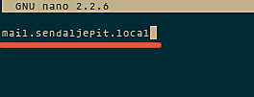](https://www.howtoforge.com/images/zimbra_on_ubuntu_14_04/big/1.png)

vim /etc/hosts

add this line:

192.168.1.101 mail.sendaljepit.local mail

[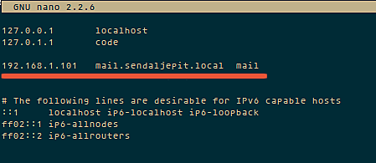](https://www.howtoforge.com/images/zimbra_on_ubuntu_14_04/big/2.png)

**Step 2 - Edit dnsmasq configuration**

vim /etc/dnsmasq.conf

server=192.168.1.101

domain=sendaljepit.local

mx-host=sendaljepit.local, mail.sendaljepit.local, 5

mx-host=mail.sendaljepit.local, mail.sendaljepit.local, 5

listen-address=127.0.0.1

**Step 3 - Reboot**

sudo reboot

**Installing Zimbra**

**Step 1 - Download Zimbra and extract it**

wget https://files.zimbra.com/downloads/8.6.0\_GA/zcs-8.6.0\_GA\_1153.UBUNTU14\_64.20141215151116.tgz  
tar -xvf zcs-8.6.0\_GA\_1153.UBUNTU14\_64.20141215151116.tgz  
cd zcs\*

**Step 2 - Run the Installer**

./install.sh

At this step, zimbra will check the required packages and will ask you to agree to their installation.

[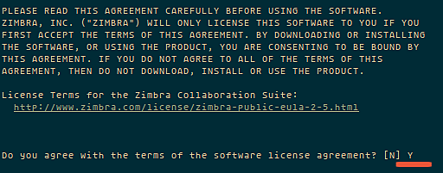](https://www.howtoforge.com/images/zimbra_on_ubuntu_14_04/big/3.png)

and then choose the zimbra package :

[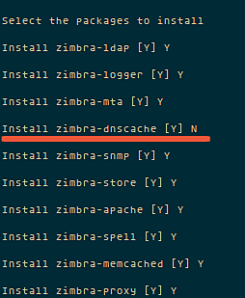](https://www.howtoforge.com/images/zimbra_on_ubuntu_14_04/big/4.png)

here doesn`t need zimbra-dnscache, because in this tutorial use dnsmasq.

You need to wait, because this installation takes some time.

next step is configure *"zimbra-store"* for getting admin password. See the picture:

[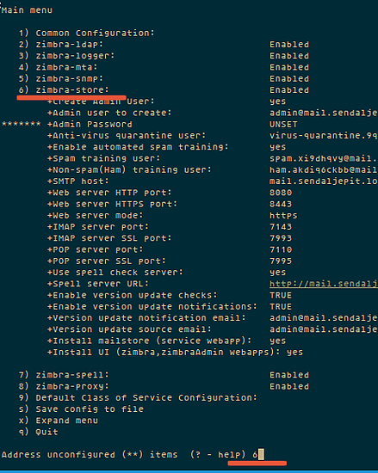](https://www.howtoforge.com/images/zimbra_on_ubuntu_14_04/big/5.png)

Choose number **"4"** and enter. and then type your password:

[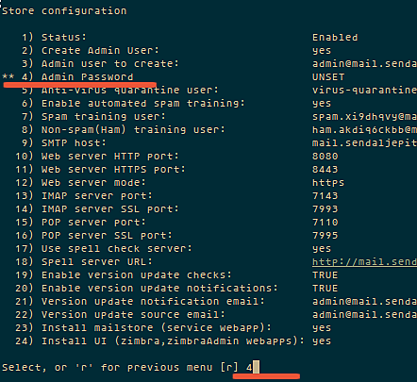](https://www.howtoforge.com/images/zimbra_on_ubuntu_14_04/big/6.png)

Apply all Configuration:

[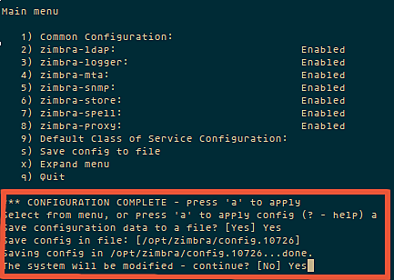](https://www.howtoforge.com/images/zimbra_on_ubuntu_14_04/big/7.png)  
  
and wait for Zimbra configuration finished.

**Testing Zimbra**

to test your zimbra server is running, you can type a command :

su - zimbra  
zmcontrol status

try to access zimbra from web browser.  [*https://192.168.1.101/*](https://www.howtoforge.com/admin/articles/add/%20https:/192.168.1.101/)

[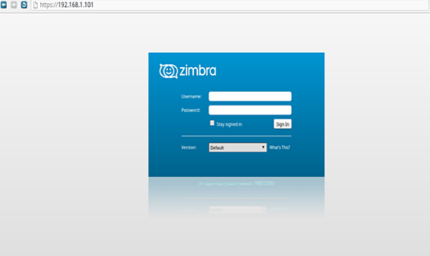](https://www.howtoforge.com/images/zimbra_on_ubuntu_14_04/big/9.png)

or try admin page " [https://192.168.1.101:7071/](https://www.howtoforge.com/admin/articles/add/%20https:/192.168.1.101/) ".

**Conclusion**

Zimbra is an Open Source mail server application which provides many features and is easy to use for admin and client. Zimbra requires a lot of server ressources, so dont use it on servers that do not match the base requirements outlines in the first chapter.

[**How to use Linux as router**](http://computernetworkingnotes.com/network-administrations/linux-as-router.html)

* [](http://computernetworkingnotes.com/network-administrations/linux-as-router/print.html)

In this article I will show you that how can you use Linux as a router. Routers are the devices those are used to connect two different networks. Routers are very costly devices. Linux could be a cost effective solution of routing in a small company.

**Exam question**  
**Your system is going use as a router for 192.168.0.0/24 and 192.168.1.0/24. Enable the IP forwarding.**

**Linux as a Router**

In this practical we are using three computers. One Linux system will be use for routing and reset two will remain in two different networks. First we will configure the system which is going to play the role of router.

How to create virtual LAN card

**Configure server system**

You need two LAN card for routing between two networks or you can create virtual LAN card instead of deploying them physically.

To create virtual Ethernet card change directory to **/etc/sysconfig/network-scripts**

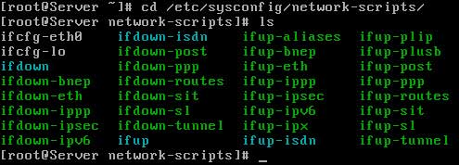

**ifcfg-eth0** is the necessary script file for Ethernet 0. Copy this file to the same folder to create new virtual LAN cards.



Now on this newly created virtual LAN card. It could be done by **service network restart**

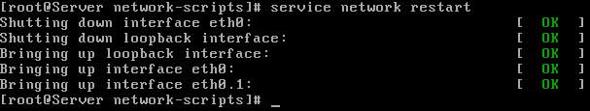

Run **setup** command and select network configuration sub window from list



You have two LAN card here, select **eth0** from list to assign IP

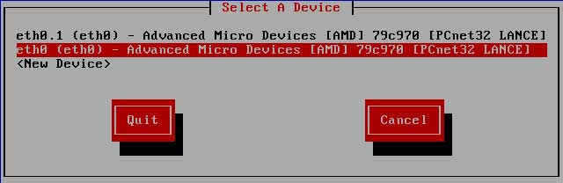

This Ethernet card will be the default gateway of first network set its IP to **192.168.1.254** and click on ok

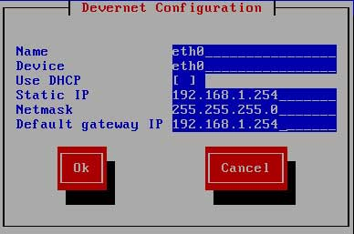

Now select **eth0.1** ( This our virtual LAN card which we create in our last sections)

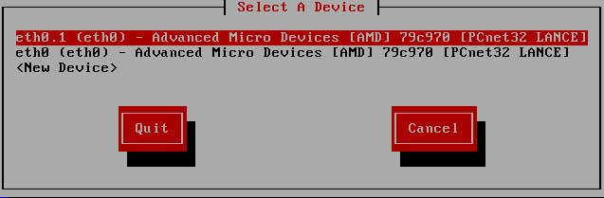

Set its IP to **192.168.0.254** This will be the default gateway of other network. Click on **OK** then **quit** and **quit** to come back on command prompt

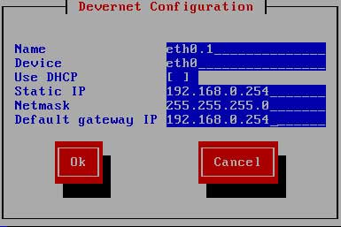

IP forwarding can be enabled by editing in **/etc/sysctl.conf** file. open this file



Locate the **net.ipv4. ip\_forward = 0 tag**. and replace the value **0** to **1**. This will enable IP forwarding to permanently . But this require a system reboot.

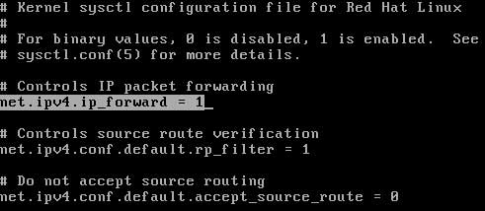

If don't want to restart the system you can tell running kernel directly by **echo** command and kernel will enable the IP forwarding



now configure our client system. we are using two system one from each network to test the connectivity .

Our first system is a Linux machine run **setup** command on it



assign its IP address to **192.168.0.1** with a default gateway of **192.168.0.254**

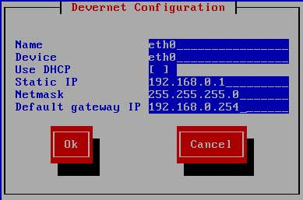

now restart the network service and check connectivity form its default gateway ( Server IP)

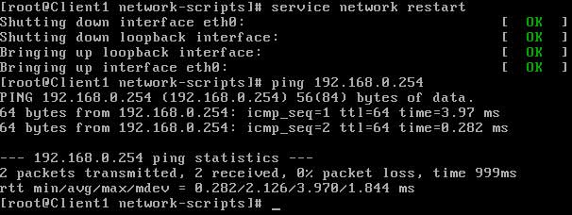

Now go on our other host which we are using a window machine ( You can also use Linux host ) and set IP address to **192.168.1.1** with a default gateway to **192.168.1.254**

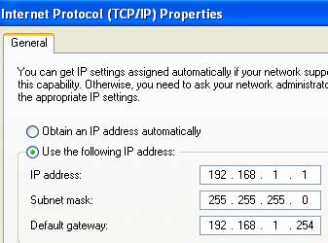

now open command prompt and test connectivity with default gateway

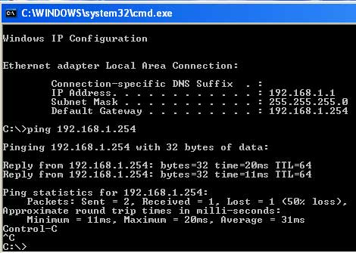

At this point you have completed all necessary step's to enable routing its time to verify this

**Test from windows system**

**ping** the Linux host located on other network

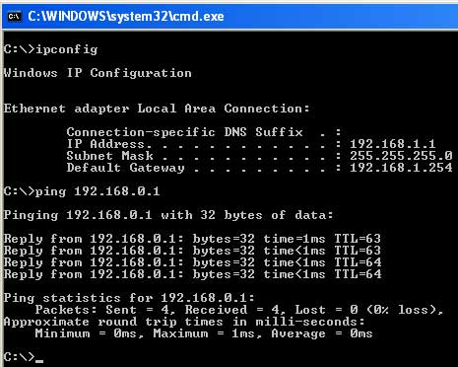

**Test from Linux system**

**ping** the Window host located on other network

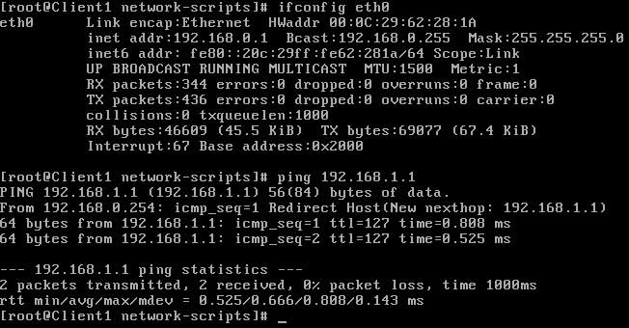

[**How to configure syslog server in Linux**](http://computernetworkingnotes.com/network-administrations/syslog-server.html)

* [](http://computernetworkingnotes.com/network-administrations/syslog-server/print.html)

**Sample Exam question:-** You are a System administrator. Using Log files very easy to monitor the system. Now there are 40 servers running as Mail, Web, Proxy, DNS services etc. Your task is to centralize the logs from all servers into on LOG Server. How will you configure the **LOG Server** to accept logs from remote host ?

**Answer with Explanation**

An important part of maintaining a secure system is keeping track of the activities that take place on the system. If you know what usually happens, such as understanding when users log into your system, you can use log files to spot unusual activity. You can configure what syslogd records through the **/etc/syslog.conf** configuration file.

The **syslogd daemon** manages all the logs on your system and coordinates with any of the logging operations of other systems on your network. Configuration information for **syslogd** is held in the **/etc/syslog.conf** file, which contains the names and locations for your system log files.

By Default system accept the logs only generated from local host. In this example we will configure a log server and will accept logs from client side.

For this example we are using two systems one linux server one linux clients . To complete these per quest of log server Follow this link

[Network configuration in Linux](http://computernetworkingnotes.com/network-administrations/network-configurations.html)

* A linux server with ip address 192.168.0.254 and hostname Server
* A linux client with ip address 192.168.0.1 and hostname Client1
* Updated /etc/hosts file on both linux system
* Running portmap and xinetd services
* Firewall should be off on server

We suggest you to review that article before start configuration of log server. Once you have completed the necessary steps follow this guide.

Check **syslog, portmap, xinetd** service in system service it should be on

#setup Select  **System service** from list [\*]portmap [\*]xinetd [\*]syslog

Now restart **xinetd** and **portmap** service  
  
To keep on these services after reboot on then via **chkconfig** command  
  
After **reboot** verify their status. It must be in running condition  


Now open the **/etc/sysconfig/syslog** file   
  
and locate **SYSLOGD\_OPTIONS** tag   
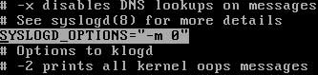  
add **-r** option in this tag to accepts logs from clients   
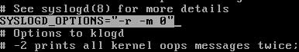

-m 0 disables 'MARK' messages.

-r enables logging from remote machines

-x disables DNS lookups on messages recieved with -r

After **saving** file restart service with **service syslog restart** command   
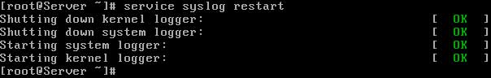

**On Linux client**

**ping** from **log server** and open **/etc/syslog.conf** file   
  
Now go to the **end of file** and do entry for serve as **user.\* @ [ server IP]** as shown in image   
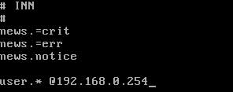  
After **saving** file restart service with **service syslog restart** command   
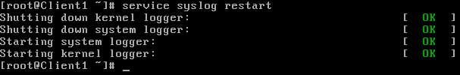

Now **restart** the client so it can send log entry to server. ( Note that these logs will generate when client boot, **so do it restart not shutdown**)  


**Check clients log on Log server**

To check the message of client on server open  
  
In the **end of this** file you can check the log from clients  
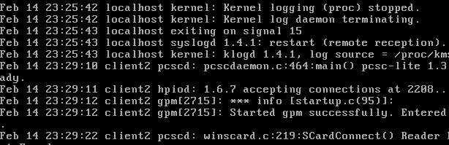

[**Configure linux server to deny icmp ping request**](http://computernetworkingnotes.com/network-administrations/deny-icmp.html)

* [](http://computernetworkingnotes.com/network-administrations/deny-icmp/print.html)

ICMP protocol is used by ping command to check the connectivity between two computers. By defaults all Linux servers will response on ICMP request. Hacker can misuse this service. They can generate countless ping requests to your Linux server. This is what called DOS denial of services.

In this article I will show that how can you block ICMP ping request

We will use to two system for this practical. Go on first Linux system and set IP address to **192.168.0.254**

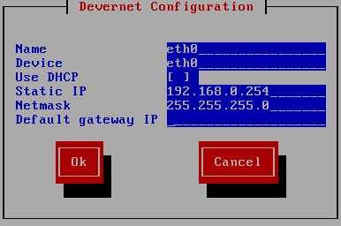

Apply new IP by **service network restart** command and verify it **ifconfig**

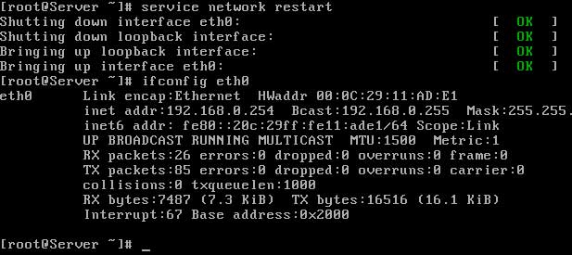

Now go other machine and set IP address to **192.168.0.1** (I am using window machine for testing you can use your Linux machine for it also.)

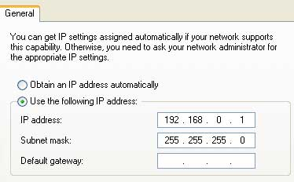

verify new ip by **ipconfig**  
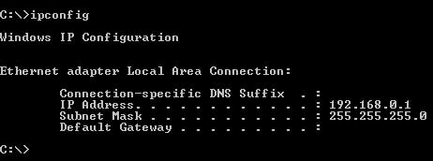  
Test connectivity with server by **ping** commands  
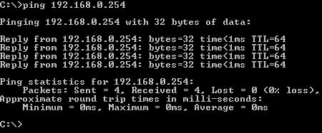  
You will get reply because all Linux servers are by default configured to response on ICMP ping request.

Now go back on Linux server and configure it to deny ping request.

We need to add deny tag in **sysctl.conf** file open **/etc/sysctl.conf** file



Now add **net.ipv4.icmp\_echo\_ignore\_all = 1** line in the end of file and save this file

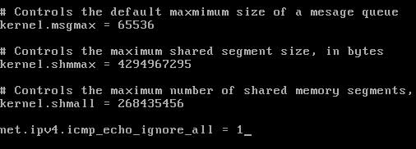

Change will take place after restart, reboot system with **reboot -f** commands



Now try to **ping** form other system again you will not get replay now

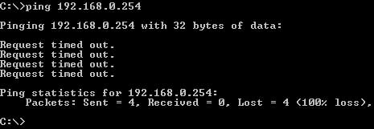

Now other system cannot **ping** the Linux server but Linux server can **ping** ohter system as so far our other system have no such service configured. Go on Linux server and **ping**other system

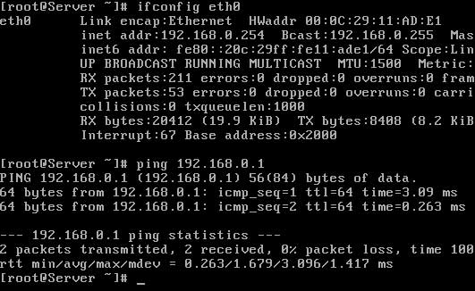

After doing practical don't forget remove **net.ipv4.icmp\_echo\_ignore\_all = 1** line form **sysctl.conf** on server. Otherwise you will not get replay form server that not good at least in classroom lab.

[**How to configure NIS Server in Linux**](http://computernetworkingnotes.com/network-administrations/nis-server.html)

* [](http://computernetworkingnotes.com/network-administrations/nis-server/print.html)

NIS, or **Network Information Systems,** is a network service that allows authentication and login information to be stored on a centrally located server. This includes the username and password database for login authentication, database of user groups, and the locations of home directories.

**RHCE exam questions**

One **NIS Domain** named **rhce** is configured in your lab, server is **192.168.0.254.** nis1, nis2,nis3 user are created on domain server. Make your system as a member of **rhce** domain. Make sure that when nis user login in your system home directory should get by them. Home directory is shared on server **/rhome/nis1**.

RHCE exam doesn't ask candidate to configure NIS server. It test only NIS client side configuration. As you can see in example questions. But here in this article we will configure both server and client side for testing purpose so you can get more depth knowledge of nis server

**Configure NIS server**

In this example we will configure a NIS server and a user nis1 will login from client side.

For this example we are using two systems one linux server one linux clients . To complete these per quest of nis server Follow this link

[Network configuration in Linux](http://computernetworkingnotes.com/network-administrations/network-configurations.html)

* A linux server with ip address 192.168.0.254 and hostname Server
* A linux client with ip address 192.168.0.1 and hostname Client1
* Updated /etc/hosts file on both linux system
* Running portmap and xinetd services
* Firewall should be off on server

We suggest you to review that article before start configuration of nis server. Once you have completed the necessary steps follow this guide.

Seven rpm are required to configure nis server. **ypserv, cach, nfs, make, ypbind, portmap, xinetd** check them if not found then install

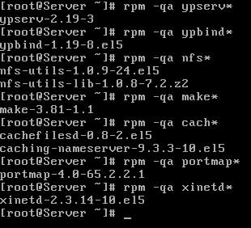

Now check **nfs,ypserv,yppasswdd,ypbind, portmap, xinetd** service in system service it should be on

#setup

Select  **System service**

from list

[\*]portmap

[\*]xinetd

[\*]nfs

[\*]ypserv

[\*]yppasswdd

[\*]ypbind

Now open **/etc/sysconfig/network** file   
  
Set **hostname** and **NIS domain** name as shown here and save file  
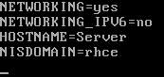

Now create a user named **nis1** and give his home directory on **/rhome** with full permission  
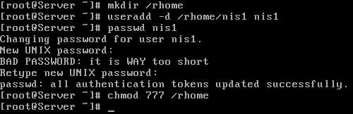

Now open **/etc/exports** file   
  
share **/rhome/nis1** directory for network  
  
save this with **:wq** and exit

now open **/var/yp/Makefile** file   
  
and locate **line number 109** [ use **ESC + : +set nu** command to show hidden lines or read our vi editor article to know more about vi command line option ]  
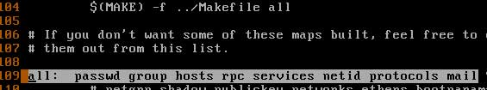  
Now remove other entry from this line excepts **passwd group hosts netid \ [as shown here]**  
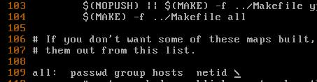  
save this with **:wq** and exit

Now restart these service

#service portmap restart

#service xinetd restart

#service nfs restart

#service ypserv restart

#service yppasswdd restart

Don't restart **ypbind** service at this time as we haven't updated our database

Now change directory to **/var/yp** and run **make** command to create database  
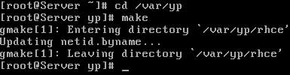

now update this database by running this commands [ first add **server** and then add all client machine one by one. After adding press **CTRL+D** to save, confirm by pressing **y**]  
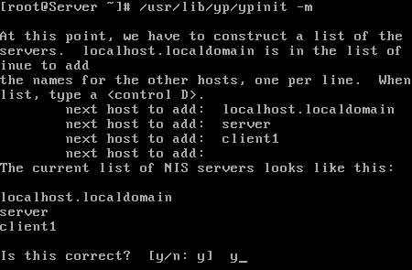

Now once again **restart** all these service this time there should be no error

#service portmap restart

#service xinetd restart

#service nfs restart

#service ypserv restart

#service yppasswdd restart

#service ypbind restart

Now set all these service to on with **chkconfig** so these could be on after restart

#chkconfig portmap on

#chkconfig xinetd on

#chkconfig nfs on

#chkconfig ypserv on

#chkconfig yppasswdd on

#chkconfig ypbind on

**Client configuration**

Before you start client configuration we suggest you to check proper connectivity between server and client. First try to login on NIS server from **telnet.** If you can successfully login via telnet then try to mount **/rhome/nis1** directory via **nfs server.** If you get any error in telnet or nfs then remove those error first. You can read our pervious article for configuration related help.

To know how configure nfs server read

[How to configure nfs server in Linux](http://computernetworkingnotes.com/network-administrations/nfs-server.html)

To know how configure telnet server read

[How to configure telnet server in Linux](http://computernetworkingnotes.com/network-administrations/telnet-server.html)

Once you successfully completed necessary test then start configuration of client sides.

Two rpm are required to configure clients **yp-tools** and **ypbind** check them for install  
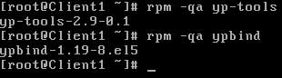

now open **/etc/sysconfig/network** file  
  
and make change as shown here  
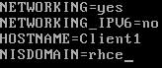  
save the file with **:wq** and exit

now run **setup** command and select **authentication configuration** from list  
**#setup**  
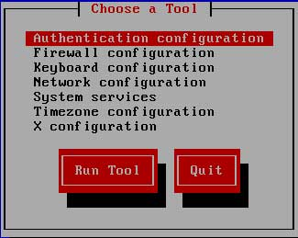  
now check mark on **NIS** and enter on next  
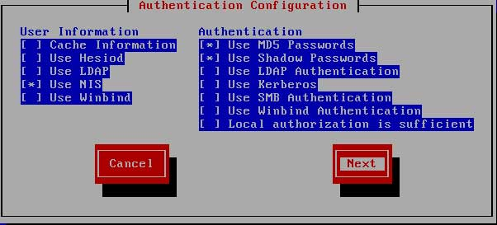  
Set domain name to **rhce** and server to **192.168.0.254** and click on ok  
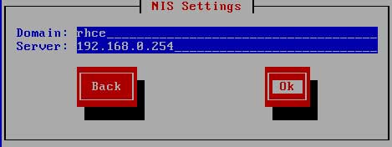  
No error should be occurred here if you see any error then check all configuration.

no open **/etc/auto.master** file   
  
in the end of file do editing of **/rhome** as shown here   
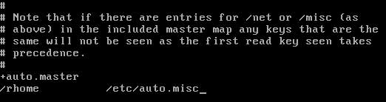  
save the file with **:wq** and exit

now open **/etc/auto.misc** file   
  
in the end of file **do editing** of user **nis1** as shown here  
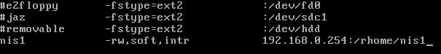  
save the file with **:wq** and exit

now restart **autofs** and **ypbind** service   
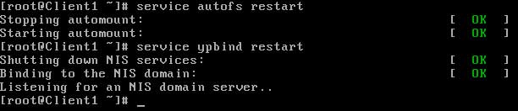

set these service **on** via **chkconfig** commands

#chkconfig autofs on

#chkconfig ypbind on

now **restart** the system

#reboot -f

login from **nis1** user on client system   
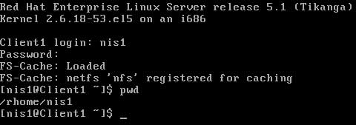

[**How to configure nfs server in Linux**](http://computernetworkingnotes.com/network-administrations/nfs-server.html)

* [](http://computernetworkingnotes.com/network-administrations/nfs-server/print.html)

NFS, or **Network File System,** is a server-client protocol for sharing files between computers on a common network. NFS enables you to mount a file system on a remote computer as if it were local to your own system. You can then directly access any of the files on that remote file system. The server and client do not have to use the same operating system. The client system just needs to be running an **NFS client** compatible with the **NFS server**.

Dear visitor this article is written for RHEL 5. We have updated version of this article for RHEL6. If you are looking for RHEL6 please check this article. [How to configure NFS Server in RHEL6.](http://computernetworkingnotes.com/network-administration/how-to-configure-nfs-server-in-rhel-6.html)

For example **NFS server** could be a Linux system and Unix could be a client. But it can’t be a window system because window is not NFS compatible. The NFS server exports one or more directories to the client systems, and the client systems mount one or more of the shared directories to local directories called mount points. After the share is mounted, all I/O operations are written back to the server, and all clients notice the change as if it occurred on the local filesystem.

A manual refresh is not needed because the client accesses the remote filesystem as if it were local.because access is granted by IP address, a username and password are not required. However, there are security risks to consider because the **NFS server** knows nothing about the users on the client system.

**Exam question 1** Some users home directory is shared from your system. Using **showmount -e** localhost command, the shared directory is not shown. Make access the shared users home directory

**Exam question 2** The System you are using is for **NFS (Network File Services).** Some important data are shared from your system. Make automatically start the nfs and portmap services at boot time

**Exam question 3** Share **/data** directory using NFS only to **192.168.0.0/24** members. These hosts should get read and write access on shared directory.

**Configure nfs server**

In this example we will configure a nfs server and will mount shared directory from client side.

For this example we are using two systems one linux server one linux clients . To complete these per quest of nfs server Follow this link

[Network configuration in Linux](http://computernetworkingnotes.com/linux-network-administrations/network-configurations.html)

* A linux server with ip address 192.168.0.254 and hostname Server
* A linux client with ip address 192.168.0.1 and hostname Client1
* Updated /etc/hosts file on both linux system
* Running portmap and xinetd services
* Firewall should be off on server

We suggest you to review that article before start configuration of nfs server. Once you have completed the necessary steps follow this guide.

Three rpm are required to configure nfs server. **nfs, portmap, xinetd** check them if not found then install  
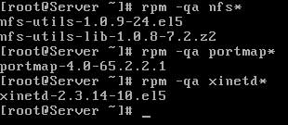

Now check **nfs, portmap, xinetd** service in system service it should be on

#setup

Select  **System service**

from list

[\*]portmap [\*]xinetd [\*]nfs

Now restart **xinetd** and **portmap** service  
  
To keep on these services after reboot on then via **chkconfig** command  
  
After **reboot** verify their status. It must be in **running** condition  


now create a **/data** directory and grant full permission to it  
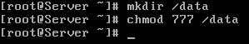

now open **/etc/exports** file   
  
share **data** folder for the network of **192.168.0.254/24** with read and write access   
  
save file with **:wq** and exit

now restart the **nfs service** and also on it with **chkconfig**   
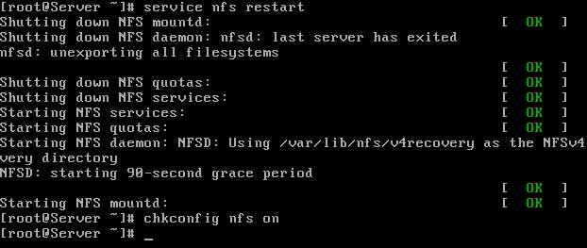  
also restart **nfs daemons** with **expotfs**   
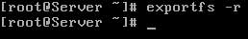

verify with **showmount** command that you have successfully shared **data folder**  
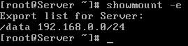

**configure client system**

ping form **nfs server** and check the **share folder**   
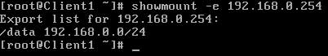

now **mount** this share folder on **mnt** mount point. To test this share folder change directory to **mnt** and create a **test file**   
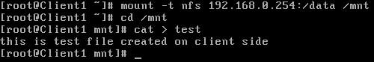

After use you should always **unmount** from **mnt** mount point  
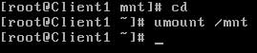

In this way you can use **shared folder**. But this share folder will be available till system is **up**. It will not be available after **reboot**. To keep it available after reboot make its entry in **fstab**

create a **mount point**, by making a directory   


now open **/etc/fstab** file   
  
make entry for **nfs** shared directory and define **/temp to mount point**

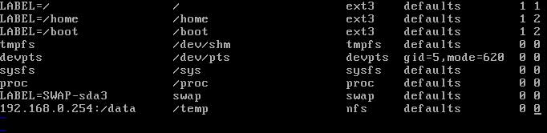

save the with **:wq** and exit reboot the system with **reboot -f** command

**#reboot -f**

after reboot check **/temp** directory it should show all the **shared data**   
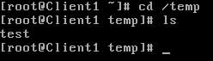

[**How to configure dhcp server in Linux**](http://computernetworkingnotes.com/network-administrations/dhcp-server.html)

* [](http://computernetworkingnotes.com/network-administrations/dhcp-server/print.html)

DHCP, or **Dynamic Host Configuration Protocol,** allows an administrator to configure network settings for all clients on a central server.

The DHCP clients request an IP address and other network settings from the **DHCP server** on the network. The **DHCP server** in turn leases the client an IP address within a given range or leases the client an IP address based on the MAC address of the client's network interface card (NIC). The information includes its IP address, along with the network's name server, gateway, and proxy addresses,including the netmask.

Nothing has to be configured manually on the local system, except to specify the **DHCP server** it should get its network configuration from. If an IP address is assigned according to the MAC address of the client's NIC, the same IP address can be leased to the client every time the client requests one. DHCP makes network administration easier and less prone to error.

**Exam Question** Configure the **DHCP server** by matching the following conditions:

* Subnet and netmask should be 192.168.0.0 255.255.255.0
* Gateway Should be 192.168.0.254
* DNS Sever Should be 192.168.0.254
* Domain Name should be example.com
* Range from 192.168.0.10-50

**Exam Question** You have **DHCP server**, which assigns the IP, gateway and DNS server ip to Clients. There is one DNS servers having MAC address **(00:50:FC:98:8D:00** in your LAN, But it always required fixed IP address **(192.168.0.10)**. Configure the **DHCP server** to assign the fixed IP address to DNS server.

**Configure dhcp server**

In this example we will configure a **dhcp server** and will lease ip address to clients.

For this example we are using three systems one linux server one linux clients and one window clients.

**dhcp** rpm is required to configure dhcp server. check it if not found then install  
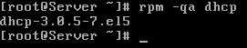

Now check **dhcpd** service in system service it should be on

#setup

Select  **System service**

from list [\*]dhcpd

**To assign IP to dhcp server**

**DHCP server** have a static a ip address. First configure the ip address **192.168.0.254** with netmask of **255.255.255.0** on server.

Run **setup** command form root user

#setup



this will launch a new window select **network configuration**

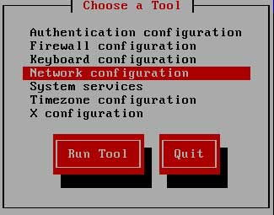

now a new window will show you all available LAN card select your LAN card ( if you don't see any LAN card here mean you don't have install driver)

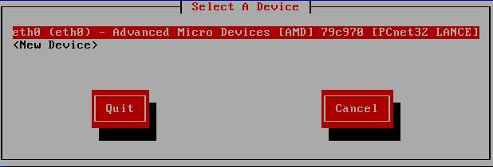

assign IP in this box and click ok

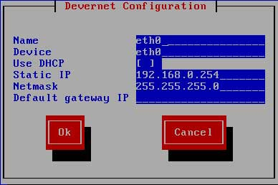

click on ok, quit and again quit to come back on root prompt.

**restart** the **network service** so new ip address can take place on LAN card

#service network restart

main configuration file of dhcp server is **dhcpd.conf.** This file located on **/etc** directory. If this file is not present there or you have corrupted this file, then copy new file first, if ask for overwrite press **y**



now open **/etc/dhcpd.conf**  
  
default entry in this file look like this   
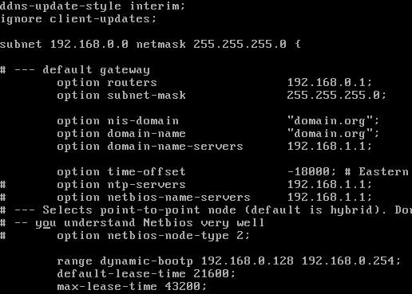  
make **these change** in this file to configure **dhcp server**

remove this line # - - - default gateway

set option routers to 192.168.0.254

set option subnet-mask to 255.255.255.0

option nis domain to example.com

option domain-name to example.com

option domain-name-servers to 192.168.0.254

range dynamic-bootp to 192.168.0.10 192.168.0.50;

**After change** this file should look like this   
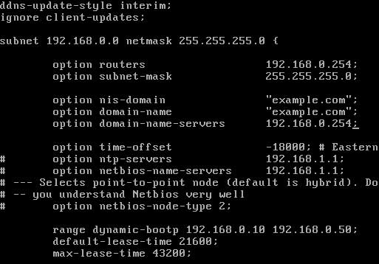

**how to assign fix ip address to any host**

locate this paragraph and change **hardware Ethernet** to client's **mac address** and **fixed -address** to **ip address** which you want to provide that host  
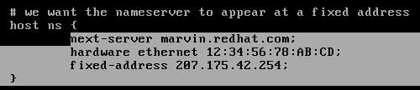  
after making necessary change **save** file and exit

now create a **blank file** use to store the allocated **ip address information**   


Now **restart dhcpd service** and on it with **chkconfig** commands

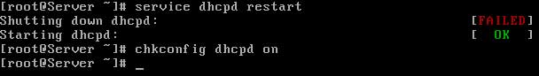

**Linux Client configuration**

Client configuration is very easy and straightforward. All you need to do is set ip address to dynamic in the properties of lan card. In linux

#setup

select  **network configuration** from menu list

Select  **lan card** and enter on ok

Select  **USE DHCP** and enter on ok

Now click on  **quit**

and  **quit** to come back on root prompt

Now restart the **network service** to obtain ip from **dhcp server**

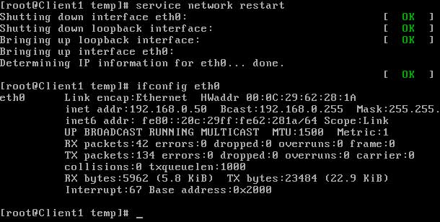

**Window Client configuration**

To configure windows system as **dhcp clients** open lan card **properties** and select **tcp/ip** and click on properties and set **obtain ip address automatically**  
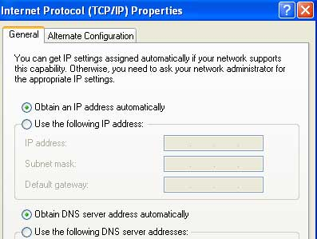

Go on **command prompt** and check new **ip address**   
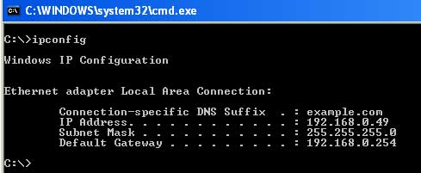

**Check lease on DHCP server**

you can check **allocated address** on server.  
  
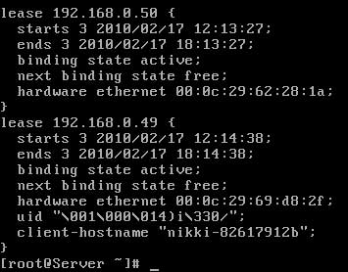

[**How to configure web server in Linux**](http://computernetworkingnotes.com/network-administrations/web-server.html)

* [](http://computernetworkingnotes.com/network-administrations/web-server/print.html)

When you view a web page over the Internet, the code to create that page must be retrieved from a server somewhere on the Internet. The server that sends your web browser the code to display a web page is called a web server. There are countless web servers all over the Internet serving countless websites to people all over the world. Whether you need a web server to host a website on the Internet a Red Hat Enterprise Linux server can function as a web server using the **Apache HTTP server**. The Apache HTTP server is a popular, open source server application that runs on many UNIX-based systems as well as Microsoft Windows.

Dear visitor this article is written for RHEL 5. We have updated version of this article for RHEL6 with video tutorial. If you are looking for RHEL6 please check this article. [How to configure Web Server in RHEL6.](http://computernetworkingnotes.com/network-administration/how-to-configure-apache-server-in-linux.html)

**Exam question 1** There are two sites **www.vinita.com** and **www.nikita.com.** Both sites are mappings to 192.168.0.X IP address where X is your Host address. Configure the Apache web server for these sites to make accessible on web

**Configure web server**

In this example we will configure a **web server.**

necessary rpm for web server is **httpd, httpd-devel** and **apr** check them for install



Now configure the ip address to **192.168.0.254** and check it   


start **httpd daemons** and verify its running **status**   


**Configure virtual hosting**

In this example we will host a website **www.vinita.com** to apache web server. create a **documents root** directory for this website and a **index page**   
  
for testing purpose we are writing **site name** in its **index page**   
  
**save** file and **exit**

now open **/etc/hosts** file   
  
in the **end of file** bind system **ip** with **www.vinita.com**  


now open **/etc/httpd/conf/httpd.conf** main configuration file of **apache server**   
  
locate **virtual host** tag   
  
remove **#** from the beginning and add the **IP of host**   
  
Now go in the end of file and copy last seven line [ virtual host tag ] and paste them in the end of file. **change these seven lines as shown in image**   
  
now **save** this file and exit from it

you have done necessary configuration now **restart the httpd service** and test this configuration run **links** command   


if **links** command retrieve your **home page**  
  
means you have successfully configured the **virtual host** now test it with **site name**   
  
In output of **links** command you should see the **index page** of site   


**Configure multiple site with same ip address**

At this point you have configured one site **www.vinita.com** with the ip address **192.168.0.254.** Now we will configure one more site **www.nikita.com** with **same** ip address

create a **documents root** directory for **www.nikita.com** website and a **index page**  
  
for testing purpose we are writing **site name** in its **index page**   
  
**save** file and exit

now open **/etc/hosts** file and bind **system ip** with **www.nikita.com**  


now open **/etc/httpd/conf/httpd.conf** main configuration file of apache server   
  
Now go in the end of file and copy last seven line [ virtual host tag ] and paste them in the end of file. **change these seven lines as shown in image**   
  
now **save** this file and exit from it

you have done necessary configuration now restart the **httpd service**   
  
test this configuration run **links** command  
  
In output of **links command** you should see the **index page** of site

**configure multiple site with multiple ip address**

Now we will host multiple sites with multiple ip address. Create a virtual lan card on server and assign its an ip address of **192.168.0.253.** we will create a testing site **www.nidhi.com** and will bind it with ip address of **192.168.0.253**

create a **documents root** directory for **www.nidhi.com** website and a index page  
  
for testing purpose we are writing **site name** in its **index page**   
  
**save** file and exit

now open **/etc/hosts** file and bind **system ip** with **www.nidhi.com**  


now open **/etc/httpd/conf/httpd.conf** main configuration file of apache server   
  
Now go in the end of file and copy last seven line [ virtual host tag ] and paste them in the end of file. **change these seven lines as shown in image**   
  
now **save** this file and exit from it

you have done necessary configuration now restart the **httpd service**   
  
test this configuration run **links** command  
  
In output of **links** command you should see the **index page** of site

**How to create site alias**

Now I will show you that how can you use **site alias** to configure more name of same site. we configure a site **www.vinita.com** in stating of example. now we will create **www.goswami.com** site alias for this site so this site can be access with both name.

To create **alias** first make its entry in **/etc/hosts** file as shown here   


Now open main apache configuration **/etc/httpd/conf/httpd.conf**  
  
Now go in the end of file and copy last seven line [ virtual host tag ] and paste them in the end of file. **change these seven lines as shown in image**   
  
now **save** this file and exit from it

you have done necessary configuration now restart the **httpd service** and test this configuration run **links** command  
  
In output of **links** command you should see the **index page** of site   


[**How to configure samba server in Linux**](http://computernetworkingnotes.com/network-administrations/samba-server.html)

* [](http://computernetworkingnotes.com/network-administrations/samba-server/print.html)

Most Linux systems are the part of networks that also run Windows systems. Using Linux **Samba servers**, your Linux and Windows systems can share directories and printers. This is most use full situation where your clients are window native and you want to use the linux security features.

**Exam question** There are mixed lots of System running on Linux and Windows OS. Some users are working on Windows Operating System. There is a **/data** directory on linux server should make available on windows to only vinita should have right to connect with samba server . Configure to make available.

**Configure samba server**

In this example we will configure a **samba** server and will transfer files from client side.For this example we are using two systems one linux server one window clients.

per quest of samba server

* A linux server with ip address 192.168.0.254 and hostname Server
* A window client with ip address 192.168.0.2 and hostname Client2
* Updated /etc/hosts file on linux system
* Running portmap and xinetd services
* Firewall should be off on server

We have configured all these steps in our pervious article.

We suggest you to review that article before start configuration of samba server. Once you have completed the necessary steps follow this guide.

**samba** rpm is required to configure samba server. check them if not found then install  
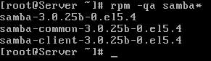

Now check **smb, portmap, xinetd** service in system service it should be on

#setup Select  **System service** from list

[\*]portmap

[\*]xinetd

[\*]smb

Now restart **xinetd** and **portmap** and **smb** service  
  
To keep on these services after reboot on then via **chkconfig** command  
  
After reboot verify their status. It must be in running condition  


Create a normal user named **vinita**   
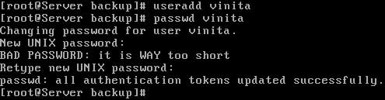

now create **/data** directory and grant it **full permission**   
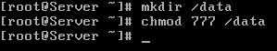

open **/etc/samba/smb.conf** main samba configuration files   
  
By default name of workgroup is **MYGROUP** in **smb.conf** file. you can change it with desire name   
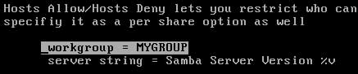  
our task is to share **data** folder for **vinita** user so go in the end of file and do editing as shown here in this image   
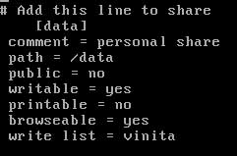  
save file with **:wq** and exit

Now add vinita user to **samba user**  
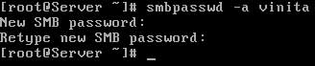  
we have made necessary change now on **smb service** and check it status   
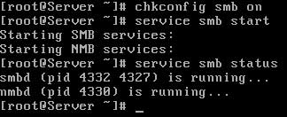  
if you already have on this service then restart it with **service smb restart** commands.

**Client configuration for samba server**

Go on windows system and **ping** samba server, change computer name to **client2** and workgroup name to **MYGROUP**   
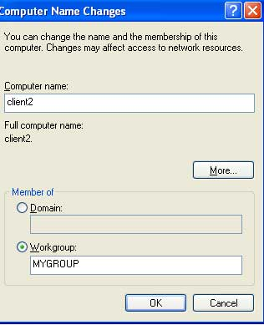  
**reboot** system after changing workgroup name

After reboot open my network place here you can see **samba server** [ if not see then click on view workgroup computer in right pane, if still not see then use search button from tool bar and search computer samba server form ip ]  
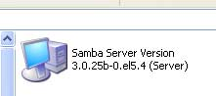  
First try to login from user **nikita** she will not successes as nikita have not permission to login   
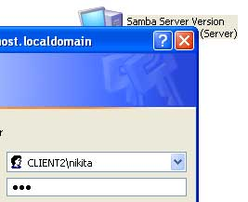  
Now login from user **vinita** [ give the password which you set with **smbpasswd** command ]

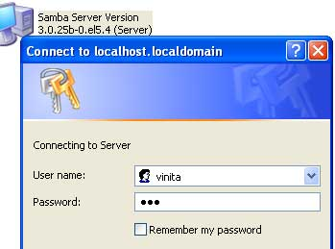

As you can see in image user vinita gets the **/data** folder which we share from **samba server**   
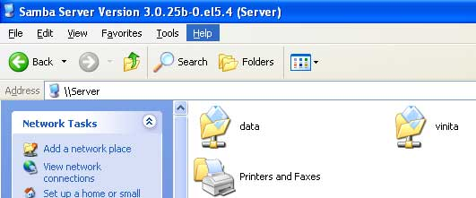  
Copy some window files in **data** folder   
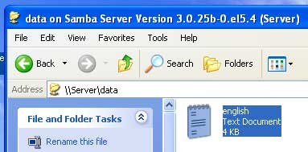

**Check status on samba server**

on **samba server** you can check runtime status of samba server to check it run **smbstatus** command   
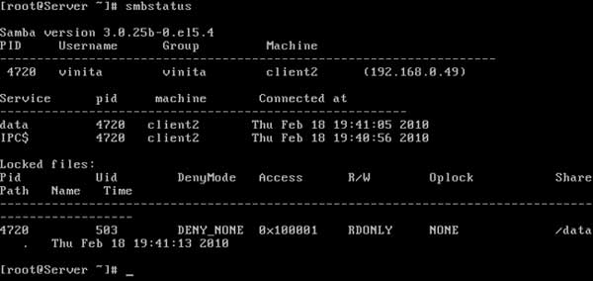  
in output you see that one **samba shared directory** is used on window system

[**How to configure vnc server in Linux**](http://computernetworkingnotes.com/network-administrations/vnc-server.html)

* [](http://computernetworkingnotes.com/network-administrations/vnc-server/print.html)

**VNC server** is a used to share desktop with remote computer. VNC works on client server architecture. To share desktop you need **vnc-server** package and to access from other computers you need vnc-viewer. In this tutorials I will show you how to configure **vnc server**.

For demonstration purpose we will use two linux systems. Both systems should have graphics installed.

**To configure VNC- Server**

Boot system in init 5 or graphic mode. **vnc-server** rpm is required to configure server check it if not found install it.  
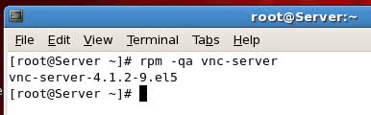

now click on **preferences** from system and select **remote desktop**   
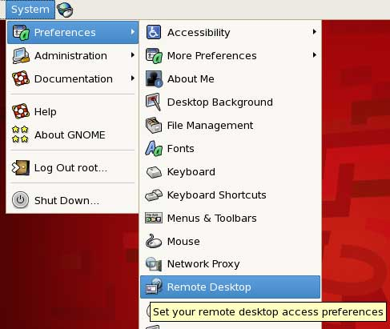  
This will launch a new window where you can set **sharing and security** for remote desktop  
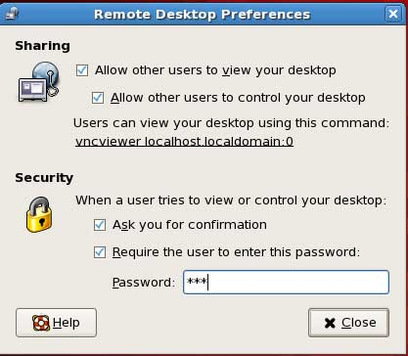  
**Allow other users to view your desktop** check this option if you to present your desktop on other computer  
**Allow other users to control your desktop** Check this options if you want to grant permission to control user desktop to other user  
In security tab you can **set password** for the user who want to connect with server **[Recommended]**

**Configure Linux client**

Go on client system and **ping** server. **vnc-viewer** rpm is required to configure clients   
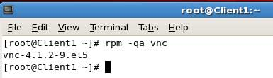  
check it and if not found install

Now select **accessories** from application menu and click on **vnc viewer**

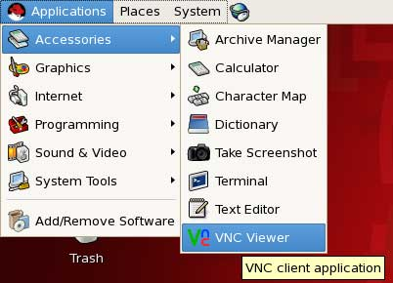

this will launch a window Give **vnc server ip** in it and click on **ok**  
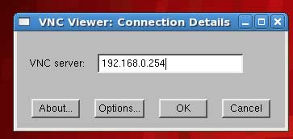

Once connected it will ask for **password** Give the password which you set on **server**   
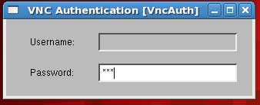

On **server side** it will show a pop up and ask for permission click on **allow**  
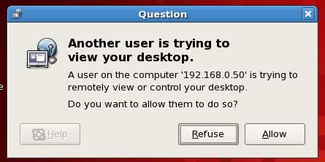

After getting permission from server side you can use **server desktop** on client side   
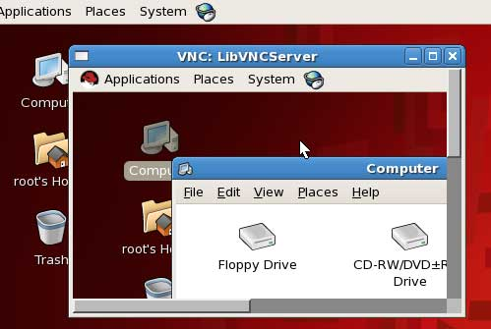

[**How to configure printer server in Linux**](http://computernetworkingnotes.com/network-administrations/printer-server.html)

* [](http://computernetworkingnotes.com/network-administrations/printer-server/print.html)

Linux uses the **Common UNIX Printing System**, also known as CUPS. **CUPS** uses the Internet Printing Protocol (IPP) to allow local printing and print sharing. The **/etc/cups/** directory stores all the configuration files for printing. However, these files can be easily managed with the Printer Configuration Tool in Linux.

**Exam question** Raw (Model) printer named printer1 is installed and shared on 192.168.0.254. You should install the shared printer on your PC to connect shared printer using IPP Protocols.

**Exam question** Raw printer named printerx where x is your station number is installed and shared on server1.example.com. Install the shared printer on your PC to connect shared printer using IPP Protocols. Your server is 192.168.0.254.

Before you can use any printer, you first have to install it on a Linux system on your network. To start the Printer Configuration Tool, go to the **System menu** on the top panel and select **Administration**, Printing or execute the command **system-config-printer**.

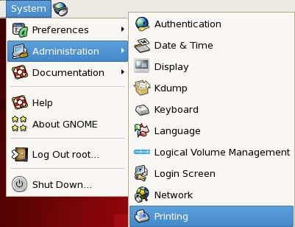

If no printers are available for the system, only the **Server Settings** view is available for selection. If local printers are configured, a **Local Printers** menu will available.

**Install new printer**

click **New Printer** on the toolbar.  
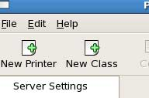  
In the dialog window that appears, accept the **default queue name** or change it to a short, descriptive name that begins with a letter and does not contain spaces. Then select **printer** from list and click on **forward** and click on **finsh**.

**spool directories**  
When your system prints a file, it makes use of special directories called **spool directories.** The location of the spool directory is obtained from the printer's entry in its configuration file. On Linux, the spool directory is located at **/var/spool/cups** under a directory with the name of the printer.

**print job**  
A print job is a file to be printed. When you send a file to a printer, a copy of it is made and placed in a spool directory set up for that printer.

**classes**  
CUPS features a way to let you select a group of printers to print a job instead of selecting just one. That way, if one printer is busy or down, another printer can be automatically selected to perform the job. Such groupings of printers are called **classes**. Once you have installed your printers, you can group them into different classes.

Once you have successfully installed local printer it will show in right pane. and in left pane you can see all **administrative options.**  
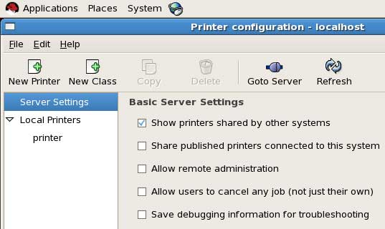

* To **view shared printer** on other system Tick mark on first option
* To **share** locally attached printer tick mark on second option
* To **allow remote administration** of this printer check mark on third option

Tick mark on appropriate option and click on **apply**  
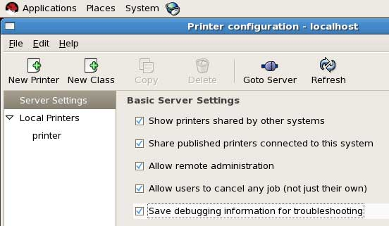

**configure window clients**

Go on window system and **ping** from printer server and open **internet explorer** and give the **ip address** of server with printer port **631**   
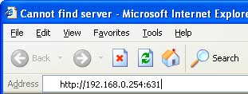

This will launch **CUPS web application** click on **manage printer**   
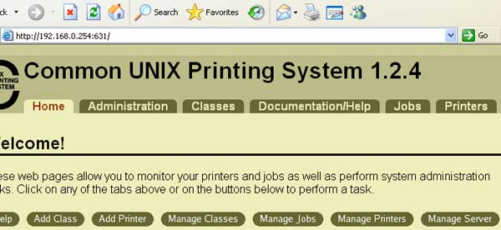

now you will see the **shared printer** on server click on print **test page**   
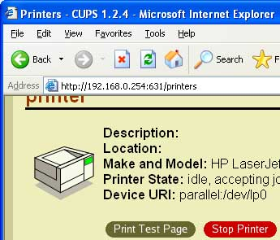  
A test page will be send on printer server copy this **url of printer**   
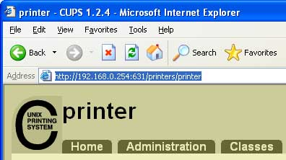

click on **start** button select **printer and fax** and click on **add new printer**. this will launch add new printer wizard click **next** on welcome screen and select **network printer**  
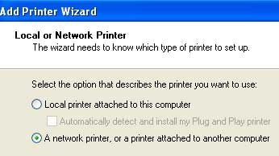  
On this screen select **internet printer** and **paste the url** which you copied from **internet explorer**   
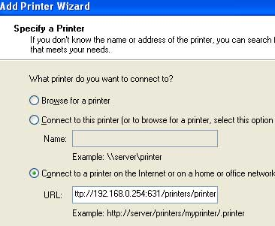  
Install appropriate driver from list or use have disk option you have drive cd and click next. On next screen set this printer **defaults** and click on next and **finish**.   
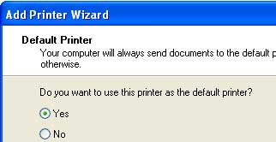

**Remote administration of print server**

Go on linux system and **ping** from server and click on **printing** from **administration menu**  
  
Now click on **go to server**   
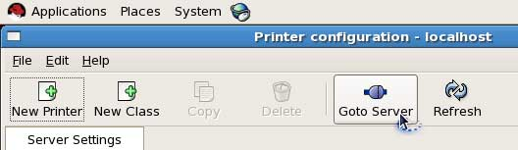  
Now give print server **ip address**   
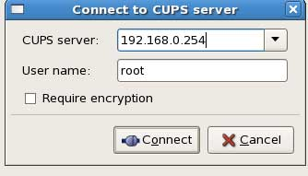  
It will take few minute to connect from server depending on network speed  
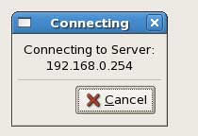  
Now give **root password** to connect printer server   
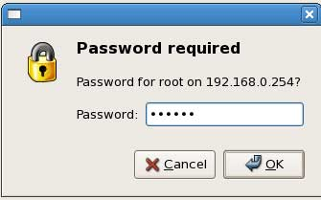  
you can see all **print administrative Manu** in right pane Once you have connected with sever   
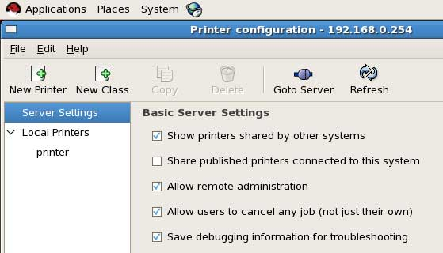

**configure Linux clients**

Go on linux system and **ping** from server and click on printing from **administration menu**  
  
Now click on **new printer**   
  
Click on forward In the next New Printer screen, select the type of connection to **internet printing protocols** and in hostname give **server ip** and printer name in **printername**   
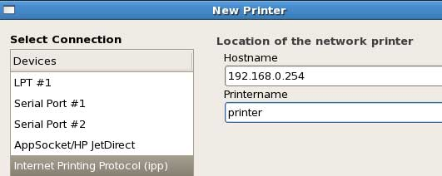  
select the appropriate model. If multiple drivers are available, select the one most appropriate for your configuration. If you do not want to choose the **default** and click forward and finish. The main Printer Configuration window should now include the name of your printer.  
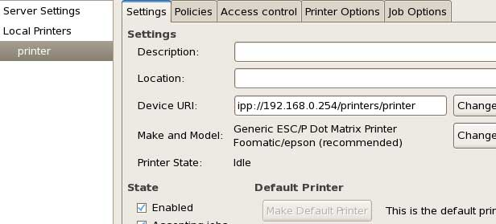  
To print test page click on **print test page** and a test page will send to print server   
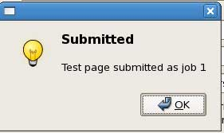

**Managing Printers from the Command-Line**

The **lpadmin** command enables you to perform most printer administration tasks from the command-line.

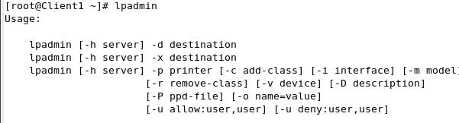

*lpc* To view all known queues  
 *lpr* To send print requests to any local print queue   
 *lpq* To see the print queue  *lprm* To delete the jobs of your choice use it with the job number  *lp* To print any file.

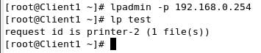

[**How to configure dns server in Linux**](http://computernetworkingnotes.com/network-administrations/dns-server.html)

* [](http://computernetworkingnotes.com/network-administrations/dns-server/print.html)

A DNS server, or name server, is used to resolve an IP address to a hostname or vice versa.  
You can set up four different types of DNS servers:

* A **master DNS server for your domain(s),** which stores authoritative records for your domain.
* A **slave DNS server,** which relies on a master DNS server for data.
* A **caching-only DNS server,** which stores recent requests like a proxy server. It otherwise refers to other DNS servers.
* A **forwarding-only DNS server,** which refers all requests to other DNS servers.

Before configuring BIND to create a DNS server, you must understand some basic DNS concepts.

The entire hostname with its domain such as ***server.example.com*** is called a fully qualified domain name (FQDN). The right-most part of the FQDN such as .com or .net is called the ***top level domain,*** with the remaining parts of the FQDN, which are separated by periods, being sub-domains.

These sub-domains are used to divide FQDNs into zones, with the DNS information for each zone being maintained by at least one ***authoritative name server.***

The authoritative server that contains the master zone file, which can be modified to update DNS information about the zone, is called the ***primary master server,*** or just ***master server.***

The additional name servers for the zone are called ***secondary servers*** or ***slave servers.*** Secondary servers retrieve information about the zone through a zone transfer from the master server or from another secondary server. DNS information about a zone is never modified directly on the secondary server

**chroot features**

chroot feature is run named as user **named**, and it also limit the files named can see. When installed, **named** is fooled into thinking that the directory ***/var/named/chroot*** is actually the **root or /** directory. Therefore, named files normally found in the **/etc** directory are found in **/var/named/chroot/etc** directory instead, and those you would expect to find in **/var/named** are actually located in **/var/named/chroot/var/named.**

The advantage of the chroot feature is that if a hacker enters your system via a BIND exploit, the hacker's access to the rest of your system is isolated to the files under the chroot directory and nothing else. This type of security is also known as a chroot jail.

**Configure dns server**

In this example we will configure a dns server and will test from client side.

For this example we are using three systems one linux server one linux clients and one window clients.

**bind** and **caching-nameserver** rpm is required to configure dns. check them for install if not found install them.  
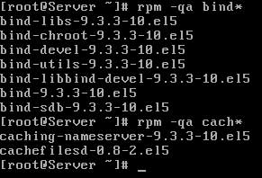  
set hostname to **server.example.com** and ip address to **192.168.0.254**  
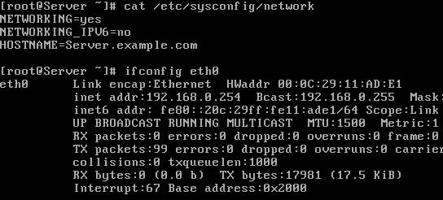

main configuration file for dns server is **named.conf.** By default this file is not created in **/var/named/chroot/etc/** directory. Instead of named.conf a sample file **/var/named/chroot/etc/named.caching-nameserver.conf** is created. This file is use to make a caching only name server. You can also do editing in this file after changing its name to **named.conf** to configure master dns server or you can manually create a new **named.conf** file.

In our example we are creating a new named.conf file   


We are using bind's **chroot** features so all our necessary files will be located in chroot directory. Set directory location to **/var/named.** Further we will set the location of **forward zone** and **reverse lookup zone** files. If you cannot create this file manually then download this file and copy to **/var/named/chroot/etc/**

[To download do right click here and choose save link As..   
named.conf](http://computernetworkingnotes.com/images/rhce_certification/image/named.conf)

Or do editing exactly as shown here in image   
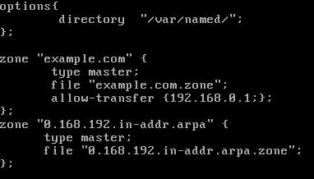  
save this file with **:wq** and exit

**Configure zone file**

We have defined two zone files **example.com.zone** for forward zone and **0.168.192.in-addr.arpa** for reverse zone. These files will be store in **/var/named/chroot/var/named/** location. We will use two sample files for creating these files.

Change directory to **/var/named/chroot/var/named** and copy the sample files to name which we have set in named.conf  
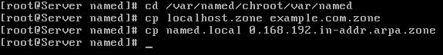

Now open forward zone file **example.com.zone**  
  
By default this file will look like this   
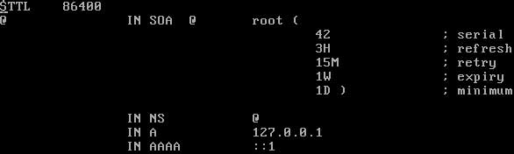  
Change this file exactly as shown in image below  
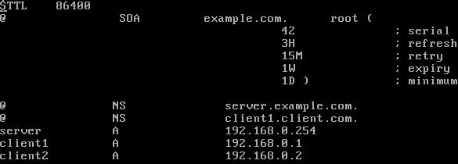  
If you feel difficulty to modify this file then download this configured file and copy to **/var/named/chroot/var/named**

[To download do right click here and choose save link As..   
example.com.zone](http://computernetworkingnotes.com/images/rhce_certification/image/example.com.zone)

Now open reverse lookup zone file **0.168.192.in-addr.arpa**   
  
By default this file will look like this   
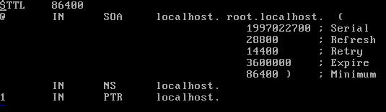  
Change this file exactly as shown in image below  
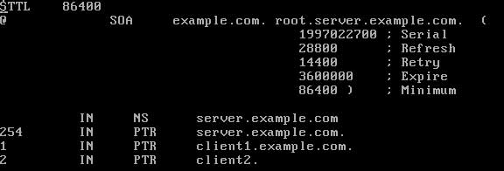  
If you feel difficulty to modify this file then download this configured file and copy to **/var/named/chroot/var/named**

[To download do right click here and choose save link As..   
0.168.192.in-addr.arpa](http://computernetworkingnotes.com/images/rhce_certification/image/0.168.192.in-addr.arpa.zone)

Now changed the ownership of these zone files to **named** group   


Now start the named service   
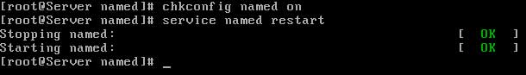

If service restart without any error means you have successfully configured master name server in our next article we will learn how to configure salve dns server and test it.

[**How to configure dns slave server in Linux**](http://computernetworkingnotes.com/network-administrations/dns-slave-server.html)

* [](http://computernetworkingnotes.com/network-administrations/dns-slave-server/print.html)

A DNS server, or name server, is used to resolve an IP address to a hostname or vice versa.  
You can set up four different types of DNS servers:

* A **master DNS server for your domain(s),** which stores authoritative records for your domain.
* A **slave DNS server,** which relies on a master DNS server for data.
* A **caching-only DNS server,** which stores recent requests like a proxy server. It otherwise refers to other DNS servers.
* A **forwarding-only DNS server,** which refers all requests to other DNS servers.

In our pervious article we have configured **Master dns server**. In this tutorial we will extended pervious article and configure **salve dns server.** This article is the second part of How to configure dns server step by step guide. We suggest you to review pervious article before starting it.

**Configure dns slave server**

For this example we are using three systems one linux server one linux clients and one window clients.

We have configured master DNS server with ip address of **192.168.0.254** and hostname **server.example.com** on linux server. Now we will configure **slave DNS server** on linux clients

To configure slave DNS server go on client1 system.

First test connectivity from dns server by ping commands and check necessary rpm. **bind** and **caching-nameserver** rpm is required to configure dns. check them for install if not found install them.  
  
set hostname to **client1** and ip address to **192.168.0.1** And create a new **named.conf** file  


We are using bind's **chroot** features so all our necessary files will be located in chroot directory. Set directory location to **/var/named.** As we are configuring **slave server** so we need not to define the location of zone database files. Zone database file can be created and modified only on master server. A **slave server** only copied it's from master server.

Do editing exactly as shown here in image in **named.conf**   
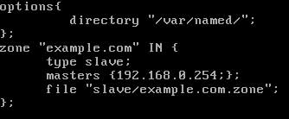  
save this file with **:wq** and exit

If you cannot create this file manually then download this pre configured file and copy to **/var/named/chroot/etc/named.conf**

[To download do right click here and choose save link As..   
named.conf](http://computernetworkingnotes.com/images/rhce_certification/image/named.conf1)

Now restart the named service. It should be start without any error.  
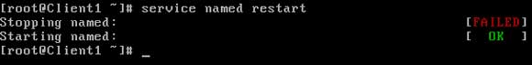

**Congratulation** you have configured both Master and client DNS server. Now we will configure dns client and test it with dns server.

**Configure Window DNS Client**

Now go on windows xp system and test connectivity from DNS server. And set **DNS ip address** in LAN card properties.

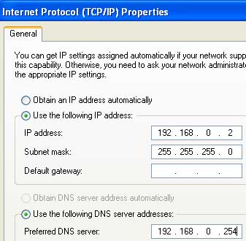

Now go on **commands prompt** and ping from other client by name to test **dns**.   
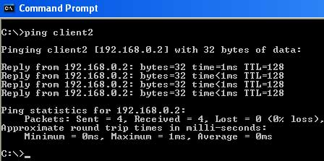  
Alternately You can also verify **DNS server** by **nslookup** command  
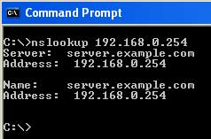  
Test also by **pinging server** from name   
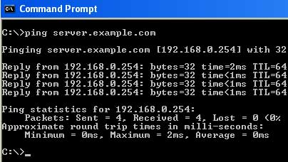

**Configure Linux DNS clients**

**RHCE Exam question   
Dig Server.example.com, Resolve to successfully through DNS Where DNS server is 192.168.0.254.**

**RHCE Exam question2**

**Your System is configured in 192.168.0.0/24 Network and your nameserver is 192.168.0.254. Make successfully resolve to server.example.com.**

On command line interface you don't have any options to set DNS ip in network configuration window. IP of DNS server can be set from **/etc/resolv.conf** file. Each nameserver line represents a DNS server, and the search line specifies domain names to try if only the first part of a hostname is used. For example, if just the name client1 is used as a hostname, **client1. example.com** will also be tried if the /etc/resolv.conf file is configured as shown in image below on the system.

To set DNS ip open **/etc/resolv.conf** file   
  
set **nameserver** ip to **192.168.0.254** and **search** option to **example.com**  
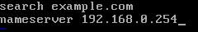  
After saving **/etc/resolv.conf** file restart the network service   
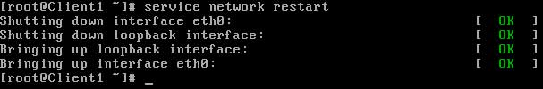

dig **server.example.com** to test dns server   
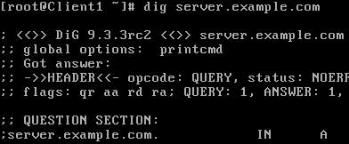  
now verify by pinging to other client from name   
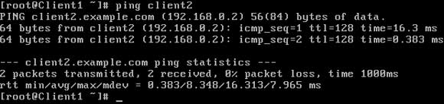

[**How to configure squid server in Linux**](http://computernetworkingnotes.com/network-administrations/squid-server.html)

* [](http://computernetworkingnotes.com/network-administrations/squid-server/print.html)

Proxy servers operate as an intermediary between a local network and Internet. Requests from local clients for web services can be handled by the proxy server. Squid is a high-performance HTTP and FTP caching proxy server. It is also known as a Web proxy cache. As it stores data from frequently used Web pages and files, it can often give your users the data they need without their systems having to look to the Internet.

From squid web proxy server you can control what should be access on your network from internet. It could be act as a filter that could filter everything from porn site to advertise , videos.

In our example we will configure squid web proxy server and filter sites and deny permission to specific host from accessing internet.

**Configure squid web proxy server**

**squid** rpm is required to configure squid web proxy server check it for install if not found install it.  
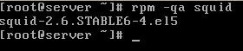  
check the hostname and ip address of server it will be use in editing of squid.conf  
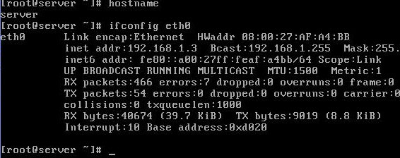

Main Squid configuration file is squid.conf in the /etc/squid/ directory. This file contains over 4000 lines in , but only a few are active by default. Most of this file is filled with comments that describe most directives and associated options. To make editing easier use show line numbers options and locate desire tag from line number. We suggest you not to cram line number use them only to locate the desire tag as a simple enter can change the number of all lines in file.

open /etc/squid/squid.conf for editing  
  
show hidden line with : set nu option on vi command mode

You need to add three lines to the squid.conf file in the /etc/squid/ directory before activating Squid

First editing is about hostname locate visible\_hostname tag near about line no 2835  
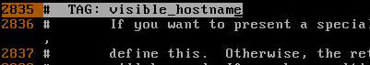  
Go in the end of this tag near about line no and add the hostname which you have checked in pervious command  
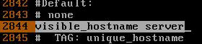

By default squid works on port no 3128 but can change this. Port tag is located near line no 73  
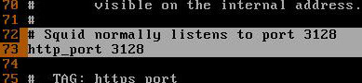  
For our example we using the default port.

Next editing is to create access control list. Access control tag is located near the line no 2226  
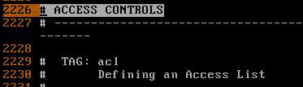

We will create three access list.

* First to block host with ip address 192.168.1.7 from accessing internet.
* Second to block a particular site.
* Third to allow our lab network for accessing internet.

Go in the end of access control tag near about line 2410 and create access list as show here  
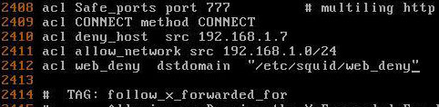

Final editing is to implement whatever access list you have configured in access list tag go to http access tag near line no 2482   
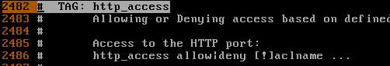  
In the end of this tag near line no 2529 apply the configured access list   
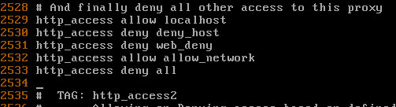

Be very careful about the order of access list alway put http\_access deny all line in the end of all line. Whatever access list defined below the http\_access deny all line will never be checked.

You have made necessary changed in squid.conf now save it and return to command prompt.

We have created a access list web\_deny to filter the web traffic. We have set http\_access deny web\_deny tag in squid.conf. Now you can add the url of those websites in this file which you want block.

Now create /etc/squid/web\_deny file.  
  
for testing purpose in our example we are blocking www.google.com   
  
you can add any sites url in this file which you want to block.

You have completed all necessary steps now start the squid service.  
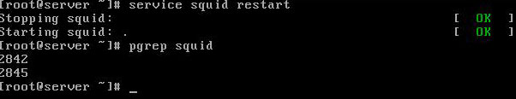

**Squid client configuration**

On client set the ip configuration. Set proxy servers ip 192.168.1.3 to default getway and dns server ip on client system.

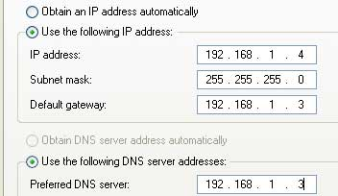

Now open the web browser and set the port number and ip address of proxy server in connection tab  
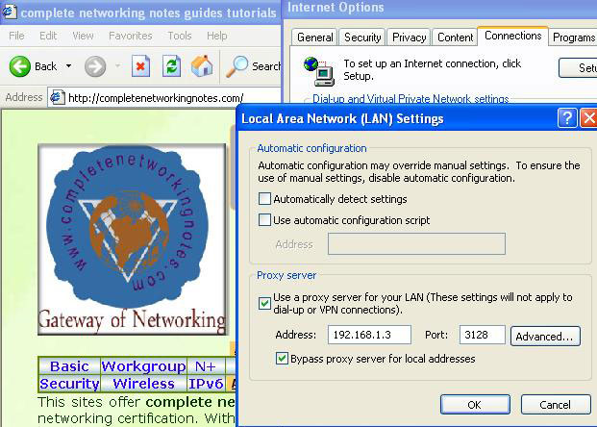  
If you can successful retrieve website mean squid is working correctly   
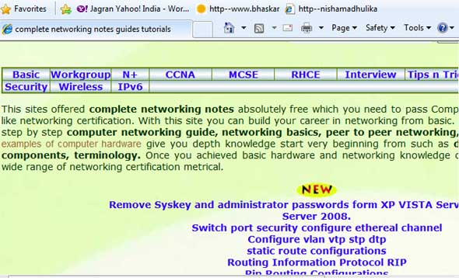

Now try to open www.google.com   
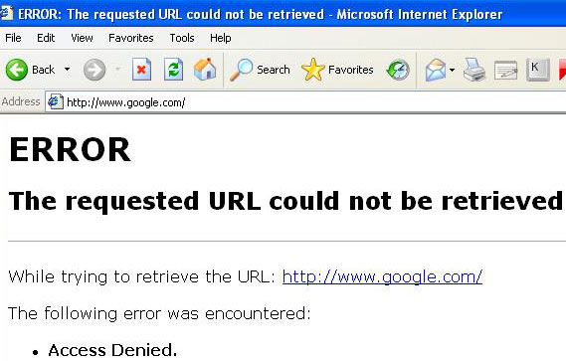

Now go system which ip address is 192.168.1.7 and try to access after doing same setting   
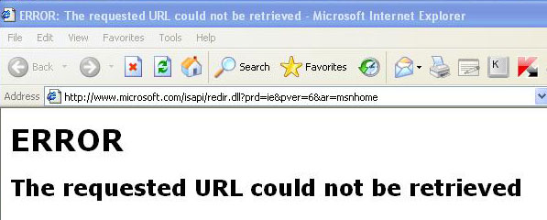

[**How to configure sendmail server in Linux**](http://computernetworkingnotes.com/network-administrations/sendmail-server.html)

* [](http://computernetworkingnotes.com/network-administrations/sendmail-server/print.html)

In a company environment, email is an essential component to the work day. Email is used to communicate with both internal employees and external customers. In exam you will be tested to configure the **send mail server** for you local LAN.

By default sendmail server allows to connect to local host only. So we should edit the **/etc/mail/sendmail.mc** file to allow connect to other hosts.

The **sendmail** daemon is configured from a directory of files in /etc/mail and a directory of configuration files in **/usr/share/sendmail-cf**. There are two basic configuration files:

* **sendmail.cf** The main sendmail configuration file.
* **sendmail.mc** A macro that's easier to edit, which can be used to generate a new **sendmail.cf** file.

For this example we are using two systems one linux server one linux clients. These are the pre quest for a sendmail server

* A linux server with ip address 192.168.0.254 and hostname Server
* A linux client with ip address 192.168.0.1 and hostname Client1
* A Configured DNS server on Linux server
* Updated /etc/hosts file on both linux system
* Running portmap and xinetd services
* Firewall should be off on server

We suggest you to review that article and configure DNS server before start configuration of **sendmail server.** Once you have completed the necessary steps follow this guide.

**Configure sendmail server**

**sendmail** and **m4** rpm are required to configure sendmail server check them for install if not found install them.  
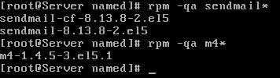

Mail server program reads the **/etc/mail/sendmail.cf**. To change the configuration on mail server, we should edit the **/etc/mail/sendmail.mc** file. When Sendmail is started or restarted with the **service sendmail restart** command a new **sendmail.cf** file is automatically generated if **sendmail.mc** has been modified. In exam you should generate it with **m4** command.

open **/etc/mail/sendmail.mc** for editing  
  
show hidden line with **: set nu** option on vi command mode

By default, the following line limits sendmail access to connect local host only **[line no 116]**   
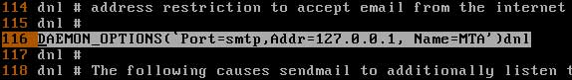  
You can allow other computers to use your **sendmail server** by commenting out this line.

In the **sendmail.mc** file , lines that begin with **dnl**, which stands for delete to new line, are considered comments. Some lines end with dnl, but lines ending in dnl are not comments

comment this line with **dnl** keyword followed by **#** sign  
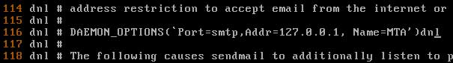  
save this file with **:wq** and exit.

Now generate new **sendmail.cf** file by using **m4** command as shown here   


Now restart **sendmail service** and also set it on with **chkconfig**   
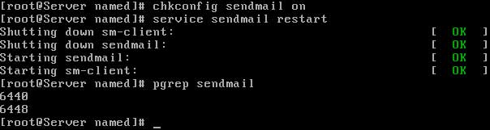  
if **sendmail service** restart without any error means you have configured **sendmail** successfully.

**Configure sendmail client side**

We are using another linux system to test **sendmail server**. All configuration are same as you have done on server system.

Check **sendmail** and **m4** rpm for install. Open **/etc/mail/sendmail.mc** file and locate **line no 116** and put a **dnl** with **#** sing and save file. All step are same which you have done on server.

Now generate new **sendmail.cf** file by using **m4** command as shown here   


Now restart **sendmail service** and also set it on with **chkconfig**   
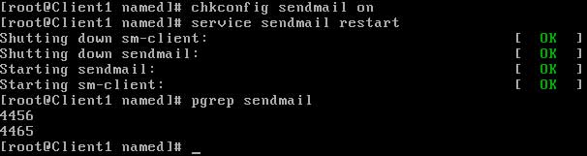

**Testing of sendmail server**

We will test **sendmail server**by sending and receiving mail in lab environment. for this we use two user one on each system.

Now create one user on each system **vinita** on server  
  
and nikita on **client system**   
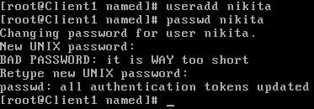

Now send mail from user vinita to nikita and from nikita to user vinita and also check each others mail by **mail command**

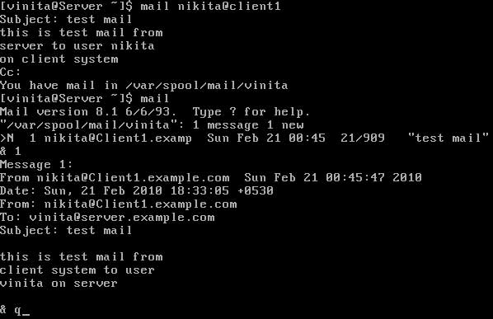

Use full user name to send mail. For example to send mail to nikita use **nikita@client1**

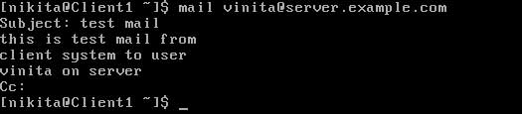  
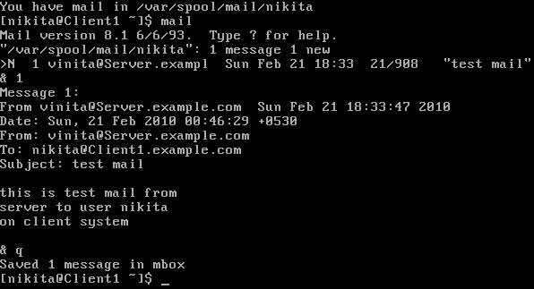

[**Configure linux yum server step by step guide example and implementation**](http://computernetworkingnotes.com/network-administrations/yum-server.html)

* [](http://computernetworkingnotes.com/network-administrations/yum-server/print.html)

**YUM** stands for **Yellow dog Updater, Modified** because it is based on **YUP**, the **Yellow dog Updater.** Yellow Dog is a version of Linux for the Power Architecture hardware. YUP, and later YUM, were written by the Linux community as a way to maintain an RPM-based system.

**Advantages of YUM**

Automatic resolution of software dependencies. If a package installation or upgrade request is made and requires the installation or upgrade of additional packages, YUM can list these dependencies and prompt the user to install or upgrade them.

Command-line and graphical versions. The command-line version can be run on a system with a minimal number of software packages. The graphical versions offer ease-of-use and a user-friendly graphical interface to software management.

Multiple software locations at one time. YUM can be configured to look for software packages in more than one location at a time.

Ability to specify particular software versions or architectures. Software locations accessible by YUM can contain multiple versions of the same RPM package and different builds for different architectures such as one for i686 and one for x86\_64. yum can easily check the appropriate version and download it.

While it's unlikely that you'll have an Internet connection during the exam, you could have a network connection to a local repository. So you should be ready to use the yum command during the Red Hat exam.

**How to create dump of RHEL CD**

Whether you perform network installation or create yum repository file you need dump of RHEL CD. It is generally created on server in RHCE exam. Candidate is given a location of this dump to perform network installation. We will create dump of RHEL CD on /var/ftp/pub and use this for network installation or to create yum repository files.

Check how many space is available on **/var** partition mimimun **4 GB** space is required  
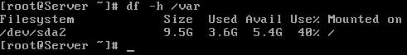

Now mount RHEL dvd on **mnt** and copy entire disk on **/var/ftp/pub**  
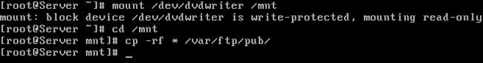

**Dump** is created on **/var/ftp/pub** now you can **umount** RHEL dvd  


**Configure yum server**

**RHCE EXAM QUESTION**  
Backup of the Redhat Enterprise Linux 5 is taken in **/var/ftp/pub** on server named Server.example.com. You can install all required packages using yum by creating the repository file.

Pre quest of yum server

we assume that you have completed these pre quest of yum server

* A Linux system with hostname **Server.example.com** and with ip address of **192.168.0.254**
* **Dump** of RHEL disk on **/var/ftp/pub** location

Once you have completed these pre quests follow this guide.

change directory to **/var/ftp/pub/Server**  
  
**yum** and **createrepo** rpm are required for yum server install them   
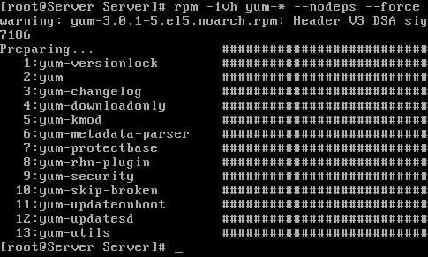  
Now install **createrepo** rpm   
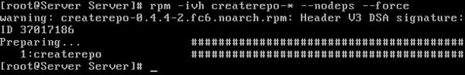

After installing necessary package change directory to **/var/ftp/pub**  
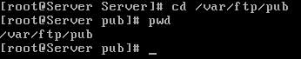

Now create repository of **Server** directory   
  
repository of all rpm will be created in few minute   
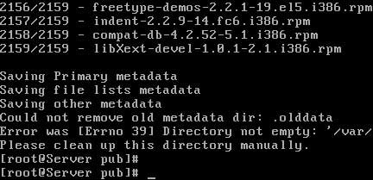  
Now create repository for **VT**   
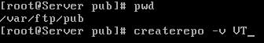  
In few second all necessary repository will be created for **VT**  
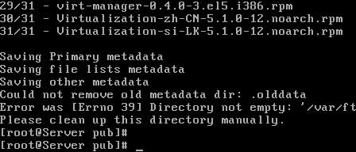  
Now create **errata** directory and repository for it   
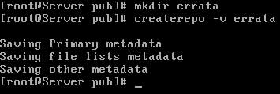

During the process of creating repository **two hidden directory** with named **.olddata** is created automatically remove them   
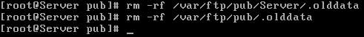

Now check **hostname** and change directory to **/etc/yum.repos.d**. copy sample repository file to the file with hostname And open it   
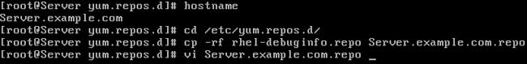  
Default repository file look like these   
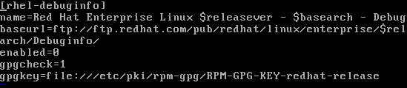  
Remove defaults line and set new location of **Sever** and **VT** as shown here   
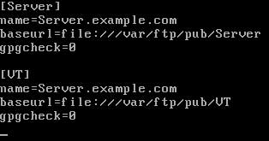  
Save file with **:wq** and exit

Now remove all temporary data file with **yum clean all** command

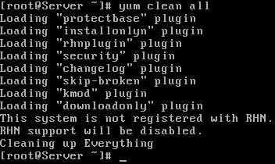

**Congratulation** You have successful create yum server

To test yum server **remove telnet** package   
  
After checking all dependences it will ask for conformation press **y**   
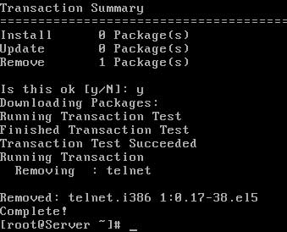  
Now **install telnet** package from yum server  
  
After checking all dependences it will ask for conformation press **y**   
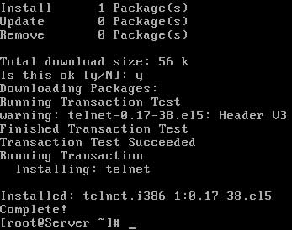

[**Install Linux via ftp or nfs server step by step guide example and implementation**](http://computernetworkingnotes.com/network-administrations/network-installation.html)

* [](http://computernetworkingnotes.com/network-administrations/network-installation/print.html)

During the first phase of RHCE exam you are asked to install Linux via nfs or ftp or apache server. you will be provided a Linux boot disk and IP address and necessary directory name for installation. You need not to prepare server side on exam but here in this article we will configure both server and client side . In this practical we will show you How to prepare nfs or ftp server for network installation and further we will installation linux via nfs as well as ftp server. We will take apache server in our next article.

**RHCE Exam Questions**

Install the Redhat Linux RHEL 5 through NFS. Where your Server is server.example.com having IP 192.168.0.254 and shared /var/ftp/pub. The size of the partitions are listed below:

**/ - 1048 /home - 1028 /boot - 512 /var - 1028 /usr - 2048 swap 2X256 (RAM SIZE)**

There is a NFS server 192.168.0.254 and all required packages are dumped in /var/ftp/pub of that server and the /var/ftp/pub directory is shared. Install the Redhat Enterprise Linux 5 .

There is a FTP server 192.168.0.254 and all required packages are dumped in /var/ftp/pub of that server and anonymous login is enabled. Install the Redhat Enterprise Linux 5.

**prepare Linux server for network installation**

For this practical we need two systems one linux server and one client system. These pre quests should be completed on Linux server.

* Dump of RHEL disk must be taken on **/var/ftp/pub.**  
  [How Dump of RHEL disk](http://computernetworkingnotes.com/linux-network-administrations/yum-server.html)  
  
* Linux server should be configured with hostname **Server.example.com** and IP address **192.168.0.254**  
  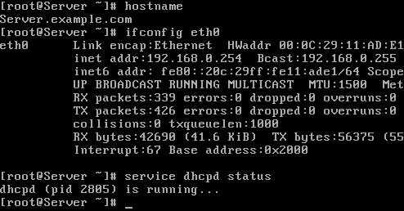
* **DHCP, FTP, NFS** server should be configured and **dhcpd, nfs, vftpd** services must be running. If you feel difficulties in configuration of **dhcp, ftp and nfs** server then check our articles

Once you have completed these pre quests remaining configuration is very easy. Follow this guide.

**Prepare FTP server for network installation**

By default pub directory is shared with anonymous user account login enable in ftp server. So you need no additional configuration just create dump and restart the services.

create dump of RHEL disk to **/var/ftp/pub** and restart **vsftpd** service   
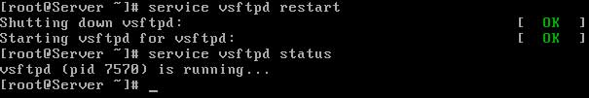

**Prepare NFS server for network installation**

As dump is already taken on /var/ftp/pub so sharing of **/var/ftp/pub** directory will do the task.

open **/etc/exportfs** with vi editor   
  
Share **/var/ftp/pub** for our network   
  
Now restart **nfs** service  


We have prepared both FTP and NFS server for network installation.

**Configure Client for network installation via ftp server**

Boot system with Linux boot CD, [ disk will be provided by examiner] Give **linux askmethod** command on boot prompt   
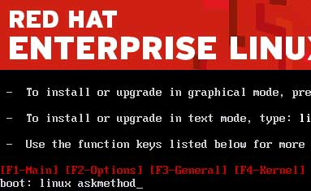  
Select language to **English**   
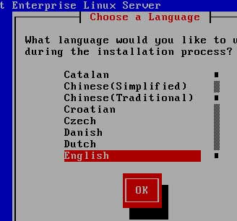  
Select Keyboard layout to **US**   
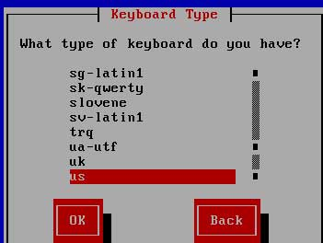

Select install method **ftp** to install via ftp server

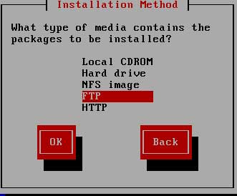

At this point you can remove Linux boot disk form CDROM as we installing linux from ftp server.

Select **Enable IPv4 supports** and select dynamic ip configuration [ we have configured **dhcp server** on linux server so ip will be automatically retrieve ]  
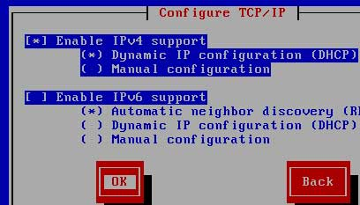  
Give to ip address of **FTP server** in ftp site name and **pub** in directory name   
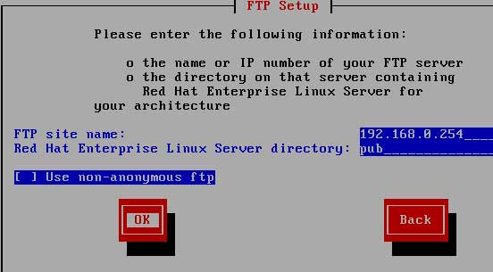  
After few second you will retrieve **anaconda linux boot loader** form server   
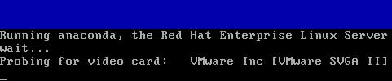

Now you can install linux as you have installed it from local CD ROM . All remaining steps are same.

**Configure Client for network installation via nfs server**

Boot system with Linux boot CD, [ disk will be provided by examiner] Give **linux askmethod** command on boot prompt   
  
Select language to **English**   
  
Select Keyboard layout to **US**   


Select install method nfs to install via **nfs** image   
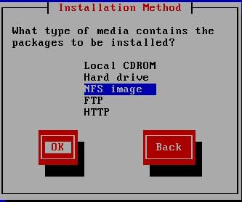

At this point you can remove Linux boot disk form CDROM as we installing linux from nfs server.

Select **Enable IPv4 supports** and select dynamic ip configuration [ we have configured dhcp server on linux server so ip will be automatically retrieve ]  
  
Give to ip address of **nfs server** in nfs server name and **/var/ftp/pub** in directory path   
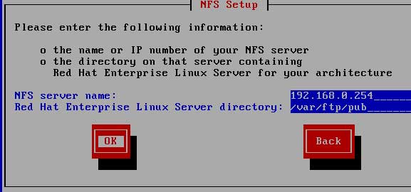  
After few second you will retrieve anaconda linux boot loader form server   


Now you can install linux as you have installed it from local CD ROM . All remaining steps are same.

**Two time saving technique**

During RHCE exam most concern thing is time. So we suggest to create the partition According to the Question because Size and what-what partition should you create at installation time is specified in your question. Do not create any extra partition to save time because any additional partition will take time in formatting.

Due to the time limit, you should care about the installation packages. At Exam time these packages are enough.

* X-Window System
* GNOME Desktop
* (these two packages are generally not required)
* Administration Tools.
* System Tools
* Windows File Server
* FTP Servers
* Mail Servers
* Web Servers
* Network Servers
* Editors
* Text Based Internet
* Server Configuration Tools
* Base
* Printing Supports

When installation will complete, your system will reboot. Jump for another Question.

[**Install Linux via apache http web server step by step guide example and implementation**](http://computernetworkingnotes.com/network-administrations/network-installation-apache.html)

* [](http://computernetworkingnotes.com/network-administrations/network-installation-apache/print.html)

During the first phase of RHCE exam you are asked to install Linux via nfs or ftp or apache server. you will be provided a Linux boot disk and IP address and necessary directory name for installation. You need not to prepare server side on exam but here in this article we will configure both server and client side . We have configured nfs and ftp server for network installation in our pervious article you can check it.

In this practical we will show you How to prepare apache httpd server for network installation and further we will installation linux via apache httpd web server.

**RHCE Exam Questions**

There is a HTTP server 192.168.0.254 and all required packages are dumped in /var/www/html/rhel5 of that server. Install the Redhat Enterprise Linux 5 by creating following partitions:

/ - 1048 /home - 1028 /boot - 512 /var - 1028 /usr - 2048 swap 2X256 (RAM SIZE)

**prepare Linux server for network installation**

For this practical we need two systems one linux server and one client system. These pre quests should be completed on Linux server.

* Linux server should be configured with hostname Server.example.com and IP address 192.168.0.254  
  
* DHCP and HTTP server should be configured and httpd and dhcpd service should be in running status  
  

**Prepare HTTP server for network installation**

By default document root for http server is /var/www/html. So create a directory here with name rhel5 and make the dump of RHEL CD in it and restart the httpd service.

create dump of RHEL disk to /var/www/html/rhel5 and restart httpd service   
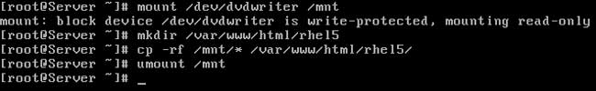  


We have prepared HTTP server for network installation.

**Configure Client for network installation via web server**

Boot system with Linux boot CD, [ disk will be provided by examiner] Give linux askmethod command on boot prompt   
  
Select language to English   
  
Select Keyboard layout to US   


Select install method HTTP to install via web server

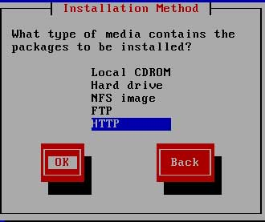

At this point you can remove Linux boot disk form CDROM as we installing linux from http server.

Select Enable IPv4 supports and select dynamic ip configuration [ we have configured dhcp server on linux server so ip will be automatically retrieve ]  
  
Give to ip address of web server in website name and rhel5 in directory name   
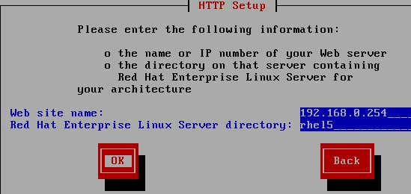  
After few second you will retrieve anaconda linux boot loader form server   


Now you can install linux as you have installed it from local CD ROM . All remaining steps are same.

**Two time saving technique**

During RHCE exam most concern thing is time. So we suggest to create the partition According to the Question because Size and what-what partition should you create at installation time is specified in your question. Do not create any extra partition to save time because any additional partition will take time in formatting.

Due to the time limit, you should care about the installation packages. At Exam time these packages are enough.

* X-Window System
* GNOME Desktop
* (these two packages are generally not required)
* Administration Tools.
* System Tools
* Windows File Server
* FTP Servers
* Mail Servers
* Web Servers
* Network Servers
* Editors
* Text Based Internet
* Server Configuration Tools
* Base
* Printing Supports

When installation will complete, your system will reboot. Jump for another Question

[**How to configure IP address in Linux**](http://computernetworkingnotes.com/network-administrations/basic-networking-commands.html)

* [](http://computernetworkingnotes.com/network-administrations/basic-networking-commands/print.html)

Every node participating in networking needs a valid IP address. On Linux command prompt IP address is assigned by a network configuration window. This window can be invoked by selecting **network configuration** sub menu form **setup** command or directly executing **system-config-network** commands.

Run **setup** command form root user

#setup



this will launch a new window select **network configuration**



now a new window will show you all available LAN card select your LAN card ( if you don’t see any LAN card here mean you don’t have install driver)



assign IP in this box and click ok



click on ok, quit and again quit to come back on root prompt.

Alternately you can use **system-config-network** command directly to invoke this setup window

#system-config-network



whatever change you made in network configuration will not take place till you restart the LAN card

#service network restart

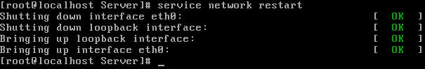

**ifconfig**

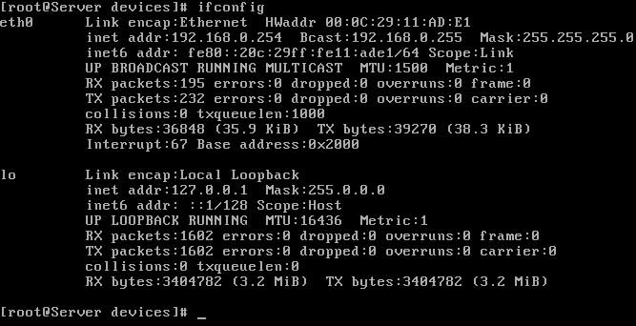

The **ifconfig** command will display the configuration of all active Ethernet card. Without specifying any parameter this command will show all active Ethernet card. if you want to see the configuration of any specific Ethernet card then use the name of that card as the command line arguments. for example to show the IP configuration on loop back Interface execute this command

#ifconfig lo

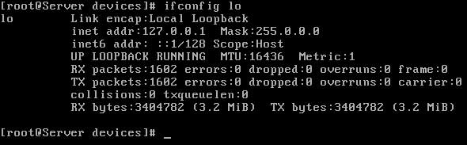

**ifup/ifdown**

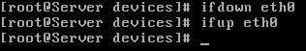

Each installed network adapter has a corresponding **ifcfg-\*** file in **/etc/sysconfig/network-scripts.** You can activate or deactivate that adapter with the ifup and ifdown commands. Either of the following commands will activate the eth0 network adapter:

#ifup ifcfg-eth0 #ifup eth0

**netstat**

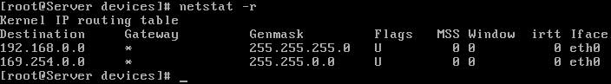

The netstat program provides real-time information on the status of your network connections, as well as network statistics and the routing table. The netstat command has several options you can use to bring up different sorts of information about your network.

**arp**

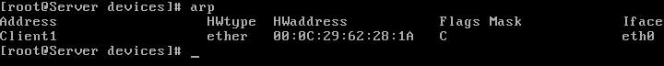

The Address Resolution Protocol associates the hardware address of a network adapter with an IP address. The arp command (in the /sbin directory) displays a table of hardware and IP addresses on the local computer. With arp, you can detect problems such as duplicate addresses on the network, or you can manually add arp entries as required.

**mii-tool**

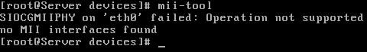

mii-tool command is used to check the link is activated or not. Most use of mii-tool command is to check to physical link of Ethernet card on command line. With this command you can check on command prompt that cable is plugged in LAN card or not.

**ping**

ping command is used to check the physical connectivity. If you get reply mean everything is ok. If you get request time out response means there is some problem it could be unplugged cable power off switch or enabled firewall on destination node. If you get Destination host unreachable means remote node is not in your network. **Use CTRL+C to abort the ping sequence**

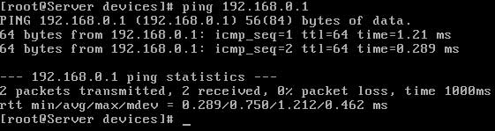

**service network restart**

Whatever change you made in network configuration files will not take place until you restart the network services. To implement change this command is used.



http://computernetworkingnotes.com